CPT205-Computer Graphics
Wang.Qi
1929518
Information and Computing Science

Introduction
The greeting card I design for the 15th anniversary of XJTLU with a blue to pink gradient color has five main features, blooming flowers, fireworks, smiling faces, two pinballs and the simplified shape of the Central Building.
The gradient effect is implemented by setting the GL_SMOOTH value in glShdeModel. Two pinballs in the background are achieved by changing values of global position variables in time function. Another animated object fireworks are achieved by lines of different directions and time callback. Flowers are drawn with the help of semi-ellipses as petals and geometric primitives as leaves. Smiling face takes advantage of the polar coordinates. The most symbolised one of XJTLU, the Central Building, was structured by the glutSolidCube function and glLines. Also, projection, viewing and matrix transformation are widely used in the card to adjust the position and angles. This report will show the specific instruction of this card and related graphical technology implementation.

Instruction
1. Background
The background is drawn on a rectangle that has the same height and width as the display window. By setting GL_SMOOTH in glShadeModel, we achieve the gradient effect with the same color for the top two angles and another color for the two angles below. Here is the static result of the greeting card.

  - Two moving pinballs
These two circles mainly use the changing values of their position coordinates. If their values exceed the window size, then it will turn the direction achieved by subtracting the initial value of the “step” variable. Moreover, to simulate the collision effect, if the distance between the center of two circles is less than their diameter, they will both move towards the opposite direction simultaneously.
2. Simplified shape of Central Building
By using the function of glutSolidCube and glutSolidTorus, it is easy to get an outline of the Central Building. But it is also hard to recognise, so geometric primitives GL_LINES are used here to draw the symbolized splitting lines. To make the object look real, projection transformation and look at point are changed here.
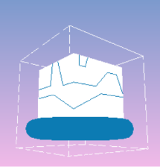

3. Blooming flowers
The implementation of flowers is an application of drawing a semi ellipse by polar coordinate. The branch and leaves are drawn by geometric primitives.

Here is a mouse interaction. Five processes of flowers growing up have been set controlled by the left button of the mouse. Press the left button and then all flowers will grow taller simultaneously. Besides, the number of petals will be added and displayed symmetrically. This is achieved by rotating transformation with clicking times marking it.

Here are five different processes of blooming flowers.
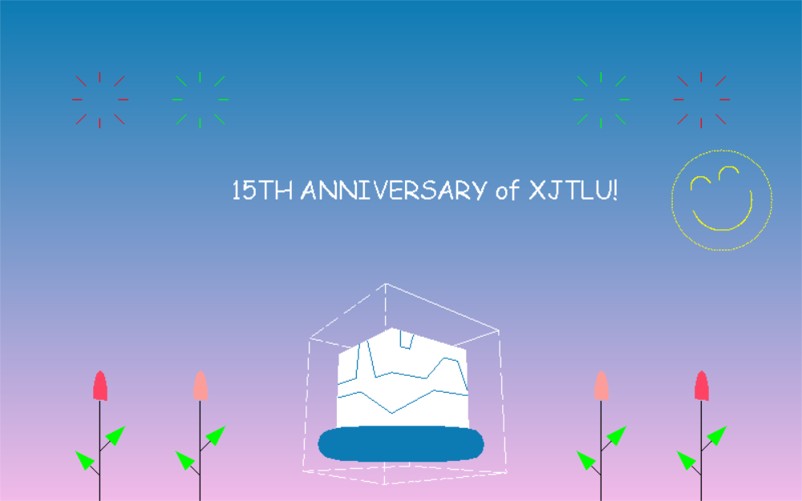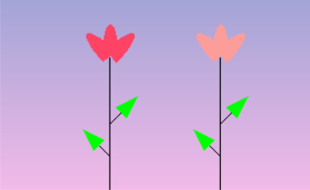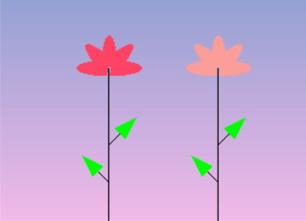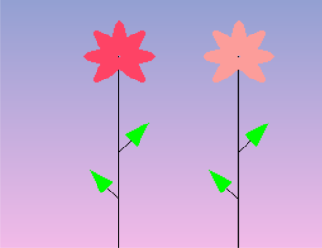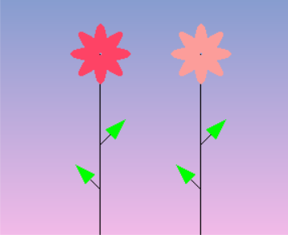

4. Smiling face
With the help of polar coordinates, geometric primitives GL_POLYGON and GL_POINTS can draw the “smiling face”. Besides, the eyes and mouse are achieved by a similar method and translating or rotating transformation.

Here is a keyboard interaction to move the position of a smiling face. Type “w” or “W” to move upward. Type “s” or “S” to move downward. Similarly, Type “a” or “A” to move left. Type “d” or “D” to move right.

5. Fireworks
The main point of this effect is making use of the time callback function to control every line moving simultaneously. Setting global variables to control the moving trace and calculating the moving steps are also important.

Conclusion
Through making this greeting card, It gives me a deeper understanding of the practical application of these functions, for example, geometric primitives, viewing and projection, keyboard and mouse interactions and the method of drawing animated objects. In this process, from overall to partial, considering holistically and being proficient in every function both helps a lot.

