2.2Congestion Control in Internet networks

2.2.1Problem description
A key characteristic of IP networks is its packet switching mechanism that allows a significant increase in the efficiency of bandwidth utilization. This efficiency is explained by the fact that multiple communications could take place over the same physical resource. However, this scheme rises the important question of how the capacity should be shared. And Internet discovered this in the hard way; during the mid 80' a serial of network crashes took place: high packet delay, high loss rate and low goodputs are the characteristics of the communications taking place then. These are now the symptoms of a network being over-utilized, and though these collapses had been baptised as Congestion Collapses \cite{RFC896}.
As described in the RFC, the causes of this problems is that the offered load in the network is overpassing the network capacity resulting in full queues and so increase delay and more packets being drop. The same RFC state that the problem particularly occurs when TCP is the transport layer being used over IP. Rightly, TCP retransmission mechanism was really clumsy. Indeed, when the liable transport layer considers that a packet wasn't routed to destination it retransmits not only one but multiple packets. This means additional load over the already congested network and congestion getting worst. But even if this retransmission scheme was replaced, it is up to the end host to adapt their transmission rate to limit the congestion and enhance the overall network performance. This is what was achieved through the implementation of congestion avoidance algorithm proposed by Van Jacobson [Jacobson88] for TCP. The same report suggested also that the network performing congestion control might enhance further the global performance. Some of the techniques used by the network were introduced later in what is known today as Active Queue Management AQM.

2.2.2TCP and congestion control algorithm

Transmission Control Protocol TCP is a transport layer protocol that provides a connection-oriented, reliable stream delivery service over the connectionless unreliable IP network. As a transport protocol it provides a demultiplexing function that allows several process or flows at a single IP address to communicate concurrently. It provides also reliability by establishing a connection with the destination end host, so data is transferred and acknowledge in terms of byte streams enabling thus the possibility of retransmissions when the losses are detected either by the expiration of the acknowledgement timer or the reception of acknowledgement of previously acknowledged bytes (duplicate acks).
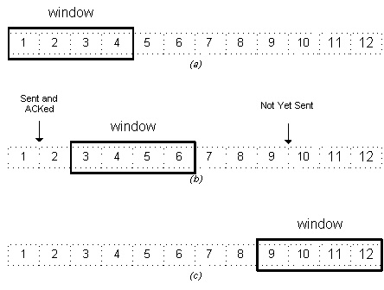

To avoid bandwidth wastes that usually accompany positive acknowledgement schemes, TCP use a sliding window algorithm that limits the number of segment a sender could transmit before receiving acknowledgements. Once the acknowledgement of the first packet arrives the window slides and a next packet could be sent. The number of packets that could be sent before receiving a first acknowledgement is called the window size(figure douglas book page 214). Thus, the transmission rate of a sender could be estimated in function of the window size as:
\begin{equation}
R_{Tx} = \fract{Window size}{RTT}
\end{equation}
where RTT is the Round Trip Time which is the necessary time for the packet to arrive to the receiver and that the acknowledgement to get back. This window side is variable and limited by the receiver advertisement window, that allow the receiver to specify the number of bytes that it could receive, and also the congestion window that is used by the sender to limit the transmission rate to control the congestion. A variety of congestion control algorithms exist depending on TCP implementation but they all have “Slow Start” and “Congestion Avoidance” in common.
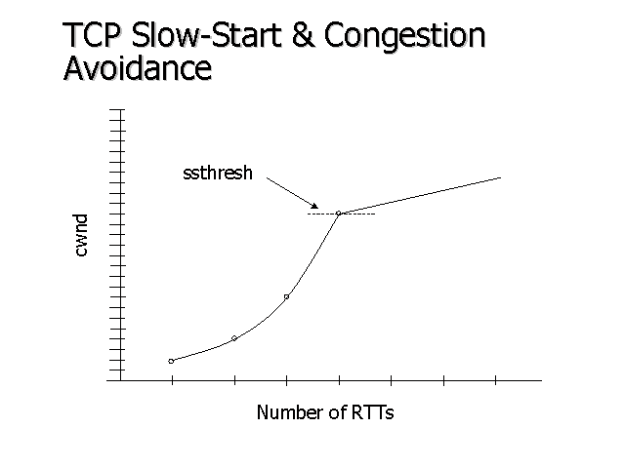
So during the Slow Start phase the sender increase exponentially the congestion window (cwnd) until reaching the slow start threshold (ssthresh) then TCP sender enters the “Congestion Avoidance” phase where the cwnd is increased by 1 every time an acknowledgement is received.
The next part is when TCP implementations differ, so when the loss is identified (Retransmission TimeOut (RTO) or duplicate acks) the cwnd is reduced to 1 and the slow start is restarted, or to ssthresh in the case of “Fast Transmit” and TCP senders enter directly the phase of “Congestion avoidance”. ssthres is reduced also and usually put to the half of the cwnd before that the congestion occurs. Thus this algorithm is designed as Additive Increase Multiplicative Decrease AIMD.

    - Active Queue Management

An individual action from the end hosts toward the congestion presents some limitation. End hosts are only aware of the congestion when the packets start being dropped and they react simultaneously to the congestion causing thus a global synchronisation. RFC 2309 states that using some queue management techniques for congestion control will allow to decrease the number of dropped packets and avoid global synchronisation.
RED or Random Early Discard is one of these scheme that permit to avoid oscillation and the global synchronisation by starting to discard packets randomly before the queue is completely full:
a figures
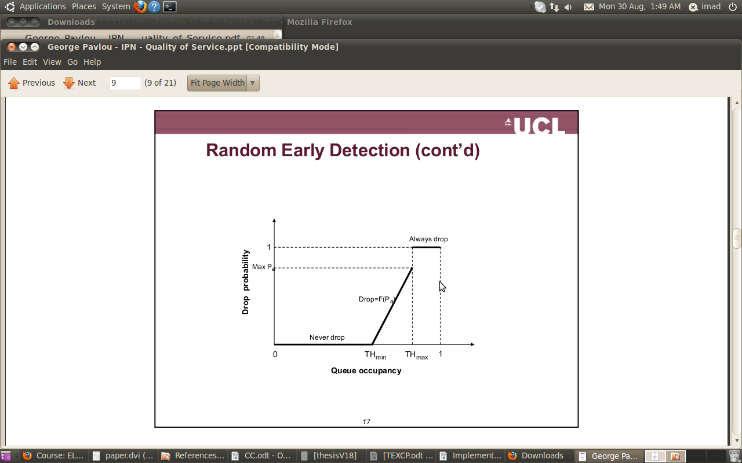
The algorithms could be described as
- If the queue size is smaller than $T_{min}$, packets are enqueued.
- If queue size is larger than $T_{max}$ discard the packet.
- If the queue size is between $T_{min}$ and $T_{max}$ packets are dropped according to a probability p.
The key to make the algorithm work is to well choose the algorithm parameters. Some of the consideration are to ensure a high utilization of the outgoing link and provision enough difference between $$T_{min}$ and $T_{max}$ so the end hosts are informed and could react. Also differntial treatment could be applied by using different value of the discard probability p for different flow classes.
Explicit Congestion Notification (ECN)
RED could also be combined with ECN \cite {RFC 2481} another AQM technique that allows the network to explicitly inform the end user of the congestion instead of relying only on the the host detecting packet losses. The network feedback is passed to the end user through two unused bits in the IP TOS byte. Thus 4 code points are available :

- 00: Non ECN-Capable Transport - Non-ECT
- 10: ECN Capable Transport - ECT(0)
- 01: ECN Capable Transport - ECT(1)
- 11: Congestion Encountered - CE
ECT(0) and ECT(1) indicates that the originator of the packet is ECN capable and in this case, if the packet has experienced congestion the router will mark the packet with CE code point. This is carried out in a similar scheme to RED and allows transport protocols and particularly TCP of being notified of congestion without having to experience loss.
By marking packets instead of dropping them, ECN reduces the number of dropped packets. It also reduces the delay for the network layer to consider the packet as dropped and hence the delay of its reaction to the congestion. Finally, is in-band signalling mechanism and doesn't add additional traffic which is particularly harmful when the network is experiencing congestion.

2.1.2 Explicit Congestion Notification
ECN (EXPLICIT CONGESTION NOTIFICATION) [Floyd94, RFC 2481] is a pro-
posed extension to IP and TCP. It allows the network to provide the user with
extra feedback concerning its congestion state using two bits in the IP TOS
byte. These indicate firstly whether or not the originator of the packet is
ECN aware, and secondly whether or not this packet has experienced con-
gestion. A variety of router marking strategies can be implemented to signal
the onset of congestion to end-points using these bits, discussed briefly in
Section 2.2.1. They allow higher layer protocols, currently TCP and RTP in
particular, to make decisions about their use of network resources without
having to experience loss, previously the only available feedback signal.
There are a variety of proposals concerning the treatment of ECN marks,
generally falling into one of two categories. The first category is similar to the
‘technology oriented’ approaches discussed in Section 1.3, and mandates that
the protocol should have some standard behaviour in the face of ECN marks,
perhaps even behaviour identical to that in the face of loss [RFC 2481]. The
second category is ‘price driven,’ where the network counts the marks it
sees, and presents the user with a bill for the marks they receive [Key99a,
Gibbens99b, Kelly00]. This category is discussed further in Section 2.2.4.

When end hosts acted alone to
The network participates also in congestion control. RFC 2309 states that pro active reaction of the network towards the congestion could enhance the global performance by reducing the number

2.1.4 Transmission Control Protocol
TCP (TRANSMISSION CONTROL PROTOCOL) [RFC 793] is designed to pro-
vide a connection oriented ordered reliable byte stream on top of the connec-
tionless unreliable IP. It implements window-based flow control and allows
multiple processes at a single IP address to communicate concurrently with
a process or processes at other IP addresses. It uses a three-way handshake
to establish a connection, and data is then transferred and acknowledged in
terms of segments measured in octets. This enables retransmission of miss-
ing segments when notified of loss by reception of acknowledgements for
previously acknowledged data, or by expiry of a timer. The timer values are
adjusted as each end-point of the connection estimates the RTT (ROUND TRIP
TIME ) of the connection.
Modern TCP implementations also support a variety of congestion control
mechanisms [RFC 2914]. Congestion occurs due to contention for limited
network resources, typically buffer space or transmission bandwidth. If it
is not detected and prevented, then congestion collapse may occur; this is
where the network, or some subset of the network, is loaded to such a level
that goodput – the throughput of data, disregarding retransmissions – falls
to negligible levels [Jacobson88, Morris99]. Following the rapid increase in
the use of TCP and enormous changes in the topology and size of the Inter-
net, a succession of congestion control mechanisms have been proposed and
implemented for TCP.
These began with the ‘Slow Start’ and ‘Congestion Avoidance’ schemes [Ja-
cobson88], and include the TCP varieties known as Tahoe, Reno, and SACK
(SELECTIVE ACKNOWLEDGEMENT) [Fall96]. In general, they are based on
the idea that when the TCP sender notices congestion, it will multiplicatively
decrease its transmission rate or back-off. Congestion is traditionally de-
tected through loss2 of a packet, but alternatives where packets are marked
to signal the onset of congestion are under consideration [Floyd94, RFC 2481,
2
Throughout this dissertation it is noted that loss of a packet might not simply be the
packet being dropped in the network either through congestion or error at a lower layer, but
also its excessive delay, detected through timeout.

Laevens00], as was discussed in Section 2.1.2. The connection will subse-
quently linearly increase its transmission rate until another loss event is de-
tected. This gives TCP its characteristic sawtooth transmission pattern, as it
probes for bandwidth, experiences loss, backs-off, and repeats the cycle.
A more recent attempt to improve the congestion behaviour of TCP resulted
in Vegas [Ahn95, Brakmo95, Low01]. Rather than continually probing the
network to see if it may increase its congestion window when it reaches
steady state, it attempts to estimate the correct congestion window size. This
is done by accurate estimation of the RTT using the assumption that the low-
est RTT is the RTT that the network would allow if it was not carrying the
traffic associated with this connection. This allows the protocol to estimate
the amount of data it has in flight, and then to adjust its transmission rate
(and RTT estimate) to ensure that its estimated fair share is not exceeded.
This behaviour only applies in the congestion avoidance, or steady-state,
phase; when loss is detected, the standard TCP congestion control mecha-
nisms are applied. In Chapter 3 it will be shown that there are situations
in which neither the behaviour of standard TCPs nor that of Vegas TCP is
sufficient to guarantee acceptable performance of the network.

ECN: In 1994, Floyd published “TCP and Explicit Congestion Notification” (ECN) [Flo94]. It pro-
posed a new field in the Internet protocol (IP) header, which finally reached the first ‘Proposed Stan-
dard’ stage of the Internet Engineering Task Force’s (IETF’s) standards track nearly seven years later, in
2001 [RFB01].
Prior to ECN, a queue experiencing congestion would discard some packets, then Internet con-
gestion controls like TCP would detect the lost packets as gaps in the sequence numbers of the packet
stream. The idea of ECN was to use an explicit marking on packets to indicate the onset of congestion,
to try to keep the network at an operating point just below where losses started to be experienced. There
is always a possibility that a gap in a packet sequence is merely a symptom of re-ordering, so a transport
protocol waits for stronger evidence of a loss (further packet arrivals without filling the gap, or ultimately
a timeout) before deciding congestion has really been experienced and slowing its rate. This delay due to
uncertainty (which ECN solves) has a disproportionately detrimental effect on the performance of short
transfers.
The reason ECN is important to the present research is an unintended but necessary side-effect of its
introduction. It makes congestion visible to network devices downstream of the congested link, whereas
any discards of packets by upstream devices are difficult if not impossible to monitor within the network.
This is because there is no need for a sequence number space at the IP layer. So if the transport or higher
layers choose not to reveal their sequence numbers (e.g. by encrypting them), the network cannot detect
a gap in them. And even if they are not encrypted, a network element doesn’t know whether gaps are
due to re-routes or congestion. Readability of the ECN field at the IP layer is a fortunate side-effect of
the need for writability of the field at the network layer.
In outline, ECN works as follows. As an ECN-enabled queue in the network starts to grow, it sets
the new ECN field to a codepoint termed congestion experienced (CE), with increasing probability the
longer the queue. Whenever a CE mark arrives at the receiver it notifies the sender, which can quickly
and unambiguously know that congestion has been experienced. The sender is then meant to reduce its
rate as if it had detected a drop (e.g. in its congestion avoidance phase TCP would halve its window).
Despite the mention of TCP in the title both of the research paper and the proposed standard,
ECN was a change to the network layer’s notification of congestion, which then requires any higher
layer transport protocol, not just TCP, to be updated in order to understand it. TCP was merely the
first transport protocol to be adapted to the new IP. This required some careful attention to backward
compatibility to avoid using ECN to signal congestion to legacy transports that only understood loss as
a sign of congestion.
Specifically, prior to ECN, the two bits of the ECN field had (nearly) always been left containing 00
2.2. Economics of Network Congestion
23
(now termed Not-ECT, a non-ECN-capable transport). So, for packets with the ECN field cleared to zero,
even if a queue is ECN-enabled it must use drop rather than ECN to notify congestion. Also a sender-
receiver pair must not use ECN unless they have established that they are both capable of understanding
it, typically in the capability negotiation during the initial handshaking to start a flow. Then the sender
must set the ECN field in every data packet to a non-zero value2 to indicate to the network that the
transport understands ECN (termed ECN-capable transport or ECT).
Hence some congestion avoidance were introduced in TCP.
Though the performance of these algorithm could be optimized with a little help from the network. Instead of waiting the congestion to the queue being completely full the routers could start informing the network with what is hepening through dropping the packets before or marking them using ECN.

, that Significant increase of bandwidth efficiency and many other advantages were behind this choice. This mechanism applies that many communications are taking place over the same physical circuit. Meanwhile, mainly for scalability reasons, Internet designers wanted to keep core network simple and leaving all the complexity at the edge. This means that all the mechanisms of capacity sharing should be at the end hosts. Because of the small size of Internet at its beginning, this issue didn't raise a real problem. But, during the mid 80' a serial of Internet collapses took place: a small good throughput, high packet delay and loss rate are the observation that end hosts were making. These are now the symptoms of a network being over-utilized, and though these collapses had been baptised as Congestion Collapses \cite{RFC896}.

