Congestion Exposure

    - Motivation

As explained in the previous section, congestion control in TCP/IP networks is mostly based end users running congestion avoidance algorithm. In fact, every TCP routine increases its transmission rate until packets are dropped due to a congestion in bottlenecks. This mechanism might seems weird, but it is fundamental in the Internet architecture where there is no circuit dedicated for a communication and though no fixed rate. The second outcome of TCP congestion avoidance algorithm is capacity sharing. From a first glance at the mechanism , we might think that it could be considered as fair since all the users are running the same algorithm and respond the same way to the state of the network. However, this fairness is only a mirage. A first way to walk around TCP limitation is by running simultaneously multiple TCP instance, since every instance gets an equal share of the available capacity. But, the real problem is that the users are not all the same, having different behaviours and participating differently to congestion. This problem is a real puzzle for ISPs today. A small part of their customers that uses greedy applications, like peer-to-peer and video streaming, are taking more and more shares of their network capacity \cite{RFC5594}. Hence, they couldn't leave any more the capacity sharing task for TCP and they turned to new methods for controlling the traffic and explicitly making sure that heavy users are not taking the whole bandwidth. However, the success of these methods is mitigated because the lack of the information about the congestion a flow is causing and though they are unable to treat them according to what really matters. Hence, making congestion visible in the network layer is a necessity to build a fairer sharing mechanism. ECN(see section ??), the protocol that the core routers uses to explicitly inform the end hosts of the congestion they are causing is a step in the right direction. Using ECN, a network is able to calculate the congestions caused by the flows that a user receive. But this is not enough, the problem with P2P applications for example is the congestion that they users are making in their upload sense and also receiver could also ask “politely” the senders to change their rate and can't imply how they work, congestion exposure goal is to make the congestion fully visible in both direction and for all the network nodes.

    - Overview of the current traffic control methods
As pointed out in the previous section, ISPs are attempting to control their customers traffic. These methods could be divided in three categories: network layer measurement based, transport and application.
L3 Measurement policing
The original design of Internet supposes that routers looks only for information in the detained in the network layer. Two possible measurement could be carried on: volume and rate.
Volume accounting is the easiest information that a network provider could calculate to have a clue about who are heavy users . To obtain this information, it is enough to look for the packets sizes at the IP header and then add them up. ISPs could use this information to impose the maximum limit for a user in a period of time. However, volume accounting doesn't give a real vision of the damages that a volume of traffic is making since it might depends on the period of time as well as the part of the network where it goes.
The second tool in this category is the rate measurement. It is especially the case for the accounting between ISPs, where for instance the charging could be made on the percentage of peak rate crossing the border. A simple way to measure the rate is by accounting the volume for short periods of time. Traffic shapers could be used to make sure that the traffic doesn't overflow the maximum rate. Even, if such policies will allow to limit the damage of heavy users on the others, but they induct situations where some users are allocated more capacity than they really need to prevent the risk of all the users sending fast at the same time, resulting though a poor bandwidth efficiency.
Higher Layer Discrimination
ISPs are aware of the limitation hourglass design of the Internet and in the same time the equipment capacity is increasing exponentially, and the reasons for keeping the routers simple are diminishing. Hence, some ISPs have introduced DPI operations that allow to investigate the packet to identify the flows that belongs to the applications that they thought being responsible for the network congestion. A common example is P2P file sharing. ISP regard these applications as ith low value for the customers and cause most of the congestion problems in the network. These technique are in the center of the ongoing debate about Net Neutrality. Even more, the efficiency of these techniques is being questionnaire since P2P applications responded to the DPI by using encryption techniques.
The last example is usually called bottleneck rate policing. They require the deployment of the rate policers at the bottleneck that based on some assumption over what an flows might accept about traffic shaping. Another problem with these approaches is that the traffic usually traverses multiple bottlenecks and therefore limiting hence the utility of the solution.

    - Re-inserting the Feedback Re-Feedback
All the approaches described above fail in controlling the traffic based on what counts the most, the congestion caused by the customer. The main reason behind this failure is in Internet design itself that doesn't provide enough information about congestion to the network. Re-Feedback attempts to correct the weak points in Internet feedback mechanism. As explained, previously, ECN markings till routers about the congestion on the upstream route (the part of the route between the sender and receiver). Similar accounting could be achieved with the Time To Live (TTL) field. The modification that Re-Feedback is suggesting, is that instead of aligning the information at the source, the sender modifies the field by targeting to reach a certain metric at the destination. For example, TTL field shouldn't be initiated to 255 at the source, but should be modified to reach an agreed value at the destination (say 16). This means that the routers by inspecting the IP header will be able to have an estimation of how many nodes left for the packet to reach destination.
Re-ECN is the implementation of this principle using ECN markings that will attempt to provide a metric for accounting the congestion. As table ?? depicts, a value is associated with each markings, for example a neutral packet has a value of 0 and if it experience congestion it will become negative with a value of -1, and the accounting at the routers is decremented. Thus, the sender should transmit enough packets with a positive value +1 (router increment their accounting when they see positive packets)so the accounting near the destination won't go bellow 0. If these packets experienced itself congestion they will be cancelled 0. Now the network needs to control the network at two critical points. At the egress where it could have a vision of the congestion for the full path, the operator should ensure that the source is putting enough credit or positive packets so the accounting stays positive, and provision incentives for that ( for instance dropping packets where the metric is negative). Now the network is capable to account the congestion created by the source by accounting the positive packets that correspond to the congestion the source make. Based on this metric the network will be able to identify the sources that cause most of the congestion and could treat them accordingly. For instance, each source will be allocated a limit of the positive packets and once it over pass this limit the quality of the service might drop (traffic policing, limited bandwidth etc.)

    - Use Cases

Now that the operator is able to charge the customer on explicitly the congestion they are causing, Heavy users are motivated to act less aggressively when the network is experiencing congestion. This won't significantly delayed their communication, since when “light” users acting more aggressively will have a bigger share allocated and they will finish their communication faster, so the heavy users could recuperate the whole bandwidth again.
Other benefits could be drawn from the Congestion Exposure scheme like the use of the new encoding to identify the attacks by their patterns. And the aim of this project is to evaluate the use of another congestion exposure scheme in Traffic Engineering.

State
Cautious
Positive
Neutral
Cancelled
Negative
Not ECN Capable
Legacy ECN
Currently Unused

Notation Worth Variable ECN-RE
(+?) +1 g 00-1
(+1) +1 z 01-0
(0) 0 y 01-1
(±0) 0 c 11-0
(-1) -1 u 11-1
Not-ECT -
ECT(0) -
CU 0
00-0
10-0
10-1
We propose collecting path information in packet header fields as data traverses a path, just as can already be done with time to live (TTL) or congestion notification (ECN [RFB01]). But previously, as each node added characterisation of its local hop, the header values accumulated upstream path knowledge. By a simple realignment, we arrange each field to characterise the remaining downstream path. We aim to reach a target for the metric at the destination, rather than aligning the datum at the source. For example, TTL currently always starts at the datum 255. Instead we propose it should arrive at the destination set to an agreed datum (say 16). To achieve this, each receiver needs to occasionally feed back the TTL values arriving in packets, so the sender can adjust the next attempt in order to continue to hit 16. §4.2 expands on this basic explanation with more precision.

    - How the congestion exposure help
a faster internet the figure.
Detecting anomalies
and traffic engineering
The economics of network congestion: the network provider can't just throw new capacity the network, since a large share will be still consumed by the users
Design Internet itself is to blame for much of the tussle that ISP encounters to build a fairers mechanisms for sharing the information. One of the problem is the lack a signalling mechanism
in bound, out bound
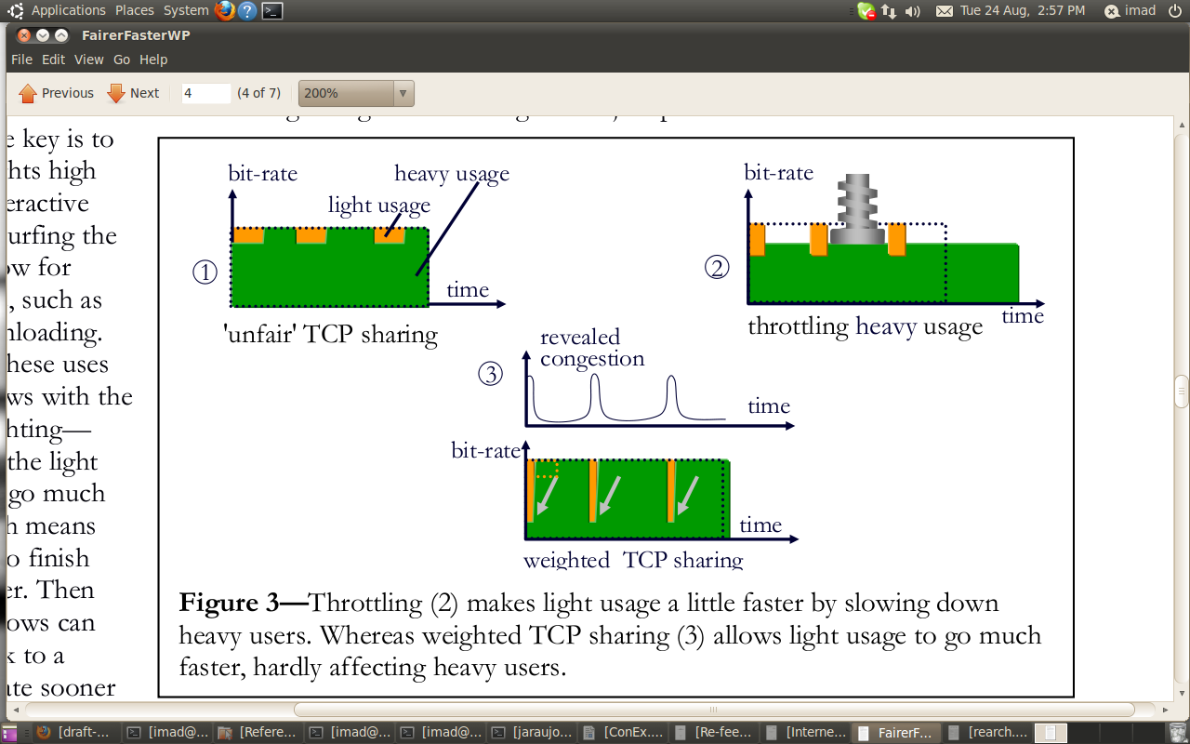
figure from Internet fairer is faster

The signalling of such packets has many practical im-
plications. For one, from simply inspecting the IP hea-
der, networks are made aware of the first of a succession
of similar packets, which poses significant advantages in
allocating state in middleboxes, whether it be to per-
form admission control, policing or traffic shaping. All
of the above are possible by inspecting TCP, but we
attempt here to make apparent an architectural illu-
sion: that a connectionless layer should be oblivious to
connection setup. By making such information expli-
cit at the IP layer we are alleviating in some measure
the need for consistent violation of layering by network
equipment, or hopefully circumscribing such practices
to a small subset of packets

All the tools that network providers are using to control their customers traffic miss the objective of policing them based on the congestion that they are making. The main reason behind this failure is the lack of visible information about the congestion. In a larger scope, most of the signalling in IP is kept at the edge of the network. ICMP, the protocol designed for the control has limited used and can't be used especially in the case of congestion since an out band signalling will only make the congestion worst. As described previously ECN is a step in the right direction and allow to measure the congestion cause in the upstream. Re-Feedback principle suggests the alignment by the sender of path information that it collected during the last period of time. IP Time To Live (TTL) or ECN markings are examples of the path informations that

