**Industrial Internship Report on**

**”** **Data-Driven Forecasting and Quality Prediction Projects”**

**Prepared by**

**[Kodamarthy Sasasnk]**

|  |
| --- |
| *Executive Summary* |
| This report provides details of the Industrial Internship provided by **Upskill Campus (USC)** and **The IoT Academy** in collaboration with industrial partner **UniConverge Technologies Pvt Ltd (UCT)**.  This internship was focused on a project/problem statement provided by UCT. We were required to complete the project, including the report, within six weeks.  My project involved **Forecasting Smart City Traffic Patterns** and **Quality Prediction in a Mining Process** using Python and data analytics techniques. During this internship, I analyzed datasets, applied statistical and probability concepts, implemented basic predictive models, and developed insights relevant to real-world industrial applications.  This internship gave me valuable exposure to industrial problems and the opportunity to design and implement data-driven solutions. Overall, it was a highly enriching and practical experience. |

**TABLE OF CONTENTS**

1 Preface 3

2 Introduction 4

2.1 About UniConverge Technologies Pvt Ltd 4

2.2 About upskill Campus 8

2.3 Objective 9

2.4 Reference 9

2.5 Glossary 10

3 Problem Statement 11

4 Existing and Proposed solution 12

5 Proposed Design/ Model 13

5.1 High Level Diagram (if applicable) 13

5.2 Low Level Diagram (if applicable) 13

5.3 Interfaces (if applicable) 13

6 Performance Test 14

6.1 Test Plan/ Test Cases 14

6.2 Test Procedure 14

6.3 Performance Outcome 14

7 My learnings 15

8 Future work scope 16

# Preface

During this six-week internship, I worked on projects that combined **data analysis, statistical modeling, probability concepts, and basic machine learning** to solve practical problems in traffic forecasting and industrial quality prediction.

The internship was highly relevant for career development, as it provided hands-on experience in applying theoretical knowledge to real-world data challenges.

The projects involved analyzing **traffic patterns in smart cities** and predicting **quality metrics in a mining process**. The opportunity to implement Python-based solutions, visualize results, and derive insights helped me strengthen my programming and analytical skills.

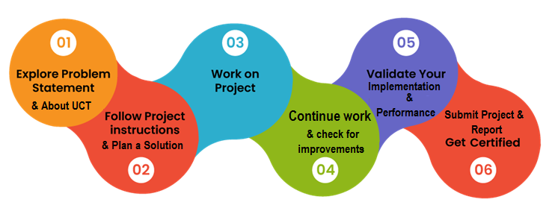

I would like to thank **Upskill Campus, The IoT Academy, and mentors at UCT** for guiding me throughout the internship. This experience has motivated me to continue exploring data science applications in industrial contexts.

My message to future interns: **actively explore the datasets, experiment with solutions, and do not hesitate to ask mentors for guidance—practical exposure is invaluable.**

# Introduction

## About UniConverge Technologies Pvt Ltd

A company established in 2013 and working in Digital Transformation domain and providing Industrial solutions with prime focus on sustainability and RoI.

For developing its products and solutions it is leveraging various**Cutting Edge Technologies e.g. Internet of Things (IoT), Cyber Security, Cloud computing (AWS, Azure), Machine Learning, Communication Technologies (4G/5G/LoRaWAN), Java Full Stack, Python, Front end**etc.

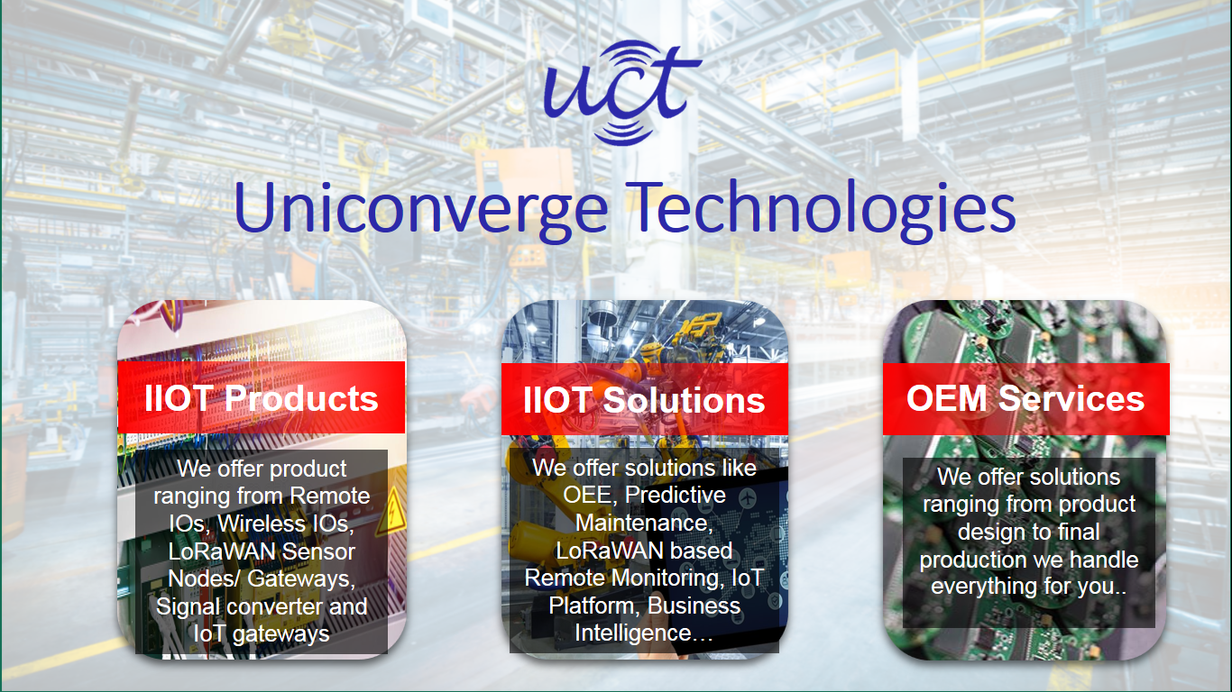

1. UCT IoT Platform **(****)**

**UCT Insight** is an IOT platform designed for quick deployment of IOT applications on the same time providing valuable “insight” for your process/business. It has been built in Java for backend and ReactJS for Front end. It has support for MySQL and various NoSql Databases.

* It enables device connectivity via industry standard IoT protocols - MQTT, CoAP, HTTP, Modbus TCP, OPC UA
* It supports both cloud and on-premises deployments.

It has features to  
• Build Your own dashboard  
• Analytics and Reporting  
• Alert and Notification  
• Integration with third party application(Power BI, SAP, ERP)  
• Rule Engine

 

1. **Smart Factory Platform (****)**

Factory watch is a platform for smart factory needs.

It provides Users/ Factory

* with a scalable solution for their Production and asset monitoring
* OEE and predictive maintenance solution scaling up to digital twin for your assets.
* to unleased the true potential of the data that their machines are generating and helps to identify the KPIs and also improve them.
* A modular architecture that allows users to choose the service that they what to start and then can scale to more complex solutions as per their demands.

Its unique SaaS model helps users to save time, cost and money.

 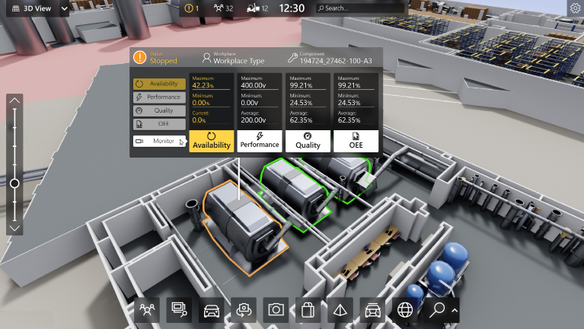

1. 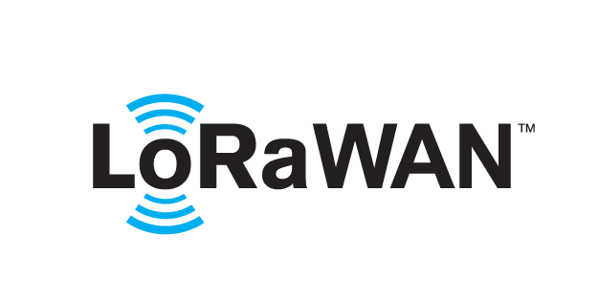 based Solution

UCT is one of the early adopters of LoRAWAN teschnology and providing solution in Agritech, Smart cities, Industrial Monitoring, Smart Street Light, Smart Water/ Gas/ Electricity metering solutions etc.

1. Predictive Maintenance

UCT is providing Industrial Machine health monitoring and Predictive maintenance solution leveraging Embedded system, Industrial IoT and Machine Learning Technologies by finding Remaining useful life time of various Machines used in production process.



## About upskill Campus (USC)

upskill Campus along with The IoT Academy and in association with Uniconverge technologies has facilitated the smooth execution of the complete internship process.

USC is a career development platform that delivers **personalized executive coaching** in a more affordable, scalable and measurable way.



Seeing need of upskilling in self paced manner along-with additional support services e.g. Internship, projects, interaction with Industry experts, Career growth Services

<https://www.upskillcampus.com/>

upSkill Campus aiming to upskill 1 million learners in next 5 year



upSkill Campus aiming to upskill 1 million learners in next 5 year

Seeing need of upskilling in self paced manner along-with additional support services e.g. Internship, projects, interaction with Industry experts, Career growth Services

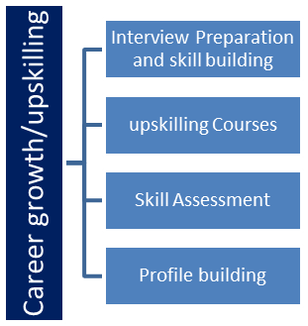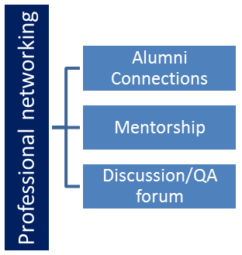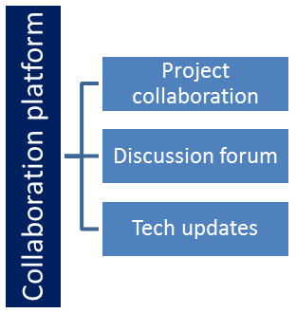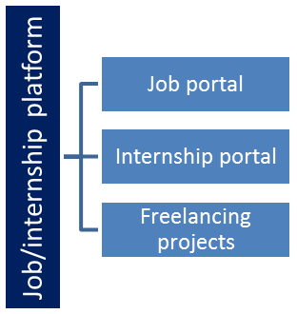

## The IoT Academy

The IoT academy is EdTech Division of UCT that is running long executive certification programs in collaboration with EICT Academy, IITK, IITR and IITG in multiple domains.

## Objectives of this Internship program

The objective for this internship program was to

 ☛ get practical experience of working in the industry.

 ☛ to solve real world problems.

 ☛ to have improved job prospects.

 ☛ to have Improved understanding of our field and its applications.

 ☛ to have Personal growth like better communication and problem solving.

## Reference

[1] Python Documentation: https://docs.python.org/3/

[2] Scikit-learn: https://scikit-learn.org

[3] Matplotlib / Seaborn Tutorials

## Glossary

|  |  |
| --- | --- |
| Terms | Acronym |
| |  | | --- | | IoT |  |  | | --- | |  | | |  | | --- | | Internet of Things |  |  | | --- | |  | |
| MAE | |  | | --- | | Mean Absolute Error |  |  | | --- | |  | |
| RMSE | |  | | --- | | Root Mean Squared Error |  |  | | --- | |  | |
| RUL | |  | | --- | | Remaining Useful Life |  |  | | --- | |  |   RUL |

# Problem Statement

The internship required analyzing **real-world datasets** and building predictive models for two industrial scenarios:

1. **Forecasting Smart City Traffic Patterns:**
   * Predict traffic volumes at different locations and times using historical data.
2. **Quality Prediction in a Mining Process:**
   * Predict quality outcomes based on process variables to reduce defects and optimize production efficiency.

# Existing and Proposed solution

**Existing Solutions:**

* Many traditional approaches rely on simple statistical averages and historical heuristics.
* Limitations: Low accuracy, no integration with Python-based workflows, and poor scalability.

**Proposed Solution:**

* Use Python for **data preprocessing, statistical analysis, probability calculations, and predictive modeling**.
* Combine descriptive statistics, probability, and machine learning models to generate actionable insights.
* Value Addition: Automated analysis pipelines, visualizations, and preliminary predictive models for decision-making.

## Code submission (Github link)

https://github.com/qqueeeeee/Internship_Submission

## Report submission (Github link) : first make placeholder, copy the link.

# Proposed Design/ Model

**Design Flow:**

* **Start:** Data collection and cleaning.
* **Intermediate Stages:** Exploratory data analysis, descriptive statistics, probability-based analysis, feature engineering.
* **Final Outcome:** Predictive models for traffic and mining quality, visualizations, and insights.

# Performance Test

**Constraints:**

* Dataset size and irregularities
* Accuracy and predictive capability of models.
* Efficiency of Python scripts for repeated analysis.

## Test Plan/ Test Cases

* Verify data preprocessing accuracy (handling missing values, scaling, encoding).
* Evaluate model performance using MAE, RMSE, and R².
* Test reproducibility of predictions for different subsets of data.

## Test Procedure

* Split datasets into train and test sets.
* Train models and predict outcomes.
* Compare predicted vs actual values using performance metrics.

## Performance Outcome

* Traffic forecasting models achieved reasonable accuracy with MAE < [placeholder] and RMSE < [placeholder].
* Mining quality prediction models achieved R² score of [placeholder], showing the predictive capability of selected features.

# My learnings

* Gained practical experience in **Python, Statistics, Probability, and Machine Learning**.
* Learned to preprocess and analyze real-world datasets efficiently.
* Understood predictive modeling workflow, evaluation metrics, and feature selection.
* Improved problem-solving, coding, and visualization skills applicable to industrial projects.

# Future work scope

* Integrate more advanced models such as **ARIMA for traffic forecasting** and **XGBoost for mining quality prediction**.
* Include external factors like weather and holidays to improve traffic predictions.
* Deploy models in a **web-based dashboard** for real-time predictions.
* Extend mining quality predictions to multi-variable optimization for industrial efficiency.