AI FUNDAMENTALS IN THE
WORK ENVIRONMENT

CAPSTONE EVALUATION PROJECT
Workplace AI Implementation
AI-Assisted IT Troubleshooting Guide Creation
Project Focus
Using an AI assistant to transform sanitized IT support notes into a short, user-friendly troubleshooting guide for non-technical employees while preserving privacy and human verification.
Prepared by
Renad Alanzi
Final Submission | September 2026


01 Target Task
This capstone applies AI to a real, recurring text-based workplace task: converting short IT troubleshooting notes into clear instructions that a non-technical employee can follow before contacting IT support.
Target Task
Create a concise workstation sign-in troubleshooting guide from sanitized technical support notes.
Why this task is suitable
• It is a recurring support documentation task.
• It involves reading, rewriting, and reformatting text.
• The output can be checked directly against the original notes.
• Human review and final approval remain with the employee.
02 Sanitized Input and Data Masking
Sanitized troubleshooting notes
• Confirm that the workstation is connected to the network.
• Check that Caps Lock is turned off before entering the password.
• Restart the workstation and try signing in again.
• If the password was recently changed, use the updated password.
• If the issue continues after these steps, contact IT support.
Data Masking
No employee names, usernames, passwords, account IDs, company names, internal system names, customer data, or confidential organisational information were included in the AI input.

03 Structured Prompt - R.A.C.E.
The prompt used all four required R.A.C.E. elements: Role, Action, Context, and Expectation.
R - Role | You are an IT support documentation specialist experienced in turning technical troubleshooting notes into simple instructions for non-technical employees.
A - Action | Convert the sanitized IT support notes into a clear troubleshooting guide that an employee can follow before contacting IT support.
C - Context | This is a recurring workplace task. Technical support notes are often short and written for IT staff, while employees need simple and easy-to-follow instructions. The sanitized notes contain no personal or confidential organisational data.
E - Expectation | Create a short user-friendly guide with a clear title, one-sentence introduction, five numbered troubleshooting steps, and a final escalation instruction. Use simple professional English, keep it under 150 words, and do not invent new causes, procedures, system names, or policies.
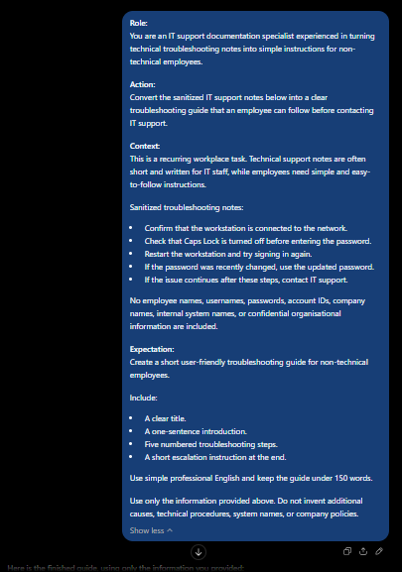
Figure 1. Structured R.A.C.E. prompt with sanitized workplace input.

04 Initial AI Output
The first AI response followed the requested structure and remained within the supplied information. It was treated as a draft for review.
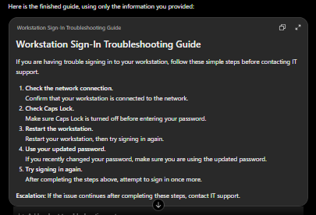
Figure 2. Initial AI-generated troubleshooting guide.
Initial Draft Review
The draft preserved all five troubleshooting instructions and the final escalation step. However, some wording was more technical and formal than necessary for a non-technical employee, so a refinement prompt was used.
Verification before refinement
• All five source instructions were present.
• No personal or confidential information appeared.
• No additional technical procedures were introduced.
• The content could be simplified for easier reading.

05 Iterative Refinement and Final Output
Follow-up prompt used
Refinement Request
The first draft is useful, but some of the wording is still too technical for a non-technical employee. Please use simpler everyday language, make each step shorter and more direct, keep the five original troubleshooting steps and the final escalation instruction, keep the guide under 100 words, and do not add any new causes, technical steps, system names, passwords, account details, or organisational information.
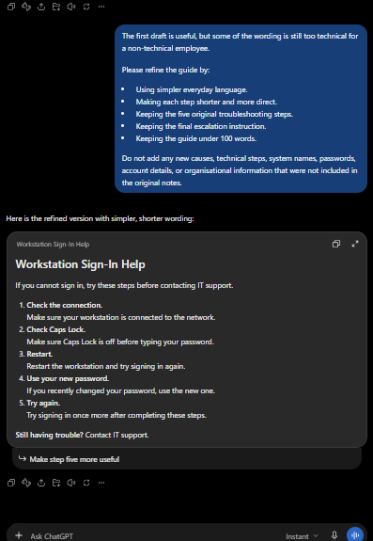
Figure 3. Follow-up prompt and final refined output.
Final Output Result
The refined guide is shorter, simpler, and easier to scan while preserving the same five source instructions. No new technical procedure or confidential information was added.

06 Verification and Impact
Human verification
The final guide was checked line by line against the sanitized source notes before acceptance.
Check | Result
Network connection instruction | Preserved - PASS
Caps Lock instruction | Preserved - PASS
Restart and retry instruction | Preserved - PASS
Updated password instruction | Preserved - PASS
Escalation to IT support | Preserved - PASS
Invented causes or procedures | None found - PASS
Personal/confidential data | None included - PASS
Estimated time impact
Measure | Estimate
Manual drafting and simplification | 15-20 minutes
AI-assisted drafting, refinement, and checking | 5-7 minutes
Estimated time saved per guide | Approximately 10-13 minutes
Responsible use
• Only sanitized, non-confidential information was provided to the AI assistant.
• The AI was used to draft and simplify text, not to make decisions about employees or access permissions.
• The final output was manually verified before being accepted.
Final Result
The required capstone elements are complete: a real recurring task, a structured R.A.C.E. prompt, iterative refinement, data masking, human verification, and an estimated time-saving impact.

