**Chapter 2 – Technical Background**

**2.1 Global Positioning System**

The Global Positioning System (GPS) was developed by the U.S Department of Defense (DoD) to provide civilian and military users with worldwide positioning, navigation and timing services. The position measurements can be used to study the movements of the Earth surface (deformation) associated with different Earth processes. Here, a brief introduction about the principles of GPS and errors sources of the GPS position measurement is presented. For detailed studies, the reader is referred to special literatures, e.g. Dixon 1991, Mao et al., 1999, and Hofmann et al., 2001.

**2.1.1 Structure**

The GPS system consists of three segments: the space segment, the control segment, and the user segment. The space segment consists of the GPS satellites that transmit radio signals to users. The nominal GPS constellation consists 24 satellites that are equally spaced in 6 orbital planes with 4 satellites in each plane (Figure 1). Orbital planes are 60 degree separated and inclined at about 55 degree respect to the equatorial plane. Each satellite flies in medium Earth orbit at an altitude of about 20200 km and circles the Earth twice a day. This constellation ensures users can view at least 4 satellites from any point on the Earth. The control segment on the ground consists of a system of facilities that receive signals from the satellites, perform analysis to compute satellite orbital data (ephemerides) and clock corrections, and send ephemerides back to each satellite. The user segment consists of the GPS receivers that receive the signals from the GPS satellite and convert them into three-dimensional position and time.

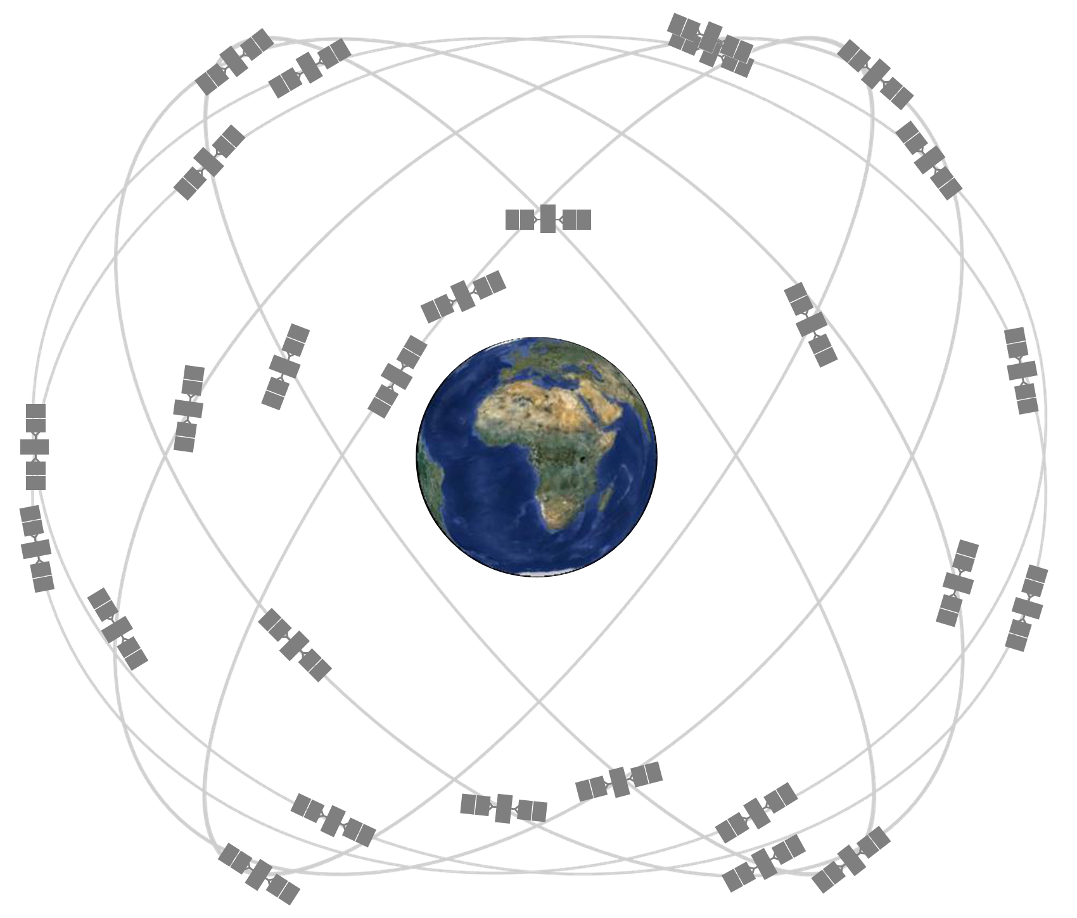

**Figure 1.** GPS satellite constellation [http://www.gps.gov/systems/gps/space/]

**2.1.2 GPS Signal**

Each GPS satellite transmit microwave signal on two carrier frequencies: L1 (1575.42 MHz) and L2 (1227.60 MHz). Two pseudorandom noise (PRN) codes and navigation message are modulated into the carrier frequencies. The Coarse/Acquisition (C/A) code is modulated into the L1 carrier. The Precision (P) code is modulated into the L1 and L2 carriers. The P-code is encrypted into Y-code in the Anti-Spoofing (AS) mode, which denies unauthorized users to use it. Note that as a major focus of the GPS modernization program, three new civil (L1C, L2C, L5) signals and a new military (M) signal are added to the L1 and L2 carriers.

**2.1.3 GPS basic observations**

To determine three-dimensional position of a user, the GPS receiver should compute the range to at least four satellites combing with satellites positions at time of transmitting signals. However, due to synchronism problem between satellite clock and receiver clock and other factors, the GPS receiver can only provide pseudorange measurements rather than the true geometry range. GPS receivers are capable to provide two types of pseudorange observations: code pseudorange and carrier phase pseudorange observations. The code pseudorange is obtained by multiplying the speed of light by the travelling time, where the travelling time is determined by correlating the received code (C/A or P(Y)) from the satellite with the replicas generated by the receiver. The carrier phase pseudorange is obtained by multiplying the wavelength by difference between carrier phase from the satellite and the carrier phase generated by the receiver. Carrier phase pseudorange is about two orders of magnitude precise than the code pseudorange, but the carrier phase observation is ambiguous by an integer number of cycles [Remondi, 1985]. In order to achieve millimeter-precision, the ambiguity problem is needed to be fixed. Carrier phase ambiguity resolution has been studied by Lichten and Border [1987] and Blewitt [1989, 2008].

**2.1.4 GPS error sources**

There are many sources of error contaminating the GPS position measurements. Major GPS error sources are briefly discussed in below. For detailed descriptions on GPS error sources the reader is referred to literatures, e.g. Hofmann et al., 2001.

(i) Satellite clock and orbit errors

GPS satellite clock time should be synchronous with GPS time (the time scale used by the GPS system). Error in the satellite clock has a major impact on the computed code pseudorange. Satellite orbits error is the discrepancies between the predicted position of each satellite and the true satellite position, causing error in the computed position. In this dissertation, we use the precise final orbits and adjusted clock products provided by the Jet Propulsion Laboratory to mitigate satellite clock and orbit errors. Another source of precise satellite orbits and adjusted clock products is the International GNSS Service (IGS).

(ii) Atmospheric effects

The GPS signals encounter both inonspheric refraction and tropospheric refraction when propagating through the atmosphere, causing propagation delay. The ionospheric delay is frequency dependent and can be corrected by using dual frequency (L1/L2). The tropospheric effect can be reduced by using an elevation mask to avoid receiving signals from satellites lower than a certain elevation. The tropospheric delay must be modeled. The tropospheric model consists of mean tropospheric parameters or measurements data (temperature, air pressure, water vapor) and a mapping function [Niell, 1996, Böhm., 2006; Boehm et al., 2006].

(iii) Multipath effects

Multipath effects means receiver antenna gets direct signal through straight-line path and reflected signals through multiple paths. Multipath effects on code observation are much larger than on the carrier-phase observation. Due to the randomness, the multipath effects cannot be modeled. But it can be reduced with relatively long time observations. In our processing routine, we estimate observations every 24 hours to minimize the multipath error [Sella et al., 2002].

(iv) Antenna phase center offset and variation

The electrical antenna phase center (APC) is the point in space where radio signal is received. However, the position of APC varies depending on the intensity and direction of incoming signal. Thus, antenna phase center variation (PCV) is defined as the difference between the APC of each measurement and the mean position of the electrical antenna phase center (MPC). The antenna phase center offset (PCO) is defined as the difference between MPC and antenna reference point (ARP) given by the manufacture. Steigenberger et al. [2006] reprocessed years of GPS data and estimated the antenna phase center offsets for a variety of GPS receivers. An absolute phase center correction model estimated by Schemid et al. [2007] can be use to calibrate both GPS satellite and receiver antennas.

Note that only the major error sources are discussed here. Other factors such as receiver clock error, monument movement and software accuracy also cause errors in GPS position measurement. Last but not least, deformations due to ocean tidal, earth tidal and atmospheric loading need to be modeled and removed so that the geophysical process of interest (e.g., ice mass loss) can be separated from other geophysical processes.

**2.2 Interferometric Synthetic Aperture Radar**

Interferometric Synthetic Aperture Rader (InSAR) is a radar technique for mapping the Earth topography and/or Earth surface deformation using an inteferogram formed by two Synthetic Aperture Radar (SAR) images. Using InSAR to study Earth surface deformation is briefly summarized here.

**2.2.1 Basic concept**

A satellite borne Synthetic Aperture Radar (SAR) transmits a pulse of microwave signal to illuminate a target area on the Earth and receives the returned signal scattered by the Earth’s surface. The returned signal contains two kinds of measurements: amplitude and phase, which are recorded in a two-dimensional radar image. The amplitude is a measure of target reflectivity, which reflects the physical properties of ground target. The phase corresponds to the fractional part of the round trip range between satellite antenna and ground target. Current satellite borne SARs work in three typical microwave bands: X-band (wavelength of 3 cm), C-band (wavelength of 6 cm) and L-band (wavelength of 24 cm). With a high bandwidth microwave signal and synthetic aperture technique (transmit and receive signals using a radar antenna installed on a moving platform), satellite borne SAR image can achieve a high spatial resolution.

InSAR uses two SAR images to produce an interferogram which contains the phase difference (also called interferometric phase, ) between every pair of corresponding pixels in two SAR images. The range change (R2-R1) between two image acquisitions is then measured in terms of the interferometric phase ():

Where is the carrier wavelength, is the range from satellite antenna A1,2 to the ground target (Figure 2). As with the GPS, the phase of SAR image is ambiguous because it is only the fractional part of the change in phase. Therefore, the interferometric phase is ambiguous and need to be unwrapped by adding the correct integer part in order to determine the absolute range change. Phase unwrapping is a critical step for using InSAR to monitor topography or surface deformation and various approaches have been developed to solve the problem [e.g., Zebker and Lu, 1998].



**Figure 2.** Acquisition geometry of repeat-track interferometry. A1 and A2 are the antenna positions at the initial acquisition and second acquisition; R1 and R2 are the ranges from antenna A1 and A2 to the ground target; H is the flight height; B is the baseline; LOS is the line of sight of the radar beam; is the elevation of the ground target.

**2.2.2 Monitoring surface deformation**

If the two SAR images are acquired from slightly different viewing points at different times, any movement of the ground target with a component projected onto the line of sight (LOS) of the radar beam gives the phase of:

where is the interferometric phase caused by surface deformation (termed deformation phase after); is the carrier wavelength; is the range change, which is the surface displacement projected onto the LOS of the radar beam. Theoretically, if is known, the surface displacement can be determined at millimeter-precision. However, besides deformation phase, other phase terms also contribute the interferometric phase measurement (:

where , and are the phase due to range changes associated with topography, atmospheric effects and orbit errors. In order to monitor surface deformation, , and should be removed from .

(i) Topography

In most cases, two SAR images are taken from slightly different viewing points (A1,2) so that the interferometric phase contains the topographic component (Figure 2). A Digital Elevation Model (DEM) is used to represent the topography. Thus, if an accurate DEM is available, the topographic phase can be estimated and then subtracted from the interferometric phase. Note that errors in the DEM cause tropospheric phase residuals in the deformation phase. In place of DEM, differential InSAR technique can be used to separate topographic phase from deformation phase. Two or more interferograms with different baselines are differenced to produce differential interferograms. In practice, along with topographic phase the reference phase induced by acquisition geometry is estimated and subtracted from the interferometric phase.

(ii) Atmospheric effect

As with GPS, it is important to consider atmospheric effects on monitoring surface deformation using InSAR [Goldsten 1995; Zebker et al., 1997]. The state of atmosphere changes if the two images are acquired at different times. Therefore, the atmospheric heterogeneity leads to difference in atmospheric delay and hence the phase difference. Temporal and spatial variations of atmospheric pressure, temperature and water vapor all leads to errors in deformation. Particularly,

large errors (10 cm) in deformation measurements can be resulted from variations (20%) of atmospheric water vapor [Zebker et al., 1997]. Producing robust estimates of atmospheric delay remains to be one of the challenges in improving the accuracy of surface deformation using the InSAR technique. A variety of methods are proposed to reduce the atmospheric delay, including averaging multiple interferograms to cancel out uncorrelated atmospheric delay [e.g., Zebker et al., 1997], spatial-temporal filtering [e.g., Berardino 2002], and using complementary data such as GPS data and meteorological models to estimate atmospheric delay [e.g., Williams et al., 1998, Foster et al., 2006, Jolivet et al., 2014].

(iii) Orbital errors

Errors in the satellite orbits are considered as limitation of InSAR in measuring surface deformation accurately. To remove both tropographic phase and reference phase (together called geometry phase), precise satellite orbits are required to determine the interferometric baseline at millimeter-precision level. However, orbits of most remote sensing satellites are given with uncertainties of 2 – 10 cm [Yoon et al., 2009; Eineder et al., 2011; Rudenko et al., 2012], hence the interferometric baseline cannot be precisely determined. Therefore, orbital errors contributes to phase difference in the interterograms. Lots of methods are proposed to reduce the effects of orbital errors. A simple but widely used method is to estimate a planner phase ramp that fits to the interferometric phases [Massonnet and Feigl, 1998].

Besides the factors discussed above, phase noise induced by radar system (e.g., thermal noise), changes in the scattering behavior of the ground target (e.g., changes in dielectric constant), and data processing (e.g., phase unwrapping errors) also contributes to the interferometric phase, all remaining as errors in the InSAR measurements.

**2.3 Gravity Recovery and Climate Experiment**

Launched in March 2002, the Grace Recovery and Climate Experiment (GRACE) mission is detailed measuring the time variations of Earth’s gravity field with a spatial resolution of 400 - 40000 km. GRACE measures gravity variations that are related to the redistributions of mass in the solid Earth and the fluid envelopes. Currently, many studies focus on using GRACE to study changes in terrestrial water storage, including ice sheets and glaciers, snow, soil moisture, surface water and groundwater. Here, the principle of GRACE measurement and its application in measuring surface mass change are briefly summarized.

**2.3.1 Basic concept**

GRACE consists of two identical satellites at altitude of ~ 450 - 500 km, one following the other in a near-polar orbit (89 °), ~ 220 km apart (Figure 3). The GRACE is a Low-Low Satellite-to-Satellite Tracking (LL-SST) mission since the twin satellites are tracking each other along a low Earth orbit (LEO). A highly accurate inter-satellite, K-Band microwave range (KBR) system, continuously measures the range between two satellites [Dunn et al., 2003]. Each satellite transmits carrier phase to the other at dual-frequency (24 and 32 GHz), allowing for ionospheric correction at the stage of data processing. Each satellite receives the carrier phase and compares it with the on-board generated phase in order to obtain the range between two satellites. Changes in range are related to changes in the gravity field: the leading satellite accelerates when passing an area of stronger gravity (anomaly), resulting the range between two satellite to increase; the leading satellite then decelerates when passed the anomaly and the following satellite accelerates, resulting in the range to decrease. The range is measured at a sampling rate of 10 Hz, and then at the stage of data processing the range-rate and range-acceleration are reduced to a sampling rate of 0.1 Hz. In addition to the KBR system, each satellite is equipped with a GPS receiver, a high precision accelerometer and star cameras. The GPS receiver provides the position of two GRACE satellites and the time-tag of KBR measurements. The accelerometer is used to measure the surface force acceleration so that the effects of non-gravitational forces can be removed from the range-rate measurement. The star cameras are used to measure the orientation of satellites in space so that the K-Band antennas are pointing towards each other precisely.

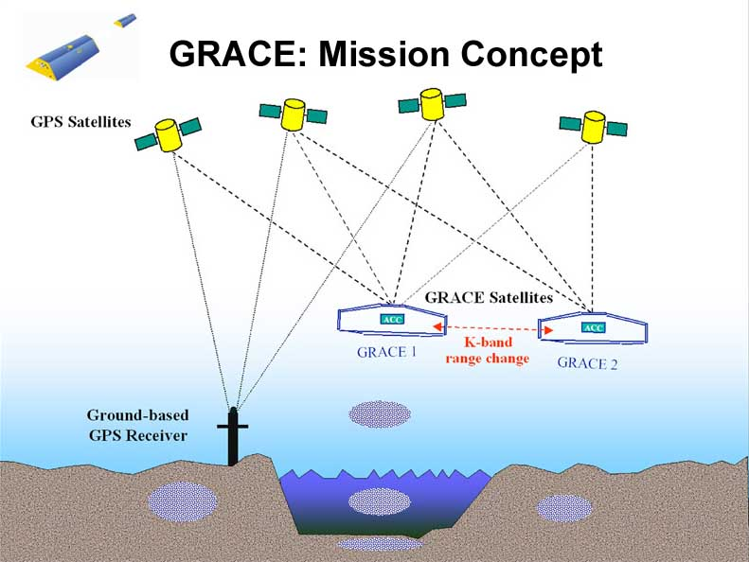

Figure 3: Basic mission concept of GRACE. [http://www.csr.utexas.edu/grace/publications/presentations/HPC2001.html].

**2.3.2 Data Products**

The GRACE gravity data products are developed, processed and archived by three centers within a shared Science Data System (SDS): Jet Propulsion Laboratory (JPL), the Center for Space Research at the University of Texas (UTCSR), and the Geoforschungszentrum in Potsdam (GFZ). The GRACE gravity data product is divided into three levels: Level-0, Level-1, Level-2.

Level-0 data is the raw data from GRACE satellite. It is collected, stored and documented by the Raw Data Center (RDC) of the Mission Operation System (MOS) in Germany. Level-0 data product includes both instrument and ancillary data. Level-1 data product is processed by JPL with the support of GFZ. Level-0 data product is not available to the public.

Level-1 data product is divided into two levels: Level-1A and Level-1B. Level-1A data product is the raw data which has been calibrated and time-tagged in a reversible way. Level-1B data product is the result of extensive and irreversible processing applied to Level-0 and Level-1A data product. Level-1B data product includes inter-satellite range, range-rate, range-acceleration, the non-gravitational acceleration for each satellite, etc. The sampling rate of Level-1B data is reduced from 10 Hz to 0.1Hz.

Level-1B data product is available to the public.

Level-2 data are processed by JPL, GFZ and UTCSR independently and are released to the public through two portals: the Physical Oceanography Distributed Active Archive Center (PO.DAAC) at JPL and the Information System & Data Center (ISDC) at GFZ. Level-2 data product includes monthly and mean estimates of spherical harmonic (Strokes) coefficients (Clm, Slm) of the Earth gravity field. Note that the degree () and order (*m*) of the Strokes coefficients are up to 60 for CSR and 120 for JPL and GFZ. Most scientific studies based on GRACE measurements utilize the Level-2 data product. The latest version of the gravity field coefficients is Release-05, which is more accurate than the previous version based on better knowledge of on-board instruments (star cameras, accelerometer and the KBR system) and updated mean gravity field, ocean tide, pole tide and de-aliasing models for Level-2 processing [Chambers and Bonin, 2012].

**2.3.3 Measuring surface mass change using GRACE data**

How to use GRACE gravity data to measure the surface mass change? Here, we consider surface mass change as a thin layer of water on the Earth’s surface with varying thickness. According to Wahr et al. [1998], the surface mass density [kg m-2] can be expressed as:



Where are the colatitude and longitude of a point of interest, is the radius of the Earth, is the average density of the Earth, and *m are* the degree and order of the spherical harmonic coefficients, is the Love number of degree , is the normalized Legendre Polynomials,  and are the coefficients for some month of degree and *m* order released by GRACE. Many studies report mass change using changes in height of water by dividing [kg m-2] by the density of water [kg m-3].

Several corrections need to apply to the GRACE gravity field solutions in order to estimate surface mass change correctly.

(i) Striping effect

Spatially correlated errors in the Strokes coefficients cause the north-south oriented stripes in maps of surface mass change, which is called the striping effect. Such errors are prominent in the high degree Stroke coefficients. Spatial averaging (smoothing) is required to reduce the striping effect in the gravity field solutions. A variety of approaches have been proposed to reduce the stripping effect and the most common approaches are Gaussian smoothing [Wahr et al., 1998] and a correlated-error filter [Swenson and Wahr, 2006].

(ii) Leakage effects

The limited spatial resolution of the GRACE gravity field solution and spatial averaging causes leakage, where signals do not concentrated over the region of mass variation in reality but spread out into nearby regions artificially [e.g., Chen et al., 2006]. Thus, the surface mass variation over a region of interest could be contaminated by signals leaked in from nearby regions and oppositely by signals leaked out to nearby regions. Thus, it is critical to identify and correct the leakage effects in order to obtain correct estimate of surface mass change using GRACE gravity data. Using an averaging function is a simple method to minimize the combined measurement error and leakage error, and the result is then scaled to avoid signal attenuation [Velicogna and Wahr, 2006]. The mascon technique is utilized to better localize the mass variation over a relatively small region [Rowlands et al., 2005]. The original KBR range rate data and the analyzing skills are required to produce the Gravity field solution using the mascon technique, making this technique less doable for most GRACE users. Schrama and Wouters [2011] proposed an inversion modeling technique based on a least squares approximation method toestimate the optimized uniform mass variation in each block.The inversion modeling technique is useful to estimate surface mass changes in high spatial resolution and it is easy to use.

(iii) Glacial Isostatic Adjustment

Glacial isostatic adjustment (GIA) is the ongoing movement of the lands that were depressed by ice sheets during the last glacial period. The redistribution of lithospheric masses, adjusting from the ice sheet loading state to the equilibrium state, causes long-term trends in the Earth’s gravity field. To study the current surface mass changes, it is important to quantify and separate the long-term trend caused by GIA effect from the current signal of interest. Although it is possible to model the GIA effect and subtract it from the GRACE data, it is challenging to predict the GIA effect accurately [Thomas et al., 2011]. Thus, GIA effect remains as one of the major error sources in the estimates of surface mass change using GRACE gravity data.