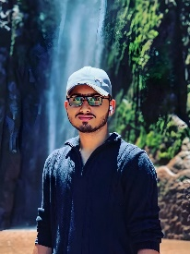
S.QaimRaza
F1024 ,Martin Road ,Karachi Sindh
Phone: 03178292329.
03330600774.
E-mail: hr803349@gmail.com
Website:
Objectives
To maintain certain information about myself.
Education
- Intermediate (Pre-Engineering.){2022-2024} from Sindh Board of education.
- Software Engineering (2022-2025) from Aptech.
- Matric (2020-2022) from Sindh Board of education.

Experience
- Sells representative (one month from ZA Academy)
- Academic consultant and volunteer (ZA Academy)
- Freelancer (Upwork two months as a GD)
Skills
- Graphic designing.
- Teaching.
- Windows management.
- Gaming.
- Typing.
- Content writing
- Web designing.
Languages
- Urdu (speak, listen and write)
- English (speak, listen and write )

