This program is designed to work in conjunction with a shared network drive. All the files will be stored on the network drive. This applications purpose is to facilitate the storage, formatting and retrieval of files sorted by PO#. For initial setup a folder for the year must be created on the shared network drive, the program will store and retrieve files from this location. The folders for the PO numbers will be generated by the application.

Entering a PO#

The user must first select the working directory in File->Open. This is where all the files will be saved. If selecting the working directory after PO files have been selected make sure to select the correct working directory and **NOT** one of the PO files, this will cause errors. This will most likely be a file already setup and will have the year.

The user will input the PO# generated by Famous into the PO# input box and press **enter**. If the PO# is not already in the system, the program will prompt the user to create the file. If the PO# is in the system, the file will be loaded to view.

Required Files

The required files are the ones that are needed for a specific order or PO#. This is dependent on the destination of the load or the customer. There are four different preset templates to expedite this process. The checked files are the ones that are required. The user can check or uncheck any of the files to meet there needs. The checking of the required files is used in the Archive check to make sure all required files are present.

Uploading Files

Once the user has checked a file to be a required the upload button will allow the user to upload a document to the system for that specific file. The user does not need to name the document a specific name the program will copy and rename it to the correct formatting.

Glo Board

This shows the status of the card on the Glo Board as well as allowing the user to add comments and labels to the card. Make sure you have generated a Personal Access Token (PAT) in the settings and copied it to the correct field in the settings. If a PAT is not generated the Glo Boards section will not work.

Tool Tips:

Create File:

Open Folder- Opens the PO# folder in File Explorer

Working Directory- The directory where files are saved

Save- Click save to create the index file and save notes.

Logo- This is the logo

Template- Select template for req files

Run Archive Check:

Run Check- Initiates Archive Check

Error Files: Files that were unable to be checked. This is usually due to a missing index file. Open the PO in Create File and hit Save to generate the index file.

**WAEX Filing Program Initial Setup**

1.Navigate to Settings

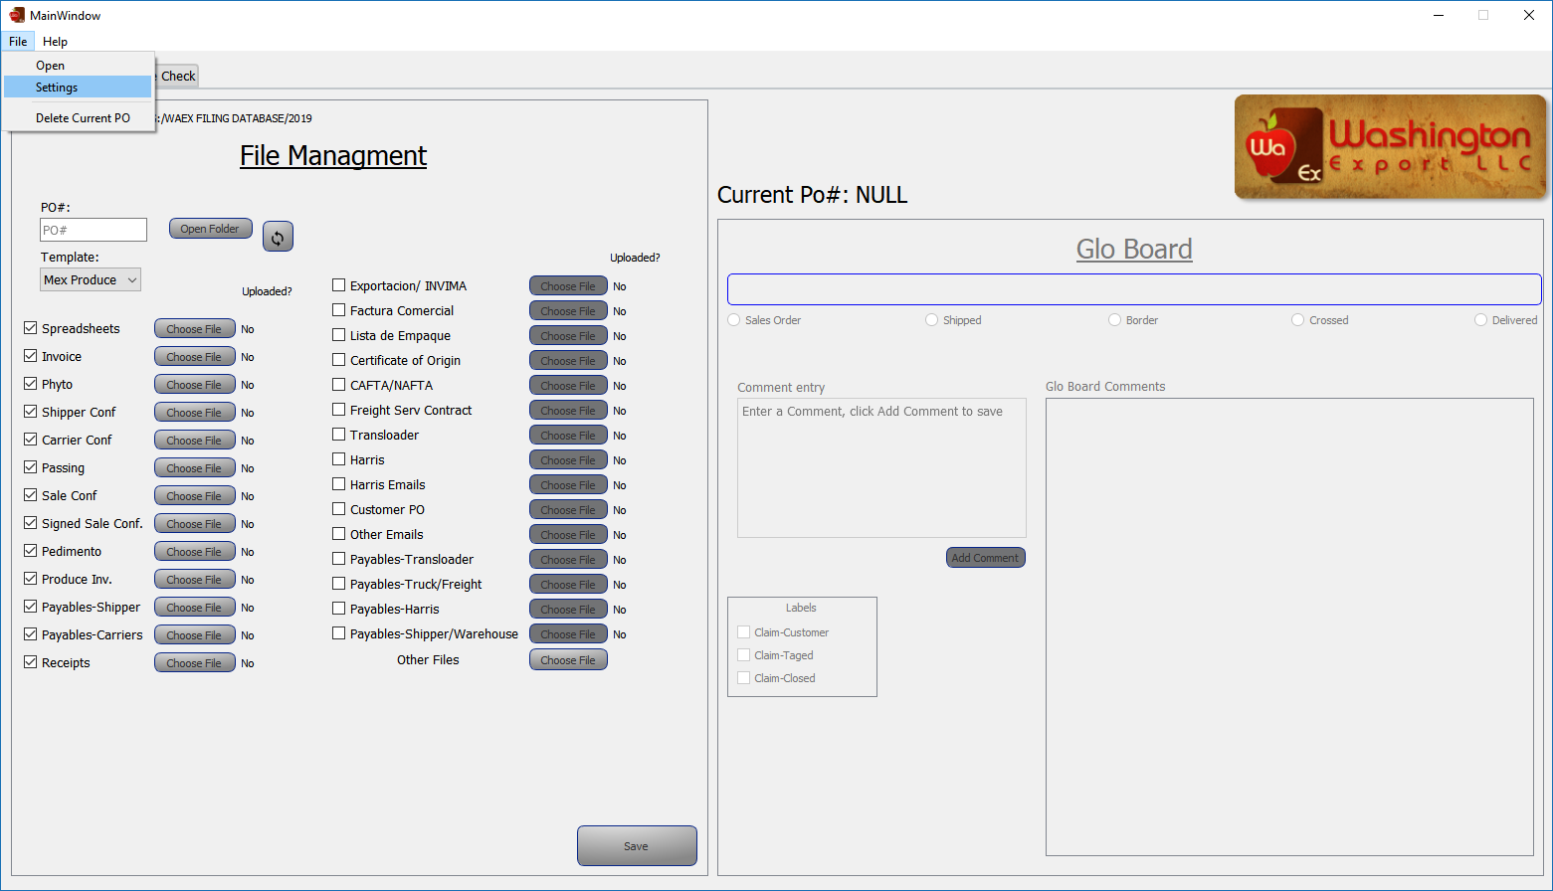

2.Click “New PAT”

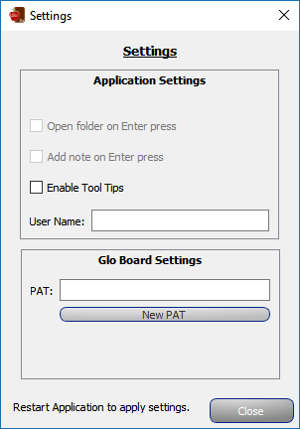

3. Create a GitKraken Account or login

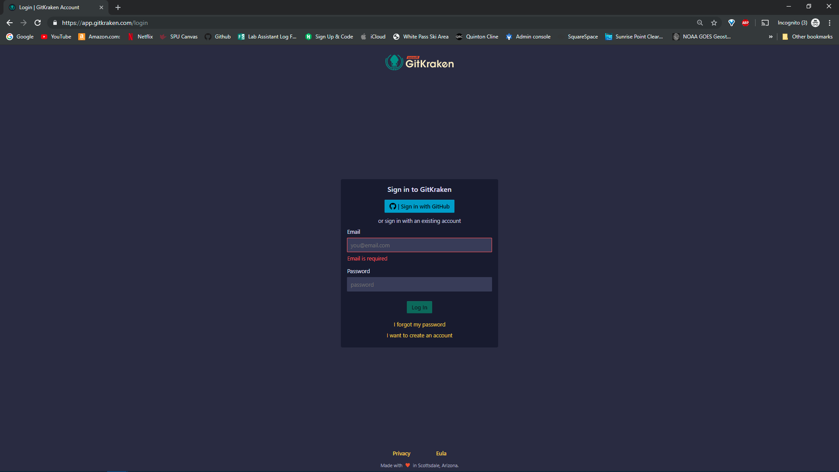

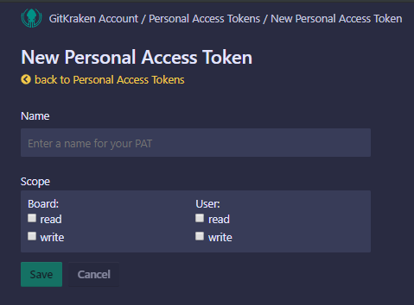4.

**3.**Check

**2.**Check

**1.**Input “WAEX”

**4.**Click to Save

5.Copy PAT and paste into PAT box in the program

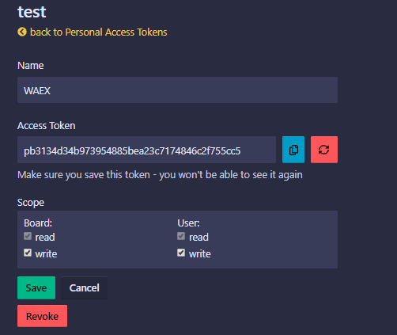

**2.**Click Save

**1.**Copy

6.Past PAT into Settings

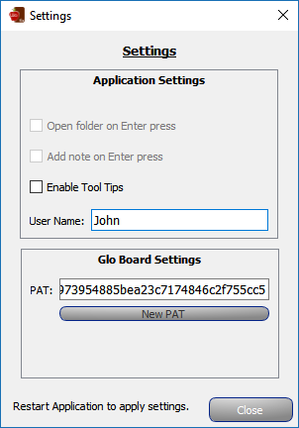

**3.**Click Close

**1.**Input First Name

**2.**Past PAT Here

7.**Restart the application to apply the setting.**