AET Tools Report

Sci2C

Overview
The translator from Scilab to C (Sci2C) is a tool that provides an interface between the Scilab scientific software package and the hArtes design flow. Sci2C translates the part of an application described using the Scilab language in a C based code. The output C code is in a plain style and does not include any part of the Scilab interpreter thus making it small, efficient and easy to interface to the hArtes tool chain.
In other words, the generated C code is standalone and minimal in the sense that SCILAB interpreter is no longer needed and only the minimal number of C files which are necessary to execute the application are generated. It follows that the generated code can be embedded in processors or used as entries for other software.
Sci2C is implemented in Scilab language, so it naturally becomes a Scilab toolbox available in the Scilab installation program and consequently it can be directly used in the Scilab Development Enviroment.
The implementation of Sci2C is mainly based on the introduction of data and function annotations into Scilab code which are seen as comment by the Scilab interpreter, but that are used by Sci2C to translate the Scilab code into an efficient and plain C code. Moreover the use of annotations allows the user to specify not only the size of data but also their precision, in that way it is possible to get a further optimization of the C code produced thanks to the possibility to use ad-hoc precision for each data to be processed.
Two major limitations can be identified in Sci2C: the first limitation of the tool is that the annotations must be manually added by the user, although it is the only manual intervention required by the tool; the second limitation is that the size of data is fixed and consequently no dynamic array extension is allowed.
Other minor limitations have been introduced in order to simplify the development of the tool without impacting on the usefulness of it for embedded systems.
All the details related to Sci2C tool can be found in the Sci2C User’s Guide available in the Scilab2C directory of the hArtes (https://www.hartes.org/svn/ToolChain/Scilab2C/Doc/SCI2CUserGuidev1.doc). More specifically in that document the interested reader can find:
- Detailed description of the blocks composing the tool
- Potentialities of the tool.
- Limitations of the tool.
- Details of function and data annotations.
- How to install and configure Sci2C
- How to use Sci2C

Status of the Tools
For the sake of clarity before introducing details about the status of Sci2C, a quick overview of Sci2C block diagram is presented here. As shown in the following figure the main blocks of Sci2C are:
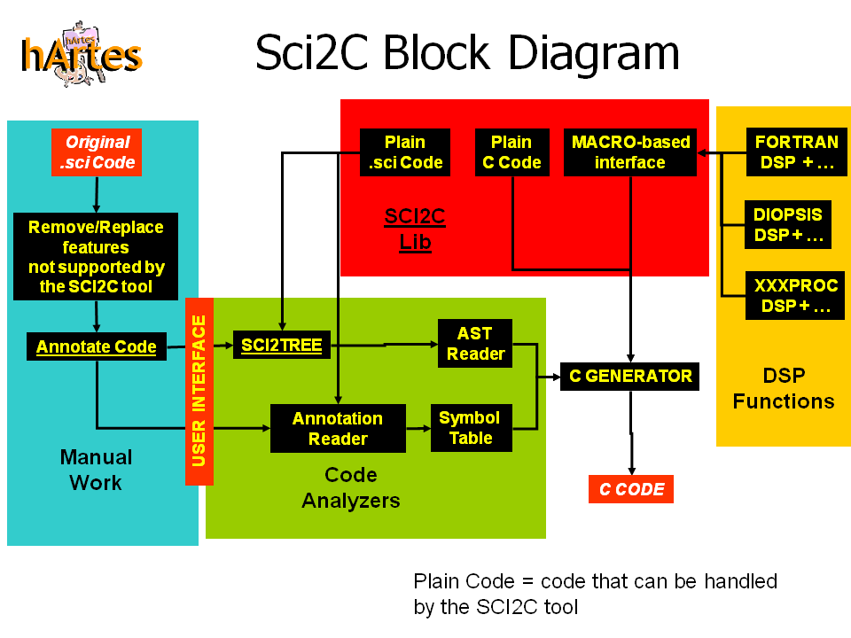
- Manual work and User interface: in these blocks there are enclosed all the activities where the user intervention is required. In the other blocks all the processes are carried out automatically. Here the user has to configure Sci2C (“USER INTERFACE” block), and change the Scilab code to be translated (“Original.sci” block) in order to remove not supported features and annotate data and functions.
- Code analyzers: at the end of the annotation step the SCILAB code is ready to be analysed in order to extract two main sets of information: the Abstract Syntactic Tree (AST) and the Symbol Table (ST). The information collected during the generation of the AST and during the Annotation extraction are useful to generate the optimized C code for a given SCILAB code line. More specifically for each SCILAB function call the following information are retrieved by the code analysers:
- Function Name (from AST)
- Name of Input Arguments (from AST)
- Size, Type and Dimensions of Input Arguments (from Annotations)
- Number of Output Arguments (from AST)
- Size, Type and Dimensions of the Output Arguments (from Annotations)
- Sci2C lib: this block represents the set of functions already available in Sci2C; this set has been named Sci2C library. Most of the functions in Sci2C library are written in C in order to get the maximum level of optimization even though it is also possible to have functions directly written in Scilab. It is also possible to introduce additional libraries into the Sci2C library by using the MACRO-based interface.
- DSP Functions: with this block the user can provide his/her own optimised implementation of the Sci2C library functions by using a dedicated software interface. It is an important feature because typically embedded processors are already equipped with their own optimised libraries.
- C generator: this block is in charge of collecting all the information coming from the AST and the Symbol table and to generate the best combination of C functions selected among those available in the Sci2C library.
The first year of the project has been mainly devoted to the definition of the specifications and structure of Sci2C.
The second year of the project has been mainly devoted to the implementation of what has been defined during the first year of the project. This implementation stage has led to an alpha version of Sci2C where all the blocks shown in the Sci2C block diagram have been implemented. Although all these blocks have been implemented, it must be said that they are not fully operative. It follows a short description of the status of each of them (names of the blocks refer to the block diagram shown in the figure above):
- User Interface:
  - Status: fully operative.
  - Comments: expected only minor changes.
- Annotation Reader:
  - Status: fully operative.
  - Comments: expected only minor changes.
- SCI2TREE:
  - Status: fully operative.
  - Comments: found minor bugs that will be fixed by INRIA during the third year of the project.
- AST Parser (Reader):
  - Status: 30%.
  - Comments: missing functionalities to parse “if/else”, “for” and “while” constructs and to handle complex data types.
- Symbol Table Management:
  - Status: Operative.
  - Comments: improvement of this block are necessary to manage special Scilab symbols as %T, %F, %nan, %inf, %pi, %i.
- SCI2C Library:
  - Status: 80% Operative / 60% Integrated with Sci2C.
  - Comments: According to the limited set of functionalities the basic functions are available in the Sci2C Lib. Missing specific DSP functions will be added current the third year.
- SCI2C Library Macro-Based Interface:
  - Status: Fully Operative.
  - Comments: expected only minor changes.
- C Generator:
  - Status: 30%.
  - Comments: missing functionalities to generate C code for “if/else”, “for” and “while” constructs and to handle complex data types. Improvements of the error messages produced by the C generator are also necessary.
During the second year of the project a preliminary Sci2C User’s Guide and a small set of Demos have been produced in order to simply the approach of the user to the tool.

Major Results
As stated in the previous section, while the first year of the project has been mainly focused to design the structure of Sci2C tool with its main limitations and requirements, the second year of the project has been mainly focused to its implementation.
From a general point of view the major results are:
- the implementation performed in the second year has a good matching with specifications identified during the first year of the project.
- Milestone for month 24 has been fully achieved.
- The activities accomplished so far settle the good basis for the final milestone set for month 36.
- Intense co-operation between INRIA and PoliBa has been established.
From a technical point of view the major results are:
- During the second year of the project an operative (alpha) version of Sci2C has been implemented comprehensive of a short user’s guide and few example codes. Main limitations of it are related to the missing support for “if/else”, “for” and “while” constructs.
- Sci2C has been developed in Scilab so it naturally becomes a Scilab toolbox available in the Scilab installation program and consequently it can be directly used in the Scilab Development Enviroment.
- Sci2C has been successfully tested on Scilab 4.1.2 (stable version) and also on the latest Scilab version 5.0.1
- Sci2C has been successfully tested on both Windows and Linux Operating Systems.

Future Directions
According to milestone M2T2.5M36 (The version 1.0 of the entire Tool-Chain validated by month 36th) the main actions set for the third year of the project are focussed to provide full functionality to all the building blocks of Sci2C. More specifically the following blocks will be the main subject of PoliBa and INRIA activities:
- AST Parser (Reader): implementation of functionalities to parse “if/else”, “for” and “while” constructs and to handle complex data types.
- Symbol Table Management: improvement of this block are necessary to manage special Scilab symbols as %T, %F, %nan, %inf, %pi, %i.
- SCI2C Library: integration of the entire library within the C generator. Development of last missing functions to feet the set of functionalities established at the beginning of the project.
- C Generator: implementation of functionalities to generate C code for “if/else”, “for” and “while” constructs and to handle complex data types. Improvements of the error messages produced by the C generator to help the user to easily achieve the Scilab to C translation.

