**4gif for paper 3 – symmetry**

**I. 4gif is a simpler alternative for the non-P1 paper found by Pavel.**

It is 2.8 A resolution, P_3_2_1 symmetry. Below a structure from PDB file 4gif_ready.pdb (yellow) and the expansion.pdb (blue)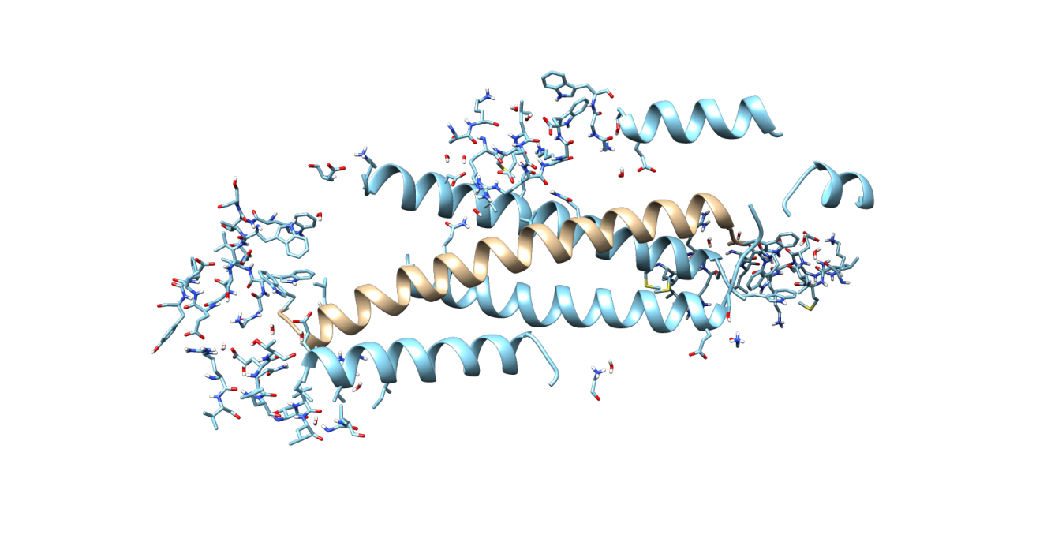

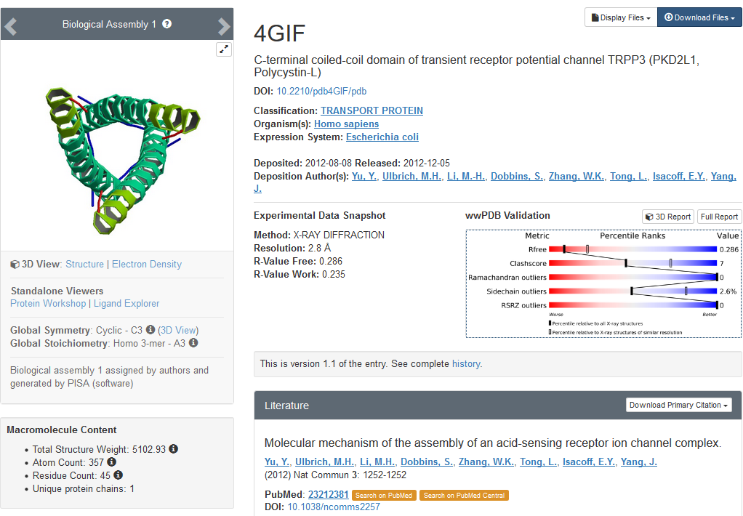

**II. Refinement and Optimisations have been done with**

1. **Xtb** : xtb.6.0 gfn2+water solvent (--gfn 2 --etemp 500 --acc 0.1 --gbsa h2o)
2. **TeraChem** : TeraChem v1.93P , HF-D3/6-31G plus water solvent with COSMO model

For xtb and TeraChem the same qr.refine options have been used (*described below*)

Timing: xtb takes about 8 h, TeraChem 60 h

xtb: 8 weigth cycles 5 refinement, TeraChem: 7 weight cycles, 5 refinement (so essentially the same)

1. **Cctbx** – all default parameters

In all cases phenix-dev-3407 and Q|R v1.0-39 have been used

**qr.refine options:**

mode=refine

maxnum_residues_in_cluster=50 (or default=15, in both cases the same 9 clusters are created)

~ # clusters : 9

~ list of atoms per cluster:

~ [198, 166, 148, 108, 78, 56, 6, 3, 3]

~ list of atoms per fragment:

~ [890, 1347, 1458, 1091, 1088, 828, 339, 267, 449]

max_bond_rmsd=0.02 (preliminary run with larger max_bond_rmsd was not satisfactory, see /home/qr/paper4_refine on cu39)

stpmax=0.2 (larger steps create problems for quantum computations – atoms can move too far)

gradient_only=true

clustering=true

use_convergence_test=true

opt_log=1

restraints=qm

**III. Results/comparison**

1. All files are uploaded on github in

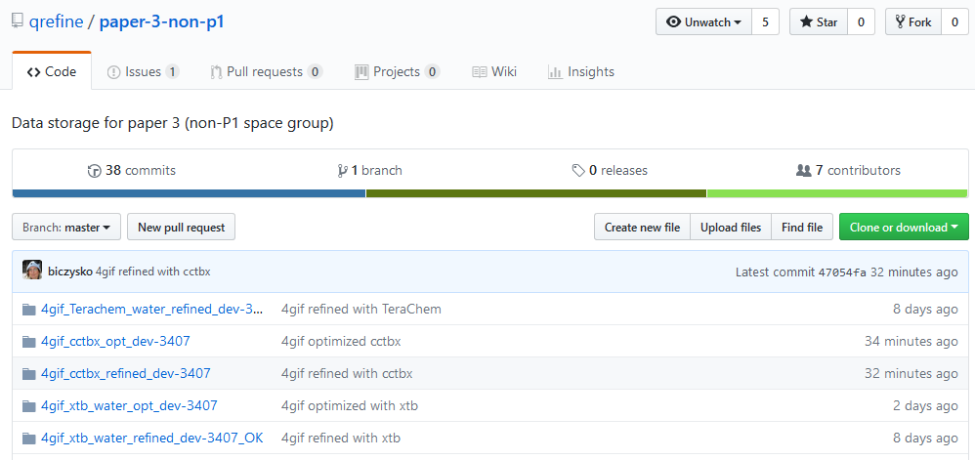

*Note: TeraChem optimization is still running*

1. Starting PDB is showing several clash-scores which are removed fully by both xtb and Terachem qr.refine



**Comments (for xtb refinement file)**

**Nigel:** My validation shows that this is a fine model. There are two ARG that are not planar which is fine in my opinion. The three rotamer outliers seem to be due to a lack of density.

**Pavel:** What's also remarkable is the clashscore being zero as well as cross-symmetry interactions of some side chains.