**4gif for paper 3 – symmetry**

**I. 4gif is a simpler alternative for the non-P1 paper found by Pavel.**

It is 2.8 A resolution, P_3_2_1 symmetry. Below a structure from 4gif_refine_001_complete.pdb_modified_Pavel16March.pdb PDB file (yellow) and the expansion.pdb (blue)

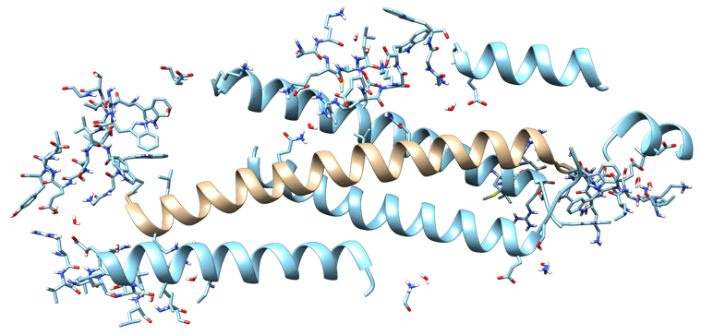

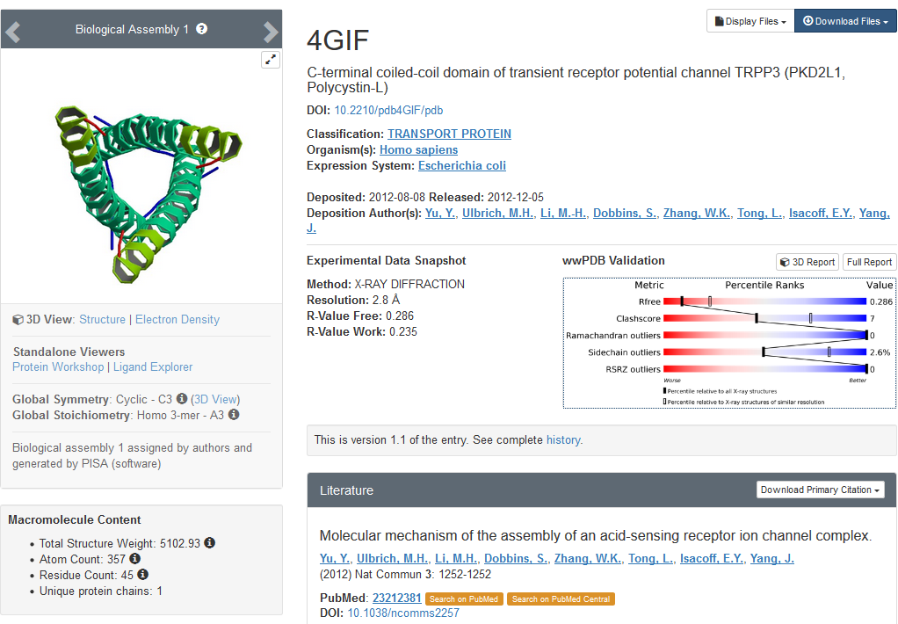

**II. Model preparation (Pavel 16March, redone by Goska)**

1. phenix.fetch_pdb --mtz 4gif
   1. 4gif.mtz
   2. 4gif.pdb
2. phenix.refine 4gif.{pdb,mtz} ordered_solvent=true ordered_solvent.low_res=3
   1. 4gif_refine_001.pdb
   2. 4gif_refine_001.mtz
3. qr.finalise 4gif_refine_001.pdb
   1. 4gif_refine_001_complete.pdb
4. phenix.pdbtools 4gif_refine_001_complete.pdb occupancies.set=0 modify.selection="element H"
   1. 4gif_refine_001_complete.pdb_modified.pdb

**III. Refinements have been done with**

1. **Xtb** : xtb.6.0 gfn2+water solvent (--gfn 2 --etemp 500 --acc 0.1 --gbsa h2o)

qr@cu38

nohup qr.refine 4gif_refine_001_complete.pdb_modified_Pavel16March.pdb 4gif_fresh_ready_again_refine_001.mtz mode=refine quantum.nproc=1 parallel.nproc=14 max_bond_rmsd=0.02 stpmax=0.2 gradient_only=true clustering=true use_convergence_test=true opt_log=1 restraints=qm engine_name=xtb > 4gif_refine_001_complete.pdb_modified_Pavel16March_xtb_stpmax02_dev-3407_MaxItRef100.log 2>&1 &

second refinement with max_iterations_refine=100

1. **TeraChem** : TeraChem v1.93P , HF-D3/6-31G plus water solvent with COSMO model

[qr@mu 4gif]

#!/bin/bash

nohup qr.refine 4gif_refine_001_complete.pdb_modified_Pavel16March.pdb 4gif_fresh_ready_again_refine_001.mtz mode=refine max_bond_rmsd=0.02 stpmax=0.2 clustering=true restraints=qm parallel.method=lsf parallel.qsub_command="bsub -n 4 -q gpu" engine_name=terachem basis=6-31g opt_log=1 gradient_only=true use_convergence_test=true > 4gif_refine_001_complete.pdb_modified_Pavel16March_HF3D_631G_h2o_dev-3407.log &

For xtb and TeraChem the same qr.refine options have been used (*described below*)

1. **Cctbx** and **Phenix** – all default parameters

In all cases phenix-dev-3407 and Q|R v1.0-39 have been used

**qr.refine options:**

mode=refine

maxnum_residues_in_cluster= default=15, 9 clusters are created

~ # clusters : 9

~ list of atoms per cluster:

~ [198, 166, 148, 108, 78, 56, 6, 3, 3]

~ list of atoms per fragment:

~ [890, 1347, 1458, 1091, 1088, 828, 339, 267, 449]

max_bond_rmsd=0.02 (preliminary run with larger max_bond_rmsd was not satisfactory, see /home/qr/paper4_refine on cu39)

stpmax=0.2 (larger steps create problems for quantum computations – atoms can move too far)

gradient_only=true

clustering=true

use_convergence_test=true

opt_log=1

restraints=qm

**IV. Results/comparison**



***Below are OLD results and comments***



**Comments (for xtb refinement file)**

**Nigel:** My validation shows that this is a fine model. There are two ARG that are not planar which is fine in my opinion. The three rotamer outliers seem to be due to a lack of density.

**Pavel:** What's also remarkable is the clashscore being zero as well as cross-symmetry interactions of some side chains.