COM336 ASSIGNMENT 2 TEAM 17 HELP FILE

Contents

Document Purpose 1

Description of Files 2

Passwords and Setup 5

Website Overview 11

Overview of Design Process 14

Design of the Website 14

Design of the Database 14

# Document Purpose

This document will help any user with the setup process of the website. The website will be set up in localhost, the passwords and usernames for the databases and website will be provided as the setup continues.

# Description of Files

The first step will be to download the compressed zip folder containing the website folder.

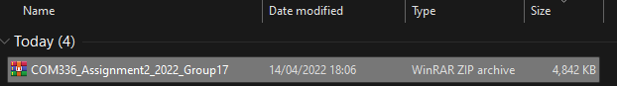

The full contents of the website will be inside the zip file and must be extracted before they can be used.

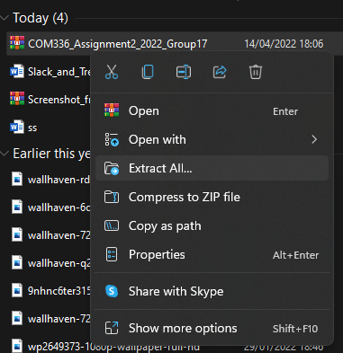

It would be wise to check that all files are functional, and that the compression process did not lose any important data.

The folder should contain:

* The project folder,

* The website folder,

* And the database SQL file,



# Passwords and Setup

After the folder has been extracted move it to the www folder within the wamp64 folder, which can be found in your computers C drive.

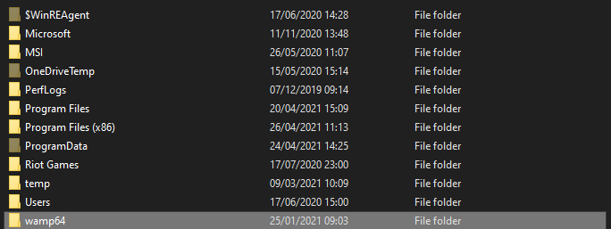

After moving the folder, you can set up the database. To do so Wamp must be enabled so that the website can run locally on this machine.

Open wamp and use the username “root” with no password to access your local area. Now press new and pick any name for the database. Then press create.

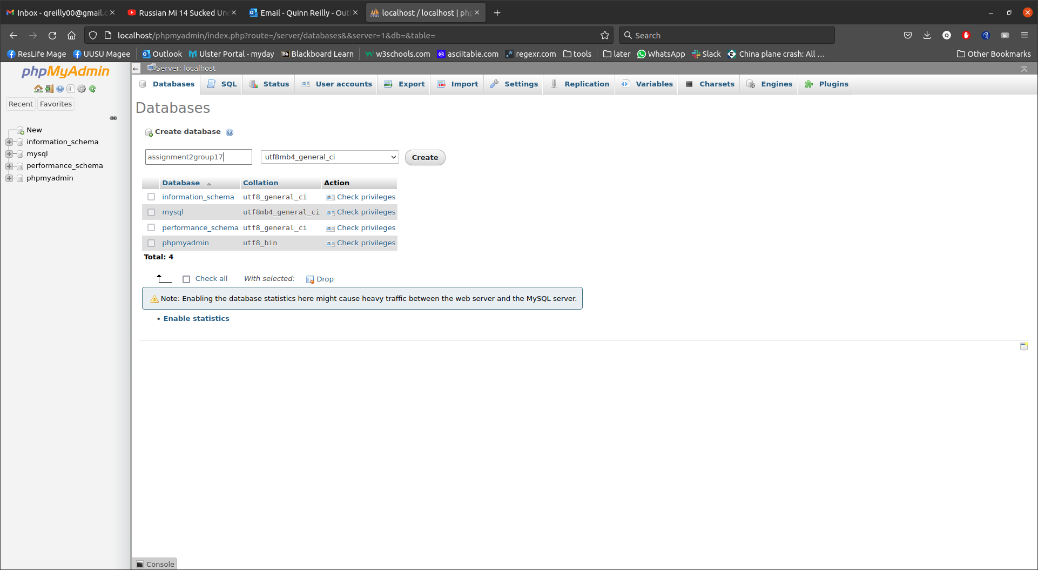

Once done, you will have to import the SQL file from the website folder shown earlier. This will get the database onto the local system. 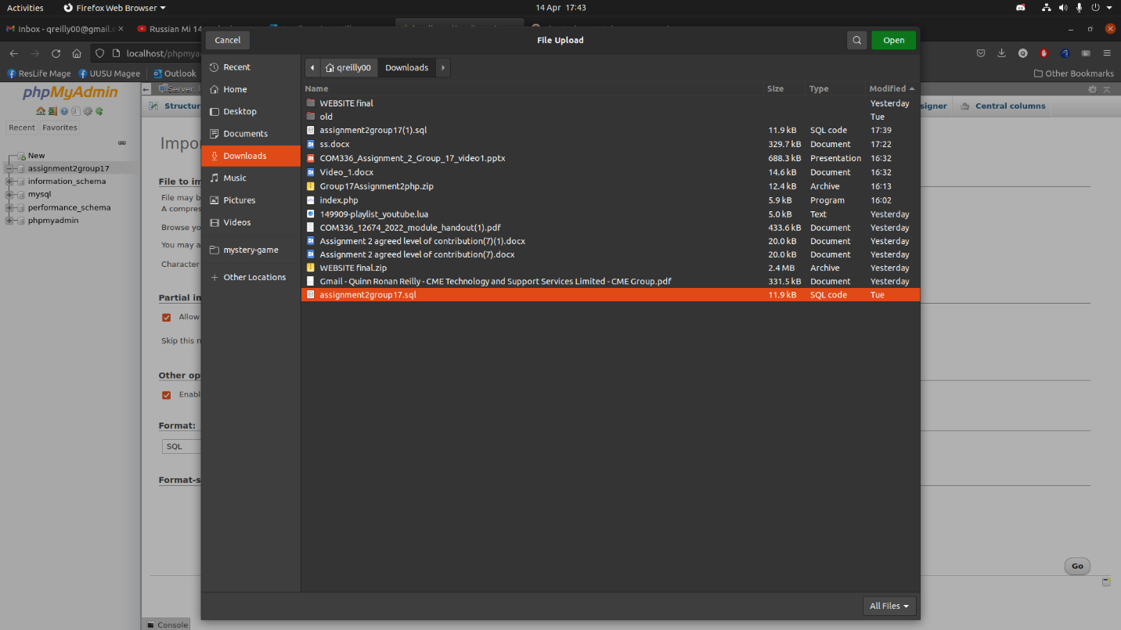

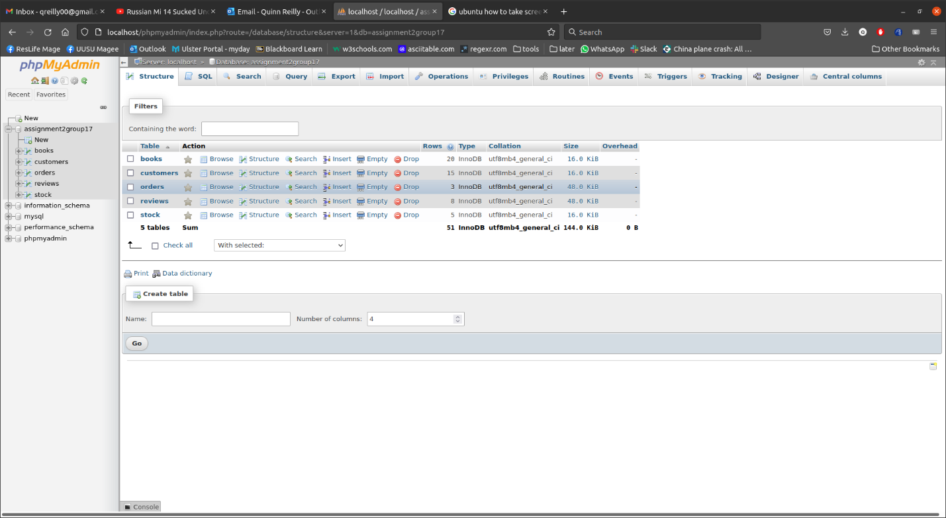

Once finished, you can see that you have the database on your system and so you can now use user accounts instead. There are two accounts made for the database. An Administrator and a Test User. These features were set up using the management portion of phpMyAdmin.

Next you will run the website. To do so, you must go into your web browser and type in “localhost/COM336Team17Website” as that is the name of the folder within your www directory.

# Website Overview

The main homepage allows the user to select a recommended book, search for a preferred book, log into their account or create an account and, scroll through books based on genre.

The search page allows the user to filter books based on genre. They can then read the book if they own it or preview the book if not.

The preview page allows the user to read the book, purchase the book, add a comment, and read other comments.

The reading page allows the user to read through each chapter of the book, accessibility options could also be implemented in the future.

The payment page allows the user to fill a form with their billing address and payment information, they can also view the books they have selected to buy from this page.

The sign in / log in page allows the user to either create a new account for the website or log into an already existing account.

# Overview of Design Process

## Design of the Website

First, we researched other similar websites and took notes of what they did.

These notes can be found in the document “ONLINE LIBRARIES AND MOCK UPS”.

Then we created a storyboard/wireframe based on the ideas that were gathered.

The storyboard can also be seen in the document “ONLINE LIBRARIES AND MOCK UPS”

## Design of the Database

First, we found out what entities and attributes were needed for the database. After which, we normalized the attributes.

Next, we designed some ERDs to map out relationships between the entities.

