**BMS INSTITUTE OF TECHNOLOGY AND MANAGEMENT**

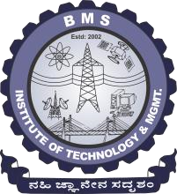 **YELAHANKA – BANGALORE - 64**

DEPARTMENT OF COMPUTER SCIENCE AND ENGINEERING

Project Based Learning for the Academic Year 2017-2018

# NUMBER PLATE RECOGNITION SYSTEM

Under the Guidance of:

G.Y.Durgadevi

Assistant Professor

Department of CSE

Team Members: Aayush Nandkeolyar, Amogh NG, Ankit Agrawal, Vishnu Menon

**AIM:** To extract the information from the given numberplate photo.

**INTRODUCTION:** The system uses various image enhancement techniques and image recognition algorithms to isolate the number from the given numberplate.

**FUNCTIONAL REQUIREMENTS:**

* Improves the brightness and contrast of the image.
* Extract the numberplate from the image.
* Return the number from the numberplate.
* Also return the degree of confidence and the processing time.

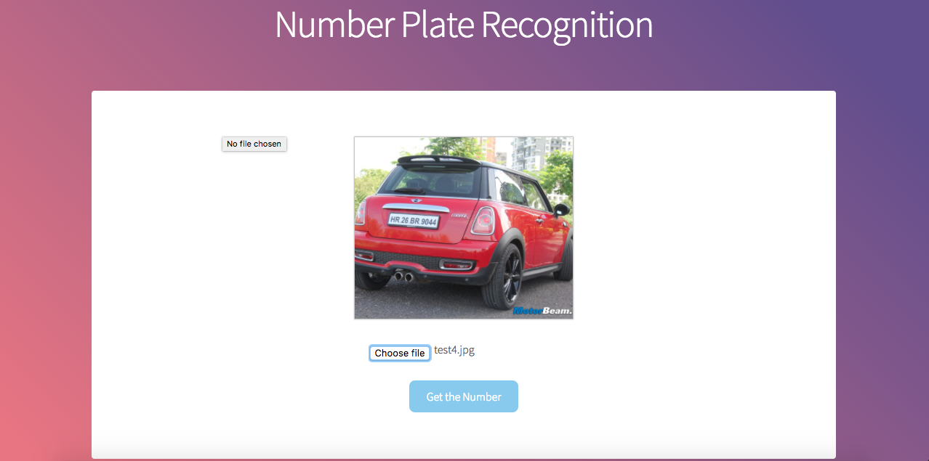**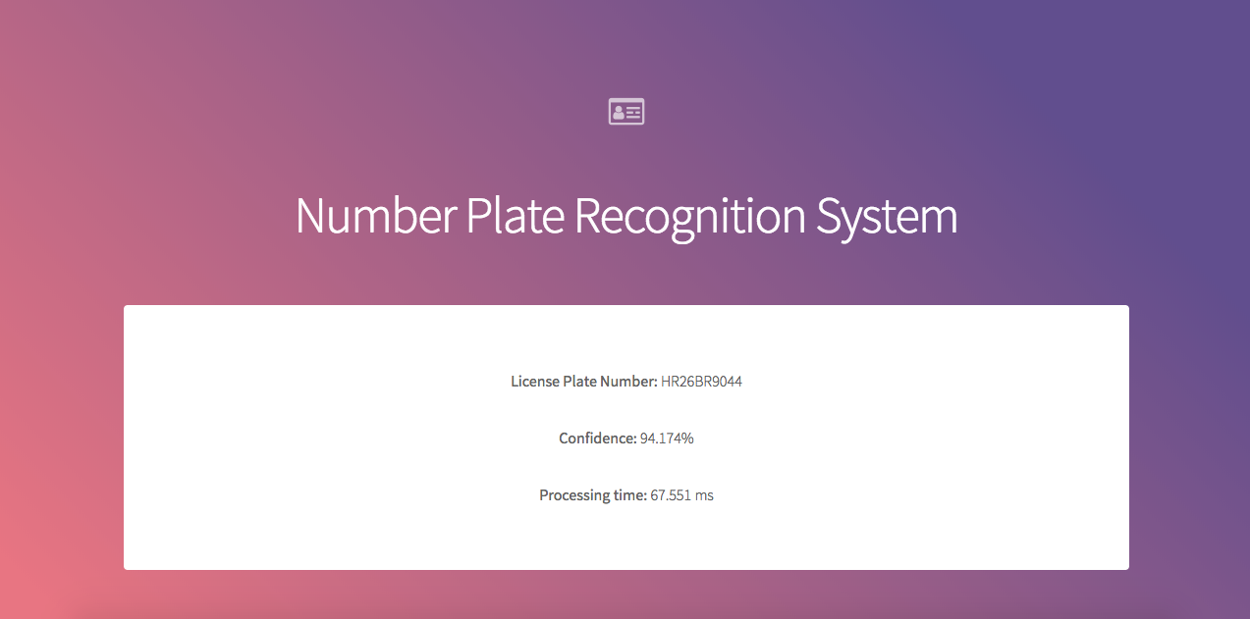SNAPSHOTS:**

The images uploaded go through a series of enhancement algorithms and then the image recognition algorithms are run on the photo. This in turn returns the license plate number of the car.

**CONCLUSION:**

The system finds various applications like Traffic Surveilance, Toll-Tax Plazas, Theft Analysis, etc. The system ensures that the number is returned with atmost degree of confidence so that the recognition can be as smooth as possible. It is easy to use and can help many people and industries with their image recognition softwares.