# Documentation

## File Structures

**Install Fabric Network:**

Install-fabric.sh script is a script that was given, and it’s the first file anyone should execute because it pulls the docker images for Hyperledger Fabric to run with.

**Fabric Network Scripts:**

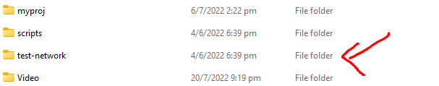

The test-network folder contains the file needed to maintain, upkeep, and facilitate with the Hyperledger Fabric network. This is the provided template folder that was given when downloading Hyperledger Fabric. The files here are scripts that helps to interact with Fabric through docker. The only common scripts that I’ve used are “./network.sh” and “./monitordocker.sh”. They execute and call internal scripts in the internal folders. “./network.sh” is a master script that calls other internal scripts when you command it to.

**My Project Folder:**

In “/capstone-blkchain/myproj”, it contains the files that I’ve created for my capstone project. “/certs” contain the certs needed for HTTPS in both my frontend and backend. “/frontend” contain my frontend React files. “/javascript” contain my JavaScript files which include backend and other sample code to invoke Fabric functions.

**Chaincode / Smart Contracts:**

The “/chaincode” folder contains all the chaincode / smart contracts written for each asset. The chaincode / smart contract is in the “/chaincode/lib” folder, and folder outside of that uses index.js to export the smart contracts.

## Code Explanation

**Chaincode / Smart Contracts:**