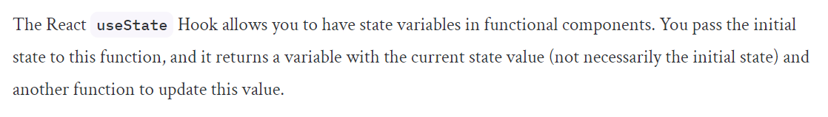

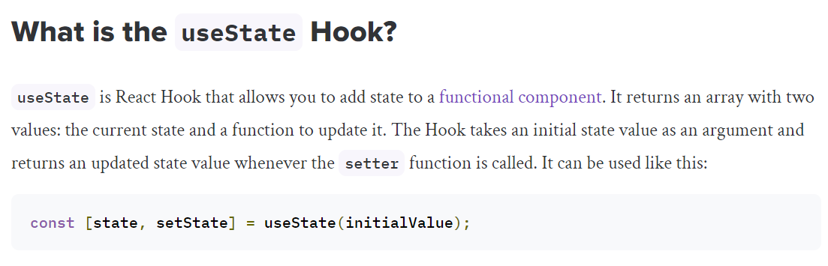

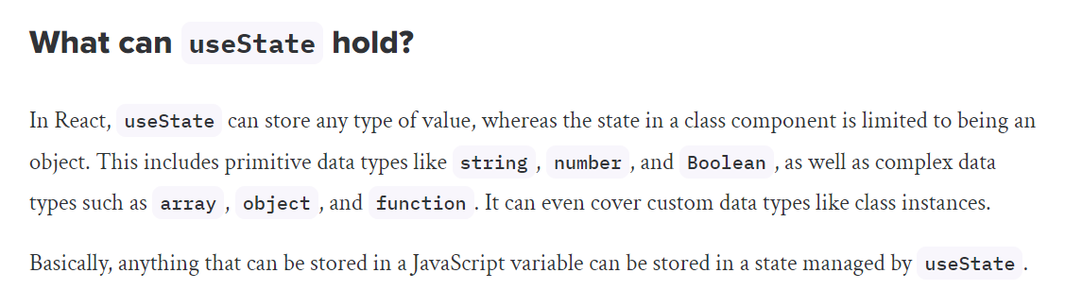

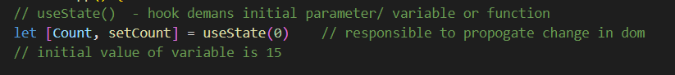

Virtual dom:

<https://github.com/acdlite/react-fiber-architecture>

