<https://vitejs.dev/guide/>

<https://tailwindcss.com/docs/installation/framework-guides>

<https://tailwindcss.com/docs/guides/vite>

<https://www.pexels.com/>

<https://www.devui.io/>

<https://nerdcave.com/tailwind-cheat-sheet>

install the dependencies

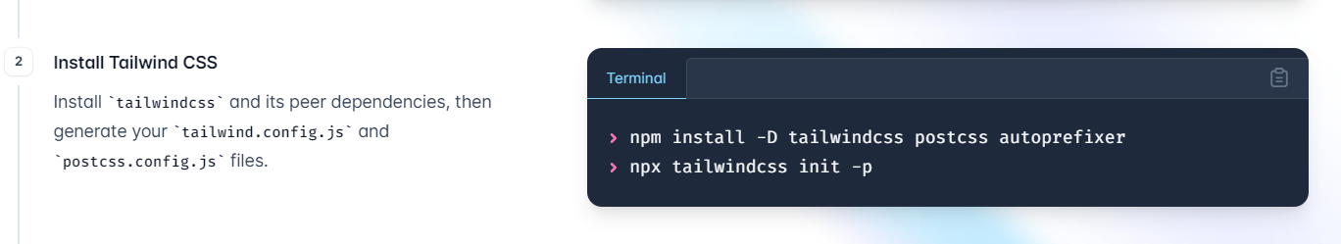

npm install -D tailwindcss postcss autoprefixer

npx tailwindcss init -p

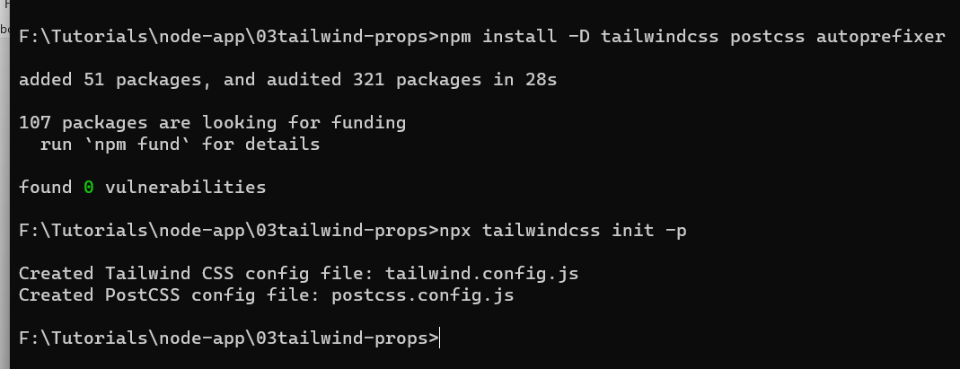



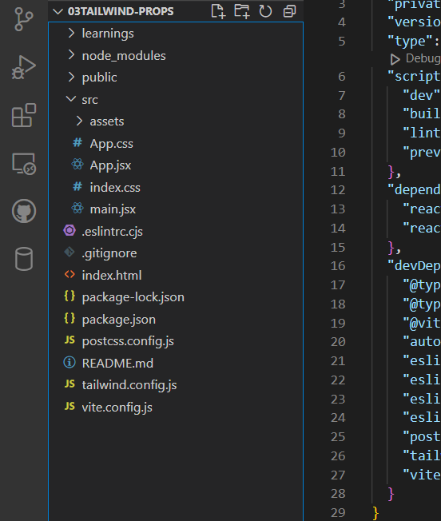



File will contain only some configurational scripts

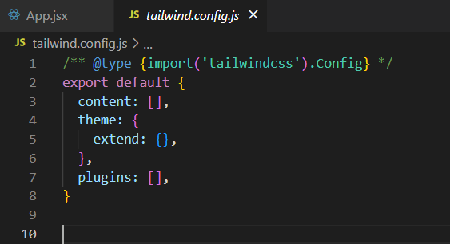

Next steps is to change the content of tailwind.config.js

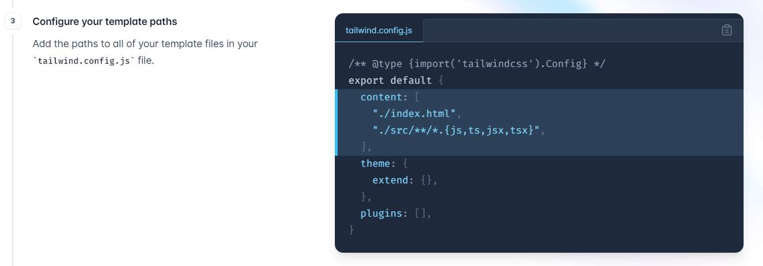

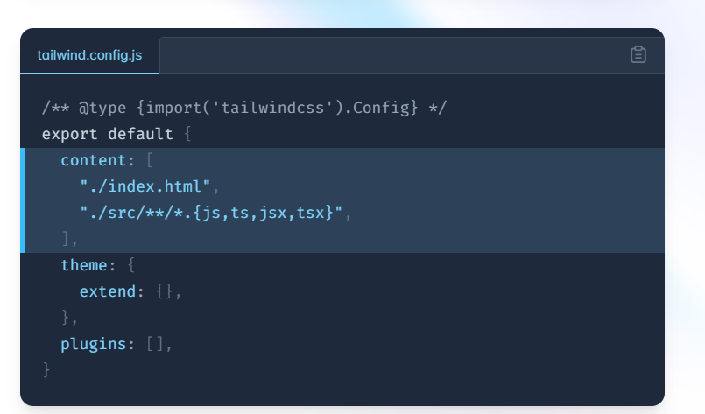

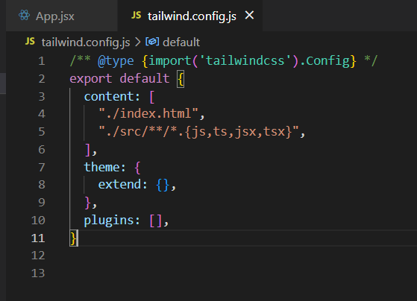

This will search for inserting css into index.html and other source files liks js,tc,jsx etc.

Next steps is to update index.css on the very top

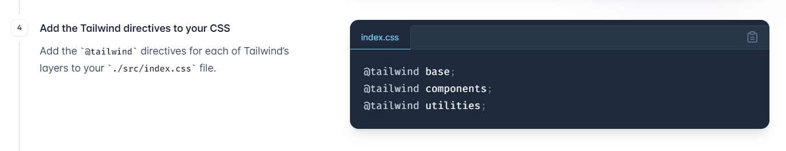

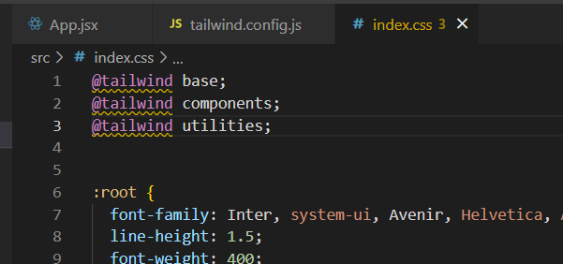

Now its our choice to keep entire css or not because now most of the things are managed by tailwind css and not by react custom css

After doing this we can run our project using vite

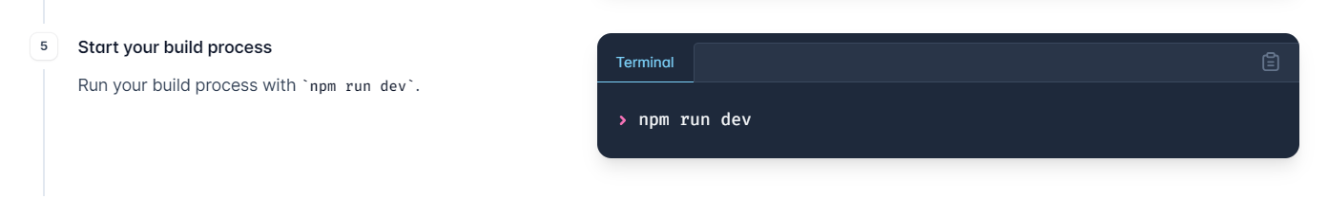

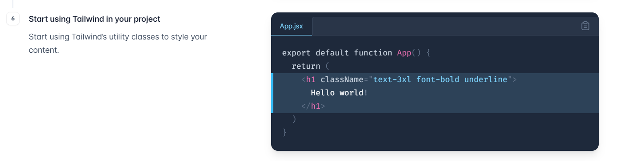

Install this extension for tailwind autocomplete

