useCallback

<https://www.w3schools.com/react/react_usecallback.asp>

<https://react.dev/reference/react/useEffect>

* Think of memoization as caching a value so that it does not need to be recalculated. (useCallback is a React Hook that lets you cache a function definition between re-renders.)
* This allows us to isolate resource intensive functions so that they will not automatically run on every render.
* The useCallback Hook only runs when one of its dependencies update.

It has the following syntax



It takes two parameters

One is function and the other one is array of dependencies



Where fn stands for function

We have to directly write a function there it can be normal function or arrow function

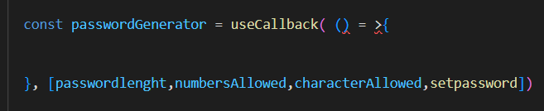

We can implement function body as per our requirements

Error:

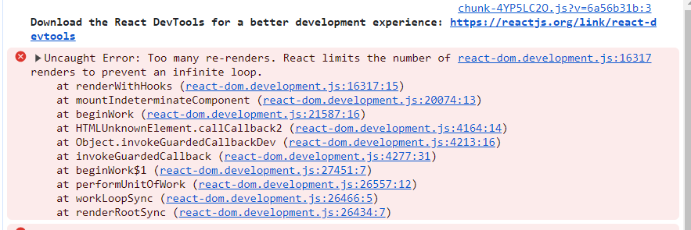

Most of the time this error is caused if we try to call callback functions manually, by treating as a manual function

Cause of error



Solution:

useEffect hook

* <https://react.dev/reference/react/useEffect>

input is two arguments,

one is call back and other is dependency array

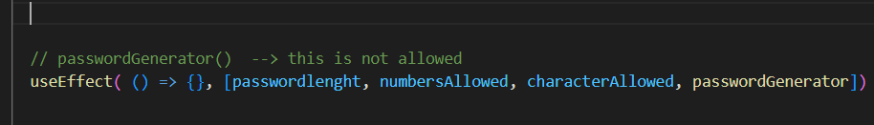

Call function in the body of callback

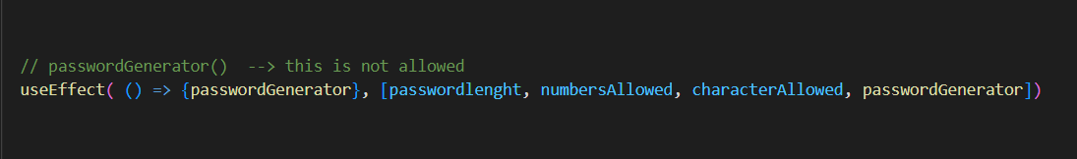

Use finction syntax

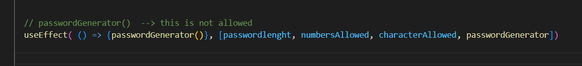

Useref hook:

* <https://react.dev/reference/react/useRef>
* 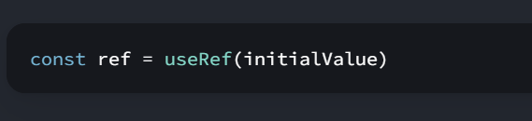

Since we don’t have any initial reference value hence initial value is null

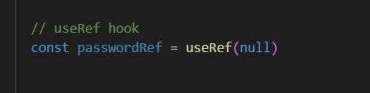

Now pass this reference to input field hat you want to refer

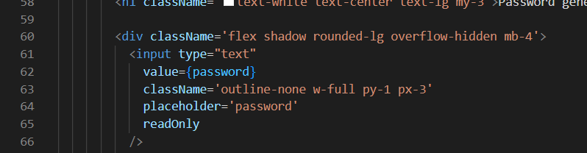

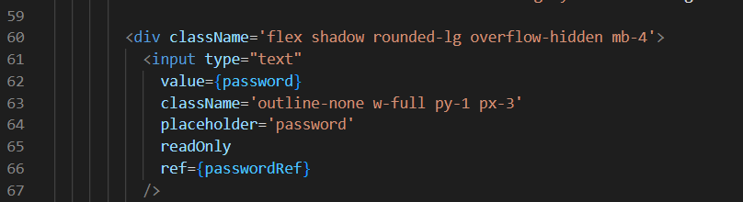



Here copy password is method

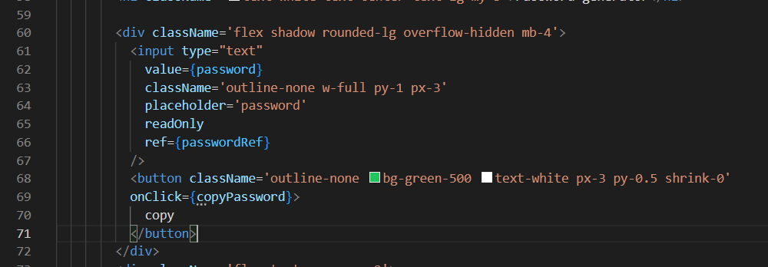

This will copy the password whenever password is generated and copy button clicked

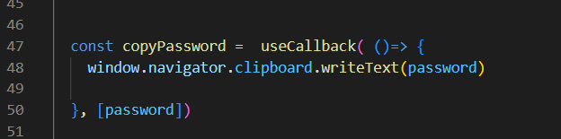

Using password reference

This code will highlight the text copied

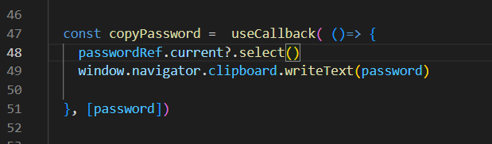

This code will copy only initial three characters

