1.Create the directory C:\Program Files\Nebula\ and place the following files in this directory:
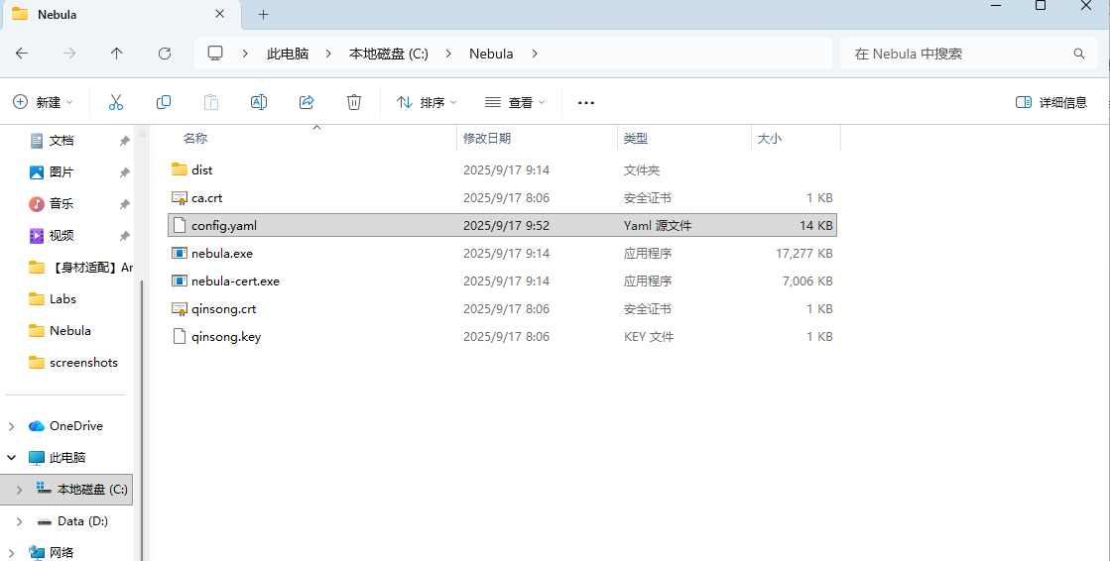
2. Edit the configuration file config.yaml
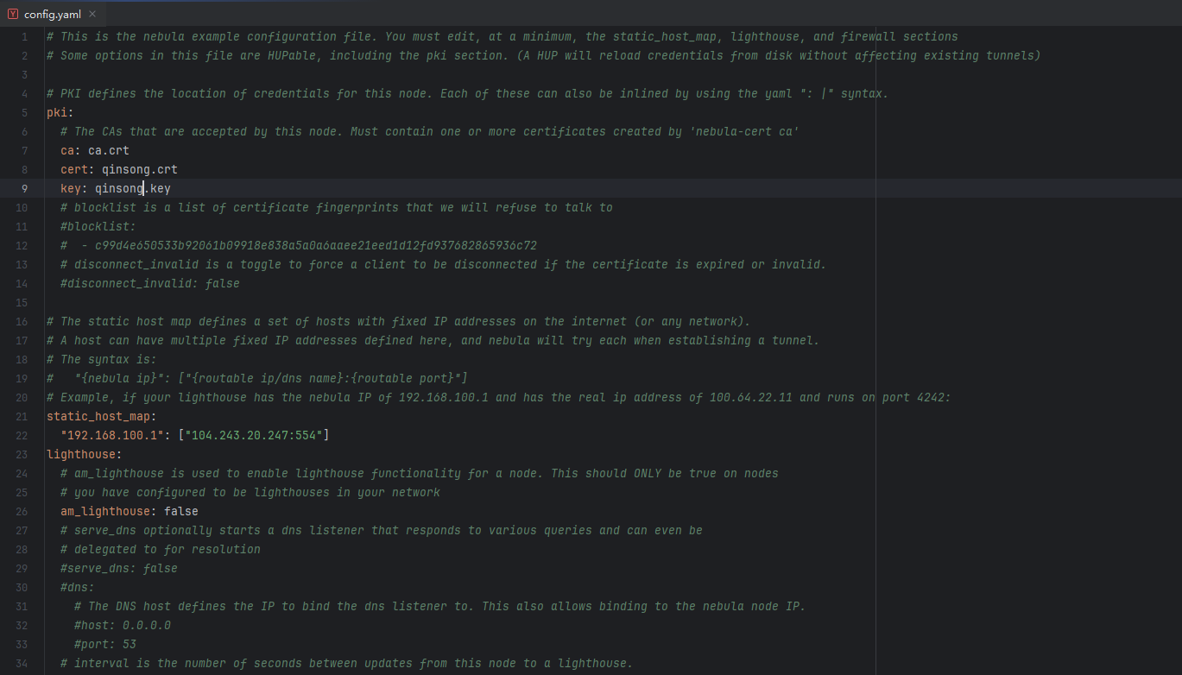
3. Open PowerShell as an administrator and run Nebula:
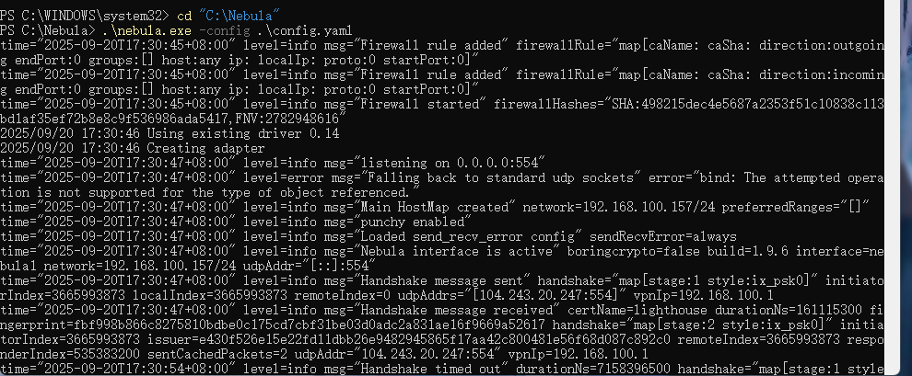
4. ping the overlay network IP of Lighthouse on a Windows computer:
