Step 1: Create a GitHub repository and name it qs50.github.io

Step 2: Create a homepage on GitHub.Enter the warehouse that was just created.
Click Add file → Create new file. Enter the website content in the editor
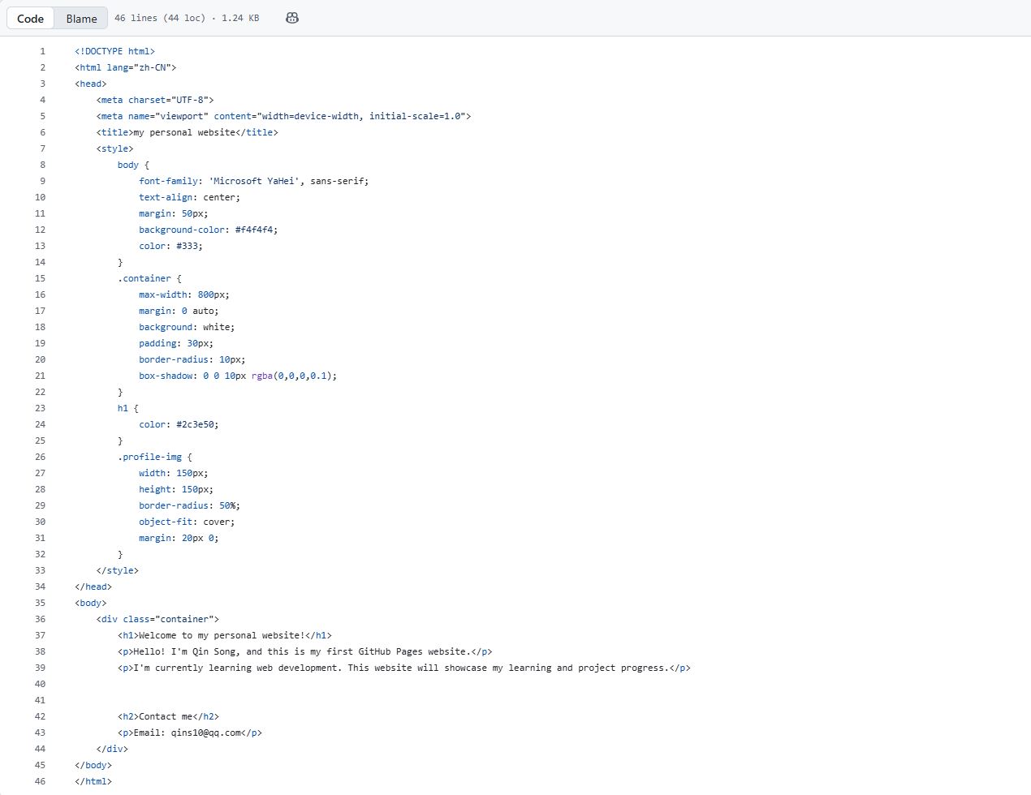
Step 3: Enable GitHub Pages
On the repository page, click Settings → Pages.
In the Source section, select:
Branch: main
Folder: / (root)
Click "Save"
