1. Open PowerShell (Administrator Mode) and enter the following command to install WSL:
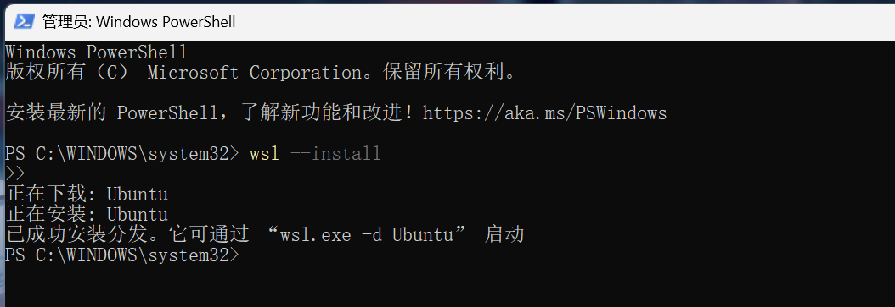
2. Download and install Docker
3. Open the terminal to verify whether the installation was successful
4. Pull the official Gitea image
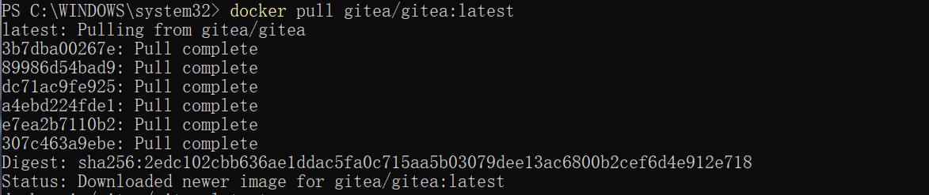
5. Start a Gitea container, run the following command to start a Gitea service:
6. Access Gitea, open your browser and type: http://localhost:3000
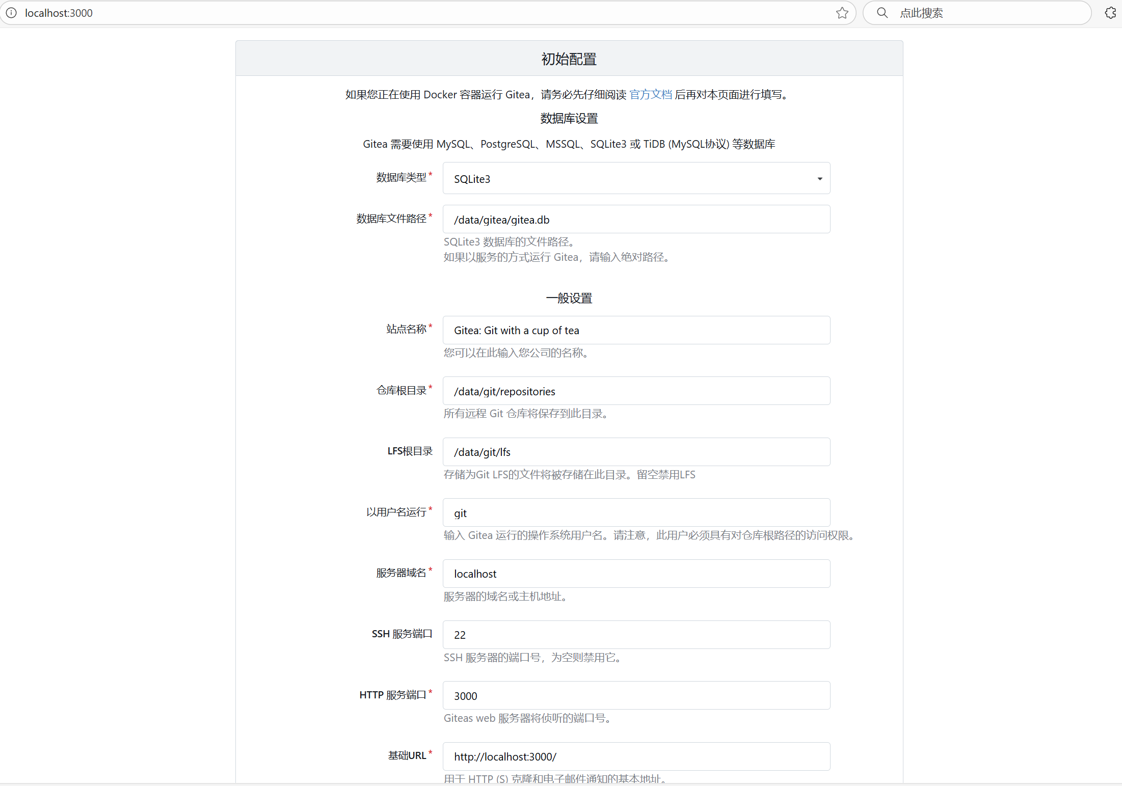
7. Verify whether LFS is supported
8. Create a new repository
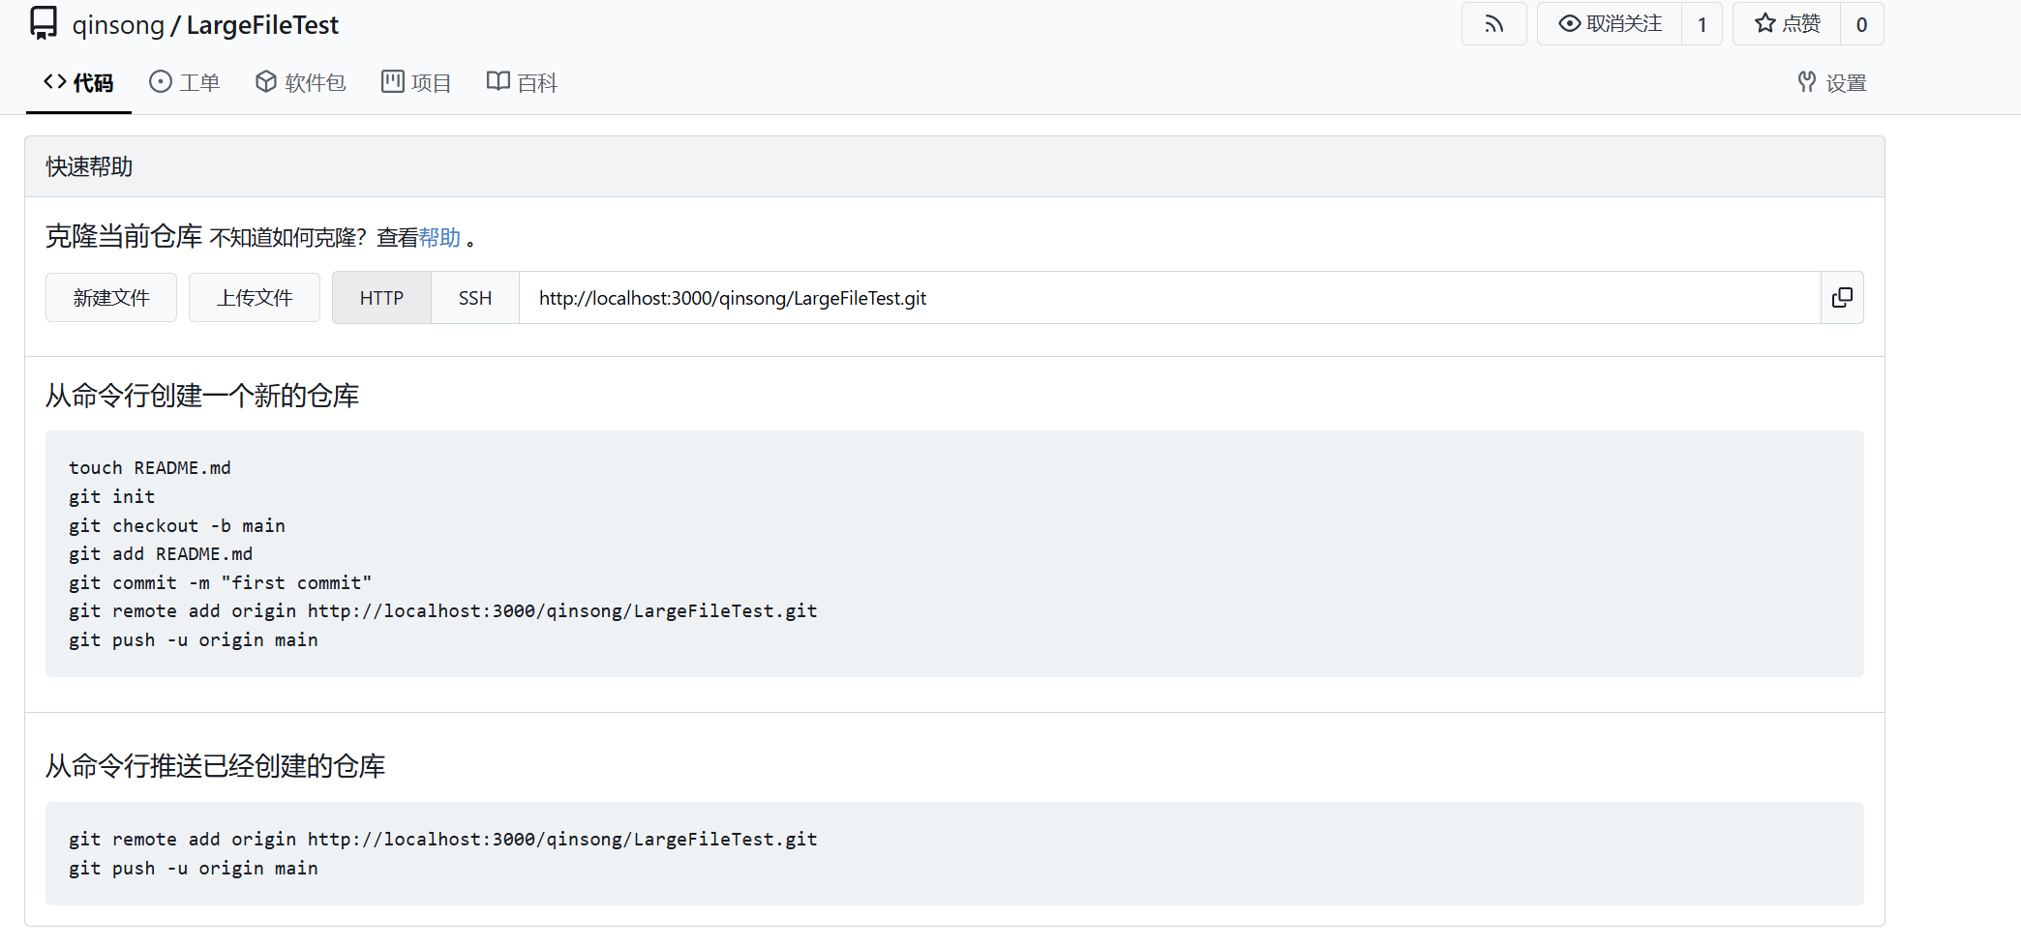
9. Generate a large file and push it to Gitea
