https://docs.docker.com/get-started/docker-concepts/the-basics/what-is-a-container/
1. Open your CLI terminal and start a container by using the docker run command: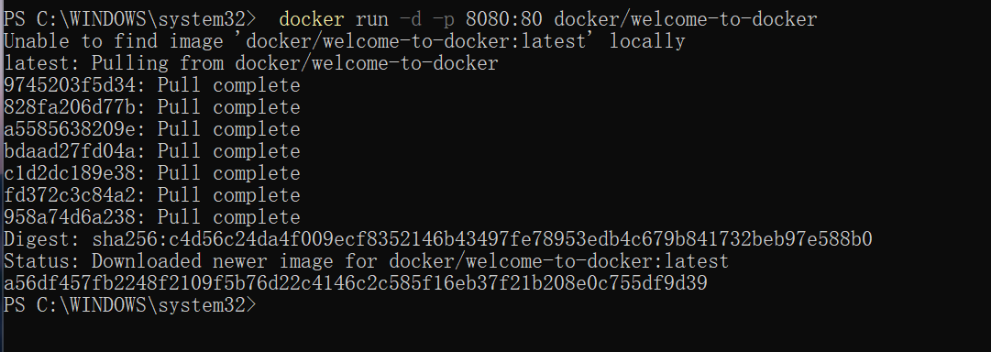
2. verify if the container is up and running by using the docker ps command:
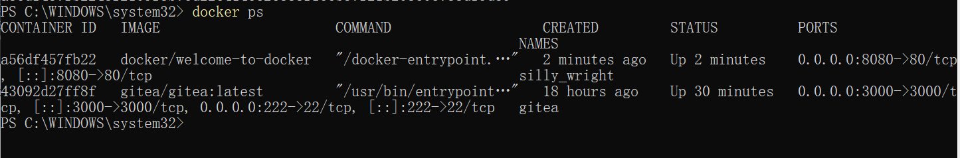
3. Visit http://localhost:8080/
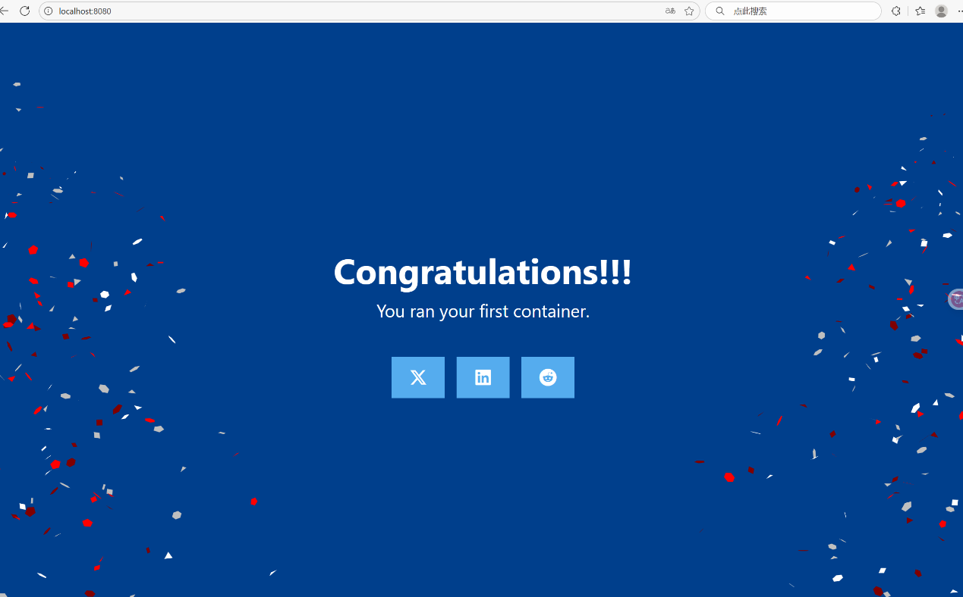
4. Provide the container ID or name to the docker stop command:
https://docs.docker.com/get-started/docker-concepts/the-basics/what-is-an-image/
1. Open a terminal and search for images using the docker search command:
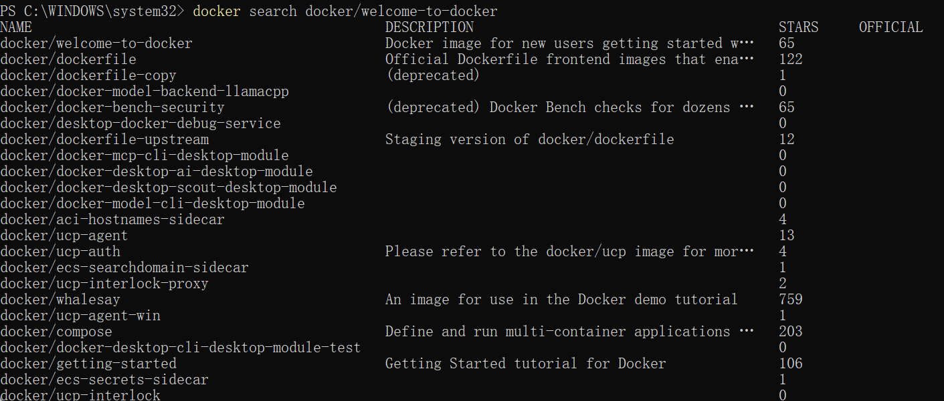
2. Pull the image using the docker pull command.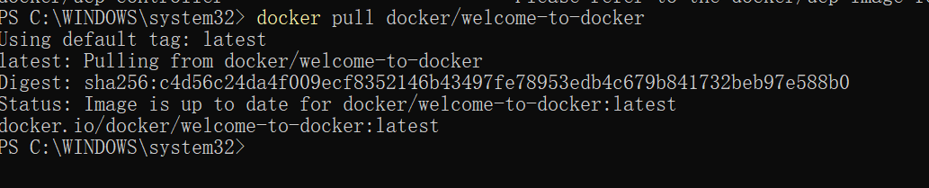
3. List your downloaded images using the docker image ls command:
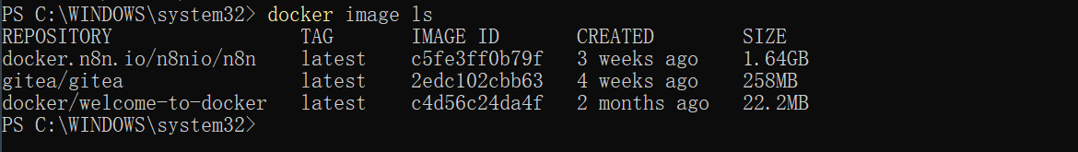
4. List the image's layers using the docker image history command:
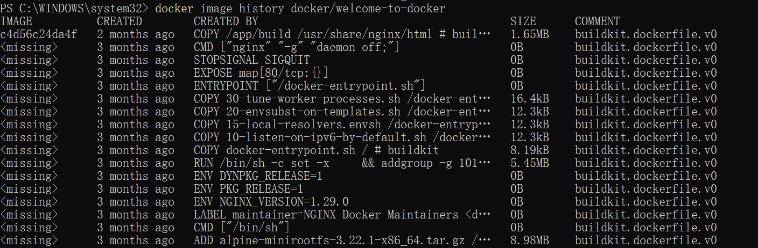

https://docs.docker.com/get-started/docker-concepts/the-basics/what-is-docker-compose/
1. Open a terminal and clone this sample application.
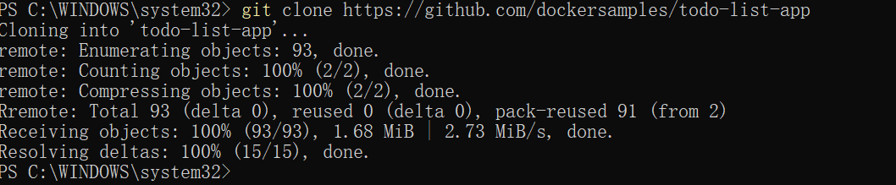
2. Navigate into the todo-list-app directory:
3. Use the docker compose up command to start the application:
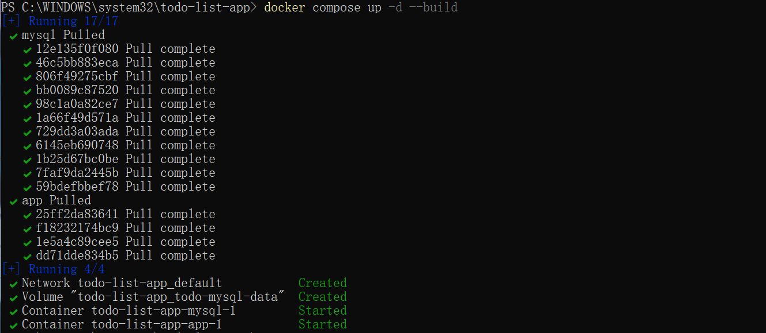
4. With everything now up and running, you can open http://localhost:3000 in your browser to see the site. Feel free to add items to the list, check them off, and remove them.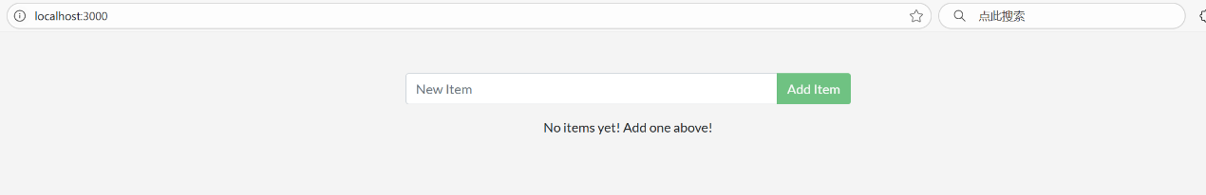
5. In the CLI, use the docker compose down command to remove everything:
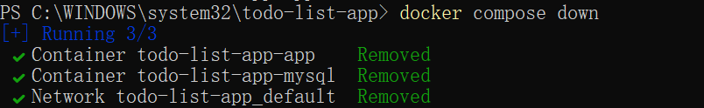
6. Alternatively, you can use the Docker Desktop GUI to remove the containers by selecting the application stack and selecting the Delete button.
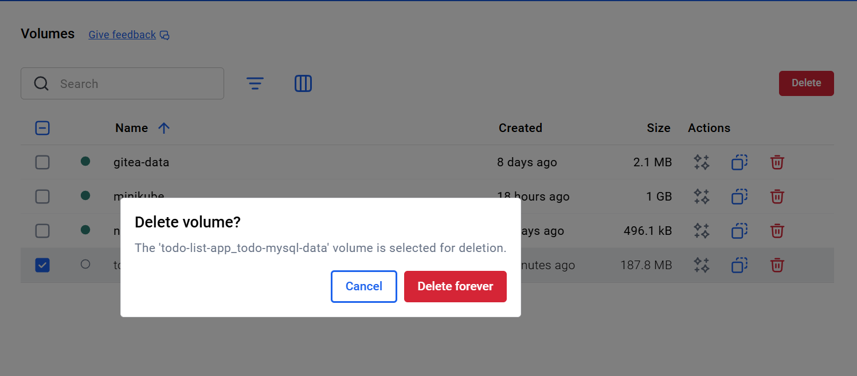
https://docs.docker.com/get-started/docker-concepts/running-containers/publishing-ports/
1. Start a container and publish the port
2. Verify port mapping
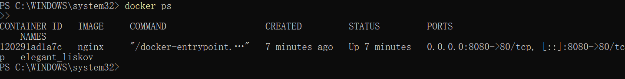
3. Open in the browser:
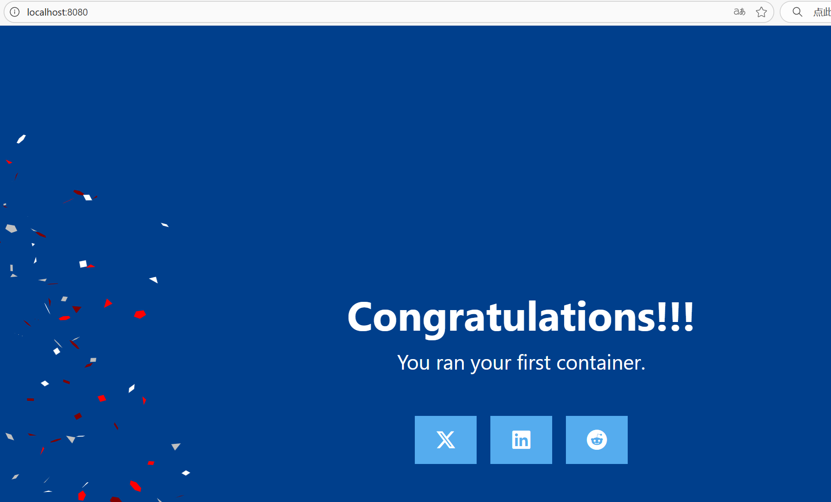
4. Create a working directory
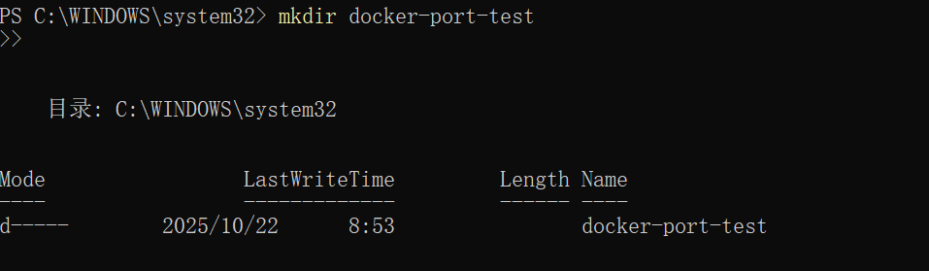
5. Enter this directory（notepad compose.yaml）
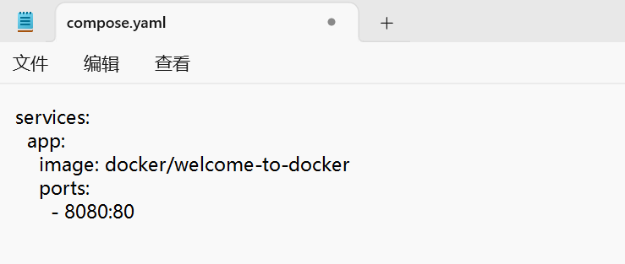
6. Start the application
http://localhost:8080
https://docs.docker.com/get-started/docker-concepts/running-containers/overriding-container-defaults/
1. docker run -d -e POSTGRES_PASSWORD=secret -p 5432:5432 postgres
2. Start a second Postgres container mapped to a different port.
3. Verify that both containers are running by going to the Containers view in the Docker Desktop Dashboard.
4. Create a new custom network by using the following command:
5. Verify the network by running the following command:
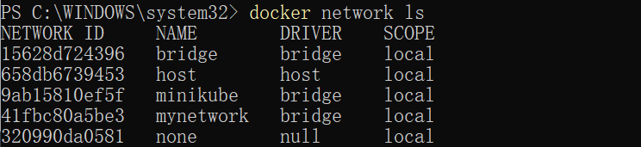
6.Connect Postgres to the custom network by using the following command:
7. Create a compose.yml file:
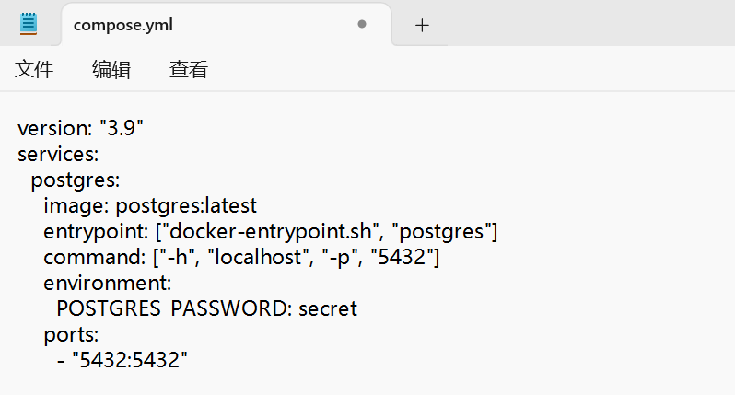
8. Bring up the service by running the following command: docker compose up -d
9. Enter the container validation database
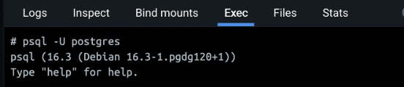
https://docs.docker.com/get-started/docker-concepts/running-containers/persisting-container-data/
- Start a container using the Postgres image with the following command:
- Connect to the database by using the following command:
- In the PostgreSQL command line, run the following to create a database table and insert two records:
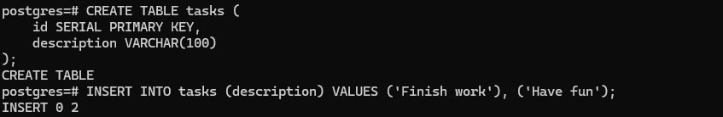
- Verify the data is in the database by running the following in the PostgreSQL command line:
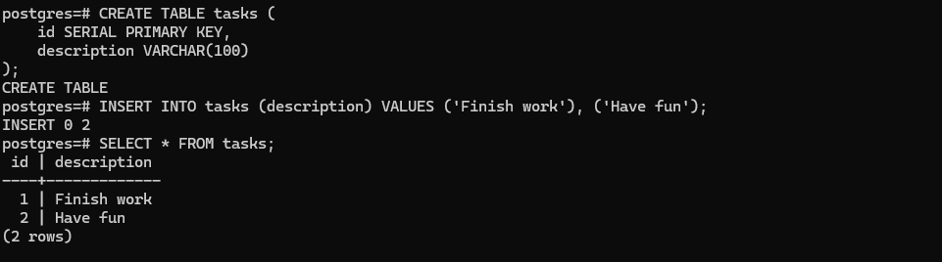
- Exit out of the PostgreSQL shell by running the following command: \q
- Stop and remove the database container. Remember that, even though the container has been deleted, the data is persisted in the postgres_data volume.
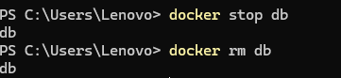
- Start a new container by running the following command, attaching the same volume with the persisted data:
- Verify the database still has the records by running the following command:
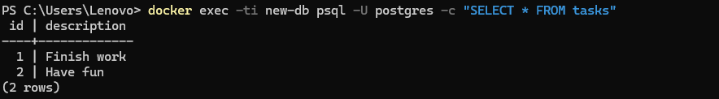
9. Remove volumes
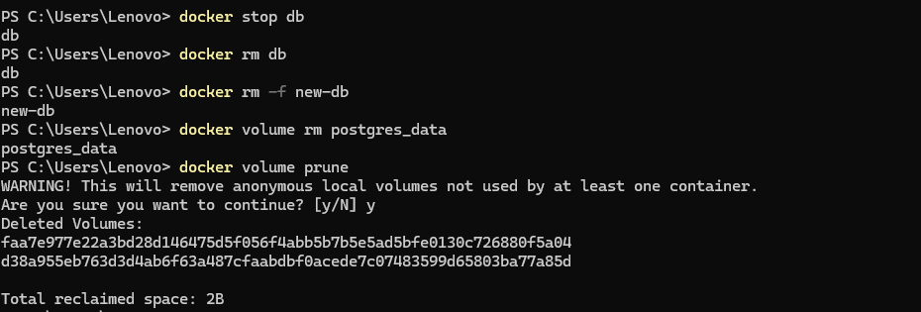

https://docs.docker.com/get-started/docker-concepts/running-containers/sharing-local-files/
1. Start a container using the httpd image with the following command:
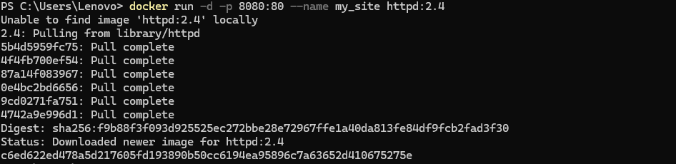
2.Open the browser and access http://localhost:8080 or use the curl command to verify if it's working fine or not
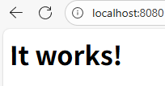
3. Create a new directory called public_html on your host system.
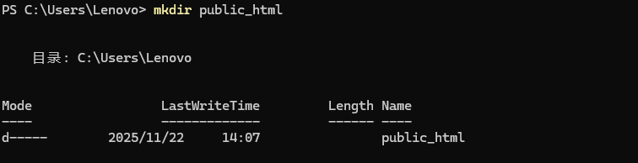
4．Navigate into the newly created directory public_html and create a file called index.html with the following content. This is a basic HTML document that creates a simple webpage that welcomes you with a friendly whale.
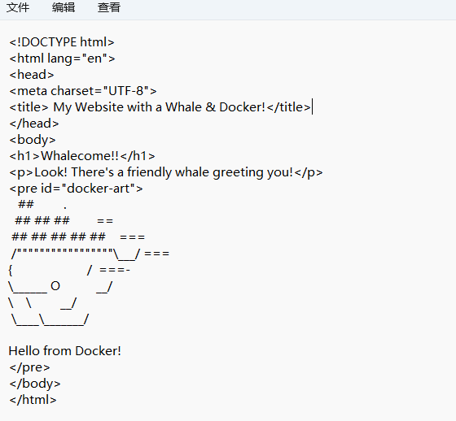
5. It's time to run the container. The --mount and -v examples produce the same result. You can't run them both unless you remove the my_site container after running the first one.
https://docs.docker.com/get-started/docker-concepts/running-containers/multi-container-applications/
1.Get the sample application. If you have Git, you can clone the repository for the sample application. Otherwise, you can download the sample application. Choose one of the following options.
2.Build the images. Navigate into the nginx directory to build the image by running the following command:
3.Before you can run a multi-container application, you need to create a network for them all to communicate through. You can do so using the docker network create command:
4. Start the Redis container by running the following command, which will attach it to the previously created network and create a network alias (useful for DNS lookups):
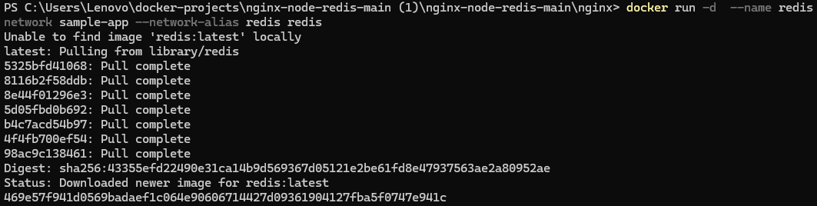
5. Start the first web container by running the following command:
6. Start the second web container by running the following:
7. Start the Nginx container by running the following command:
8. Verify the containers are up by running the following command: 