https://kubernetes.io/docs/tutorials/hello-minikube/
- Create a minikube cluster
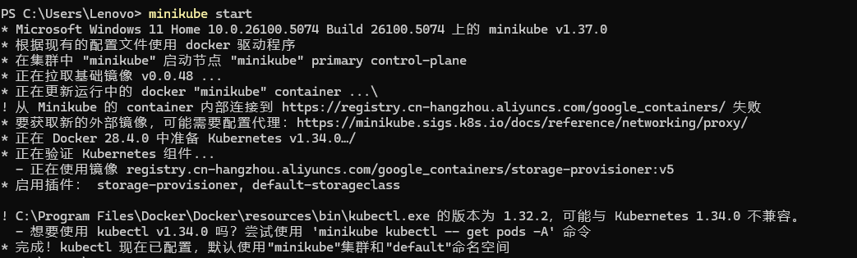
- Open the Dashboard：minikube dashboard
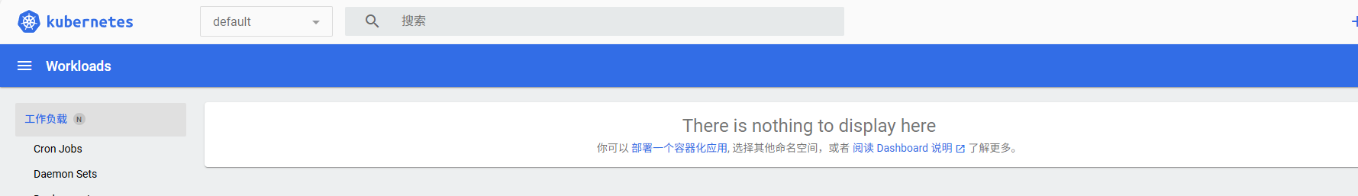
Create a Deployment
1.Use the command to create a Deployment that manages a Pod. The Pod runs a Container based on the provided Docker image.kubectl create
2.View the Deployment:
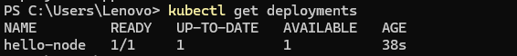
- View the Pod:
- View cluster event
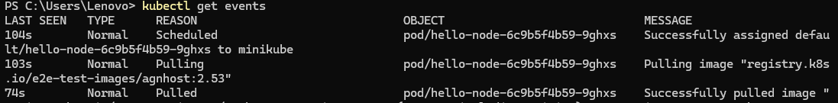
5. View the configuration:kubectl
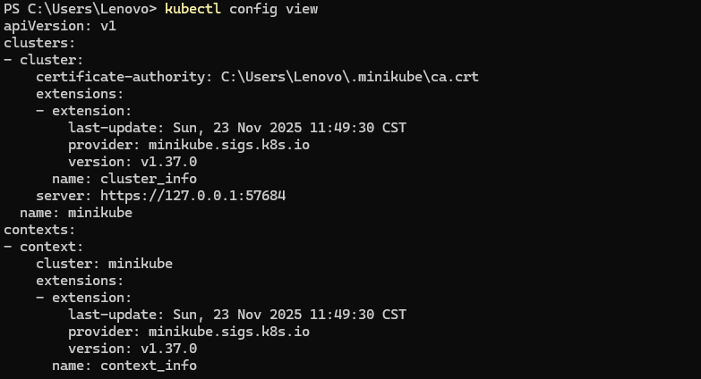
6.View application logs for a container in a pod (replace pod name with the one you got from ).kubectl get pods
Create a Service
1. Expose the Pod to the public internet using the command:kubectl expose
2. View the Service you created:
3. Run the following command:
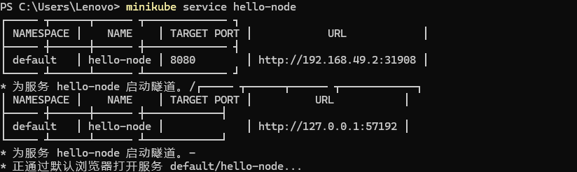Enable addons
1. List the currently supported addons:
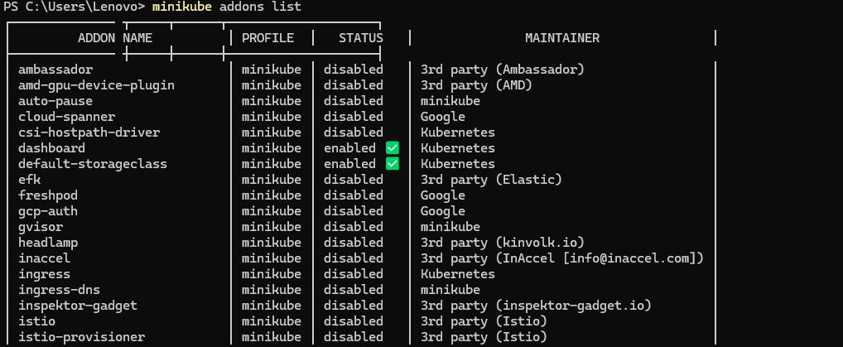
2. Enable an addon, for example, :metrics-server
3. View the Pod and Service you created by installing that addon:
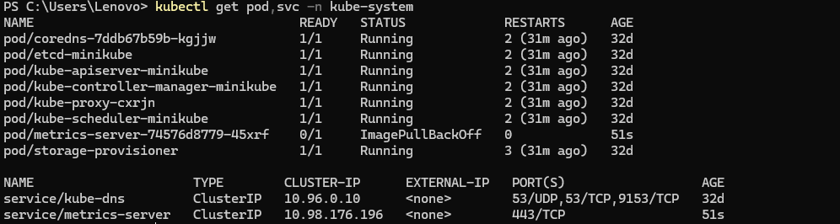
4. Check the output from :metrics-server（I tried many times but failed）
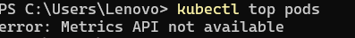
5. Disable :metrics-server
Clean up
1. Now you can clean up the resources you created in your cluster:
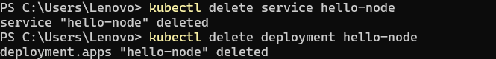
2. Stop the Minikube cluster
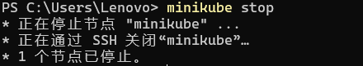
https://kubernetes.io/docs/tutorials/kubernetes-basics/deploy-app/deploy-intro/
1. Deploy an app
2. To list your deployments use the kubectl get deployments command:
View the app
1. Open a second terminal window to run the proxy.
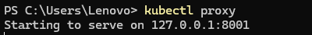
2. Query the version directly through the API using the curl command:
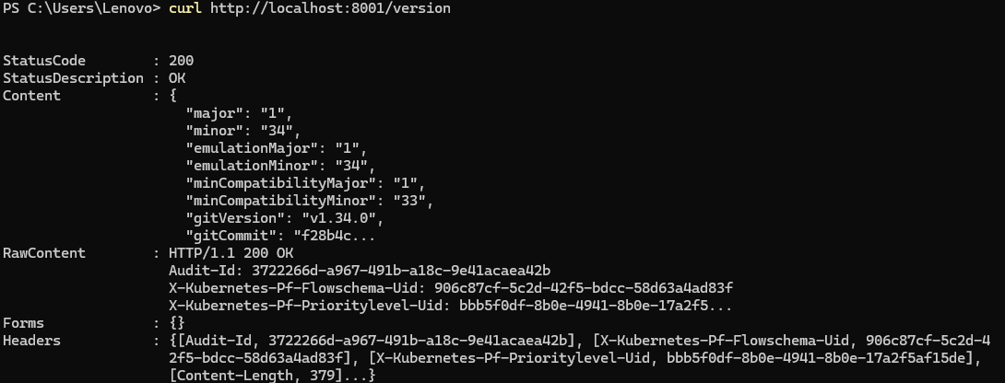
3. Get the Pod name, and we'll store it in the environment variable POD_NAME.
https://kubernetes.io/docs/tutorials/kubernetes-basics/explore/explore-intro/
Check application configuration
1. Use the kubectl get command and look for existing Pods:
2. to view what containers are inside that Pod and what images are used to build those containers we run the kubectl describe pods command:
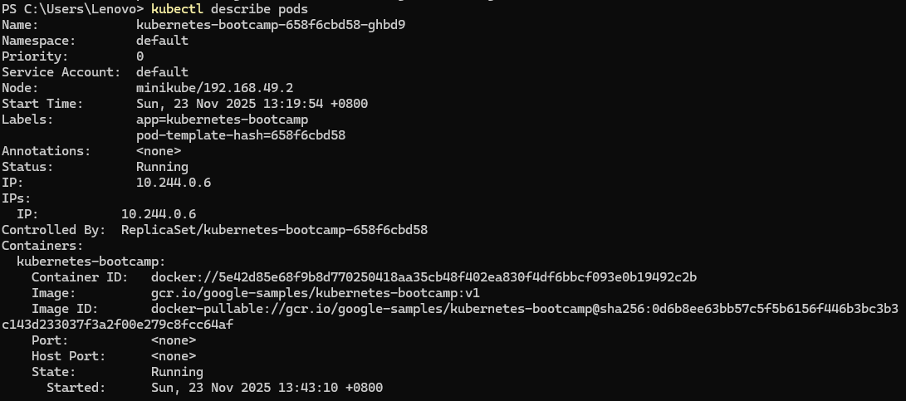
Show the app in the terminal
1. get the Pod name and query that pod directly through the proxy. To get the Pod name and store it in the POD_NAME environment variable:
2. To see the output of our application, run a curl request:
Executing commands on the container
1. We can execute commands directly on the container once the Pod is up and running. For this, we use the exec subcommand and use the name of the Pod as a parameter. Let’s list the environment variables:
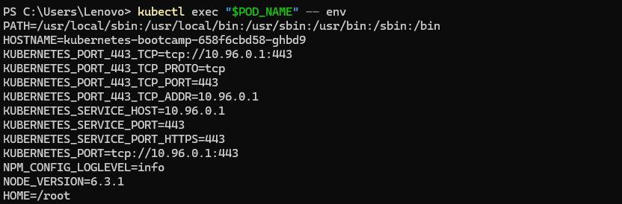
2. start a bash session in the Pod’s container:
3. We have now an open console on the container where we run our NodeJS application. The source code of the app is in the server.js file:
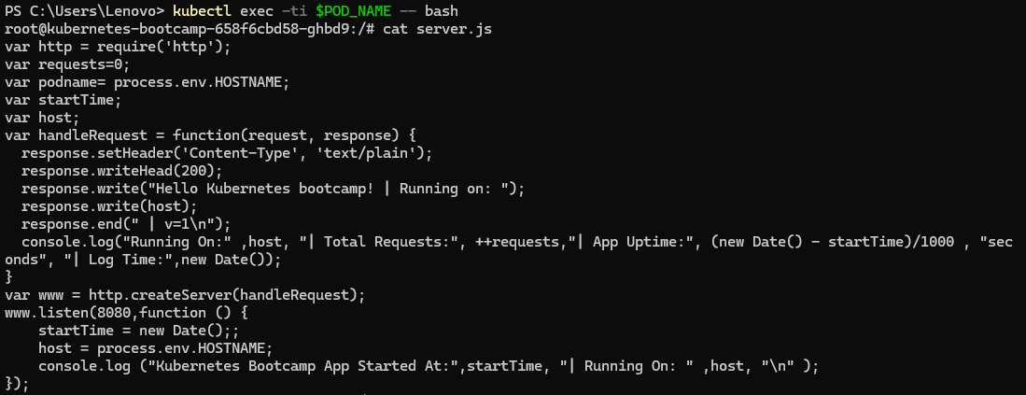
4.check that the application is up by running a curl command:
https://kubernetes.io/docs/tutorials/kubernetes-basics/expose/expose-intro/
Step 1: Creating a new Service
1. use the kubectl get command and look for existing Pods:
2. list the current Services from our cluster:
3. To expose the deployment to external traffic, we'll use the kubectl expose command with the --type=NodePort option:
4. To find out what port was opened externally (for the type: NodePort Service) we’ll run the describe service subcommand:
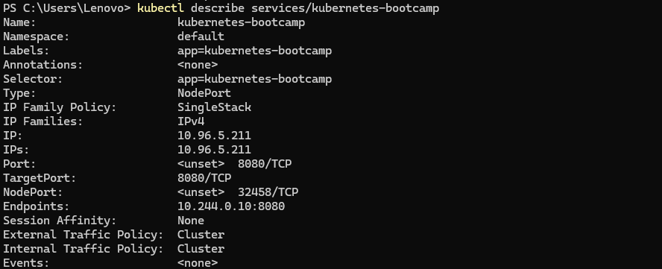
5. Create an environment variable called NODE_PORT that has the value of the Node port assigned:
6. Now we can test that the app is exposed outside of the cluster using curl, the IP address of the Node and the externally exposed port:
Step 2: Using labels
1. The Deployment created automatically a label for our Pod. With the describe deployment subcommand you can see the name (the key) of that label:
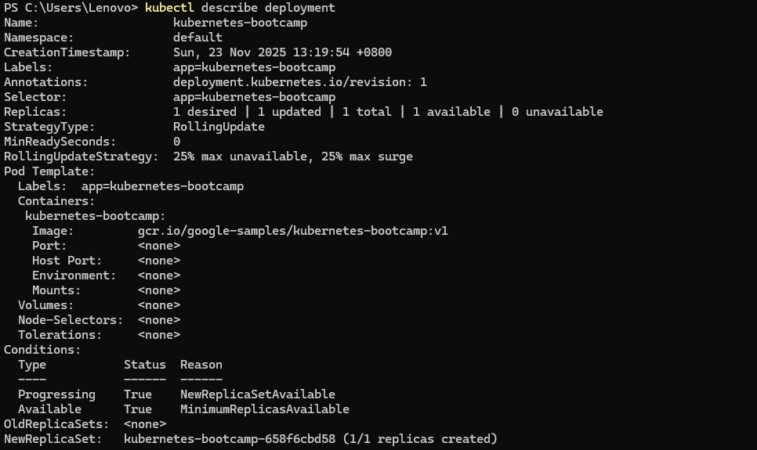
2. Use this label to query our list of Pods. We’ll use the kubectl get pods command with -l as a parameter, followed by the label values:
3. Get the name of the Pod and store it in the POD_NAME environment variable:
4. To apply a new label we use the label subcommand followed by the object type, object name and the new label:
5. check it with the describe pod command:
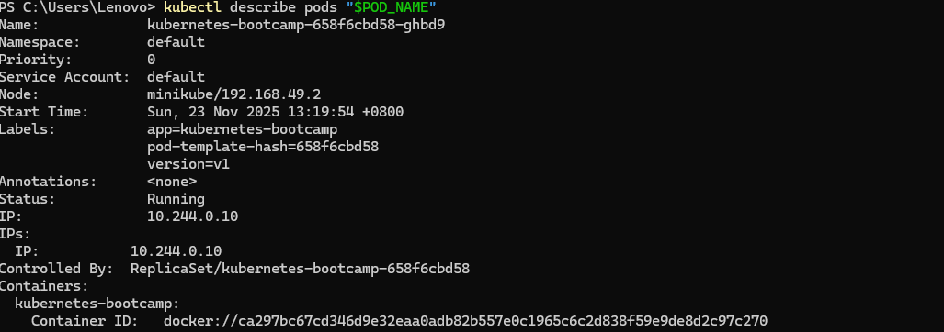
6. query now the list of pods using the new label:
Step 3: Deleting a service
1. Use the delete service subcommand to delete Services
2. Confirm that the Service is gone:
https://kubernetes.io/docs/tutorials/kubernetes-basics/scale/scale-intro/
Scaling a Deployment
1. Use the get deployments subcommand to list your Deployments
2. To see the ReplicaSet created by the Deployment, run:
3. scale the Deployment to 4 replicas. We’ll use the kubectl scale command, followed by the Deployment type, name and desired number of instances:
4. To list your Deployments once again, use get deployments:
5. check if the number of Pods changed:
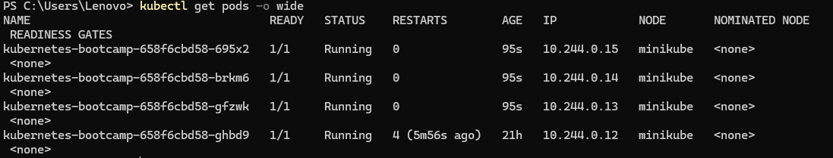
6. The change was registered in the Deployment events log. To check that, use the describe subcommand:
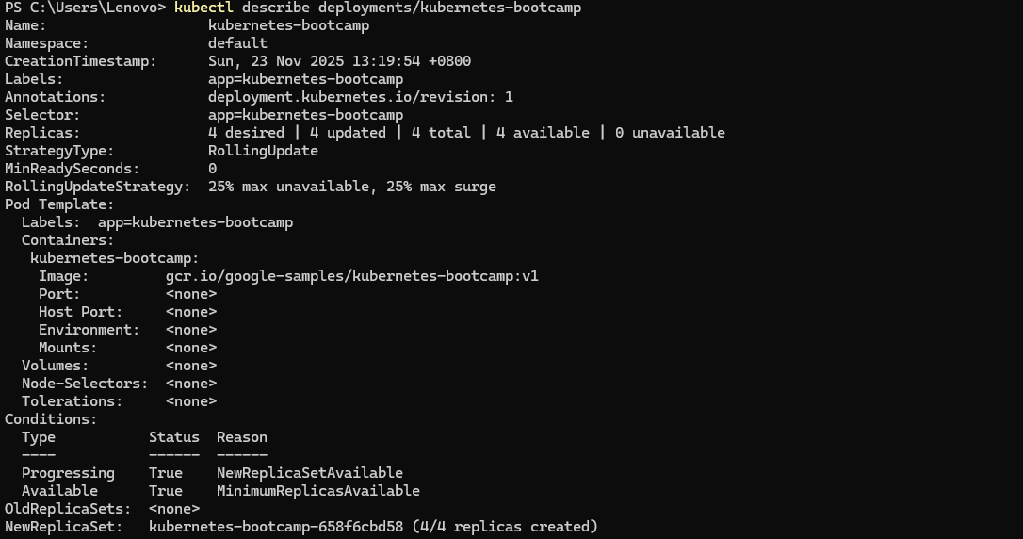
Load Balancing
1.To find out the exposed IP and Port we can use describe service as we learned in the previous part of the tutorial:
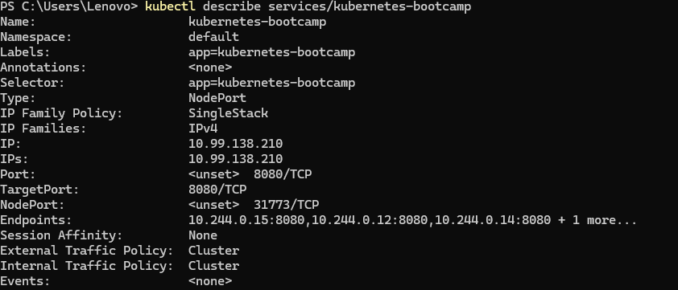
2.Obtain the exposed external port, send a request to the service, and verify whether the application can access it
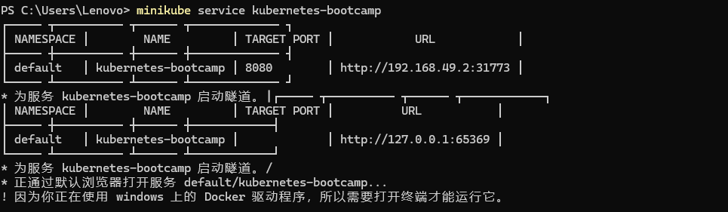
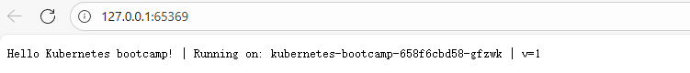
Scale Down
1. To scale down the Deployment to 2 replicas, run again the scale subcommand:
2. List the Deployments to check if the change was applied with the get deployments subcommand:
3. The number of replicas decreased to 2. List the number of Pods, with get pods:
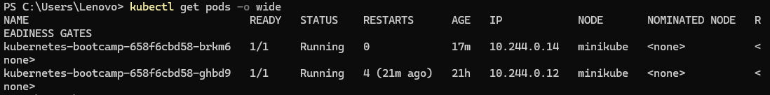
https://kubernetes.io/docs/tutorials/kubernetes-basics/update/update-intro/
Update the version of the app
1. To list your Deployments, run the get deployments subcommand:
2. To list the running Pods, run the get pods subcommand:
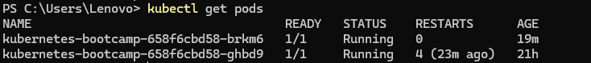
3. To view the current image version of the app, run the describe pods subcommand and look for the Image field:
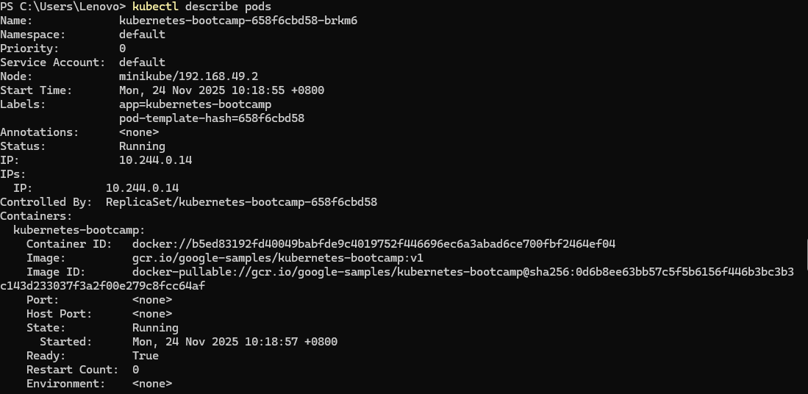
4. To update the image of the application to version 2, use the set image subcommand, followed by the deployment name and the new image version:
5. The command notified the Deployment to use a different image for your app and initiated a rolling update. Check the status of the new Pods, and view the old one terminating with the get pods subcommand:
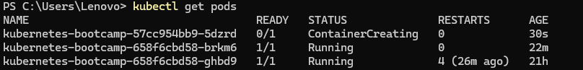
Verify an update
1. Check that the service is running,run kubectl describe service kubernetes-bootcamp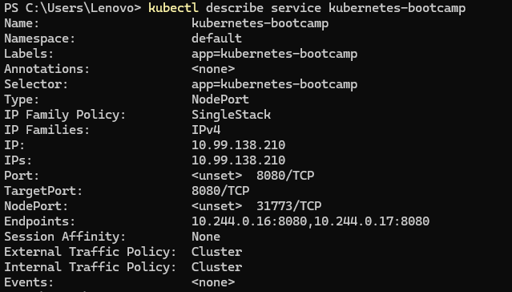
2. Create an environment variable called NODE_PORT that has the value of the Node port assigned:
3. Verify whether the applications deployed in the Kubernetes cluster can be accessed
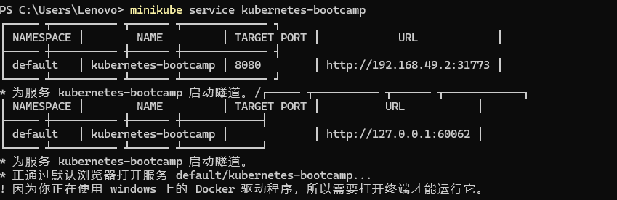
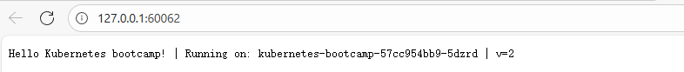
Roll back an update
1. Perform another update, and try to deploy an image tagged with v10:
2. Use get deployments to see the status of the deployment:
3. Notice that the output doesn't list the desired number of available Pods. Run the get pods subcommand to list all Pods:
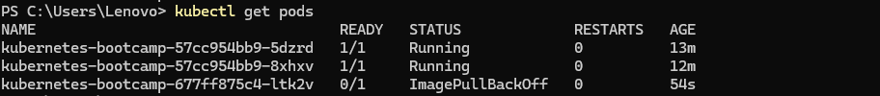
4. Notice that some of the Pods have a status of ImagePullBackOff.
To get more insight into the problem, run the describe pods subcommand:
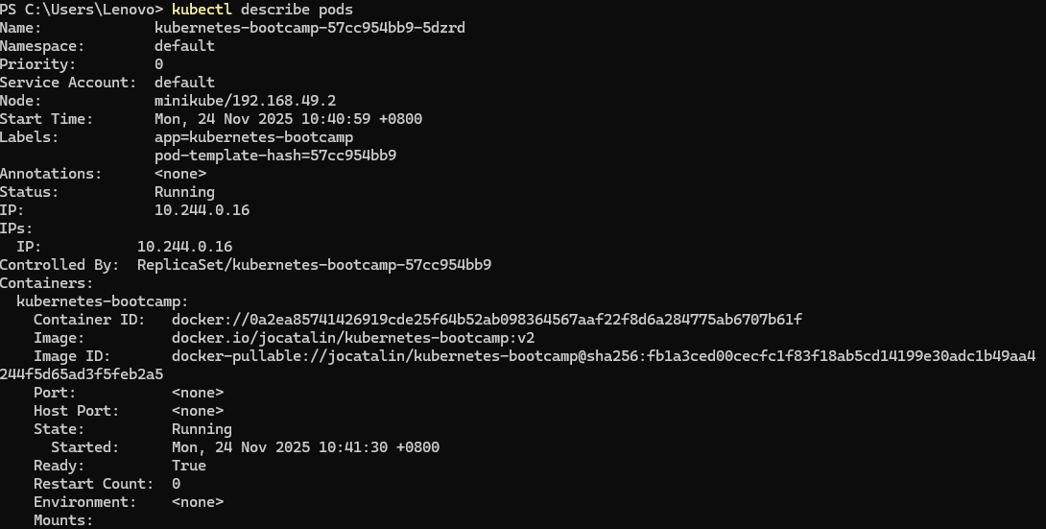
5. To roll back the deployment to your last working version, use the rollout undo subcommand:
6. Use the get pods subcommand to list the Pods again:
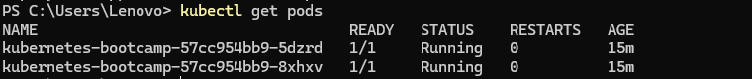
7. To check the image deployed on the running Pods, use the describe pods subcommand:
