1.Kserve environment deployment
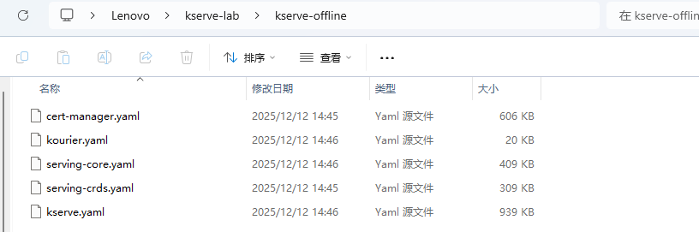
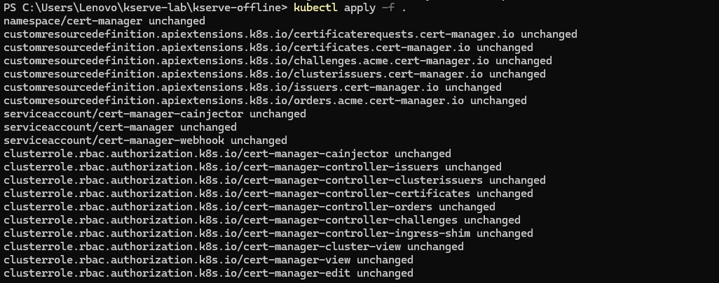
2. Check the status of the KServe controller
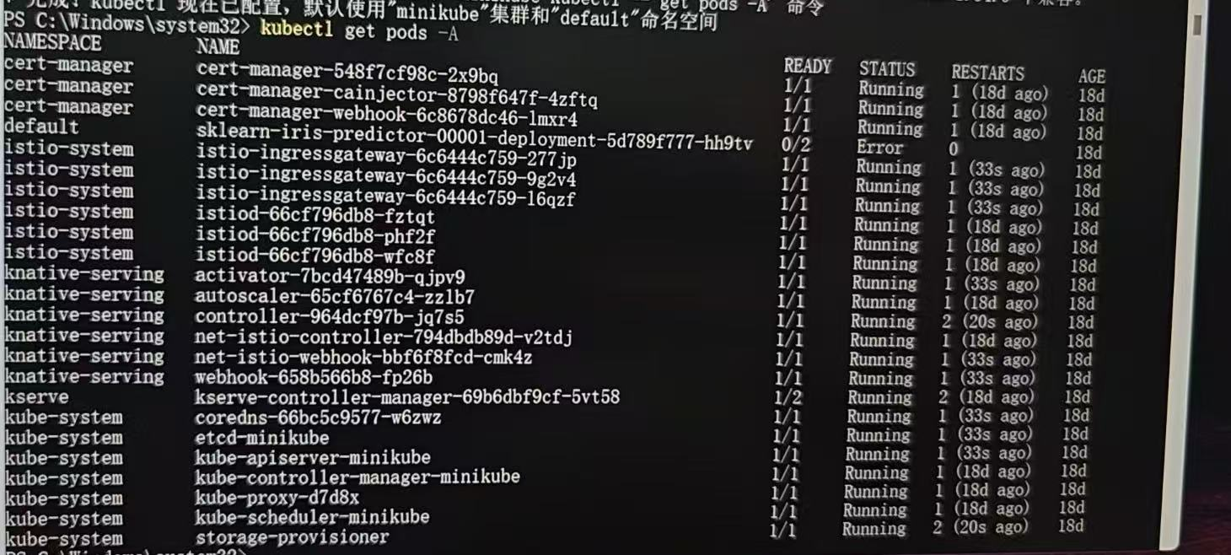
3. Deploy a predictive model
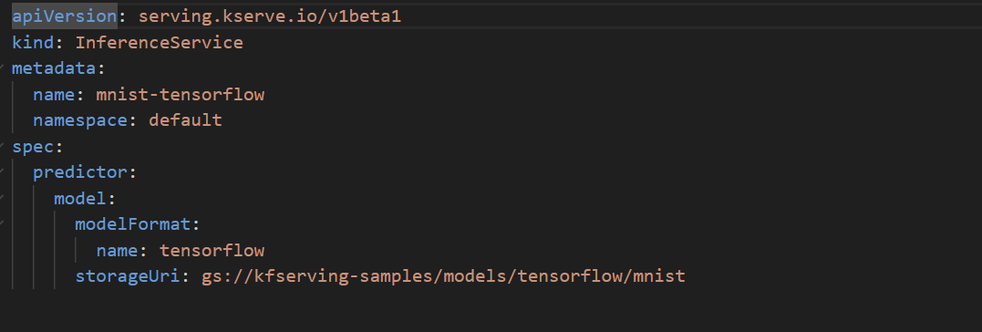
4. Monitor the service status
5. Access InferenceService from outside the cluster, port forwarding
6. Send inference requests and explain the results
