Download Istio
1.Download and extract istio
Install Istio
1. Install Istio using the command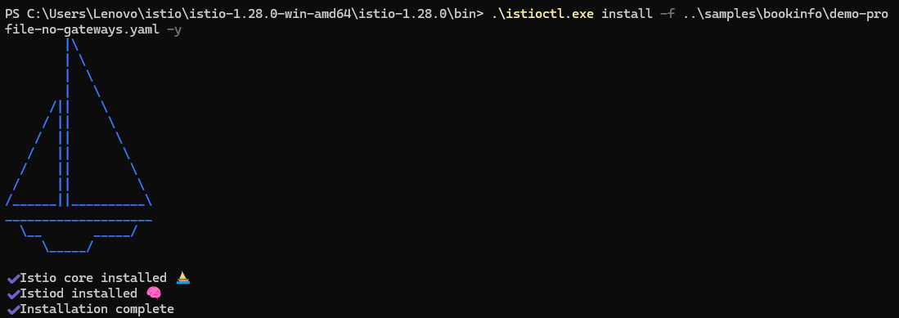
2. Tag the default namespace:
Install the Kubernetes Gateway API CRDs
1. Install the Gateway API CRDs, if they are not already present:
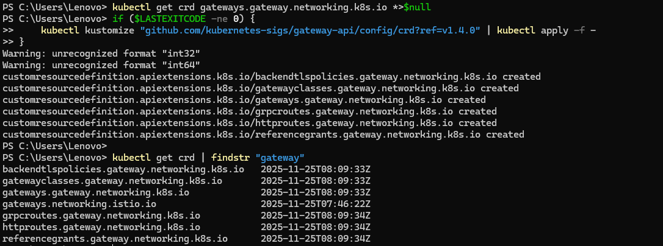
Deploy the sample application
1.Deploy the Bookinfo sample application
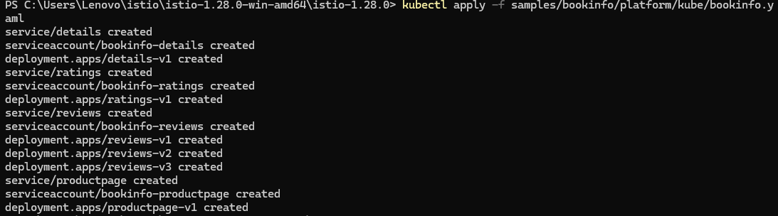
2. Check the service status
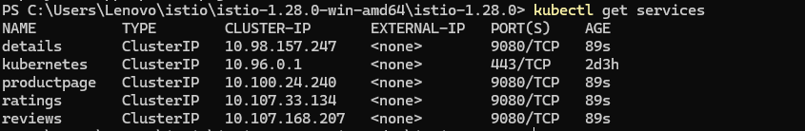
3. Check the status of the Pod
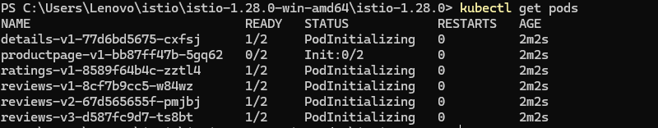
4. Verify that the application is running
Open the application to outside traffic
1. Create a Kubernetes Gateway
2. Change the Gateway service type to ClusterIP
3. Check the status of Gateway
4. Check the status of HTTPRoute
5. Verify the Gateway service
Access the application
1: Port forwarding Gateway
2: Access the application in your browser
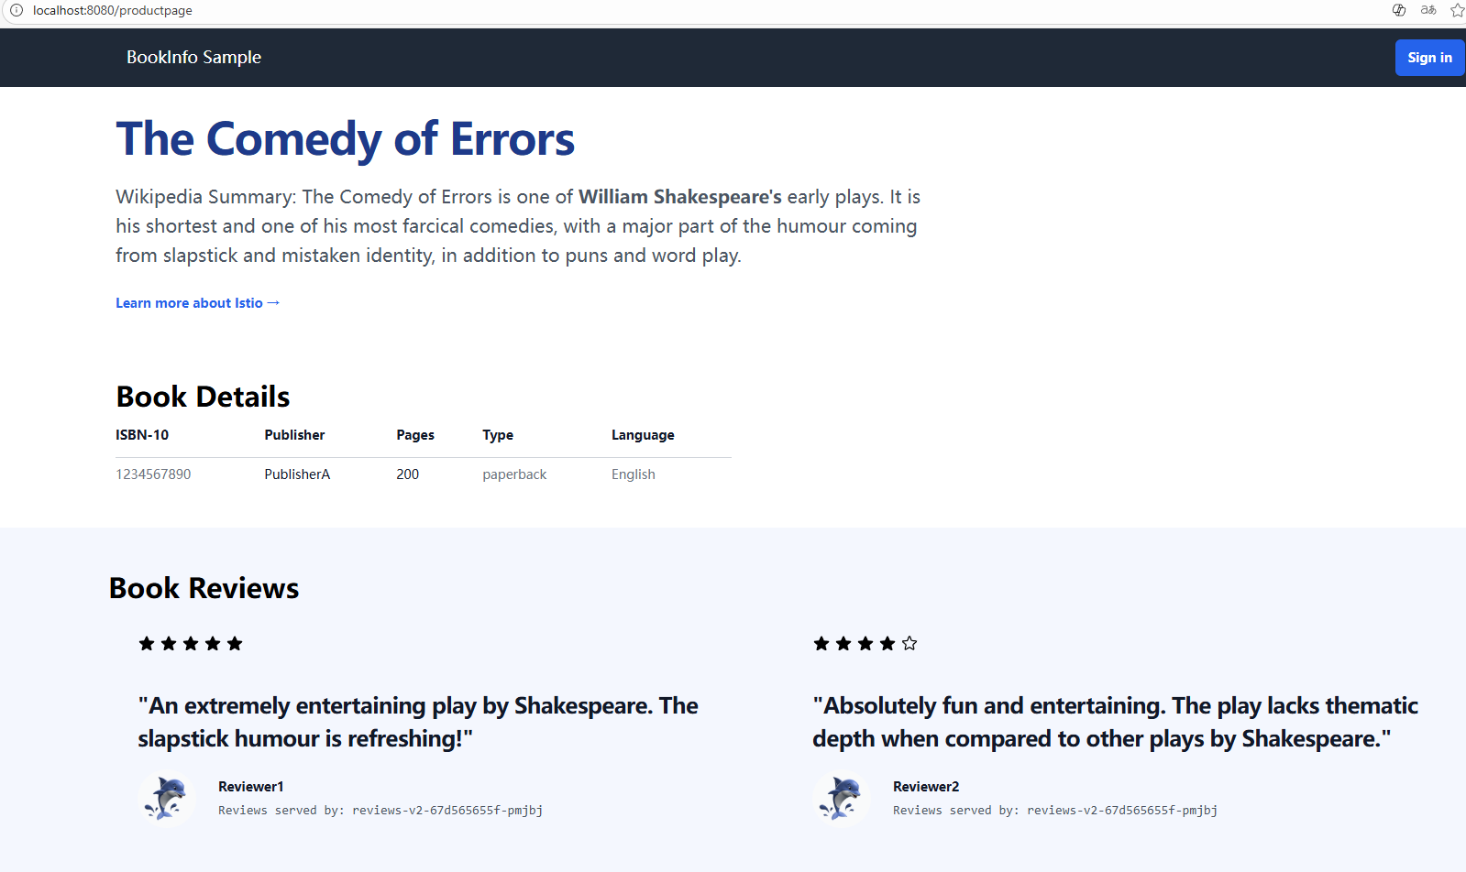
View the dashboard
1.Deploy Kiali and other monitoring components
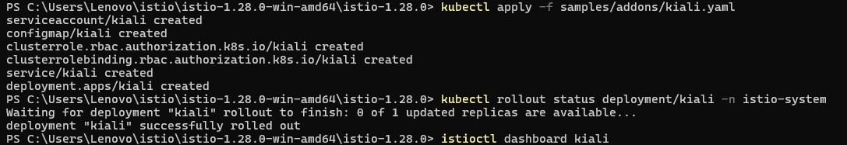
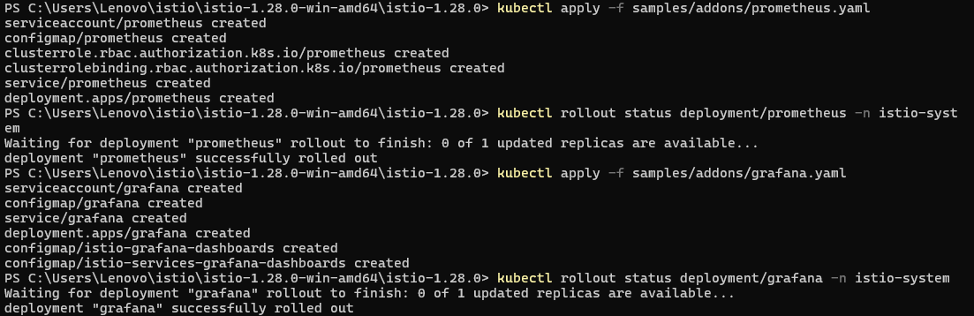
2. Open the Kiali Dashboard
3. Generate Trace data
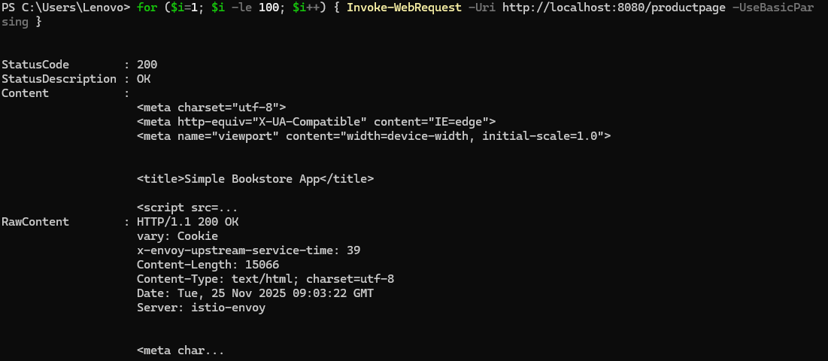
4. View the service topology