https://istio.io/latest/docs/tasks/traffic-management/traffic-shifting/
1: Ensure that Subset has been defined
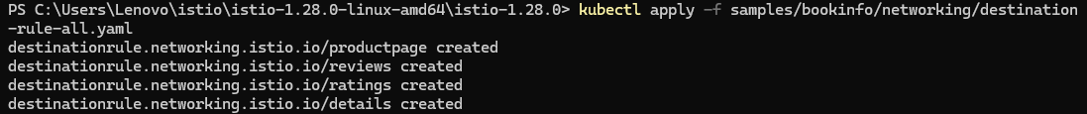
2: Route all traffic to reviews:v1
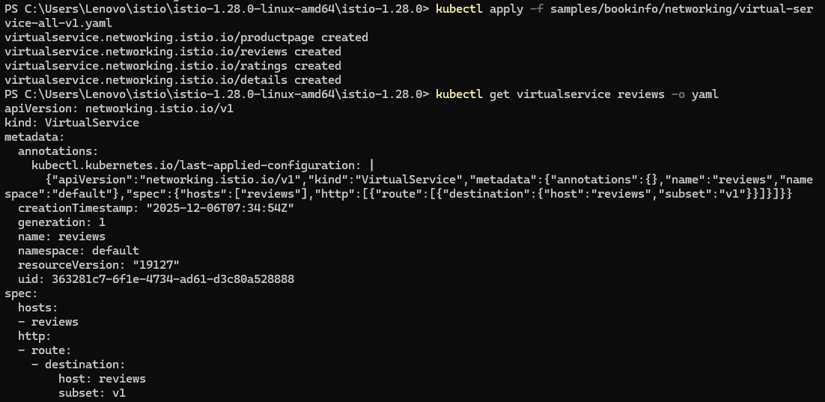
3. Visit

4. 50% of the traffic is directed to reviews:v3

or

5. 100% traffic directed to reviews:v3
always

https://istio.io/latest/docs/tasks/traffic-management/request-routing/
1. Configure all traffic to point to v1 (initial state)
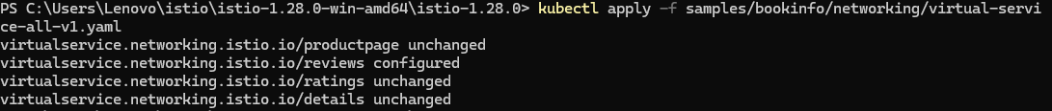
2. Configure routing based on user identity (Jason user access v2)
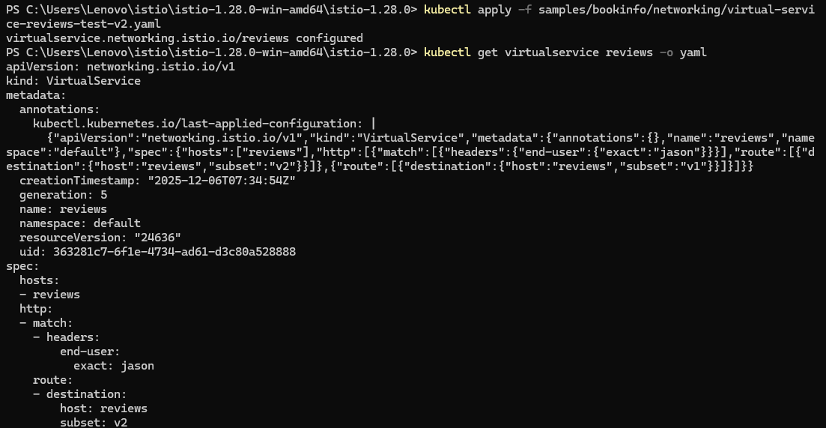
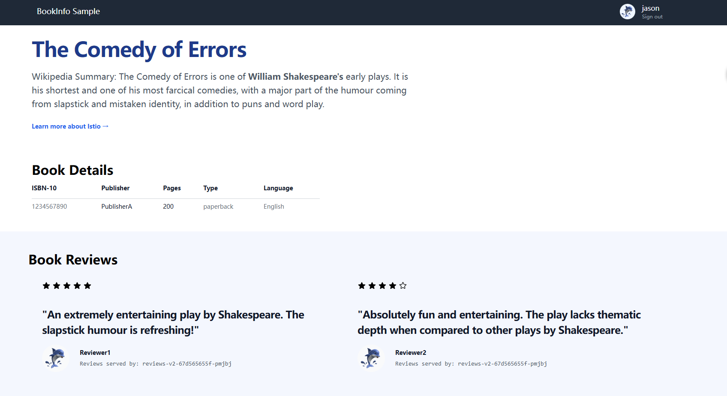
https://istio.io/latest/docs/tasks/traffic-management/fault-injection/
Injection Delay Fault
1.Apply the delayed fault rule and confirm that the rule is in effect 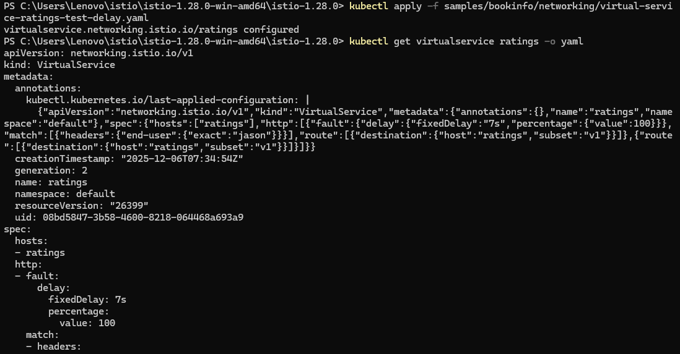
2. Visit
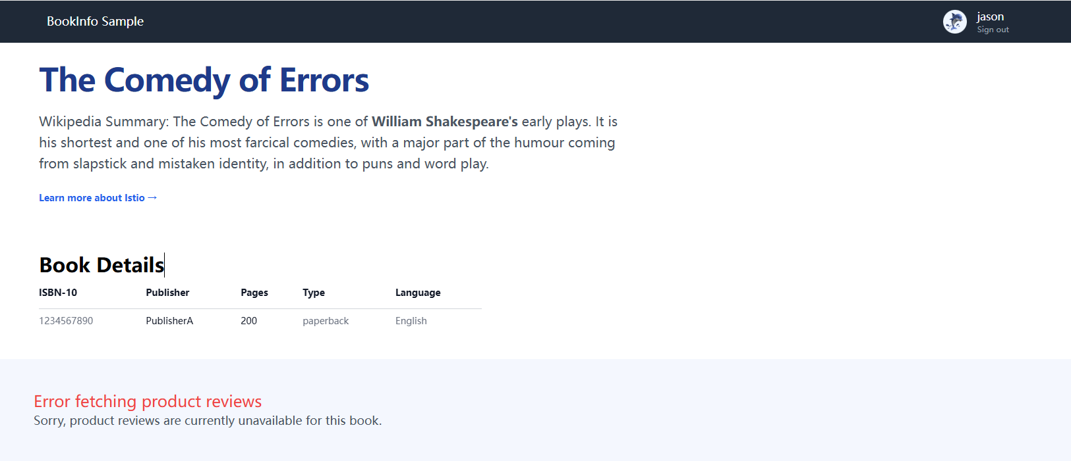
Injection Abort fault (immediately returns 500)
1: Apply the abort rule to confirm that the rule has taken effect
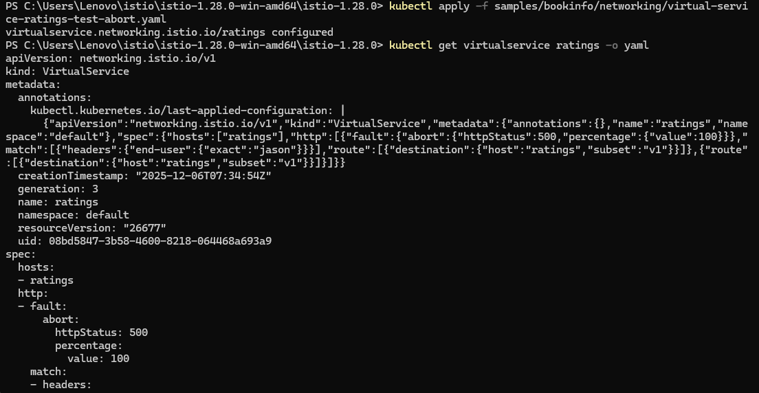
2. Visit
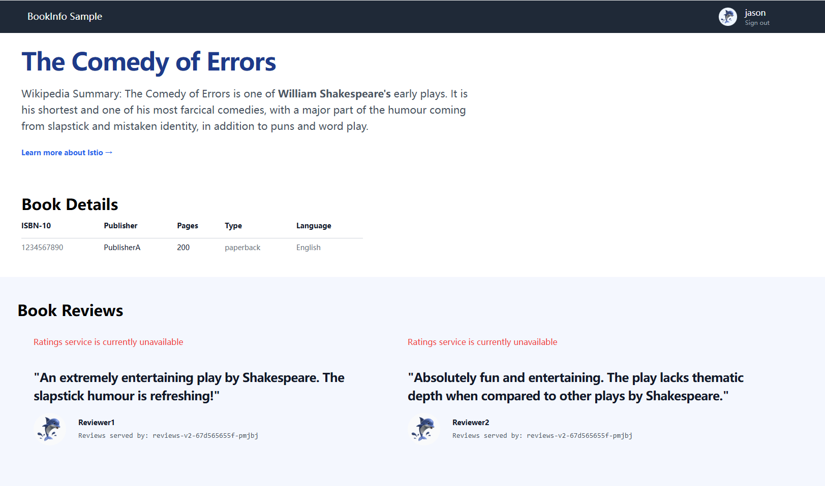
https://istio.io/latest/docs/tasks/traffic-management/circuit-breaking/
1.Deploy httpbin (server side)
2. Apply the circuit breaker strategy (DestinationRule)
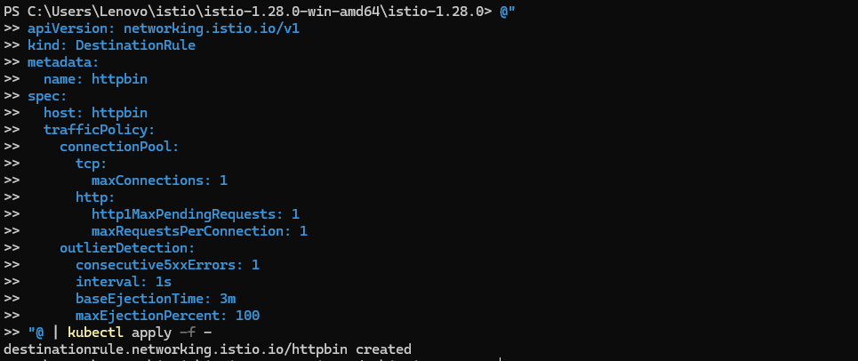
3. Deploy fortio (client)
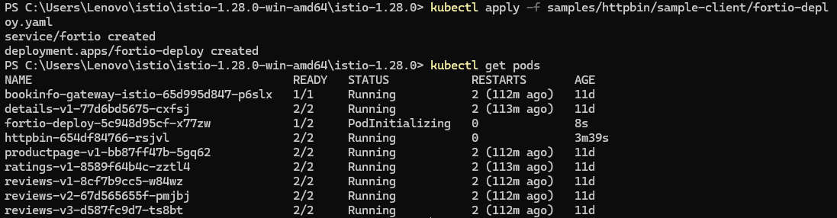
4. Test the request once (to ensure it's normal)
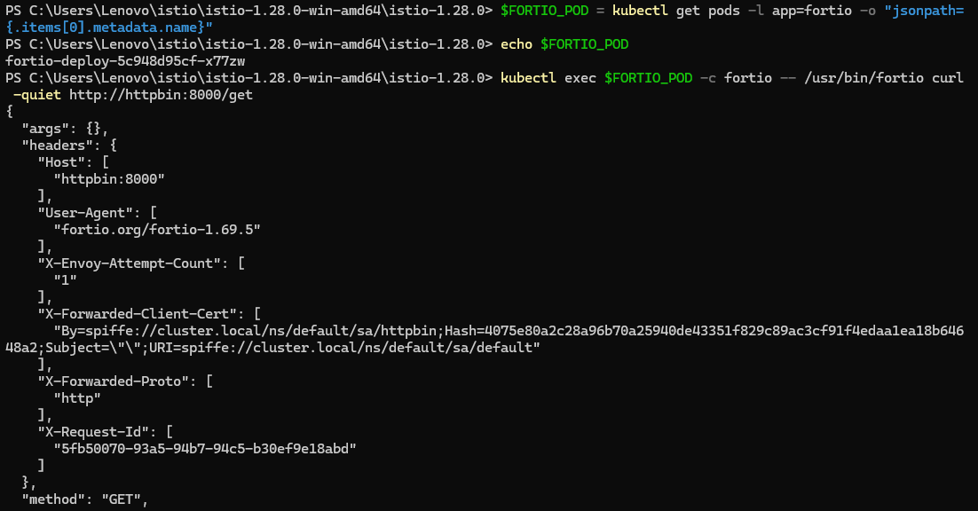
5. Two concurrent connections and 20 requests
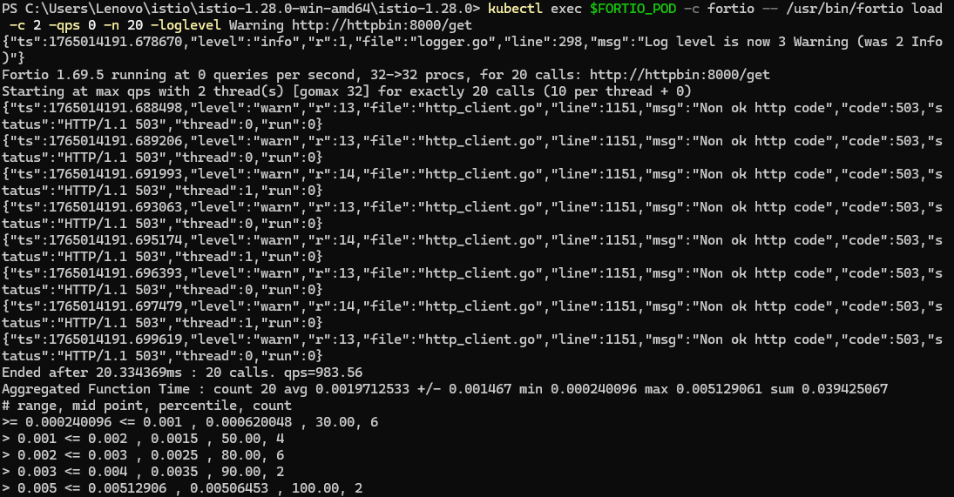
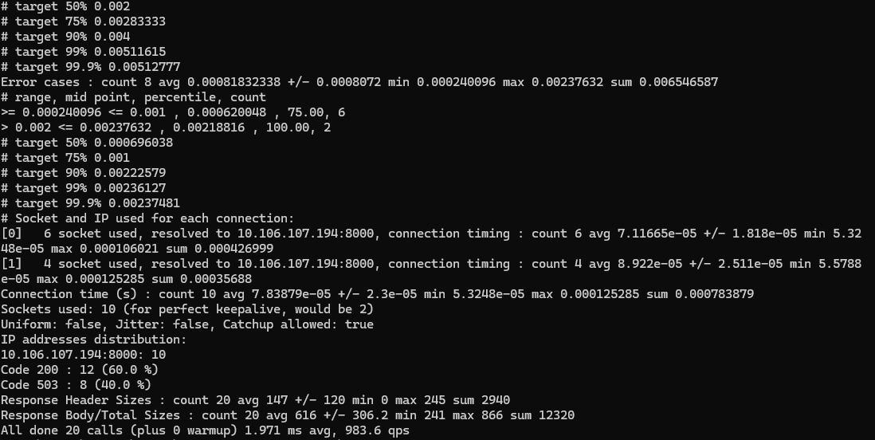
6. (Concurrent 3 connections and 30 requests)
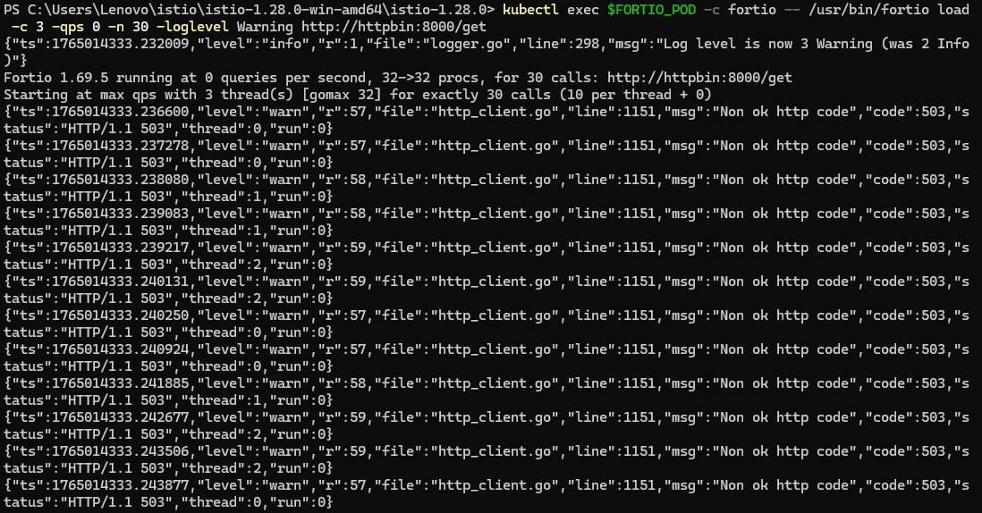
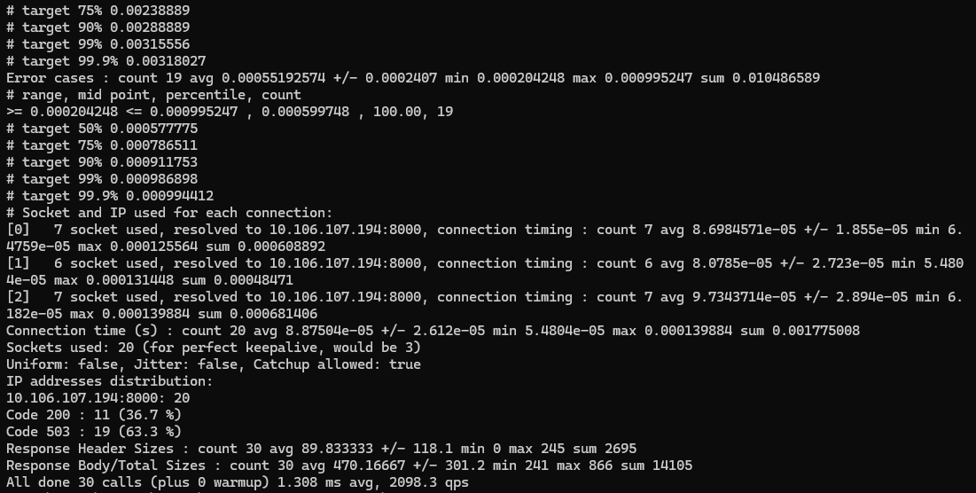
7. Check the actual number of circuit breakers
