1.Install Knative Serving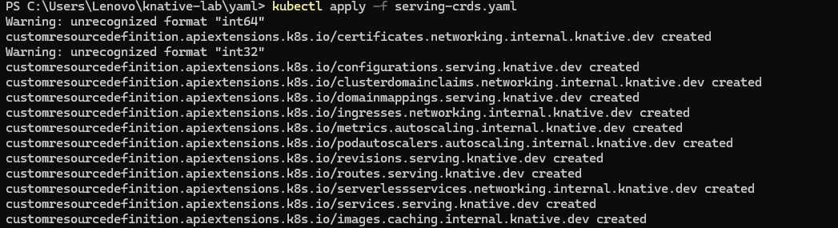
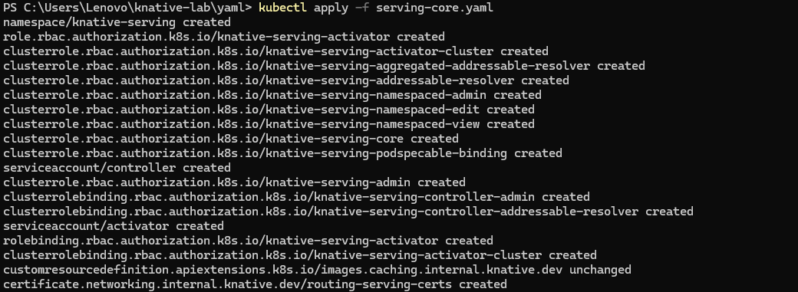
2.Configure Kourier as the default network layer
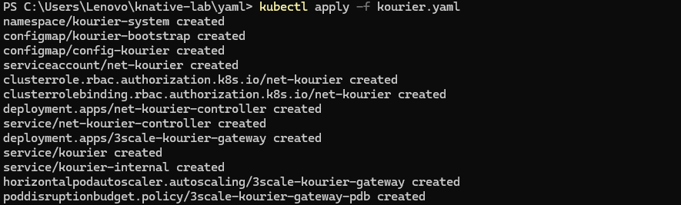
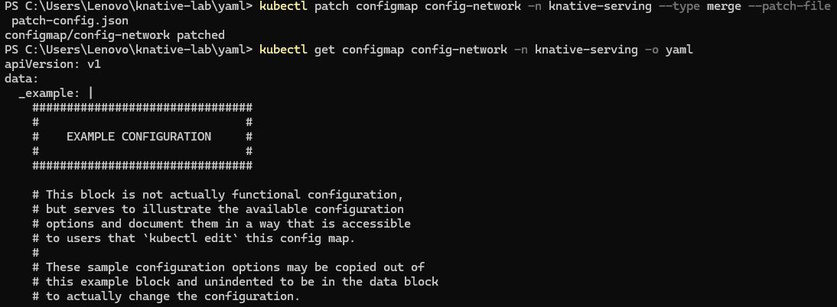
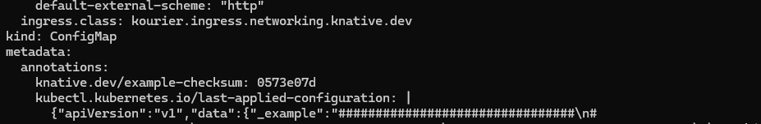
3.Install Knative Eventing
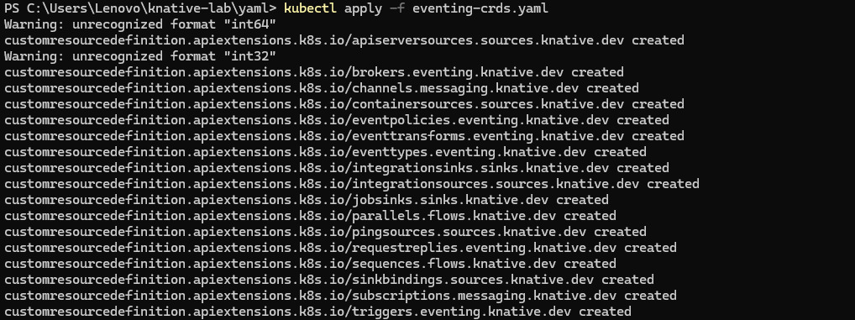
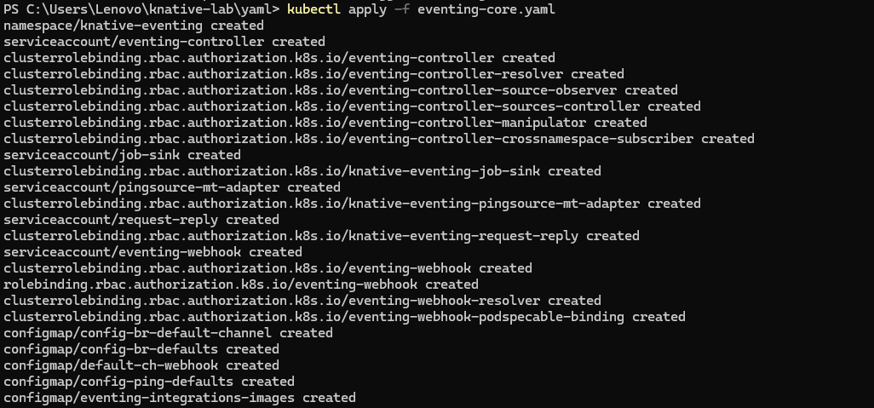
4.Install the kn CLI and func plugin
4.1 Download kn.exe and kn func.exe and add them to Path
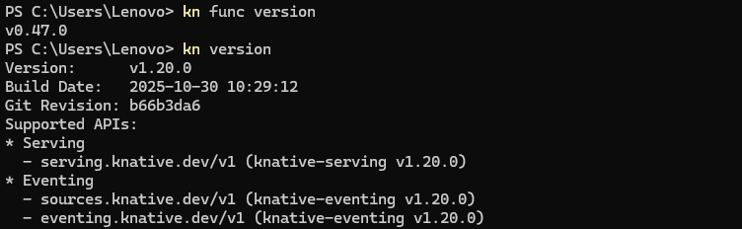
5. Create and run a function
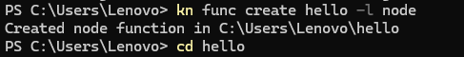
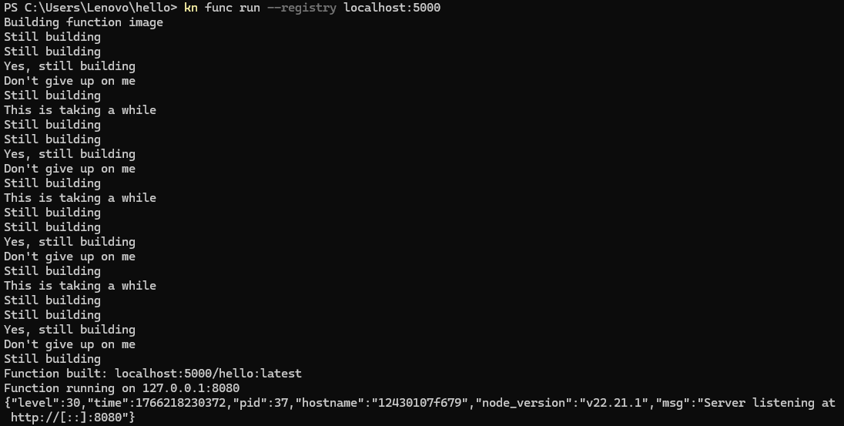
6.Deploy Knative Service
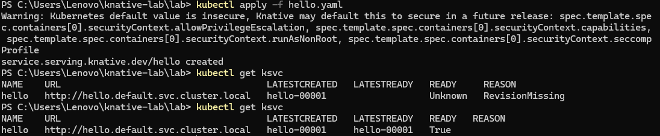
7.Direct access service (within the cluster）
8.Observe the automatic expansion and contraction behavior
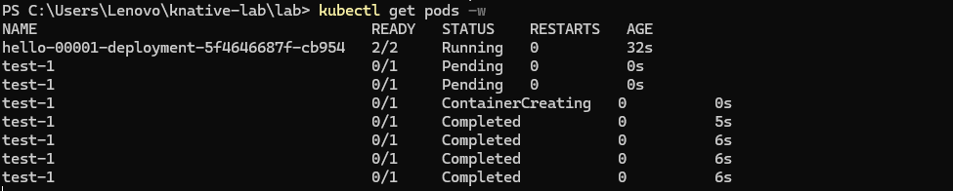
9.Traffic splitting
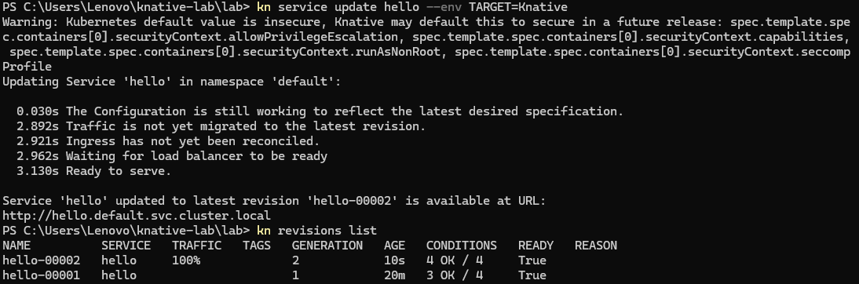
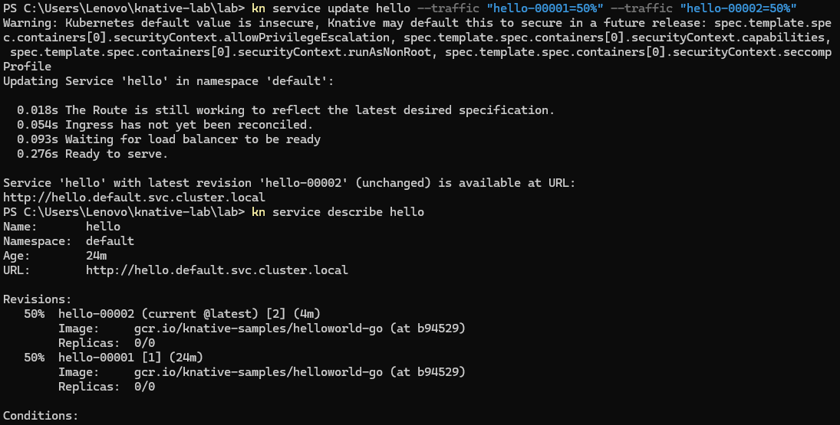
10.Knative Eventing
10.1 Deploy CloudEvents Player
10.2 Deploy CloudEvents triggers
10.3 Deploy Broker
10.4 Test event stream
