For adjacent matrix, in Kruskal algorithm, the two-dimension array needs n^2 memory usage and the parent nodes need n memory usage. Therefore, the memory usage of adjacent matrix data structure is n^2 + n.

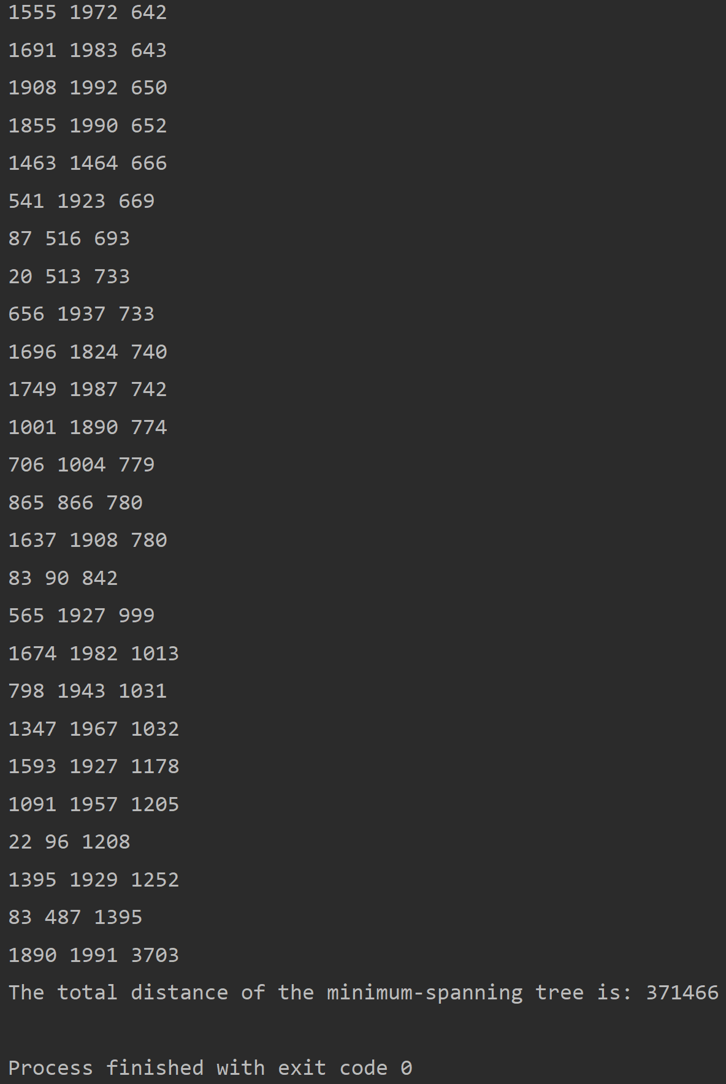

For linked-list, in Kruskal algorithm, the memory usage will be half of two-dimension array and add the parent nodes (n), which is n^2 / 2 + n / 2.

