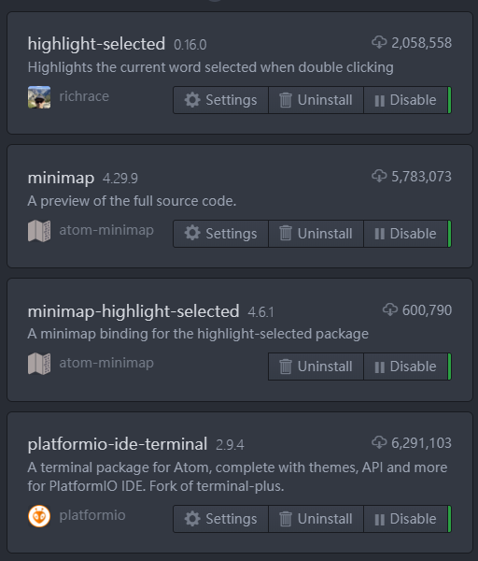

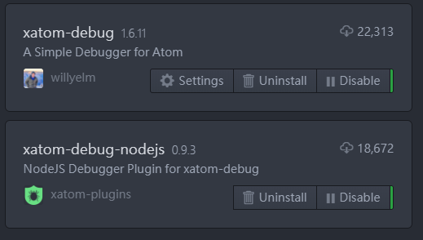

1. Highlight Selected
2. Minimap
3. [minimap-highlight-selected](https://atom.io/packages/minimap-highlight-selected)

#### [platformio-ide-terminal](https://atom.io/packages/platformio-ide-terminal)

1. Platformio Ide Terminal
2. Xatom Debug
3. Xatom Debug Nodejs