1.拉作業資料夾至D:\HW\POSD\Project\108598007_hw

2.git add 作業資料夾

3.git status查看目前暫存

4.git commit -m “HW Test”

5.git push origin master

刪除:git rm -r XXX

git commit -m “m”

git push origin master

問題1:

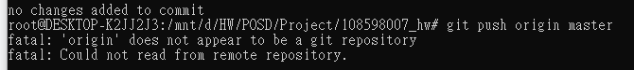

解決方案:git remote add origin /mnt/d/HW/POSD/Project/108598007_hw/.git