***MAM***

**Revision: 1.0**

|  |  |  |  |
| --- | --- | --- | --- |
| Date | Revision | Author | Description |
| 2021/07/09 | 1.0 | Vivian Wang | MAM |
|  |  |  |  |
|  |  |  |  |
|  |  |  |  |

**Eaton**

[www.eaton.com/powerquality](http://www.eaton.com/powerquality)

LEGAL NOTICE

Copyright © 2020. Eaton. All rights reserved. The contents of this document constitute valuable proprietary and confidential property of Eaton Corporation and are provided subject to specific obligations of confidentiality set forth in one or more binding legal agreements. Any use of this material is limited strictly to the uses specifically authorized in the applicable license agreement(s) pursuant to which such material has been furnished. Any use or disclosure of all or any part of this material not specifically authorized in writing by Eaton Corporation is strictly prohibited.

**Contact Eaton Support**

For your convenience, Eaton provides support to assist you with questions on installation, operation and troubleshooting. Please contact us at:

[softwareconnectivityts@eaton.com](mailto:softwareconnectivityts@eaton.com)

800-356-5737 option 2, option 5, option 1

# Contents

Contents 3

1. Overview 4

2. Design 5

# Overview

MAM is the mobile asset management tools to help audit the cables, rackmount assets and racks being managed with the application. In the audit management, the audits can be generated manually or through the project workflow.

# Audit Manager

Users can create the audit through the ‘Audit Manager’ under the racks section. The audit manager allow the users to track the audits status and view the details by clicking the audit name link.

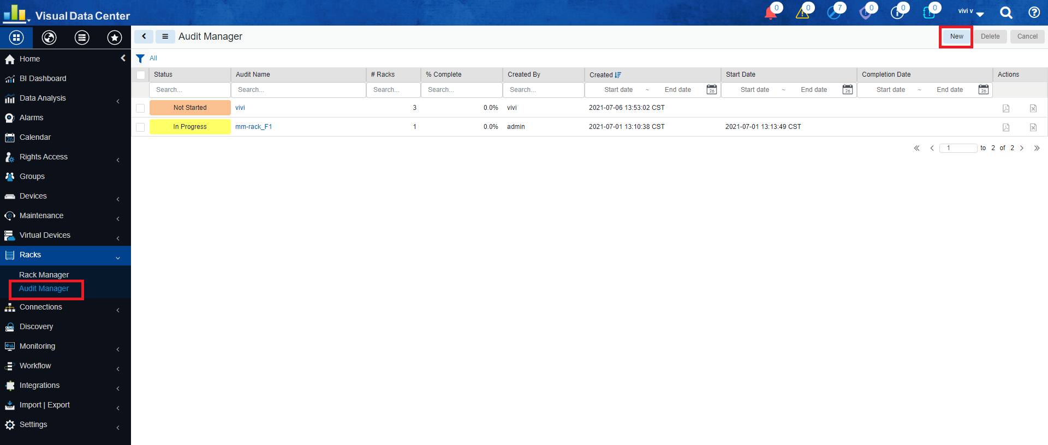

The ‘new’ button allow users to create new audits. And when users need to add racks In the Rack list through an audit. If a rack has been added to an audit, then the audit name and status will be shown in the list.

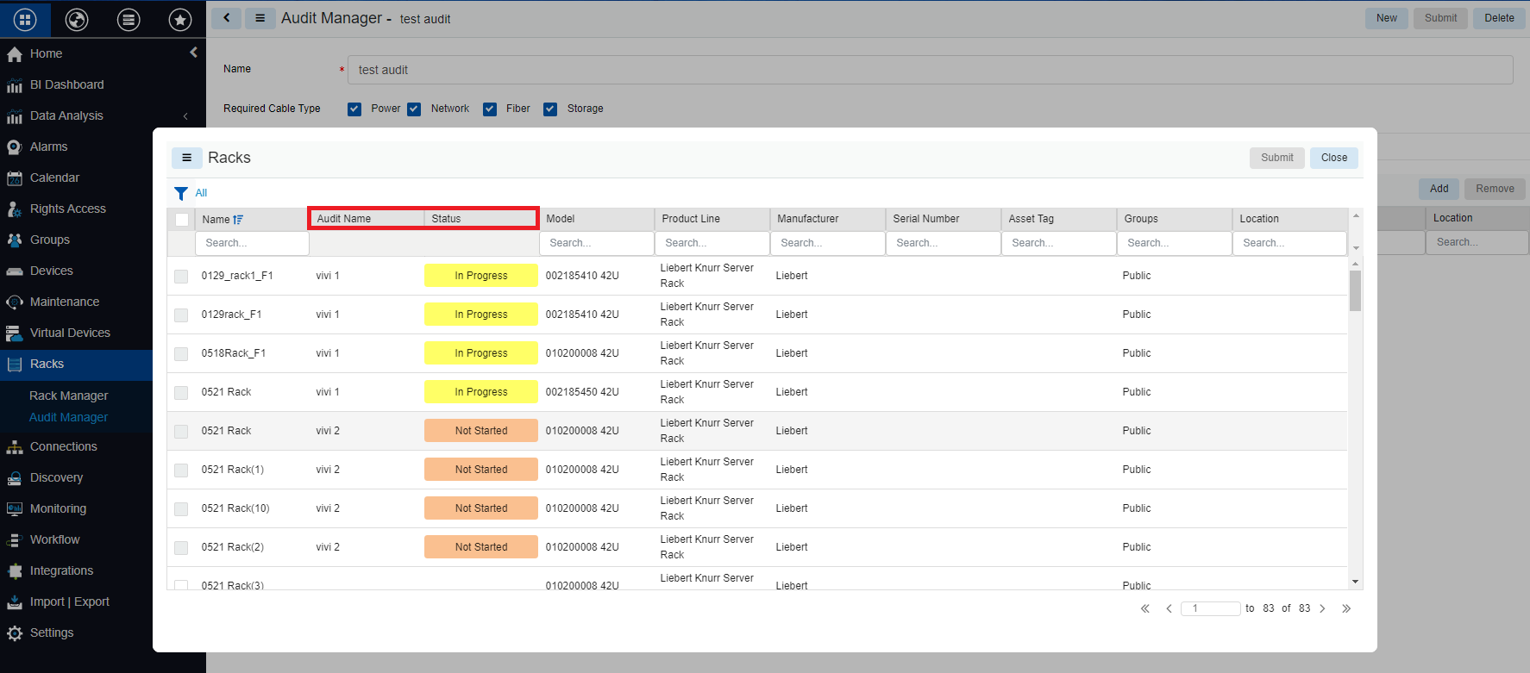

The check box will be disabled which means the racks are not able to add in to the current audit and MAM will only show the audits with the following conditions:

* The rack is already in an audit and the status of the audit is ‘Not started’
* The rack is already in an audit and the status of the audit is ‘In Progress’

The check box will be enabled with the following the conditions:

* There is no audit
* The rack used to be in an audit and the status of the audit is ‘Complete’
* The rack used to be in in an audit and the status of the audit is ‘Complete With Error’
* The rack used to be in in an audit and the status of the audit is ‘Incompleted –Error’
* The rack used to be in in an audit and the status of the audit is Canceled

1. Manual –>
2. Project–>
3. Flow chart -> cable/device/rack/audit bottom up

# Audit status

The Audit status refer to the device attribute named ‘Audit Status’. In the system there are total six possible values:

1. Not Verified

When a new audit is created manually, the device audit status of all devices will be set to ‘Not Verified’. If the audit is generated in Work Order, then keep the audit status.

1. Verified

When a user select a device / cable and clicks the Validate button in MAM, the device audit status of this device / cable will be set to Verified.

1. Verified – New

When a device / cable is created during an audit in MAM, the device audit status of this device / cable will be set to Verified - New.

1. Absent

When a user select a rack / device / cable and clicks the Absent button in MAM, the device audit status of this device / cable will be set to Absent.

1. Verified – Error

For a rack

If the device audit status of any device in this rack is set to any of the status: Verified - New / Absent / Verified - Error, the device audit status of this rack will be set to Verified – Error at end.

For an enclosure

If the device audit status of any blade devices in this enclosure is set to any of the status: Verified - New / Absent / Verified - Error, the device audit status of this enclosure will be set to Verified - Error.

For a device

If the device audit status of any cables of this device is set to Verified - New / Absent / Verified - Error, the device audit status of this device will be set to Verified - Error.

1. Unverified - Error

The device audit status is updated to the reserved device (Life Cycle: Reserved Available/Reserved Procurement/Reserved Move).

There will be a button named ‘Raise Error’ next to the Validate button in the reserved device detail panel. When the user clicks the ‘Raise Error’ button, the user needs to confirm raise error. After the user confirmed, the reserved device will have the status of Unverified - Error.

Currently reserved device will not be listed in the search list in the VDC system like the following one. This is because reserved devices are not real devices. Thus this reserved device with Unverified - Error only exists in the device list in MAM

# Device Audit Status

The device audit status could be:

1. Not Started

When an audit is newly created, the status of this audit is Not Started.

1. In Progress

If the device audit status of any racks / devices / cables in this audit is already start to verify, the status of this audit is In Progress.

1. Complete

Per the manually created audit, if the device audit status of all racks in this audit are set to Verified, the status of this audit is Complete.

Per the generated audit in WO, if the device audit status of all devices/cables related to the Work Order are set to Verified, the status of this audit is Complete.

1. Complete with Error

For both manually created audit and generated audit in WO, if the device audit status of any rack/device/cable is set to Verified - New / Absent / Verified - Error, the status of this audit is Complete with Error.

1. Incomplete - Error

When all racks are Verified/Verified - Error/Unverified - Error, the audit status will be updated. Conditions are listed in the order from high priority to low priority. Processing is in this order and it stops after the condition is met.

* If there is a rack with status Unverified - Error, the audit will get status Incomplete - Error.
* If there is a rack with status Verified - Error, the audit will get status Completed - Error.
* If all racks are with status Verified, the audit will get status Completed.

Incomplete - Error is an end state. Audits with status Incomplete - Error will not be listed in the audit list in MAM.

1. Canceled

Only a manual audit status is ‘In Progress’ and has been canceled then the audit will be changed to ‘Canceled’.

# Attribute definition

1. Racks

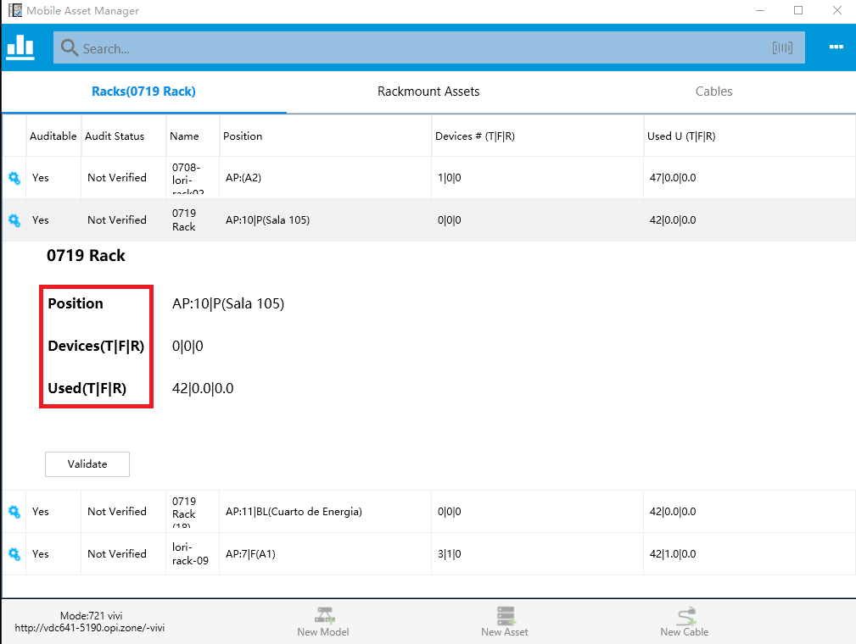

Position: Format as AP:Row|Column (Area)

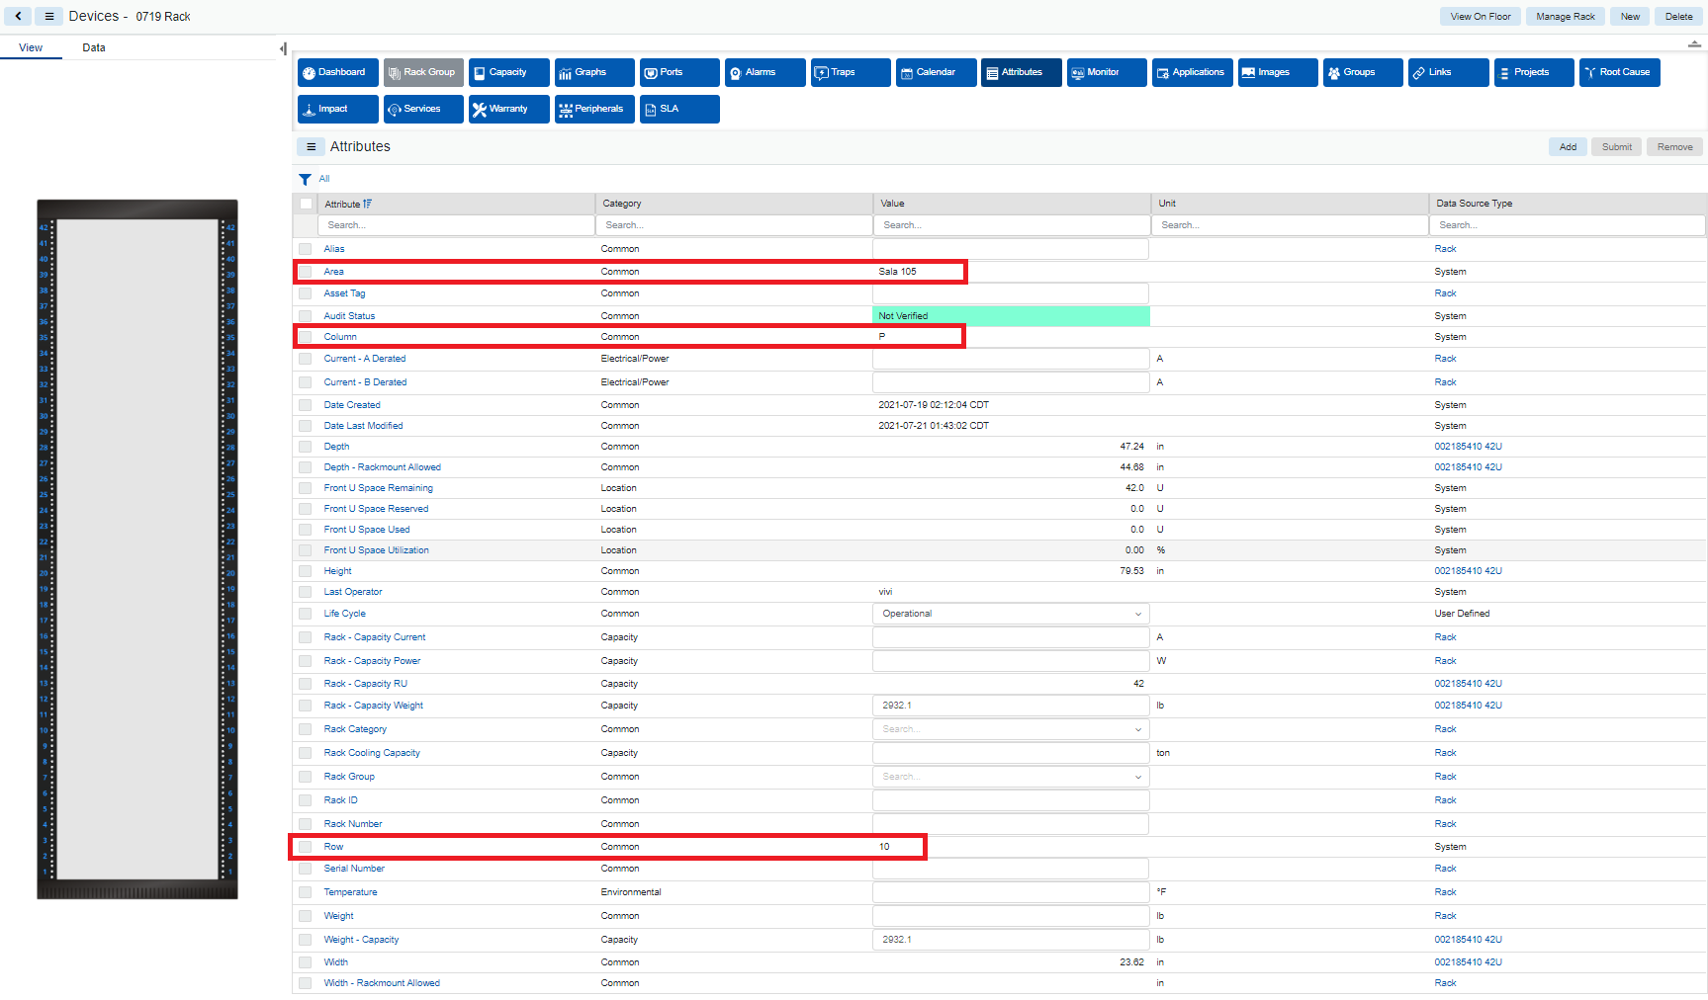

Devices (T| F|R): Total count of devices | Total count of devices in front | Total count of devices in Rear

Used (T| F|R): Total used RU | Total used RU in front | Total used RU in Rear

1. Rackmount Assets
2. Cables

# Verify Devices

There are cable types and rackmount devices required to be verified or not based on the option defined when a new audit is created before this device is verified:

* In order to verify a rackmount device, it must verify all the cables in that device.
* In order to verify a rack, it must verify all the rackmount device in that rack.

1. Audit Cables:

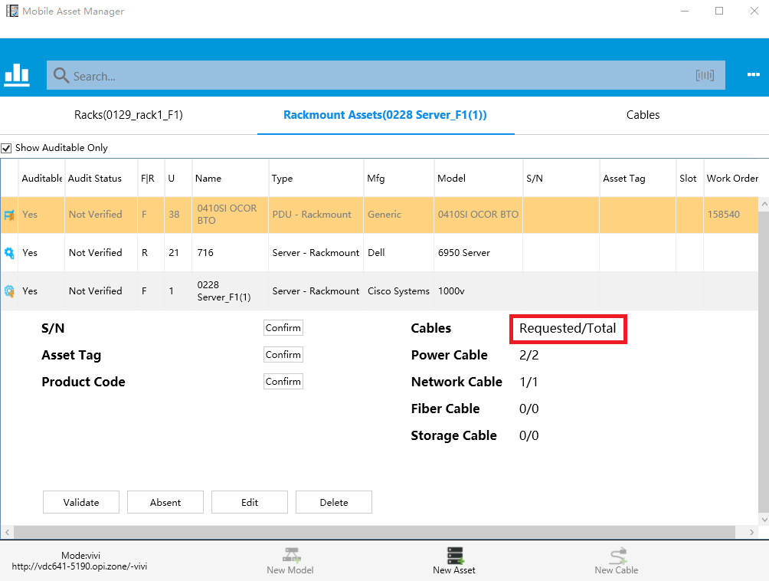

Requested: it represented how many cable requested to be verify.

Total: it represented the total count of the cables.

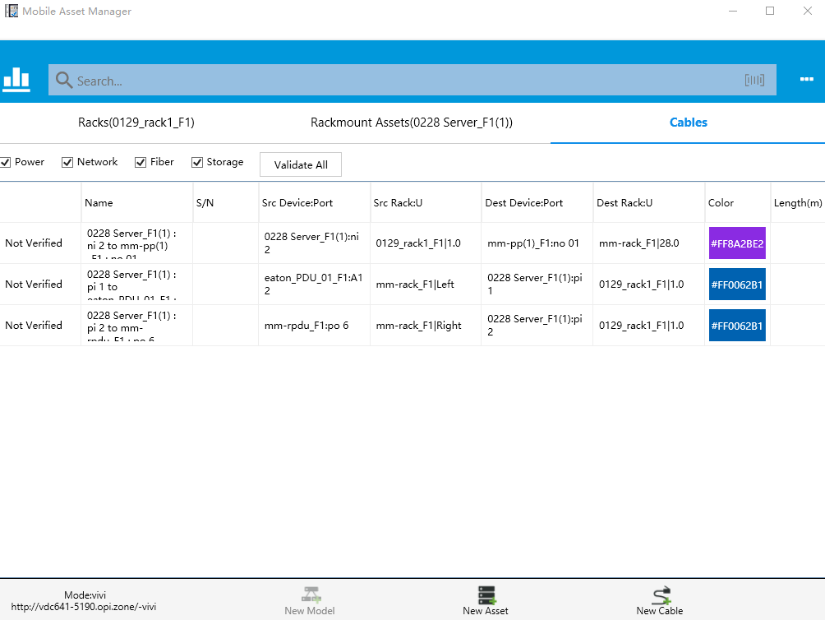

There are 4 checkbox on the top, users can choose which types of cable to display through select the checkbox.

1. Devices audit status: