## 1/ Used U

A quoi correspond la valeur Used U (F) 66.0 pour le rack V3-G-12 ?

What is the Used U (F) 66.0 value for the V3-G-12 rack? (it is greater than the total number of U)

|  |  |
| --- | --- |
| User | Comments |
| Josh | This data 66.0 is incorrect.  We may need to check these data. |
| BNPP | OK |

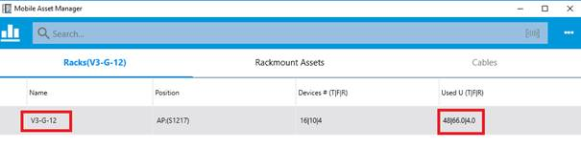

## 2/ Search

Lorsque l’on fait une recherche à partir du bouton Search il y a un bug : le résultat est affiché sous forme de polices barrées :

When you search from the Search button there is a bug: the result is displayed as crossed-out.

|  |  |
| --- | --- |
| User | Comments |
| GB | I though you were removing the results that don’t match |
| Josh | These items which is displayed as crossed-out means they don't belong to the current audit. |
| GB | it is not clear why you would cross out the negative results, please don’t display them . |
| Josh | Per the crossed-out assets, would it be better if we show them in a different way?  Such as light gray font color and un-selectable status, may be with a small tip says that these assets are not included in the current audit.  If one asset which match the search criteria but not listed in the result, it may be a little not clear. |
| GB | please don’t show to negative results – you can give a count, but it is very confusing to show information that is not relevant (I am not aware of any search that shows you items that don’t match). |
| Josh | So we will just don't display them. |
| GB | correct, do not display them |
| Josh | OK |

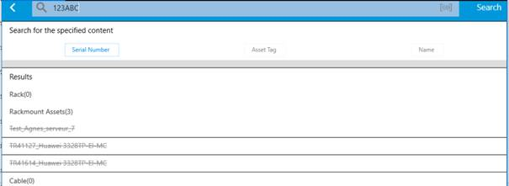

## 3/ Droits utilisateurs

3. User rights

N'importe quel utilisateur de n'importe quel groupe peut valider n'importe quel WO.

Cela n’est pas cohérent par rapport à la logique des droits dans VDC qui sont plus restrictifs.

Any user in any group can validate any WO.

This is not consistent with the logic of the more restrictive rights in VDC.

|  |  |
| --- | --- |
| User | Comments |
| Josh | Currently the audits listed in MAM that the current user can select are filtered by the current user.  The current user can select audits that generated by the work order and assignee is the current user. we may need more detailed information |
| BNPP | it doesn’t work as expected. You can connect as one user or group and display all the audits (even those for other users or groups). This is inconsistent with normal VDC security and should follow the standard WO security. |
| Josh | Per the item 3 user rights,  I am sorry about the incorrect comments. Audits in MAM are filtered by rack privileges. The rule to list a audit or not depends on that if the current user has right access to any rack of this audit.  There may be a few racks included in an audit.  If the current user has no right access to any rack, then this audit will not be listed.  If the current user has right access to more than one rack, then this audit will be listed.  We will check it on our site. |
| GB | BNPP are saying that there are no restrictions imposed, there seems to be a problem / disconnect. I will ask for screen shots, can you also send me some screen shots of how it is meant to work. |
| Josh | For Example  There are two users in two user group  User A - Group A  User B - Group B    There is one audit  Audit A    There are two racks included in Audit A  Rack A  Rack B    Group A contains the right access to View/Edit the Rack A.  Group A has no right access to Rack B.  Group B has no right access to Both Rack A and Rack B.    When User A login MAM,  the Audit A will be listed.  When User A select Audit A,  only Rack A will be listed.    When User B login MAM, the Audit A will NOT be listed.  User B cannot select Audit A. |
| GB | We don’t understand what it means by Rack Authorisation (do you mean rack-group). In any case,  the authorisation to be at a device level, not the rack level. A user needs to be authorised to “complete WO” for a device, this is not related to the rack authorisation. |
| Josh | An audit consists of racks.  So it's based on the Rack Authorisation in MAM all the time.  The main concept is still Device Group.  In VDC, if a user belongs to a user group which has right access to a device, then the user have right access to the device.  If the user group does not have right access to a device, then the user does not have right access to the device.  I have created a document Rack Authorisation with a few screenshot for this item and attached to this email.  I have also attached two emails related to the filter audit function.  [Re MAM Feedback from BNPP.msg](Re%20MAM%20Feedback%20from%20BNPP.msg)  [FW MAM Feedback from BNPP.msg](FW%20MAM%20Feedback%20from%20BNPP.msg)  [Rack Authorisation.docx](Rack%20Authorisation.docx) |
| GB | thanks, I will pass this onto BNPP for their comments |
| GB | Here is further information from BNPP regarding the user authorisations.  The guiding principle, is that if a user can’t “complete” a WO in VDC, then they shouldn’t be able to “validate” a device in MAM.  [3- A user not authorized has right access to validate a work order.docx](3-%20A%20user%20not%20authorized%20has%20right%20access%20to%20validate%20a%20work%20order.docx) |
|  |  |

## 4/ Arrivée non sollicitée sur l’onglet Cables

4. Unsolicited arrival on the Cables tab

Quand on double-clique sur des champs de l’onglet Rackmount Asset on est redirigé vers l’onglet Cables.

When you double-click on fields on the Rackmount Asset tab you are redirected to the Cables tab.

|  |  |
| --- | --- |
| User | Comments |
| GB | I think this is a user problem – only a single click |
| Josh | Yes, the page may switch to Cables tab by a single click when the current row is selected.  We will work on it.  Is it OK that we disable the double click action for now?  The users can switch between these tabs by clicking the tab label. |
| BNPP | yes – disable the double click. |
|  |  |

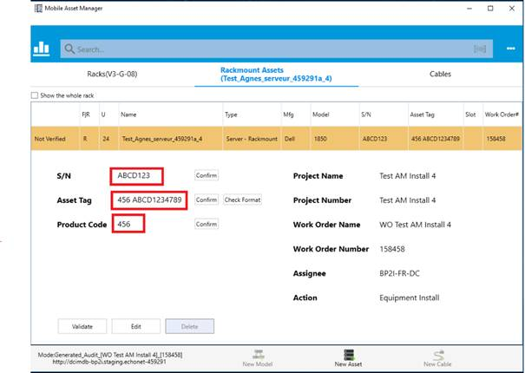

## 5/ Ajout d’un message de confirmation après avoir cliqué sur Validate

5. Add a confirmation message when you click validate..

Est-il possible d’ajouter un message de confirmation lorsque l’on a fait Validate ?

Is it possible to add a confirmation message when Validate has been done?

|  |  |
| --- | --- |
| User | Comments |
| Josh | Do you mean a confirmation message popup when the user clicks the Validate button?  And the message is like    Do you want to validate this device(cable)?                                  Proceed    Cancel |
| BNPP | yes – this is what is required. |
|  |  |
|  |  |

## 6/ Scan étiquettes S/N et Asset Tag

6. Scan Barcode tags S/N & Asset Tag

La comparaison sur le SN se fait bien comme vu au préalable (comparaison avec SN déjà présent dans la base).

Pour ce qui est de l’Asset Tag, dont la valeur est à scanner pas à saisir : il contient la valeur brute du code barre. Le résultat du scan est une chaîne de caractère sans blanc séparateur.

Si une valeur existe au préalable il faut la comparer avec celle qui vient d’être scannée sinon (c’est une nouvelle valeur) l’écrire.

Etant donné qu’il n’y a plus de blanc dans ce champ le bouton Check Format ne sert plus.

The comparison on the SN is done well as seen beforehand (comparison with SN already present in the database).

As for the Asset Tag, whose value is to be scanned not to be entered: it contains the gross value of the barcode. The result of the scan is a character string without a blank separator.

If a value exists beforehand, it must be compared with the one that has just been scanned, otherwise (it is a new value) write it down.

Since there is no more white in this field, the Check Format button is no longer used.

|  |  |
| --- | --- |
| User | Comments |
| GB | actually BNPP have found many different Asset Tag formats, so this validation needs to be removed (unfortunately). |
| Josh | We may need to make the validation flexible and able to be configured.  We may need more detailed information. |
| BNPP | at this time there are too many different formats to make the validation flexible. Therefore, it is only necessary to validate that the Asset Tag scanned is the same as is in the DB field, if not, then replace this with the one scanned (as per the other tags scanned). Additionally, the “Check Format” needs to be removed. |
|  |  |

## 7/ Validation d’un Audit de move

7. Validation of an Audit for Move

Le point que j’ai signalé le 25/02/2019 avec fiche de case est toujours d’actualité :

When validate a Server which Moves, Equipement Uninstall in WO stays at Pending status.

The point I mentioned on 25/02/2019 with ticket is still valid:

When validate a Server which Moves, Equipment Uninstall in WO stays at Pending status.

|  |  |
| --- | --- |
| User | Comments |
| GB | I don’t think this is related to MAM. |
| Josh | We will work on it. |
| BNPP | this is critical for correction in 5.6, original email attached |
| Josh | We would like to know if the user don't need to validate any uninstall actions in MAM.  For example the user just need to Validate device Equipment Install/Provisioning Power/Provisioning Network/Provisioning Storage in MAM.  Once Equipment Install is validated (There is a request that the device can only be validated after all cables are validated) by clicking the Validate button of the device, the rest Equipment Uninstall/Uninstall Power/Uninstall Network/Uninstall Storage will be marked as completed automatically in the work order. |
| GB | I don’t like any automatic validation, for an uninstall, perhaps the server has been removed, by has the cable been removed from both ends for example. You can’t make these assumptions. |
| Josh | So when moving a server, both the old rack and the new rack should be listed in the audit.  For example a Server A will be moved from Rack A to Rack B.  Then Rack A and Rack B will be listed in the audit at the same time.  When the user select Rack A, the user will see the server marked with Equipment Uninstall action.  When the user select Rack B, the user will see the server marked with Equipment Install action.  When the user click the Validate button of the server in Rack A, then the status of the Equipment Uninstall will be marked as completed.  When the user click the Validate button of the server in Rack B, then the status of the Equipment Install will be marked as completed.    Will the user need to Validate the Equipment Uninstall first, then the user will be able to Validate the Equipment Install? |
| GB | there is a mix of these processes,   1. the move could be to different data center or different rooms and the install doesn’t follow immediately or with the same person. Therefore what you propose below is perfect. 2. However, if the installation is completed, then the uninstall must logically also be completed. Therefore you can complete the uninstall if the install have been completed (separating the device and cables). 3. The equipment install and the cable install needs to be separated, only when both are completed can the WO be completed. 4. The uninstall doesn’t necessarily need to be completed before the install (see 2) |
| Josh | So we list the old rack in this audit.  And also automatically complete the equipment uninstall when the install has been completed. |
| GB | correct, thanks. |
| Philippe | I understand the perf issue with displaying the old rack. I think we can wait for a future version to show it.  However, as the “Uninstall Equipment” is involved by the “Equipment install”, the “Uninstall power” must be involve by “Power install”. In this situation, I can’t ask technician to do the “equipment” part of the job in MAM and the “Cable” part of the job in VDC.  I agree to do so when there are only “Uninstall” (Equipment and cable) actions that are done, and the “Install” actions are still Pending Deploy. |
| Josh | The one we need to change is when the Uninstall is completed from the MAM, the install will not be completed.  Currently when the uninstall is completed, the install will be completed.  We will remove it as we discussed. |

[Josh 2019/09/18] After the real device is Verified, the life cycle of the real device will not be updated. Thus the life cycle status should still be Operation Moving.

## 9. As we can now add racks in the Project Wizard and WOs, it is necessary to “validate” these in MAM as well to align this with the WO.