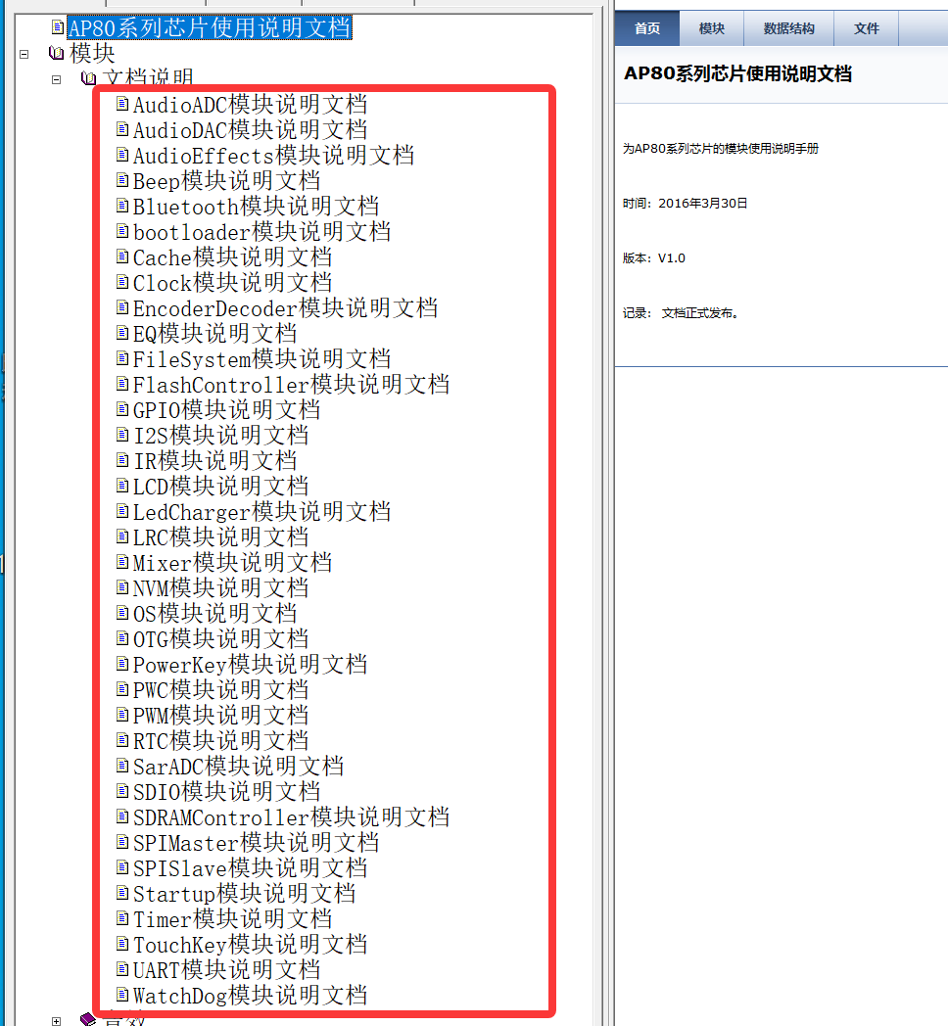

Note: The 36 doc`s content in the red box, has been translated into this folder   
“”, content are as following:

