**Overall, considering all factor is best predictive for both Subset A&B.**

* Trucks less accurate when using weekend_event subset than weekday_noevent subset
* For bicycle, effect of precipitation is relatively significant in weekend_event subset

Table only show coefficient:

|  |  |  |  |  |  |
| --- | --- | --- | --- | --- | --- |
|  |  | All factors | Remove precipitation | Remove wind | Remove wind&precip |
| Weekday_nonevent | bicycle | 0.8526 | 0.8501 | 0.8492 | 0.8492 |
| truck | 0.8462 | 0.8462 | 0.8441 | 0.843 |
| pedestrians | 0.872 | 0.872 | 0.8628 | 0.8661 |
| buses | 0.83 | 0.8399 | 0.8296 | 0.8296 |
| Weekend_event | bicycle | 0.8555 | 0.8493 | 0.8579 | 0.8579 |
| truck | 0.7764 | 0.7764 | 0.7745 | 0.7745 |
| pedestrians | 0.8849 | 0.8849 | 0.862 | 0.8616 |
| buses | 0.6878 | 0.6878 | 0.6825 | 0.6825 |

**1)Factors:**

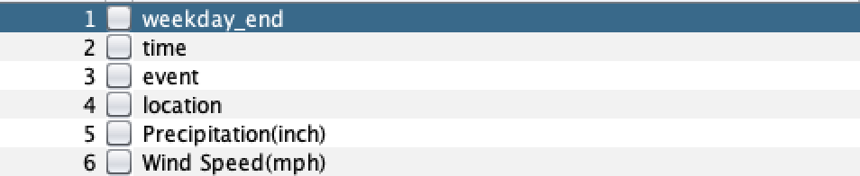

**SUBSET A: no-event weekday (7-days)**

1. **Bicycle**

* summary:

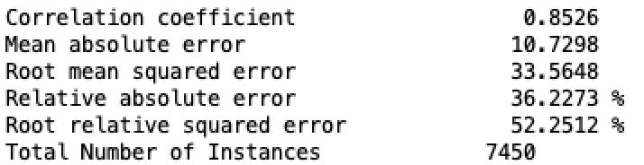

1. **Trucks**

* summary:

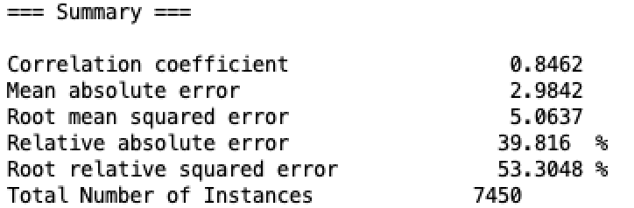

**SUBSET B: event weekend (7-days)**

1. **Bicycle：**

* Summary:

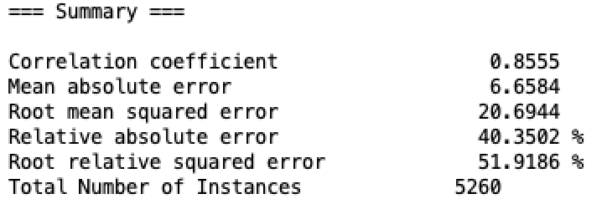

1. **Trucks**

* Summary:

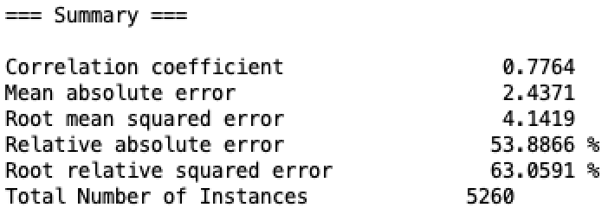

**2)Factors: remove precipitation**

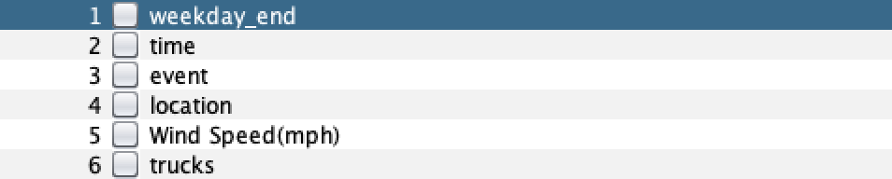

**SUBSET A: no-event weekday (7-days)**

1. **Bicycles**

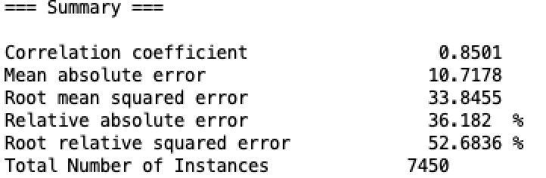

1. **Trucks**

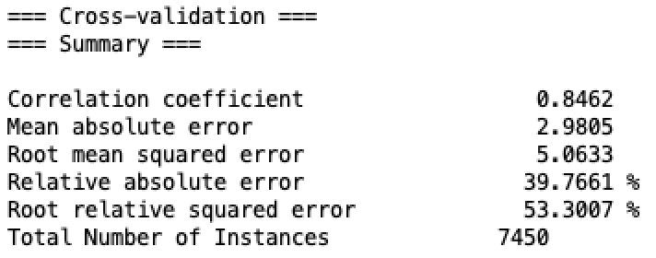

**SUBSET B: event weekend (7-days)**

1. **Bicycles**

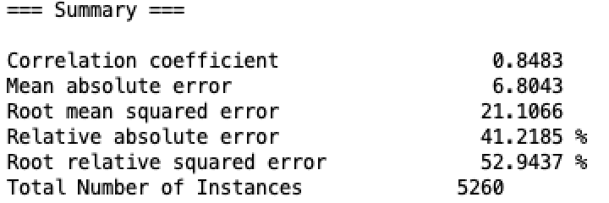

1. **trucks**

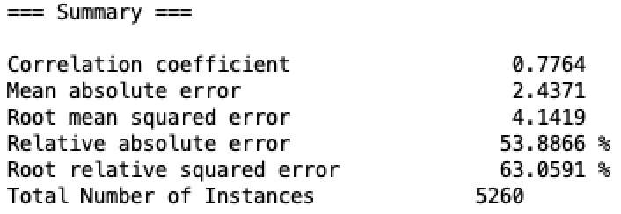

**3) Factors: remove wind**

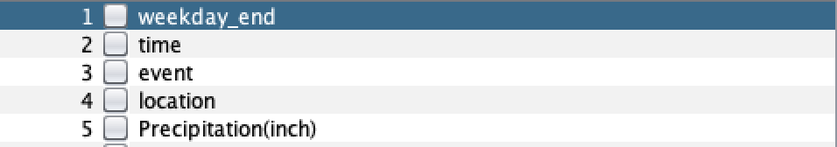

**SUBSET A: no-event weekday (7-days)**

1. **Bicycles**

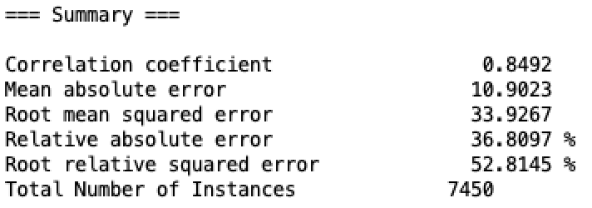

1. **Trucks**

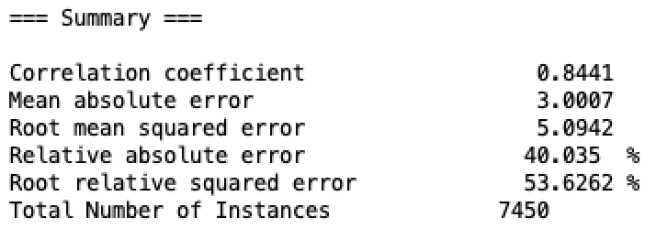

**SUBSET B: event weekend (7-days)**

1. **Bicycles**

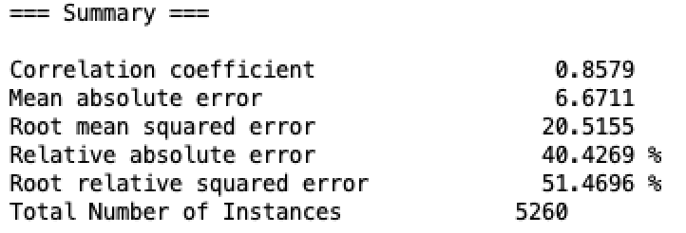

1. **Trucks**

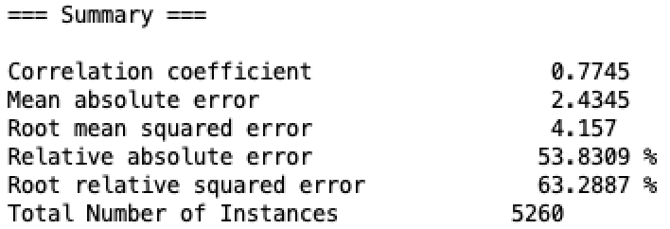

**3) Factors: remove wind and precipitation**

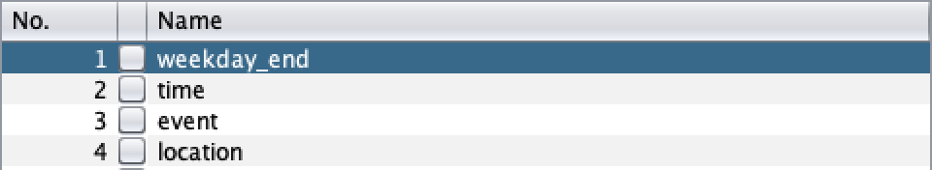

**SUBSET A: no-event weekday (7-days)**

1. **Bicycles**

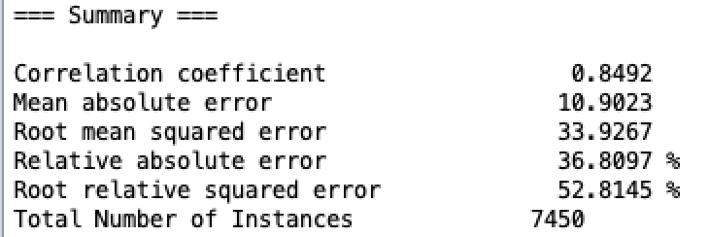

1. **Trucks**

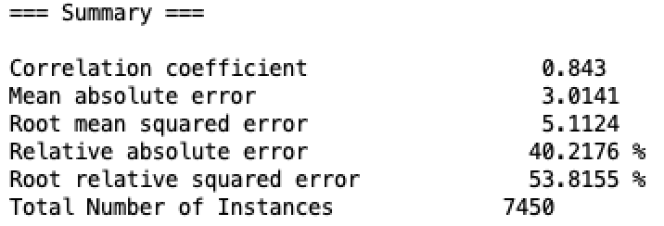

**SUBSET B: event weekend (7-days)**

1. **Bicycles**

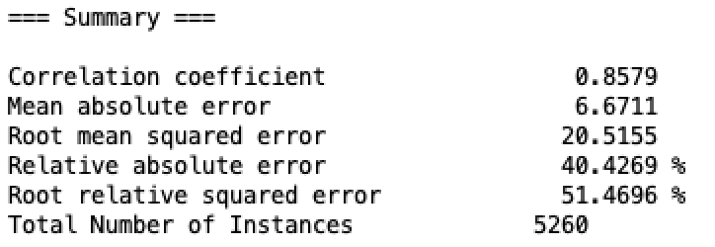

1. **Trucks**

