Project Sprint #1

The Solitaire game is described in CS449HomeworkOverview. You should read the description very carefully.

In this assignment, you aim to specify the requirements (i.e., user stories and acceptance criteria) of the target software that allows a human player to play a Solitaire game. These requirements will be fully implemented by the end of sprint 3. The minimum features include choosing the board size and type, starting a new game, making a move, determining if a game is over. The following is a sample GUI layout.

Board size
7
Board Type  - English  - Hexagon  - Diamond | 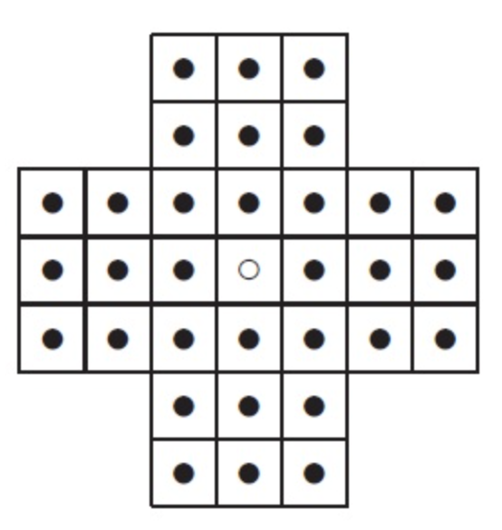 | New Game
Figure 1. Sample GUI layout of the first working program by the end of Sprint 3

Use the following tables to document your user stories and acceptance criteria.

You are required to use the free ChatGPT or another LLM to complete two user stories and two of their respective acceptance criteria. You must ensure that the generated user stories are correct and fix them if not. At the end of the submission, provide screenshots of your LLM prompts and answers, along with the description of errors the LLM made that you had to correct. Points will be deducted if no screenshots/description are provided.

For the other user stories and acceptance criteria, you are not required to use LLM.

- User Stories (3 points)

- User Story Template: As a <role>, I want <goal> [so that <benefit>]

ID | User Story Name | User Story Description | Priority | Estimated effort (hours)
1 | Choose a board size | As a player, I want to choose the size of the game board so that I can customize the size of my game. | Medium | 6 hours
2 | Choose the board type | As a player, I want to choose the type of game board so that I can customize how I play the game. | Low | 4 hours
3 | Start a new game of the chosen board size and type | As a player, I want to start a game with my selected board size and type so that I can play using my chosen game configuration. | High | 8 hours
4 | Make a move in a game | As a player, I want to be able to make a move such that I can progress through the game. | High | 16 hours
5 | A game is over | As a player, I want a game over event so that I know the game ended | Medium | 4 hours

- Acceptance Criteria (AC) (12 points): Add/delete rows as needed.

User Story ID and Name | AC  ID | Description of Acceptance Criterion | Status (completed, toDo, inPprogress)
1. Choose a board size | 1.1 | AC 1.1 <Choose board size selection>  Given: The player is starting a new game and is presented with available board sizes.  When: The player selects a valid board size, such as 5×5.  Then: The game creates and displays a 5×5 game board. | toDo
1. Choose a board size | 1.2 | AC 1.2 <Save board size selection>  Given: The player types a board size  When: The player is given a text box to enter the desired board size  Then: The selected board size is stored in a variable used later for generating the board | toDo
1. Choose a board size | …
2. Choose the board type | 2.1 | AC 2.1 <Choose board type selection>  Given the player is on the game setup screen  when the player selects a board type (e.g., English, European, or Diamond),  then the game should display the selected board layout and allow the player to start a game using that board | toDo
2. Choose the board type | 2.2 | AC 2.2 <Save board type selection>  Given the player is on the game setup screen  when the player selects a board type (e.g., English, European, or Diamond),  then the game will save the selected board type in a variable which will later be used to load the board | toDo
3. Start a new game of the chosen board size and type | 3.1  3.2 | AC 3.1 <Load new board with set board size>  Given: the user’s set board size  When: A new game is started  Then: The game generates a board with the maximum number of squares stacked vertically equal to the board size  AC 3.2 <Load new board with set board type>  Given: the user’s set board type  When: A new game is started  Then: The game generates a board with the correct board type selection displayed | toDo  toDo
4. Make a move in a game | 4.1 | AC 4.1 <Can make a move>  Given: the user selected a peg  When: there is an empty space located two positions vertically or horizontally from the selected peg.  Then: the user can move the peg to a selected empty space | toDo
A game is over | 5.1  5.2 | AC 5.1 <Can’t make a move>  Given: the player finished a move  When: there was only one move left  Then: the game ends  AC 5.2 <Trigger game ending>  Given: the game is in progress  When: When the game-ending condition occurs  Then: Then a game over event is triggered. | toDo  toDo

