Measuring Engagement with Marine Environmental Science Grey Literature: A Case Study of GESAMP
  - (Working paper)
Rémi Toupin
Madelaine Hare
Kellie Dalton
Geoff Krause
Valeriia Moroz
Philippe Mongeon
2025-09-02
 Note
This work is currently under review. Please cite as:
Toupin, R., Hare, M., Dalton, K., Krause, G., Moroz, V., & Mongeon, P. (2025). Measuring engagement with marine environmental science grey literature: A case study of GESAMP [White paper]. https://qsslab.ca/2025-toupin-gesamp/

Abstract
Environmental scientific advisory organizations and expert groups play a crucial role in synthesizing and disseminating knowledge to various stakeholders to inform practice and policy. This work is commonly disseminated through grey literature (e.g., reports and policy briefs). However, assessing the visibility, use, or impact of these outputs can be challenging because they often lack standard identifiers, such as DOIs, and are therefore not indexed in citation indexes and other databases commonly used to measure engagement using indicators like the number of views, downloads, or citations. Using the reports produced by the Joint Group of Experts on the Scientific Aspects of Marine Environmental Protection (GESAMP) as a case study, this study explores the use of various data sources (Web of Science, Overton and news indexing platforms) to track references to GESAMP reports in the scholarly literature, policy documents, and news media. Our findings indicate that attention to GESAMP reports has increased over the past twenty years, particularly in the last decade. GESAMP reports appear to generate interest in research fields dealing with environmental pollution and ocean management. Outside of academia, while sponsoring organizations tend to cite GESAMP the most, the reports also attract the interest of national and regional environmental organizations. Our study provides empirical evidence on how such reports and the organizations producing them can reach different audiences.

Introduction
The production and dissemination of scientific knowledge constitute a critical foundation for the development of evidence-based policy frameworks and coordinated societal responses to pressing socioenvironmental challenges. In the context of accelerating climate change, ecological degradation, and widening social inequities, integrating research into decision-making processes is essential for ensuring that interventions are effective. Research sheds light on the drivers and systemic interdependencies of environmental phenomena, while also enabling the modelling of future scenarios and the evaluation of policy outcomes across temporal and spatial scales (Government of Canada, 2020). There is an imperative to produce knowledge that responds to policy priorities, and in this context, the strategic production and circulation of scientific knowledge is central(Morgan & Di Giulio, 2018). Studies on communicating knowledge to decision-making bodies (Cossarini et al., 2014), stakeholders (Soomai et al., 2013), and informing policies (Lawrence et al., 2014) provide context for understanding how information relating to coastal and marine protection produced by expert advisory groups is translated into the public sphere, used to shape environmental management decisions at all levels, and communicated to stakeholders who can be informed by the knowledge produced by these groups.
Boundary spanning organizations play a pivotal role in bridging the gap between scientific research and policy implementation. Operating at the interface of science, policy, and practice, these entities facilitate the co-production of knowledge, foster mutual understanding among diverse stakeholders, and enhance the relevance and usability of scientific insights in decision-making contexts. By translating complex scientific findings into actionable policy recommendations, boundary organizations such as the Intergovernmental Panel on Climate Change (IPCC), the United Nations Environment Programme (UNEP), and the Joint Group of Experts on the Scientific Aspects of Marine Environmental Protection (GESAMP) help ensure that environmental governance is informed by evidence. This study is an investigation of the impact of reports published by GESAMP.
GESAMP was established in 1969 and bridges the science and policy by conducting research, synthesizing knowledge, and formulating recommendations for policymakers on key issues, including marine pollution and ocean acidification. GESAMP primarily contributes knowledge about ocean sustainability issues to the scientific community and worldwide marine protection advisory bodies through reports ranging “from in-depth reviews of critical marine processes, perturbations and contaminant categories to advice on monitoring, assessment and modelling, and guidance on strategic aspects of marine environmental protection and management” (Wells et al., 2002, p. 80). The reports are conducted by dedicated multidisciplinary groups (called Working Groups) of experts from autonomous organizations, which increases its legitimacy and credibility for the international community as it operates “at arm’s length from a government, although in this case, the government is not one body but is itself a network of officials drawn from eight [now ten] governing bodies” (McLaren, 1990, p. 657). Over its history, GESAMP produced over 120 reports, ranging from specific issues relating to marine protection—such as their 1985 study Atmospheric Transport of Contaminants into the Mediterranean Region—to higher-level publications that survey the current state of our oceans, such as A Sea of Troubles: Issues in Focus (2001), and more recent assessments like Marine Biofouling: Non-Indigenous Species and Management Across Sectors (2024), which explores the ecological and regulatory challenges posed by biofouling and its role in the spread of invasive species.
GESAMP reports are a form of grey literature, which encompasses a wide range of documents produced at different levels and sectors of government, academia, industry, or other (Schöpfel, 2011). Unlike scientific literature, which typically undergoes a peer-review process and is usually written for an academic audience, grey literature can be published quickly and communicate complex information to non-specialist audiences in an accessible format (Pappas & Williams, 2011), and it is increasingly used in literature reviews and policymaking (Adams et al., 2017; Babarczy et al., 2024; Lawrence et al., 2014; MacDonald et al., 2016; Paez, 2017; Pappas & Williams, 2011; Saleem et al., 2023; Thatje et al., 2007). There is evidence that GESAMP reports have contributed to scientific research and policymaking over the decades (Watson-Wright et al., 2024), but the extent of that contribution is difficult to assess. Indeed, while there are well-established methods and bibliometric indicators for measuring the impact of peer-reviewed journal publications, grey literature is not typically indexed in citation indices used for bibliometric research evaluation (Bickley et al., 2020).
Measuring the use of grey literature may be challenging, but it is not impossible, and several methods have been proposed or utilized for this purpose. For instance, Wilkinson et al. (2014) proposed a web report to identify web pages that link to grey literature, which could be used in conjunction with other altmetric indicators (e.g., mentions in news media). Bickley et al. (2020) used Scopus cited reference searches to locate grey literature citations in scholarly literature and the Google Books API to identify monograph citations. Adie (2014) similarly suggested that investigations into the use and impact of grey literature could be improved through the assignment of persistent identifiers, the adoption of advanced metadata standards, and the establishment of open indexes of grey literature. He went on to create the Overton database (Szomszor & Adie, 2022). Overton indexes grey literature and its references to scholarly outputs, making it a useful tool for measuring the impact of scientific outputs in policy-making and other non-academic sectors that produce grey literature. However, Overton does not index references to the grey literature in scientific publications and is therefore less suitable for assessing the impact of grey literature.

Research Objectives
Some attempts have been made to assess the use and impact of GESAMP publications specifically (Cordes, 2003; Hutton, 2009; MacDonald et al., 2004). Cordes (2003) conducted a citation analysis using the Web of Science, and MacDonald et al. (2004) employed a similar approach to assess the use of GESAMP literature. Hutton (2009) utilized the Web of Science, Google, and Google Scholar to investigate the influence of grey literature, advocating for a multifaceted approach to understanding GESAMP’s influence through diverse indicators. Our study follows up and expands on this past work by measuring engagement with GESAMP publications in science, policy, and news media.

Data and Methods

Methodological Approach
This descriptive study uses a bibliometric approach to measure engagement with GESAMP publications, and we thus define engagement as references to GESAMP publications in other documents. Specifically, we aim to collect evidence of engagement in three social spheres (research, policy, and news media), each represented by a distinct type of document (peer-reviewed research outputs, policy documents, and news items). We use ‘engagement’ as an all-encompassing term that encompasses all forms and varying degrees of engagement. Forms of engagement can include a mention of GESAMP or of a specific GESAMP publication, or the citation of a GESAMP publication in a research article. In either case, the mention or reference to GESAMP can occur without an in-depth report or use of the information included in the GESAMP publication, which we could qualify as a weak form of engagement; on the other hand, the GESAMP publication may be extensively discussed in the referencing or mentioning piece, which would signal a stronger form of engagement. Our work does not account for such variations in the degree of engagement.
As mentioned in the introduction, measuring the use of grey literature is methodologically challenging, primarily due to the lack of data infrastructures specifically designed for this purpose. Similarly, there are relatively standard ways of measuring engagement with scholarly outputs in social media, such as PlumX and Altmetric.com. However, these databases only cover gray literature that contains references to scholarly outputs with DOIs for the purpose of identifying citations to scholarly outputs in grey literature and other documents such as social media, blogs, and news media. These tools, which are widely used in bibliometric research, are not helpful for our purposes; therefore, we had to rely on various manual searches for GESAMP and GESAMP publications in different databases that index the types of documents we are interested in. We describe the data collection process in the following sections.

Data collection

GESAMP Reports
This study focuses on the analysis of GESAMP publications listed under the Publications page of the GESAMP website, which lists annual reports, thematic reports, proceedings, executive summaries, and histories of GESAMP as part of its Reports and Studies series. We use the generic term “publications” to refer to all these works. We collected information about 120 publications published between 1969 and 2022. Table 1 provides a list of the information collected on GESAMP publications.
Table 1: Fields used to document GESAMP reports.
Field | Description
ID | A unique identifier for the publication. When available, the publication number is the ID.
Title | The title of the publication.
Abstract | The abstract for the publication.
Publication year | The year of publication.
Publication type | The type of publication (annual report, thematic report, proceedings, executive summary, history [of GESAMP]).
Series name | The name of the Reports and Studies series as listed on the website.
Publisher | The publishing sponsoring organization (IMO, FAO, UNESCO-IOC, UNIDO, WMO, WHO, IAEA, UN, UNEP, ISA, or UNDP).
Number of pages | Number of pages of the publication.
Working group | The working group associated with the publication if available.
URL | The URL of the publication from the GESAMP website.
Suggested citation format | The suggested citation format as indicated in the publication.
_{Source: Article Notebook}

Citations
We collected citations to GESAMP publications from the Web of Science (WoS) database, limited to the Science Citation Index (SCI), the Social Science Citations Index (SSCI) and the Arts & Humanities Citation Index (A&HCI). This data was obtained through the Observatoire des sciences et des technologies (OST) at the Université du Québec à Montréal. We searched for the strings “gesamp” and “group of experts on the scientific aspects of marine” in three locations: 1) the cited reference author, 2) the cited reference title, and 3) the cited reference source. It is worth noting that these fields of the Web of Science database contain minimally processed or cleaned data. For example, there were 399 text strings representing GESAMP as the cited reference author. Overall, we retrieved 3,489 distinct reference strings (i.e., references in which GESAMP was mentioned) from a total of 4,713 references across 4,082 distinct publications. For each citing document, we retrieved the publication year and the journal, which allows us to show temporal trends as well as provides insights on the research communities where GESAMP plays a role.

Policy Citations
To collect citations to GESAMP publications in policy documents, we used the Overton database, an index of policy documents, guidelines, think tank publications and working papers, with a better coverage than alternative data sources such as Altmetric.com (Dorta-González et al., 2024; Maleki & Holmberg, 2024; Murat et al., 2023). Overton provides citation contexts by indicating where a scholarly output is used in the text of a policy document (when a bibliography section is provided in a policy document, it maps to its DOI) (Szomszor & Adie, 2022). As the referencing practices of grey literature can vary, Overton typically relies on a set of scored features to capture citations. If the overall score exceeds a certain threshold, the citation context is matched to Crossref to capture citations to scholarly literature or the rest of the Overton database for policy documents. Overton’s records include information on the authors of policy documents, source type (e.g., government, think tank), document topics, associated Sustainable Development Goals and the name of the source organization that produced the policy document (e.g., UNESCO, Institute for European Environmental Policy, Government of Canada), which can provide insights into not just how many policy documents cite GESAMP publications, but also who cites them and in what context.
We searched for each individual GESAMP publication in Overton using their titles, and we also searched for the term “GESAMP”. We identified most (118 out of 120) GESAMP publications in Overton. Two GESAMP publications – Report of the 32nd Session of GESAMP (#73) and Guidance on Assessment of Sediment Quality (#4) – are unavailable digitally as of December 2024. Thus, they were not included in the Overton database, and we were unable to collect policy citations for these two documents.
Initially, we identified a total of 2,112 references to GESAMP publications in Overton. This number dropped to 742 after removing references coming from other GESAMP publications. Most of the removed 1,370 GESAMP self-citations were due to the fact that GESAMP reports tend to include a list of past GESAMP reports at the end, which were captured as individual references to each report by Overton, thus largely inflating the numbers. The 742 references included in the analysis occurred in 551 distinct documents produced by 103 organizations.

News Mentions
News articles were collected from five databases: Factiva, Eurêka, ProQuest News and Newspapers, NexisUni, and Research Library, chosen for their international scope and the relevance of their available resources.
Factiva indexes news from over 33,000 sources globally. Emphasizing business and market intelligence data, the available sources include newspapers, trade publications, government publications, and press releases. A search for “GESAMP” or “group of experts on the scientific aspect of marine” retrieved 401 results, exported as headline data in HTML and converted to Comma Separated Values (CSV) files with an R script and manual cleaning, resulting in a final CSV file of 346 exported results.
The Eurêka database indexes approximately 2,500 sources covering current events on the local, regional, national, and international levels. “GESAMP” or “group of experts on the scientific aspect of marine” was searched in all its archives and content. This search retrieved 213 results.
The ProQuest News and Newspapers database includes seven newspapers/services: Canadian Newsstream, Global Breaking Newswires, International Newsstream, ProQuest Historical Newspapers: The Globe and Mail, ProQuest Historical Newspapers: The New York Times with Index, ProQuest Historical Newspapers: Toronto Star, and U.S. Newsstream. A search for “GESAMP” or “group of experts on the scientific aspect of marine” retrieved 93 results.
The NexisUni database indexes over 15,000 news, business, and legal source articles focusing on business, political science, and criminal justice. A search for “GESAMP” or “group of experts on the scientific aspects of marine” retrieved 189 results.
The Research Library database searches multiple interdisciplinary journal sources spanning multiple disciplines and fields. With an international scope, the database comprises a smaller collection of sources, including over 2,300 journals and newspaper sources, as well as recent newswire feeds. A search for “GESAMP” or “group of experts on the scientific aspects of marine” produced 70 results.
The combined news mentions dataset contains 911 items with seven metadata fields. After filtering out items with the type “journalArticle” from the Eurêka results (62 items), unique news items can be distinguished by title, publication, and year, leaving 716 results. Note that this curated dataset does not preclude duplicates published in multiple publications or translated works.
We subsequently examined the context in which GESAMP was mentioned to identify the specific report that was mentioned, and were able to identify 217 news items mentioning a specific GESAMP publication.

Data Analysis
Our analysis consists of descriptive statistics reporting on the GESAMP publications themselves. For each indicator (number of citations in the scholarly literature, citations in policy documents, and mentions in news media), we counted the total number of citations or mentions over time, andthe sources in which GESAMP publications are cited or mentioned. We also counted the number of citations or mentions to individual GESAMP publications, which allows us to produce a top 10 for each indicator.

Results

GESAMP Reports
We first examined the type of GESAMP reports through the years (Table 2). The number of thematic reports dipped slightly in the 2000-2009 decade, with no reports published between 2003 and 2007. There has, however, been an increase in thematic reports during the 2010-2022 period.
Table 2: Number of GESAMP publications by period and by type.
Publication type | 1969-1979 | 1980-1989 | 1990-1999 | 2000-2009 | 2010-2022 | Total
Thematic Report | 5 | 20 | 18 | 8 | 14 | 65
Annual Report | 10 | 9 | 10 | 7 | 12 | 48
History | 0 | 0 | 1 | 2 | 0 | 3
Proceedings | 0 | 0 | 0 | 0 | 3 | 3
Executive Summary | 0 | 0 | 0 | 0 | 1 | 1
Overall | 15 | 29 | 29 | 17 | 29 | 120
_{Source: Article Notebook}
We also identified the sponsoring organizations that acted as editors for the published work through the years (Table 3). The International Maritime Organization (IMO), where GESAMP’s main office is located, contributed the highest number of publications, especially in recent years, followed by the Food and Agriculture Organization of the United Nations (FAO) and the World Meteorological Organization (WMO). Notably, the participation of the FAO as an editor has been constant through the years.
Table 3: Number of GESAMP publications by period and by publisher.
Publisher* | 1969-1979 | 1980-1989 | 1990-1999 | 2000-2009 | 2010-2022 | Total
Publisher* | 0 | 1 | 7 | 4 | 13 | 25
FAO | 6 | 4 | 6 | 3 | 2 | 21
WMO | 1 | 6 | 4 | 1 | 4 | 16
UNEP | 0 | 3 | 4 | 3 | 4 | 14
UNESCO | 3 | 4 | 3 | 2 | 3 | 15
UN | 3 | 4 | 1 | 1 | 2 | 11
IAEA | 1 | 2 | 2 | 1 | 4 | 10
WHO | 1 | 4 | 2 | 0 | 0 | 7
IMO | 2 | 2 | 0 | 0 | 0 | 4
UNDP | 0 | 0 | 0 | 0 | 3 | 3
UNIDO | 0 | 0 | 0 | 1 | 2 | 3
Overall | 17 | 30 | 29 | 16 | 37 | 129
*International Maritime Organization (IMO); Food and Agriculture Organization (FAO); World Meteorological Organization (WMO); United Nations Environment Programme (UNEP); United Nations Educational, Scientific and Cultural Organization (UNESCO); United Nations (UN); International Atomic Energy Agency (IAEA); World Health Organization (WHO); International Maritime Organization (IMO); United Nations Development Programme (UNDP); United Nations Industrial Development Organization (UNIDO).
_{Source: Article Notebook}

Citations in Peer-Reviewed Research Publications
Figure 1 indicates a steady increase in scholarly citations to GESAMP publications over time. Citations slightly increased after 2000 but fluctuated consistently every few years, and 2016 marks the beginning of a sharp increase in citations. Citation counts after 2020 may not accurately represent the full reach of publications, as citations take time to accumulate.
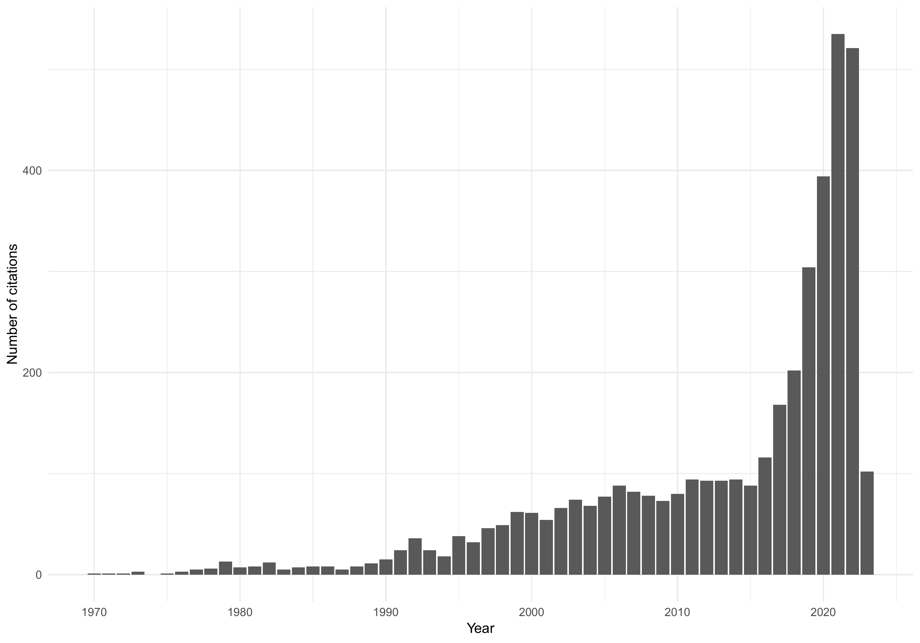
Figure 1: Citations to GESAMP publications over time
GESAMP publications have been cited in works published by 1,120 journals. Figure 2 presents the top 25 journals that have cited GESAMP publications the most, with Marine Pollution Bulletin being the journal in which GESAMP publications are the most cited, and by a substantial number. This journal cited GESAMP literature over twice as much as Science of the Total Environment, which has the second highest number of citations to GESAMP work. Environmental Pollution, Ocean & Coastal Management, and Frontiers in Marine Science, comprising the rest of the top 5 journals citing GESAMP publications, indicate a focus on pollution and ocean management. The topic of pollution is also present among the remaining top 20 journals (such as Environmental Science and Pollution Research, Bulletin of Environmental Contamination and Toxicology, and Water Air and Soil Pollution) as are the subjects of toxicology and hazardous materials (Chemosphere, Journal of Hazardous Materials, Ecotoxicology and Environmental Safety, and Aquatic Toxicology), indicating the relevance and utility of GESAMP literature to research published in these journals. Other journals tend to focus on science, technology, ecology, environmental/marine research, and management, whereas topics relating to policy appear less represented. However, several key marine management journals, such as Marine Policy and Coastal Management, show significant interest in GESAMP work.
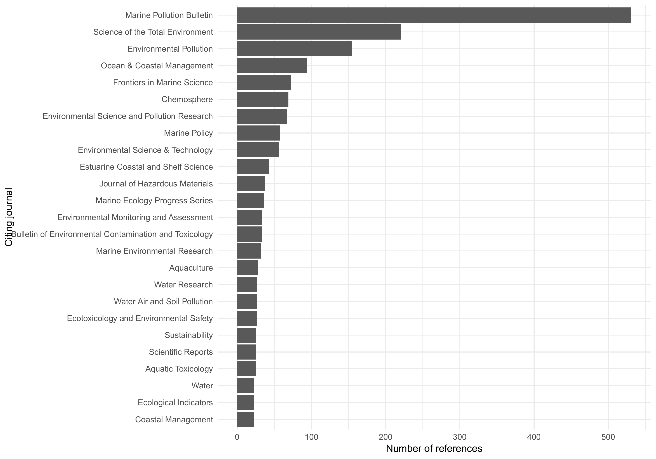
Figure 2: Top journals citing GESAMP publications
Publication-level references to GESAMP work show that the three most cited GESAMP reports address issues related to plastic pollution in marine environments (#90, #99, #93 – Table 4). Other works that attracted a substantial degree of attention by scholars include two keystone reports about marine pollution issues, The State of the Marine Environment (#39) and A Sea of Troubles (#70), as well as papers dealing with land-based contamination (#71, #32) and chemical/oil pollution (#50, #75, #65). Another report, appearing in the most cited publications of GESAMP, is The Revised GESAMP Hazard Evaluation Procedure for Chemical Substances Carried by Ships (#64), which provides guidelines for the transport of chemical substances in ships and has been updated in recent reports. While the three most cited reports were published in recent years, citations to recent GESAMP work still need some time to accumulate, as the other 12 publications included in the top 15 most cited reports were published more than 12 years ago.
Table 4: Publication-level citations to GESAMP reports.
Title | Year | Citations
Sources, Fate and Effects of Microplastics in the Marine Environment (Part 1) (#90) | 2,015 | 840
Guidelines for the Monitoring and Assessment of Plastic Litter in the Ocean (#99) | 2,019 | 436
Sources, Fate and Effects of Microplastics in the Marine Environment (Part 2) (#93) | 2,016 | 406
The State of the Marine Environment (#39) | 1,990 | 259
The Contributions of Science to Integrated Coastal Management (#61) | 1,996 | 160
Protecting the Oceans from Land-based Activities (#71) | 2,001 | 133
Impact of Oil and Related Chemicals on the Marine Environment (#50) | 1,993 | 132
Land/Sea Boundary Flux of Contaminants: Contributions from Rivers (#32) | 1,987 | 108
Estimates of Oil Entering the Marine Environment from Sea-based Activities (#75) | 2,007 | 97
Opportunistic Settlers and the Problem of the Ctenophore Mnemiopsis leidyi Invasion in the Black Sea (#58) | 1,997 | 96
A Sea of Troubles (#70) | 2,001 | 95
The Atmospheric Input of Trace Species to the World Ocean (#38) | 1,989 | 94
Proceedings of the GESAMP Workshop on Microplastic particles (#82) | 2,010 | 89
Towards Safe and Effective Use of Chemicals in Coastal Aquaculture (#65) | 1,997 | 81
The Revised GESAMP Hazard Evaluation Procedure for Chemical Substances Carried by Ships (#64) | 2,002 | 78
_{Source: Article Notebook}

Policy Citations
Figure 3 presents the number of policy citations to GESAMP publications. These are less frequent than citations in research or news mentions, but we observe a positive trend starting after 2000.
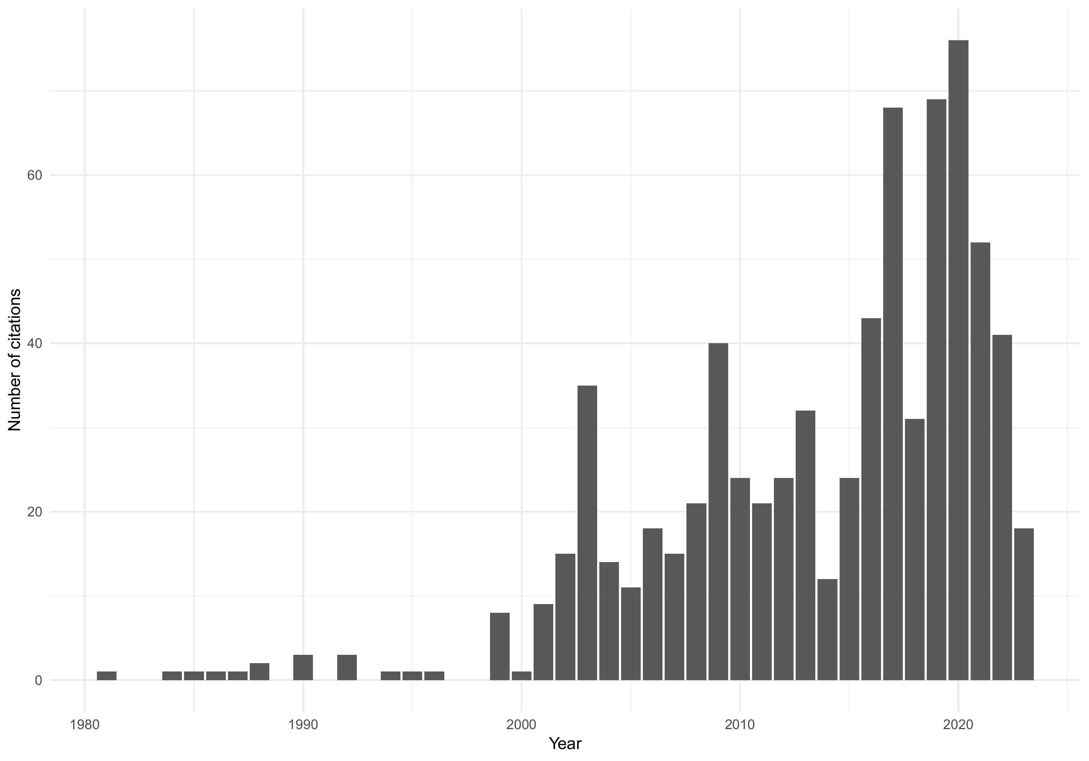
Figure 3: Number of policy citations to GESAMP publications
Figure 4 shows the top 15 policy sources citing GESAMP literature. The United Nations Environment Programme and the Food and Agriculture Organization of the United Nations are the top two citers of GESAMP literature. Data collected from Overton reveals frequent self-citations of GESAMP to its own work; the top two citers corroborate the finding that the UN often draws on its own work to advance and build knowledge. Other top citers include the International Union for Conservation of Nature, the World Meteorological Organization, and UNESCO, which shows strong international confidence in GESAMP literature for their work. Other global bodies that are not solely mandated for environmental protection or have dedicated environmental units include the World Health Organization and the World Bank. Specific national or international actors include the State of South Australia (concerned mainly with protecting the Great Barrier Reef), Natural Resources Institute Finland, the German Institute for Economic Research, and the Publications Office of the European Union.
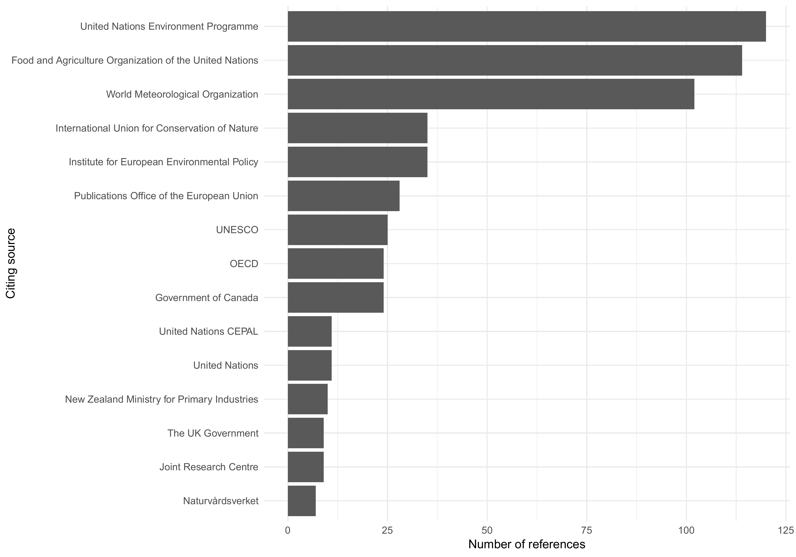
Figure 4: Top 15 policy sources citing GESAMP publications
Table 5 shows the top 15 report-level policy citations to GESAMP Reports and Studies. Notably, 11 of the 15 publications were produced in the 2000s, despite GESAMP reports dating back to the 1960s. This suggests that GESAMP reports have influenced policymaking in recent years, possibly due to the organization establishing itself during its first few decades, when grey literature was more challenging to access online. However, one report from the 1980s and three from the 1990s received significant engagement in policy documents. The 1980 report, “Interchange of Pollutants Between the Atmosphere and the Ocean,” for example, received the third-highest amount of policy mentions. The top two most cited reports are from more recent years and are complementary documents: Parts 1 (#90) and 2 (#93) of Sources, Fate and Effects of Microplastics in the Marine Environment appear to reflect important concerns in the policy sphere in recent years.
Table 5: Publication-level policy indicators to GESAMP reports
Title | Year | Policy citations
Sources, Fate and Effects of Microplastics in the Marine Environment (Part 1) (#90) | 2,015 | 113
Sources, Fate and Effects of Microplastics in the Marine Environment (Part 2) (#93) | 2,016 | 81
Interchange of Pollutants Between the Atmosphere and the Ocean (#13) | 1,980 | 72
Protecting the Oceans from Land-based Activities (#71) | 2,001 | 45
Planning and Management for Sustainable Coastal Aquaculture Development (#68) | 2,001 | 34
Guidelines for the Monitoring and Assessment of Plastic Litter in the Ocean (#99) | 2,019 | 34
The State of the Marine Environment (#39) | 1,990 | 33
Towards Safe and Effective Use of Chemical in Coastal Aquaculture (#65) | 1,997 | 31
Assessment and communication of environmental risks in coastal aquaculture (#76) | 2,008 | 26
A Sea of Troubles (#70) | 2,001 | 24
The Atmospheric Input of Chemicals to the Ocean (#84) | 2,012 | 23
Proceedings of the GESAMP Workshop on Microplastic particles (#82) | 2,010 | 19
The magnitude and impacts of anthropogenic atmospheric nitrogen inputs to the ocean (#97) | 2,018 | 19
Monitoring the Ecological Effects of Coastal Aquaculture Wastes (#57) | 1,996 | 18
Sea-based sources of marine litter (#108) | 2,021 | 17
_{Source: Article Notebook}

News Mentions
As Figure 1 and Figure 3 showed an increase in citations in scholarly work and policy documents to GESAMP literature, Figure 5 also reveals a positive trend over the past two decades. After 2010, a noticeable rise in news mentions of GESAMP publications can be observed. In 2022, in particular, there was a marked rise in news mentions, likely due to increased mainstream attention to the UN’s declared Decade of Ocean Science for Sustainable Development (2021-2030) and the ongoing climate emergency (UNESCO, 2017; UNESCO-IOC, 2023).
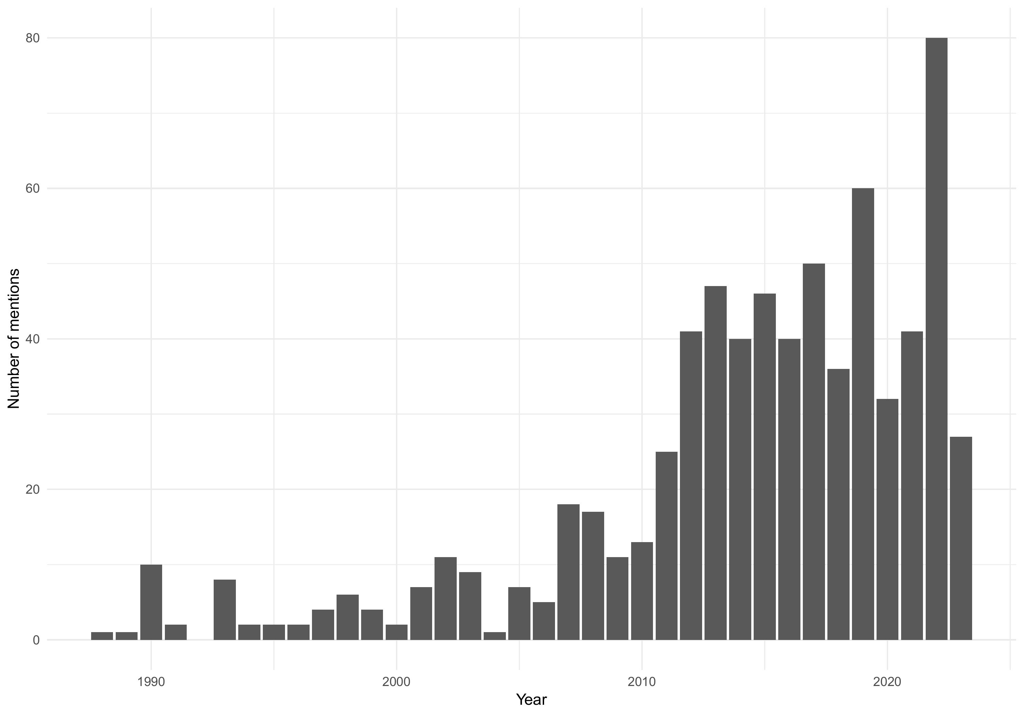
Figure 5: Number of news media mentions of GESAMP publications by year
These new works were published by 336 different publications/services, of which the top 25 are shown in Figure 6 below. Three of the top sources are American, indicating that American news services are paying more attention to GESAMP publications. The top news sources are otherwise distributed across global news services, with representation from organizations such as All Africa, South China Morning post, and ForeignAffairs (New Zealand), as well as a large proportion of European news sources: Schiff und Hafen (Germany), La Repubblica (Italy), EUR-Lex, Twitter- Environnement (France), Lloyd’s List (England), and European Union News. Overall, the representation of international news services is less than that of national sources. The World Bank (MENA Report) is also represented in top news sources, as it is among the top policy citers in the GESAMP literature, being the only organization, other than the European Union, to be represented in both policy and news groups.
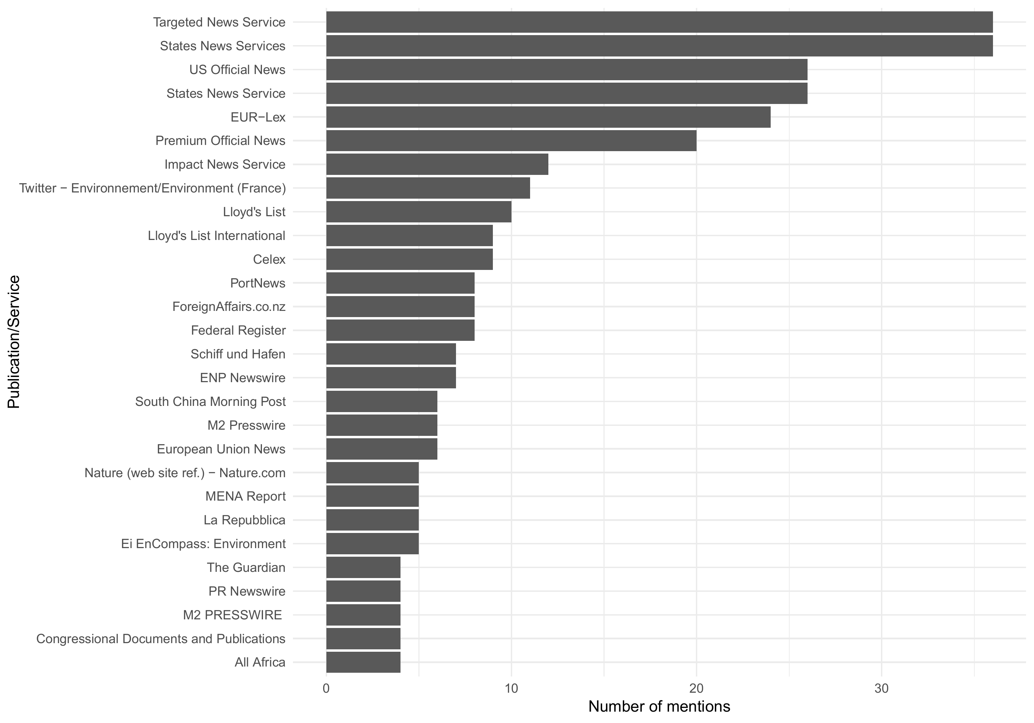
Figure 6: Top news media publication or service by number of mentions
Report-level news mentions of GESAMP Reports and Studies are depicted in Table 6. Similar to Table 4 and Table 5, reports #90 and #93 are among the top three reports mentioned in the news. News mentions seem more contemporary, with only two publications dating back to the 1990s and the rest published in the late 2010s. Table 6 also illustrates substantial overlap between news mentions and the two other groups of indicators: 7 of the top 15 reports are common to both policy and the news, while nine are common to citations and the news.
Table 6: Publication-level news indicators to GESAMP reports.
Title | Year | News mentions
Sources, fate and effects of microplastics in the marine environment (Part 1) (#90) | 2,015 | 39
Sources, Fate and Effects of Microplastics in the Marine Environment (Part 2) (#93) | 2,016 | 29
A Sea of Troubles (#70) | 2,001 | 15
High Level Review of a Wide Range of Proposed Marine Geoengineering Techniques (#98) | 2,019 | 11
The State of the Marine Environment (#39) | 1,990 | 10
Guidelines for the Monitoring and Assessment of Plastic Litter in the Ocean (#99) | 2,019 | 10
Estimates of Oil Entering the Marine Environment from Sea-based Activities (#75) | 2,007 | 9
Proceedings of the GESAMP Workshop on Microplastic particles (#82) | 2,010 | 9
GESAMP Hazard Evaluation Procedure for Chemicals carried by Ships, 2019 (#102) | 2,020 | 8
Protecting the Oceans from Land-based Activities (#71) | 2,001 | 7
Impact of Oil and Related Chemicals on the Marine Environment (#50) | 1,993 | 6
Global Pollution Trends: Coastal Ecosystem Assessment for the Past Century (#106) | 2,020 | 5
Sea-based sources of marine litter (#108) | 2,021 | 5
_{Source: Article Notebook}

Discussion and Conclusion

Summary of findings
This analysis of literature citing GESAMP publications utilized references from scholarly articles in the Web of Science, policy documents from Overton, and news mentions from Factiva, Eurêka, ProQuest News and Newspapers, NexisUni, and Research Library. All three indicators show a continuous growth in engagement with GESAMP publications over time, with an acceleration occurring around the mid-2010s. This timing aligns with an increased awareness of climate change and ocean pollution. For instance, the UN’s First World Ocean Assessment, released in 2017, exposed the degraded state of the oceans (UNESCO, 2017) and catalyzed national action. Canada, for example, launched a $1.5 billion Oceans Protection Plan (OPP), the largest federal government investment in ocean protection (DFO Maritimes Region OPP Atlantic Hub, 2020). Such efforts around the globe may have spurred research drawing on GESAMP publications. As 2021 marked the beginning of the UN Decade of Ocean Science for Sustainable Development, GESAMP reports are likely to continue being needed and used.
GESAMP publication gets cited on average 6.2 times in policy documents indexed in Overton. Without a proper benchmark, it is difficult to determine whether or not this is a low or high number of policy citations. Still, past evidence on policy citations to scholarly literature suggests much lower rates of policy citations for this type of document. For example, research articles related to sharks analyzed in Toupin et al. (2023) paper had, on average, 0.19 policy citations according to Altmetric.com. Dorta-González et al. (2024) analyzed the policy citations of 124,778 articles published in journals containing the term “policy” in their title and found and found an average of 0.6 policy citations according to Altmetric.com and an average of 2.3 policy citations according to Overton. Thus, an average of 6.2 for GESAMP reports signals an above-average use in policy. This was perhaps to be expected as it is one of the intended purposes of GESAMP reports, unlike scholarly articles, which can be relevant for policy but are typically intended first and foremost for scientific audiences. Although it’s mostly UN organizations that draw from GESAMP, the expert group is also referenced in documents produced by the Canadian and United Kingdom governments, as well as by organizations such as the International Union for Conservation of Nature.
Similarly, we have no suitable benchmark against which to assess whether 5.4 news mentions per GESAMP publication is high or low. Still, this number is about five times higher than the average number of news mentions of papers in Toupin et al. (2023), suggesting a high level of visibility of GESAMP publications in the news.
It is also challenging to determine whether the total of 4,713 citations or the average of 39.27 citations per GESAMP publication is high or low without a benchmark of other grey literature or scholarly outputs. The average citations to the set of shark-related papers in Toupin et al. (2023) was lower at 23.9. According to data from OpenAlex (Priem et al., n.d.), papers in Marine Pollution Bulletin have received an average of 35.6 times. These numbers suggest that GESAMP publications play an important role not only in policymaking but also in science published in a range of journals, such as Marine Pollution Bulletin, Science of the Total Environment, and Environmental Pollution.
Some of the most frequently cited and mentioned GESAMP publications have focused on plastic pollution in the ocean, a topic of growing interest in recent years. These reports were highly discussed in the news media upon publication. We also observe that GESAMP’s most frequently mentioned work in policy documents and news media was published in recent years, a stark contrast to citations. Some possible explanations include a faster accumulation of use in the news and policy compared to citations, which take more time to accumulate, or heightened visibility and accessibility of grey literature in the digital era.

Contributions of our study
Our findings make an empirical contribution to the literature on boundary-spanning organizations and their role in bridging the gap betweenoffer a valuable empirical contribution to the literature on boundary-spanning organizations and their role in bridging science and policy. By examining the dissemination and uptake of GESAMP reports across scholarly, policy, and media domains, it reinforces the notion that boundary organizations are not only conduits of information but active agents in shaping environmental discourse and decision-making. Kettle et al. (2017) and Leith et al. (2016) highlight the importance of boundary organizations, and our analysis of GESAMP’s increasing visibility illustrates how sustained engagement and institutional support can enhance the reach and influence of scientific advisory bodies. Bednarek et al. (2018) emphasize the importance of trust, credibility, and strategic communication in boundary-spanning work. Our findings echo these insights by showing how GESAMP’s outputs gain traction among diverse stakeholders. Cvitanovic et al. (2014);Cvitanovic et al. (2015); Cvitanovic et al. (2016) highlight the challenges of knowledge exchange in marine resource management. Our study contributes to demonstrating how grey literature, when strategically produced and disseminated, can support adaptive governance and evidence-based decision-making, particularly in ocean management. Ultimately, our study provides a compelling case for investing in boundary-spanning mechanisms that amplify the societal value of environmental science.
Our study also constitutes a methodological contribution to research aimed at measuring the impact of gray literature and the organizations that produce it. Indeed, capturing the use of grey literature is challenging, and while our process relied largely on manual searches and verifications, which makes it difficult to scale up, it may nonetheless provide guidance for others who wish to replicate or expand on our process to measure the impact of grey literature. Finally, a practical implication of our work and the process it illustrates is the potential for GESAMP and similar organizations to evaluate the impact of their contributions, and more importantly, to communicate it to stakeholders and other organizations on which they may depend for legitimacy or funding.
This study’s approach possesses several limitations. A search for GESAMP publications was conducted across databases by searching for “gesamp” and its full name. Reports were not searched for at an individual level, which may have limited the comprehensiveness of the retrieved results from databases. As extensive as the coverage of our data sources may be this report underestimates the total engagement of GESAMP literature.

Concluding remarks
This study underscores the growing relevance and reach of grey literature produced by environmental scientific advisory bodies, using GESAMP as a compelling case study. Despite the inherent challenges in tracking and quantifying the impact of non-indexed outputs, our multi-source approach reveals a clear upward trajectory in the visibility and use of GESAMP reports across scholarly, policy, and media landscapes. The increasing citation of these reports in academic literature—particularly in fields related to marine pollution and ocean governance—demonstrates their value in shaping scientific discourse. Moreover, the engagement from national and regional environmental organizations highlights the broader impact of GESAMP’s work beyond its sponsoring institutions.
These findings underscore the importance of developing robust mechanisms to monitor and assess the impact of grey literature, particularly as it continues to inform critical environmental decision-making. As global challenges intensify, the ability of expert groups like GESAMP to synthesize knowledge and disseminate it effectively to diverse audiences will remain essential. Future research should explore additional platforms and metrics to capture the nuanced pathways through which such reports contribute to policy development, public awareness, and scientific progress. Strengthening the visibility and traceability of grey literature will ultimately enhance its utility and legitimacy in the environmental knowledge ecosystem.

Data Statement
The code is available on GitHub (https://github.com/toupinr/gesamp), and aggregated data will be made available upon acceptance. However, full data obtained from Web of Science, Overton and news indexing platforms require access to these services. Interested readers can contact Clarivate (Web of Science: https://clarivate.com/academia-government/scientific-and-academic-research/research-discovery-and-referencing/web-of-science/) and Overton (https://www.overton.io/) for further access.

Acknowledgements
The authors would like to thank Peter Wells and Bertrum MacDonald, whose expertise has been invaluable to the fulfillment of this research project on GESAMP’s work.

CRediT Authorship Contributions
Rémi Toupin: Conceptualization, Methodology, Investigation, Formal Analysis, Writing – Original Draft, Writing - Review & Editing, Supervision, Funding Acquisition, Visualization
Madelaine Hare: Conceptualization, Methodology, Investigation, Formal Analysis, Writing – Original Draft, Writing - Review & Editing, Funding Acquisition
Kellie Dalton: Methodology, Investigation, Formal Analysis, Writing – Original Draft
Geoff Krause: Methodology, Investigation, Formal Analysis, Data Curation, Writing – Original Draft, Writing - Review & Editing
Valeriia Moroz: Investigation, Formal Analysis, Writing – Original Draft
Philippe Mongeon: Conceptualization, Methodology, Software, Investigation, Resources, Formal Analysis, Data Curation, Writing – Original Draft, Writing - Review & Editing, Supervision, Project Administration, Funding Acquisition

Funding Sources
This project is funded by a Social Sciences and Humanities Research Council of Canada (SSHRC) Partnership Engage Grant (#892-2023-0067) with the Joint Group of Experts on the Scientific Aspects of Marine Environmental Protection (GESAMP). Resources provided by GESAMP are gratefully acknowledged. RT is also funded by a Fonds de recherche du Québec—Culture et Société postdoctoral fellowship (#313092; https://frq.gouv.qc.ca).

References
Adams, R. J., Smart, P., & Huff, A. S. (2017). Shades of Grey: Guidelines for Working with the Grey Literature in Systematic Reviews for Management and Organizational Studies. International Journal of Management Reviews, 19(4), 432–454. https://doi.org/10.1111/ijmr.12102
Adie, E. (2014). The grey literature from an altmetrics perspective—opportunity and challenges. Research Trends, 1(37). https://www.researchtrends.com/researchtrends/vol1/iss37/7
Babarczy, B., Scarlett, J., Sharma, T., Gaál, P., Szécsényi-Nagy, B., & Kuchenmüller, T. (2024). National strategies for knowledge translation in health policy-making: A scoping review of grey literature. Health Research Policy and Systems, 22(1), 50. https://doi.org/10.1186/s12961-023-01089-0
Bednarek, A. T., Wyborn, C., Cvitanovic, C., Meyer, R., Colvin, R. M., Addison, P. F. E., Close, S. L., Curran, K., Farooque, M., Goldman, E., Hart, D., Mannix, H., McGreavy, B., Parris, A., Posner, S., Robinson, C., Ryan, M., & Leith, P. (2018). Boundary spanning at the sciencepolicy interface: The practitioners’ perspectives. Sustainability Science, 13(4), 1175–1183. https://doi.org/10.1007/s11625-018-0550-9
Bickley, M. S., Kousha, K., & Thelwall, M. (2020). Can the impact of grey literature be assessed? An investigation of UK government publications cited by articles and books. Scientometrics, 125(2), 1425–1444. https://doi.org/10.1007/s11192-020-03628-w
Cordes, R. (2003). Is grey literature ever used?: Using citation analysis to measure the impact of GESAMP, an international marine scientific advisory body. Canadian Journal of Information and Library Science, 28, 45–65.
Cossarini, D. M., MacDonald, B. H., & Wells, P. G. (2014). Communicating marine environmental information to decision makers: Enablers and barriers to use of publications (grey literature) of the gulf of maine council on the marine environment. Ocean and Coastal Management, 96, 163–172. https://doi.org/10.1016/j.ocecoaman.2014.05.015
Cvitanovic, C., Fulton, C. J., Wilson, S. K., Kerkhoff, L. van, Cripps, I. L., & Muthiga, N. (2014). Utility of primary scientific literature to environmental managers: An international case study on coral-dominated marine protected areas. Ocean & Coastal Management, 102, 72–78. https://doi.org/10.1016/j.ocecoaman.2014.09.003
Cvitanovic, C., Hobday, A. J., Kerkhoff, L. van, Wilson, S. K., Dobbs, K., & Marshall, N. A. (2015). Improving knowledge exchange among scientists and decision-makers to facilitate the adaptive governance of marine resources: A review of knowledge and research needs. Ocean & Coastal Management, 112, 25–35. https://doi.org/10.1016/j.ocecoaman.2015.05.002
Cvitanovic, C., McDonald, J., & Hobday, A. J. (2016). From science to action: Principles for undertaking environmental research that enables knowledge exchange and evidence-based decision-making. Journal of Environmental Management, 183, 864–874. https://doi.org/10.1016/j.jenvman.2016.09.038
Dorta-González, P., Rodríguez-Caro, A., & Dorta-González, M. I. (2024). Societal and scientific impact of policy research: A large-scale empirical study of some explanatory factors using altmetric and overton. Journal of Informetrics, 18(3), 101530. https://doi.org/10.1016/j.joi.2024.101530
Government of Canada. (2020). Climate science 2050: National priorities for climate change science and knowledge report. Environment; Climate Change Canada. https://www.canada.ca/en/services/environment/weather/climatechange/climate-science-2050/national-priorities-knowledge-report.html
Hutton, G. R. G. (2009). Scientific grey literature in a digital age: Tracking its use and influence in an evolving information economy. Proceedings of the Annual Conference of CAIS / Actes Du Congrès Annuel de l’ACSI. https://doi.org/10.29173/cais767
Kettle, N. P., Trainor, S. F., & Loring, P. A. (2017). Conceptualizing the science-practice interface: Lessons from a collaborative network on the front-line of climate change. Frontiers in Environmental Science, 5. https://doi.org/10.3389/fenvs.2017.00033
Lawrence, A., Houghton, J. W., Thomas, J., & Weldon, P. (2014). Where is the evidence? Realising the value of grey literature for public policy and practice. Swinburne Institute for Social Research. https://apo.org.au/node/42299
Leith, P., Haward, M., Rees, C., & Ogier, E. (2016). Success and Evolution of a Boundary Organization. Science, Technology, & Human Values, 41(3), 375–401. https://doi.org/10.1177/0162243915601900
MacDonald, B. H., Cordes, R. E., & Wells, P. G. (2004). Grey literature in the life of GESAMP, an international marine scientific advisory body. Publishing Research Quarterly, 20(1), 25–41. https://doi.org/10.1007/BF02910858
MacDonald, B. H., Soomai, S. S., Santo, E. M. D., & Wells, P. G. (2016). Science, information, and policy interface for effective coastal and ocean management. CRC Press. https://doi.org/10.1201/b21483
Maleki, A., & Holmberg, K. (2024). Policy citations tracked by overton.io versus altmetric.com: Case study of finnish research organizations in social sciences. Informaatiotutkimus. https://doi.org/https://doi.org/10.23978/inf.145570
McLaren, R. I. (1990). The international network: Administrative lessons from GESAMP. International Review of Administrative Sciences, 56(4), 653–669. https://doi.org/10.1177/002085239005600404
Morgan, E. A., & Di Giulio, G. M. (2018). Science and Evidence-Based Climate Change Policy: Collaborative Approaches to Improve the SciencePolicy Interface (S. Serrao-Neumann, A. Coudrain, & L. Coulter, Eds.; pp. 13–28). Springer International Publishing. https://doi.org/10.1007/978-3-319-74669-2_2
Murat, B., Noyons, E., & Costas, R. (2023, April 21). 27th international conference on science, technology and innovation indicators (STI 2023). https://doi.org/10.55835/6442b915bdab695b3f03d666
Paez, A. (2017). Gray literature: An important resource in systematic reviews. Journal of Evidence-Based Medicine, 10(3), 233–240. https://doi.org/10.1111/jebm.12266
Pappas, C., & Williams, I. (2011). Grey literature: Its emerging importance. Journal of Hospital Librarianship, 11(3), 228–234. https://doi.org/10.1080/15323269.2011.587100
Priem, J., Piwowar, H., & Orr, R. (n.d.). OpenAlex: A fully-open index of scholarly works, authors, venues, institutions, and concepts. https://doi.org/10.48550/arxiv.2205.01833
Saleem, S., Dhuey, E., White, L., Waese, J., & Perlman, M. (2023). Analyzing referencing patterns in grey literature produced by influential global management consulting firms and international organizations. PLOS ONE, 18(2), e0279723. https://doi.org/10.1371/journal.pone.0279723
Schöpfel, J. (2011). Towards a prague definition of grey literature. The Grey Journal, 7(1), 5–18.
Soomai, S. S., MacDonald, B. H., & Wells, P. G. (2013). Communicating environmental information to the stakeholders in coastal and marine policy-making: Case studies from nova scotia and the gulf of maine/bay of fundy region. Marine Policy, 40, 176–186. https://doi.org/10.1016/j.marpol.2013.01.017
Szomszor, M., & Adie, E. (2022). Overton: A bibliometric database of policy document citations. Quantitative Science Studies, 3(3), 624–650. https://doi.org/10.1162/qss_a_00204
Thatje, S., Laudien, J., Heilmayer, O., & Nauen, C. E. (2007). Understanding el niño—the importance of grey literature in coastal ecosystem research and management. Marine Policy, 31(2), 85–93. https://doi.org/10.1016/j.marpol.2006.04.007
Toupin, R., Melnick, K., Moharana, T., Curry, B., Gracey, C., Richards, N., MacDonald, B. H., & Mongeon, P. (2023). Measuring engagement with shark research in science, news and social media, and policy: A bibliometric analysis. Marine Policy, 157, 105829. https://doi.org/10.1016/j.marpol.2023.105829
Watson-Wright, W. M., Wells, P. G., Duce, R. A., Gilardi, K. V., Girvan, A. S. T., Huber, M. E., Kershaw, P. J., Linders, J. B. H. J., Luit, R. J., Vivian, C. M. G., & Vousden, D. H. (2024). The UN joint group of experts on the scientific aspects of marine environmental protection (GESAMP)—an ocean science-policy interface standing the test of time. Marine Pollution Bulletin, 199, 115917. https://doi.org/10.1016/j.marpolbul.2023.115917
Wells, P. G., Duce, R. A., & Huber, M. E. (2002). Caring for the sea—accomplishments, activities and future of the united nations GESAMP (the joint group of experts on the scientific aspects of marine environmental protection). Ocean & Coastal Management, 45(1), 77–89. https://doi.org/10.1016/S0964-5691(02)00047-9
Wilkinson, D., Sud, P., & Thelwall, M. (2014). Substance without citation: Evaluating the online impact of grey literature. Scientometrics, 98(2), 797–806. https://doi.org/10.1007/s11192-013-1068-7

It should be noted that because of its its more extensive coverage, OpenAlex citation counts are likely to be higher than citation counts obtained from the Web of Science, which we used for this study.

