Laboratory Work 2
Database Normalization and DDL

Student | Kassymkozha Ergali
Institution | Kazakhstan British Technical University
Course | Databases

1 Normalization
The original Booking_receipt table stores booking, passenger, flight, airline and airport data in one place. This creates repeated data and makes updates harder.

1.1 Normal Form Problems
- 1NF: seat_numbers contains several values in one column. One cell must contain only one value.
- 2NF: after separating the seat numbers, the key is (booking_id, passenger_passport_number). Some columns depend only on booking_id and some depend only on the passport number.
- 3NF: flight details, airline name and airport data depend on other non-key columns, not directly on booking_id.

1.2 Step-by-Step Result
Primary keys are underlined. Foreign keys are marked as FK.
First Normal Form
Table | Attributes
Booking_receipt_1NF | booking_id [PK], passenger_passport_number [PK], seat_number, passenger_first_name, passenger_last_name, flight_id, airline_name, departure_airport_name, departure_city, arrival_airport_name, arrival_city, departure_time, arrival_time, booking_date, amount, payment_method

Second Normal Form
Table | Attributes
Booking_2NF | booking_id [PK], flight_id, airline_name, departure_airport_name, departure_city, arrival_airport_name, arrival_city, departure_time, arrival_time, booking_date, amount, payment_method
Passenger | passport_number [PK], first_name, last_name
Booking_passenger | booking_id [PK, FK], passport_number [PK, FK], seat_number

Third Normal Form
Table | Attributes
Airline | airline_id [PK], airline_name
Airport | airport_id [PK], airport_name, city
Flight | flight_id [PK], airline_id [FK], departing_airport_id [FK], arriving_airport_id [FK], departure_time, arrival_time
Booking | booking_id [PK], flight_id [FK], booking_date, amount, payment_method
Passenger | passport_number [PK], first_name, last_name
Booking_passenger | booking_id [PK, FK], passport_number [PK, FK], seat_number

1.3 Functional Dependencies
- booking_id → flight_id, booking_date, amount, payment_method
- passport_number → first_name, last_name
- (booking_id, passport_number) → seat_number
- flight_id → airline_id, departing_airport_id, arriving_airport_id, departure_time, arrival_time
- airline_id → airline_name
- airport_id → airport_name, city

1.4 Flights Table
The Flights table is in 3NF if flight_id is the primary key. All flight columns depend on flight_id, while airline_id and airport IDs are only foreign keys. Airline and airport descriptions are stored in separate tables.

2 SQL for the 3NF Tables
The schema below separates the data into six related tables.
CREATE SCHEMA IF NOT EXISTS lab2_norm;
SET search_path TO lab2_norm;
CREATE TABLE airline (
airline_id CHAR(2) PRIMARY KEY,
airline_name VARCHAR(50) NOT NULL
);
CREATE TABLE airport (
airport_id INT PRIMARY KEY,
airport_name VARCHAR(80) NOT NULL,
city VARCHAR(50) NOT NULL
);
CREATE TABLE flight (
flight_id VARCHAR(10) PRIMARY KEY,
airline_id CHAR(2) NOT NULL REFERENCES airline(airline_id),
departing_airport_id INT NOT NULL REFERENCES airport(airport_id),
arriving_airport_id INT NOT NULL REFERENCES airport(airport_id),
departure_time TIMESTAMP NOT NULL,
arrival_time TIMESTAMP NOT NULL
);
CREATE TABLE passenger (
passport_number VARCHAR(20) PRIMARY KEY,
first_name VARCHAR(50) NOT NULL,
last_name VARCHAR(50) NOT NULL
);
CREATE TABLE booking (
booking_id INT PRIMARY KEY,
flight_id VARCHAR(10) NOT NULL REFERENCES flight(flight_id),
booking_date DATE NOT NULL,
amount DECIMAL(10,2) NOT NULL,
payment_method VARCHAR(30) NOT NULL
);
CREATE TABLE booking_passenger (
booking_id INT NOT NULL REFERENCES booking(booking_id),
passport_number VARCHAR(20) NOT NULL REFERENCES passenger(passport_number),
seat_number VARCHAR(10) NOT NULL,
PRIMARY KEY (booking_id, passport_number)
);

2.1 Sample Data
INSERT INTO airline VALUES
('KC', 'Air Astana'), ('LH', 'Lufthansa'), ('TK', 'Turkish Airlines'),
('QR', 'Qatar Airways'), ('EK', 'Emirates');
INSERT INTO airport VALUES
(1, 'Almaty International Airport', 'Almaty'),
(2, 'Astana International Airport', 'Astana'),
(3, 'Frankfurt Airport', 'Frankfurt'),
(4, 'Istanbul Airport', 'Istanbul'),
(5, 'Hamad International Airport', 'Doha');
INSERT INTO flight VALUES
('KC101', 'KC', 1, 2, '2026-10-01 08:00', '2026-10-01 09:40'),
('KC901', 'KC', 1, 3, '2026-10-02 06:30', '2026-10-02 11:10'),
('TK351', 'TK', 2, 4, '2026-10-03 09:00', '2026-10-03 12:30'),
('QR390', 'QR', 1, 5, '2026-10-04 04:30', '2026-10-04 07:20'),
('LH648', 'LH', 3, 1, '2026-10-05 13:00', '2026-10-05 22:30');
INSERT INTO passenger VALUES
('N1234567', 'Aruzhan', 'Sarsenova'),
('N2345678', 'Dias', 'Omarov'),
('N3456789', 'Amina', 'Bekova'),
('N4567890', 'Timur', 'Aliyev'),
('N5678901', 'Dana', 'Kim');
INSERT INTO booking VALUES
(1001, 'KC101', '2026-09-10', 45000.00, 'Card'),
(1002, 'KC901', '2026-09-11', 185000.00, 'Card'),
(1003, 'TK351', '2026-09-12', 140000.00, 'Cash'),
(1004, 'QR390', '2026-09-13', 210000.00, 'Card'),
(1005, 'LH648', '2026-09-14', 225000.00, 'Card');
INSERT INTO booking_passenger VALUES
(1001, 'N1234567', '12A'), (1002, 'N2345678', '18C'),
(1003, 'N3456789', '7B'), (1004, 'N4567890', '22D'),
(1005, 'N5678901', '14F');

3 Airport Database DDL
All columns are NOT NULL. Primary keys are defined when the tables are created. The rename, type change, column deletion and foreign keys are added after that.
CREATE SCHEMA IF NOT EXISTS lab2_airport;
SET search_path TO lab2_airport;
CREATE TABLE airline_info (
airline_id INT PRIMARY KEY,
airline_code VARCHAR(30) NOT NULL,
airline_name VARCHAR(50) NOT NULL,
airline_country VARCHAR(50) NOT NULL,
created_at TIMESTAMP NOT NULL,
updated_at TIMESTAMP NOT NULL,
info VARCHAR(50) NOT NULL
);
CREATE TABLE airport (
airport_id INT PRIMARY KEY,
airport_name VARCHAR(50) NOT NULL,
country VARCHAR(50) NOT NULL,
state VARCHAR(50) NOT NULL,
city VARCHAR(50) NOT NULL,
created_at TIMESTAMP NOT NULL,
updated_at TIMESTAMP NOT NULL
);
CREATE TABLE baggage_check (
baggage_check_id INT PRIMARY KEY,
check_result VARCHAR(50) NOT NULL,
created_at TIMESTAMP NOT NULL,
updated_at TIMESTAMP NOT NULL,
booking_id INT NOT NULL,
passenger_id INT NOT NULL
);
CREATE TABLE baggage (
baggage_id INT PRIMARY KEY,
weight_in_kg DECIMAL(4,2) NOT NULL,
created_at TIMESTAMP NOT NULL,
updated_at TIMESTAMP NOT NULL,
booking_id INT NOT NULL
);
CREATE TABLE boarding_pass (
boarding_pass_id INT PRIMARY KEY,
booking_id INT NOT NULL,
seat VARCHAR(50) NOT NULL,
boarding_time TIMESTAMP NOT NULL,
created_at TIMESTAMP NOT NULL,
updated_at TIMESTAMP NOT NULL
);
CREATE TABLE booking_flight (
booking_flight_id INT PRIMARY KEY,
booking_id INT NOT NULL,
flight_id INT NOT NULL,
created_at TIMESTAMP NOT NULL,
updated_at TIMESTAMP NOT NULL
);
CREATE TABLE booking (
booking_id INT PRIMARY KEY,
flight_id INT NOT NULL,
passenger_id INT NOT NULL,
booking_platform VARCHAR(50) NOT NULL,
created_at TIMESTAMP NOT NULL,
updated_at TIMESTAMP NOT NULL,
status VARCHAR(50) NOT NULL,
price DECIMAL(7,2) NOT NULL
);
CREATE TABLE flights (
flight_id INT PRIMARY KEY,
sch_departure_time TIMESTAMP NOT NULL,
sch_arrival_time TIMESTAMP NOT NULL,
departing_airport_id INT NOT NULL,
arriving_airport_id INT NOT NULL,
departing_gate VARCHAR(50) NOT NULL,
arriving_gate VARCHAR(50) NOT NULL,
airline_id INT NOT NULL,
act_departure_time TIMESTAMP NOT NULL,
act_arrival_time TIMESTAMP NOT NULL,
created_at TIMESTAMP NOT NULL,
updated_at TIMESTAMP NOT NULL
);
CREATE TABLE passengers (
passenger_id INT PRIMARY KEY,
first_name VARCHAR(50) NOT NULL,
last_name VARCHAR(50) NOT NULL,
date_of_birth DATE NOT NULL,
gender VARCHAR(50) NOT NULL,
country_of_citizenship VARCHAR(50) NOT NULL,
country_of_residence VARCHAR(50) NOT NULL,
passport_number VARCHAR(20) NOT NULL,
created_at TIMESTAMP NOT NULL,
updated_at TIMESTAMP NOT NULL
);
CREATE TABLE security_check (
security_check_id INT PRIMARY KEY,
check_result VARCHAR(20) NOT NULL,
created_at TIMESTAMP NOT NULL,
updated_at TIMESTAMP NOT NULL,
passenger_id INT NOT NULL
);
ALTER TABLE airline_info RENAME TO airline;
ALTER TABLE booking RENAME COLUMN price TO ticket_price;
ALTER TABLE flights ALTER COLUMN departing_gate TYPE TEXT;
ALTER TABLE airline DROP COLUMN info;
ALTER TABLE security_check
ADD FOREIGN KEY (passenger_id) REFERENCES passengers(passenger_id);
ALTER TABLE booking
ADD FOREIGN KEY (passenger_id) REFERENCES passengers(passenger_id);
ALTER TABLE baggage_check
ADD FOREIGN KEY (passenger_id) REFERENCES passengers(passenger_id);
ALTER TABLE baggage_check
ADD FOREIGN KEY (booking_id) REFERENCES booking(booking_id);
ALTER TABLE baggage
ADD FOREIGN KEY (booking_id) REFERENCES booking(booking_id);
ALTER TABLE boarding_pass
ADD FOREIGN KEY (booking_id) REFERENCES booking(booking_id);
ALTER TABLE booking_flight
ADD FOREIGN KEY (booking_id) REFERENCES booking(booking_id);
ALTER TABLE booking_flight
ADD FOREIGN KEY (flight_id) REFERENCES flights(flight_id);
ALTER TABLE flights
ADD FOREIGN KEY (departing_airport_id) REFERENCES airport(airport_id);
ALTER TABLE flights
ADD FOREIGN KEY (arriving_airport_id) REFERENCES airport(airport_id);
ALTER TABLE flights
ADD FOREIGN KEY (airline_id) REFERENCES airline(airline_id);

DDL

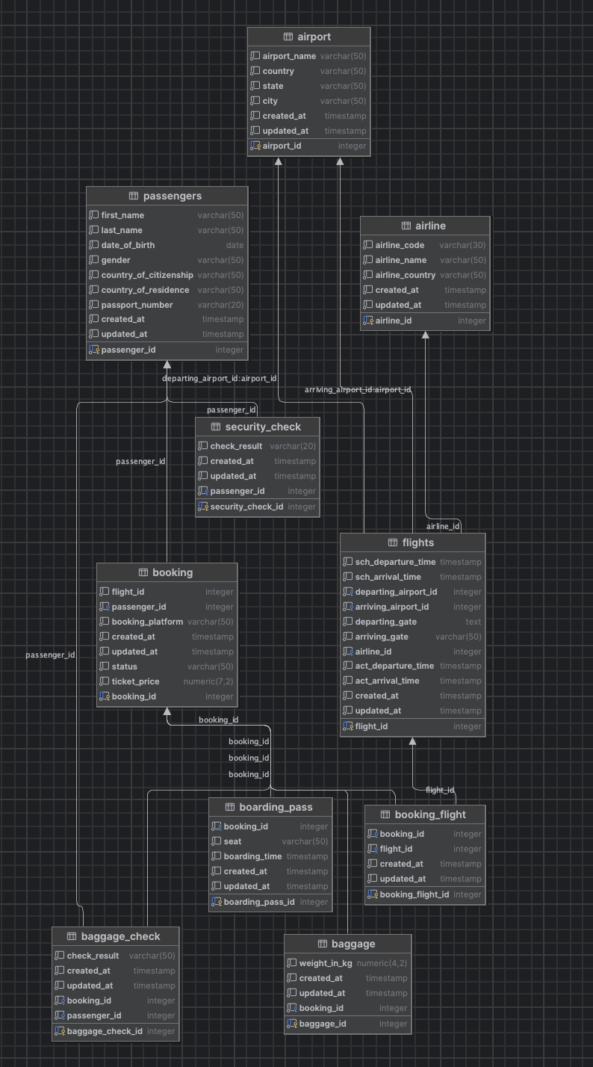
3NF
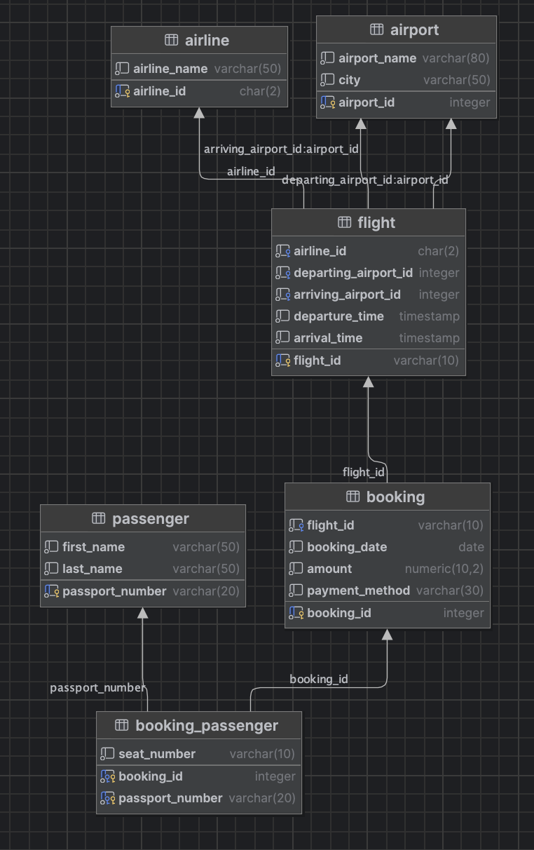

4 Short Explanation of NOT NULL
NOT NULL means that the column cannot be empty. It is used here because the task requires every attribute to have a value. For example, a passenger must have an ID and a flight must have departure and arrival data.

5 Conclusion
The receipt table was divided into smaller 3NF tables to reduce repeated data. The airport database tables, keys, changes and relationships were also created with PostgreSQL DDL.
Add DataGrip screenshots after running the scripts if they are required by the teacher.

