Seatwork No: 6.2
Activity Title: Files and Streams
Course Code: CPE 007 | Program: Computer Engineering
Course Title: Programming Logic and Design | Date Performed: 10/22/26
Section: CPE11S2 | Date Submitted: 10/22/26
Name(s): Turbela, Summer Shane M. | Instructor: Sir. Noel Jason Lusung
Objectives
This activity aims to develop programming skills using files and streams.
Instructions
1. Create a program that reads floating-point numbers line-by-line from a text file. If non-numeric characters are encountered on a line, log a warning, clear the error, and skip to the next line without crashing.
2. Write a program that opens a text file containing lines of mixed numbers and words. Read through the file line by line, print valid numbers, and handle/skip lines containing invalid text data without halting execution.
Submit a document with the format CPE007_Seatwork6_FullName.docx along with the program in two (2) .cpp file formats.
Output/Answer
#include <iostream>
#include <fstream>
#include <string>
#include <sstream>
using namespace std;

int main() {
// opening the file
ifstream file("textfile.txt");
string line;
int lineNum = 0;

// reads the file’s each line
while (getline(file, line)) {
lineNum++;
double num;
istringstream check(line);

if (check >> num) {
cout << "Number: " << num << endl;
} else {
cout << "Skipped line " << lineNum << ": \"" << line << "\" (not a number)" << endl;
}
}

file.close();
return 0;

}

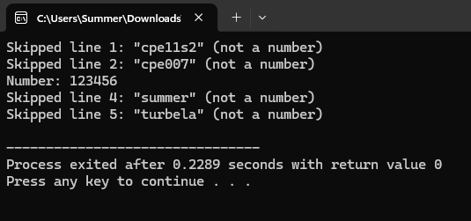
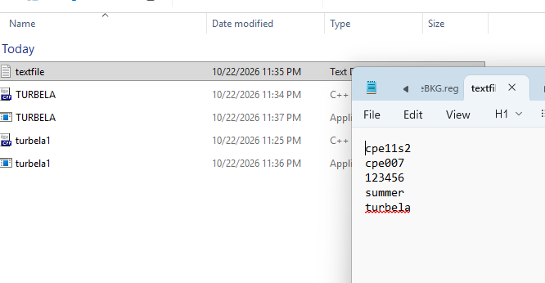

ACTIVITY 2:

//
#include <iostream>
#include <fstream>
#include <string>
#include <sstream>
using namespace std;

int main() {
// opening of the file
ifstream file("textfile2.txt");
string line;
int lineNum = 0;

// reads the file’s each line
while (getline(file, line)) {
lineNum++;
double num;
istringstream check(line);

// makes sure if there’s any line after
if (check >> num) {
cout << "Number: " << num << endl;
} else {
// skips to the next line but displays if the line is or not number only
cout << "Skipped line " << lineNum << ": \"" << line << "\" (not a number)" << endl;
}
}

file.close();
return 0;
}

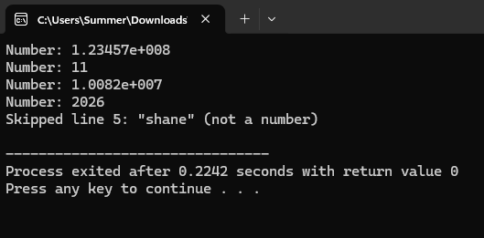
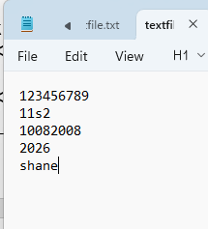

Supplementary Activity (if any)
Conclusion
Super confusing, I needed many references and clear guidelines how to make files outside.
Assessment Rubric: SO 7
