Unit 25 – IT Work Experience

Assignment 1: Preparing and Securing Your IT Work Experience
Job Search Portfolio
Made by
Adil Nsumbu

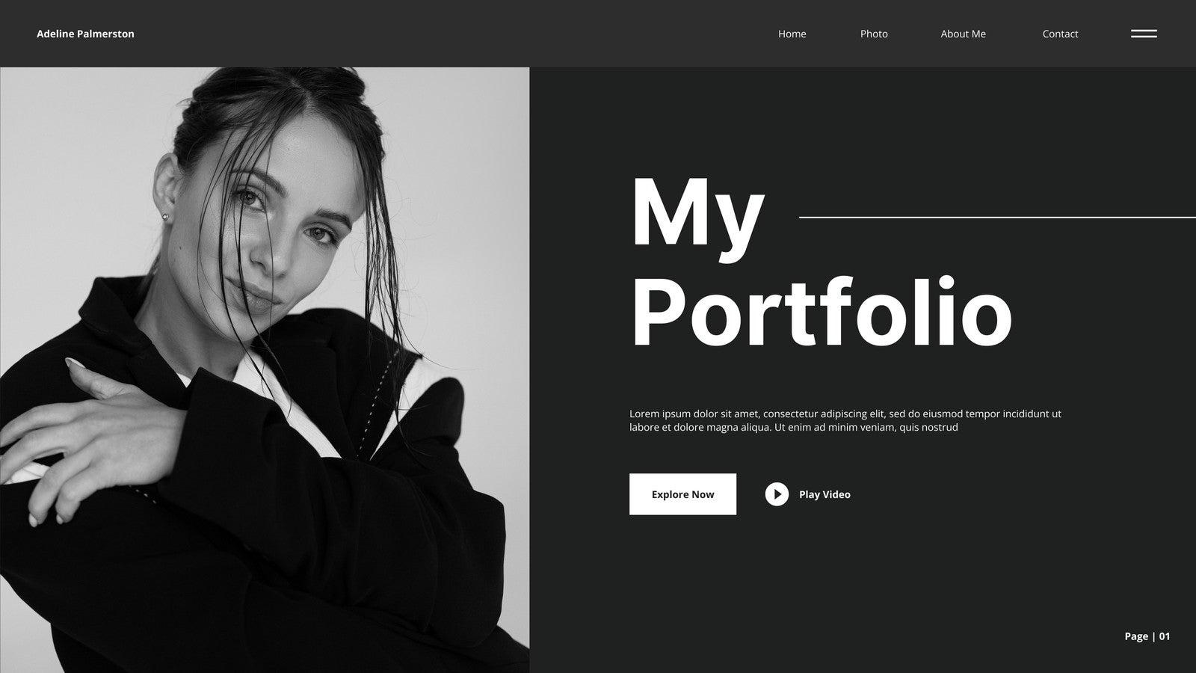

Contents
1. Introduction
2. How this portfolio meets the checklist and criteria
2. Real vacancy evidence and job-search techniques
3. Tailored covering letter and CV – Web Designer
4. Tailored covering letter and CV – Front-End Developer
5. Tailored covering letter and CV – IT Technician
6. Interview evidence and reflection
7. Enhanced applications
8. Feedback from two others and refinement log
9. Health and safety considerations
10. Potential health and safety risks during work experience
12. Measures to reduce the identified risks
13. Conclusion
14. Appendix – source list

Introduction
This portfolio has been prepared to show evidence of searching for suitable IT work experience, tailoring job applications to specific roles, preparing for interview, and understanding health and safety in the workplace. The document is structured around the checklist and the assignment brief so that every required section can be located quickly and assessed clearly. The three roles selected form the AuraLink System vacancy pack and web designer, Front End Developer and IT Technician because they cover design, development and technical support skills across the IT sector.
A stronger version of the portfolio needed real job roles rather than fictional examples, so the vacancy section now uses three genuine vacancies connected to the desire pathways named in the following checklist: Web Designer, Front End Developer and IT Technician. Using real adverts make the evidence more convincing because the CVs, cover letters and interview preparation can be matched to actual employer requirements instead of generic wording.

Real Vacancy Evidence and Job Search Techniques

Job Search Evidence
The vacancies below are suitable because they are all within the IT and creative computing industries and each role links directly to the skills developed on an ICT course. For stronger evidence, each vacancy is followed by two search techniques that could be used on IT job websites such as CWJobs or Indeed to locate similar opportunities efficiently.
Web Designer
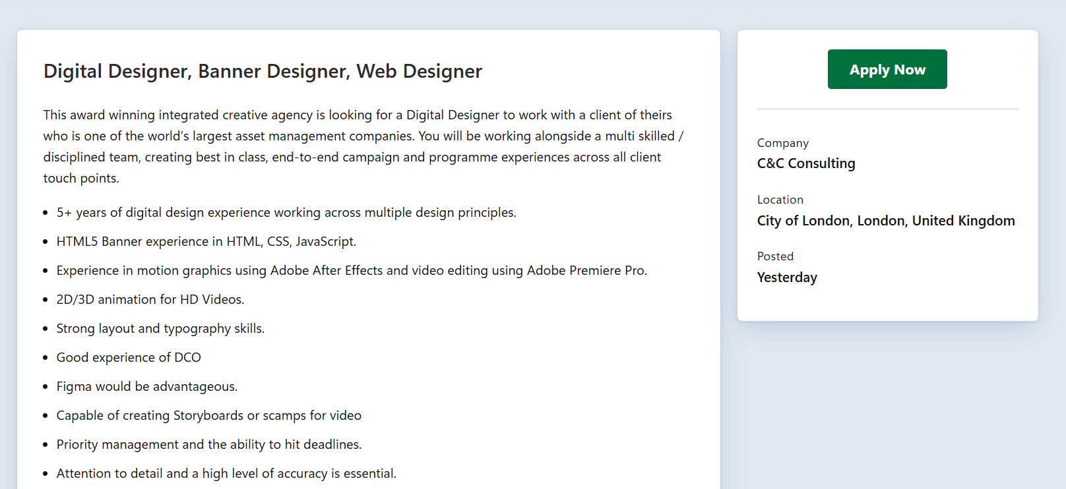

This vacancy is suitable because it is a real London based web design role in a creative agency serving education sector client. The advert focuses on designing websites, brands and e-newsletters, which means the employer is looking for both creativity and practical digital communication skills. That makes it a good match for some building experience in page layout, user interface thinking, branding and responsive design.
It is also helpful for application practice because the role gives clear clues about what the employer values. The wording points toward visual quality, client awareness, professional presentation and the ability to design for a selected audience. A strong applicant would therefore need to show design judgment, attention to detail, confidence receiving feedback and some awareness of how design is turned into working web pages.
Two Annotated Search Techniques Used
- Exact keyword and job-title search: using phrases such as “web designer,” “digital designer”, “education sector web design” and “London” would quickly narrow results to design roles that closely match the checklist. This is effective because it reduces irrelevant jobs such as general marketing roles or back-end development posts.
- Skill-based filtering: adding terms such as “responsive design”, “branding”, “e-newsletters”, “Adobe Creative Suite” and “HTML/CSS” would identify adverts that expect practical design output rather than only theory. This matters because it helps me find roles where I can directly evidence my visual and technical skills in a portfolio and cover letter.

IT Technician
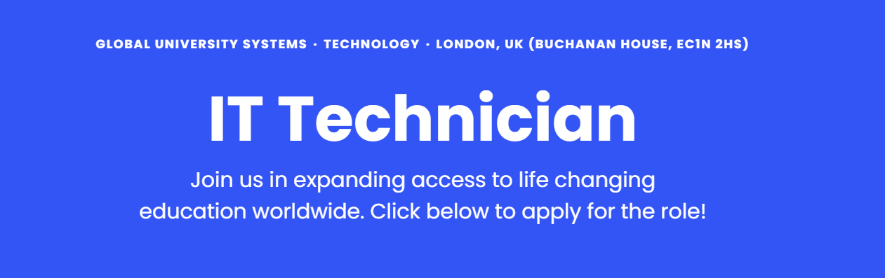

This is the strongest vacancy evidence in the set because it comes directly from the employer’s own careers page and clearly explains the duties, requirements and salary range. The role includes first line and second line support, troubleshooting hardware and software issues, assisting user onsite, supporting Microsoft 365 and understanding networks. Those tasks fit the IT technician pathway very closely.

Within the advert for the job, it also shows that employability matters as much as technical knowledge. The employer wants someone who can communicate professionally with end users, work with other IT teams, stay organised and deliver support in a customer focused way. That means a tailored application should not only list technical tools but also prove patience, clear communication, reliability and an ability to solve problems calmly.

Two Annotated Search Techniques Used
- Synonym searching, I would use related terms such as “IT technician”, “IT support technician,” “service desk”, “desktop support” and “helpdesk” because different employers use different titles for similar work. This widens the search without moving away from the core support pathway.
- Responsibility and environment filters: adding terms such as “Windows,” “Microsoft 365”, “onsite”, “1st line”, “2nd line”, “network support” and “London” helps identify support roles that include real troubleshooting and user-facing duties. This improves the quality of the jobs found because it targets practical technician work rather than broader IT administration roles.
Front End Developer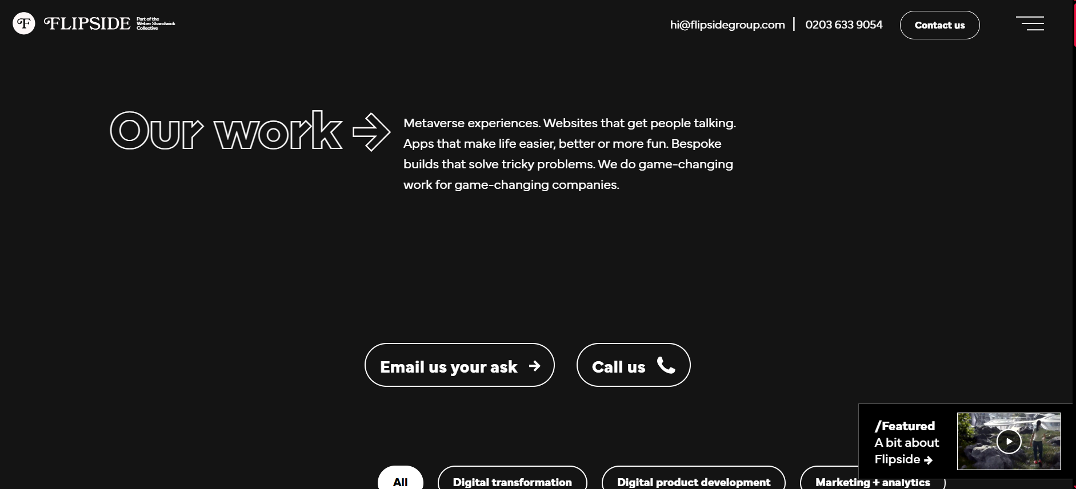

This role is suitable because it is a genuine front-end vacancy in London that links user interface work to real client project. The employer wants someone who can support the design and development teams, which means the role sits between creative thinking and technical implementation. That makes it ideal for a learner who enjoys turning mock ups into responsive pages and improving the user experience through code.
The advert is particularly useful because it names the core front end technologies expected in the role, including HTML, CSS, JavaScript, React and Git. This makes it easier to tailor an application honestly. Instead of writing a generic technology list, I can focus on the specific skills the employer values: clean structure responsive layout, version control, teamwork and the ability to translate design ideas into well organised front-end code.
Two Annotated Search Techniques Used
- Boolean title plus skill search: a search such as “junior front-end developer” AND London AND (HTML OR CSS OR JavaScript OR React) would bring back vacancies that are genuinely front-end focused. This is better than searching only “developer” because it avoids large numbers of unrelated software roles.
- Level and location filtering: selecting junior, graduate or entry-level filters and restricting the location to London makes the search more realistic for work experience or early-career applications. This matters because many front-end vacancies are mid-level or senior, so filtering by experience level saves time and improves the quality of the shortlist.

- Tailored Covering letter and CV – Web Designer
The application below is tailored to the C&C Consulting web design vacancy. The wording focuses on audience awareness, brand presentation, responsive design, and the ability to create visual work for education sector clients.

Cover Letter – Web Designer

Adil Nsumbu
London, UK
adil.nsumbu@ada.ac.uk

Hiring Manager
C&C Consulting Limited
London, UK

Dear Hiring Manager,

I am writing to apply for the job as a Web designer, Digital Designer opportunity in London. I am currently studying ICT, and I am building a strong interest in web design because it combines visual creativity, problem solving, and user focused communication. Your vacancy stood out to me because it involves designing websites, brands a e-newsletters for education sector clients, which require both creative skill and a clear understanding of audience needs.

Through my course and portfolio work, I have been developing skills in layout planning, responsive design thinking, colours and typography choices, and presenting digital ideas clearly. I enjoy improving the design through feedback and making sure that a page is not only attractive but also easy to understand and use. I also have basic knowledge of HTML and CSS, which helps me think realistically about how a design can be handed over and built successfully.

I believe I would be positive. Addition to your team because I take careful and professional approach to my work. I pay mindfulness, I respond well to feedback, and I understand that design decisions should support the purpose of the website rather than just look impressive. In a role collaborating with educational clients, this matters even mor because the content must be clear, organised, and suitable for the target audience.

I would value the role more than anything to gain experience in a creative agency environment and learn from multiple experienced designers and continue improving my technical and employability skills. Thank you for considering my application form.

Yours faithfully

Adil Nsumbu

CV- Web Designer

Main Information: Adil Nsumbu

Address: Weir Hall Road Tottenham N17 8LD Flat 71
Phone: 07735120986
Birthdate: January 23’rd 2009
LinkedIn: Adil Nsumbu| LinkedIn

I am an adaptable athletic teenager hoping to achieve greatness through efficient work and progress steps into career opportunities.

I enjoy socialising and meeting new people, especially working in teams where I can share opinions and also build off others. I am just as good at solo work as being able to focus and put my skills into practice.

I believe I can understand any job, if I get given the opportunity to learn so I can easily adapt to situations and scenarios that others may falter on.

Key skills:

- Adaptable
- Teamwork
- Communication skills
- Problem solving
- English
- IT skills
- Time management
- Organisation skills

Education: Currently Studying

GCSE grade (Secondary):

English Literature: 6
English Language: 5

Digital Information Technology: Level 2 Merit

Film Studies: 5

Enterprise: Level 2 Merit

Ada National College for Digital Skills: September 2025-September 2028
Address Line: Sutherland Street London

Currently studying: Computing Programming, Digital Information, Computing Graphics, Computing Business, Maths A-Level.

Work Experience:

Marks & Spencer’s: Customer Assistant

For this work experience, I worked as a customer assistant where I handled customer complaints, assisting shoppers on the shop floor and maintaining store presentation standards.

What I learnt: I learnt how supermarkets function and how to communicate with customers in a multitude of respectful ways, helping me to continue to be an outgoing employee, even in situations where they are disrespectful.

Achievements:
1. I went on the Outward Bound Trust expedition where I stayed there for 3 days. I had learnt a lot about the natural environment and had experienced a number of different challenges. In the end I had learnt to fend for myself, to become a leader and lead a group through harsh conditions and basic survival skills, such as starting a fire and setting up a tent.

The skills I learnt from it was the ability to become resilient when faced with trial and tribulations. I also learnt to become adaptable in situations where I need to adjust to my environment. I had also learnt how to work with people from different groups with various personalities and quirks and encouraged them to bring out the best to benefit the whole team.

Reference:OutwardBound | Aberdyfi

2. For an industry project provided by my education Ada, we had to work in teams of 4-5 with pupils who we weren’t familiar with. We were all assigned roles and tasks, Lead Presenter, UI Designer, Developer, Project Manager.
My role was the Lead Presenter, my tasks were to design the presentation, manage who spoke during the presentation and had to take up most of the presenting myself.

The skills I had learnt from it was the ability to improve my speaking skills. I had improved especially my stuttering by long and intuitive practice.
Reference: Clinica | Presentation

About Myself:
I enjoy reading and writing. I am currently reading Anthony Robbins Unlimited Power.

I used to be a part of a football team in my secondary school, learning a lot about teamwork and collaboration.

I enjoy working out, especially going to the gym with family and socialising with friends and strangers.

- Tailored Covering Letter and CV – Front End Developer

Cover Letter – Front End Developer

Adil Nsumbu
London UK

Hiring Manager
London UK
Dear Hiring Manager,

I am writing to apply for the Junior Front End Developer role in London. I am an ICT student with a strong interest in front end development because it allows me to combine logical problem solving with interface design and user experience. Your vacancy appeals to me because it links front end coding directly to client projects and highlights the importance of teamwork between design and development.

I am developing my skills in HTML, CSS and JavaScript and I understand how these technologies are used to turn design ideas into responsive, user-friendly pages. I am also building awareness of React and Git, and I understand why reusable components, organised version control and careful testing are important in professional workflow. I enjoy improving the layout, so they are organised and clean, consistent and easier for users to navigate.

What interests me most about this role is that it requires more than the initial writing code. The advert suggests that a successful applicant must be able to translate the mockups accurately, work with others and maintain a quality high across multiple different projects. These are strengths that I am constantly continuing to develop through my coursework, where I plan my work efficiently.

I would introduce the chance to learn in a real development environment and to contribute my enthusiasm and reliability to improve. Thank you for considering my application.

CV- Front End Developer

Main Information: Adil Nsumbu

Address: Weir Hall Road Tottenham N17 8LD Flat 71
Phone: 07735120986
Birthdate: January 23’rd 2009
LinkedIn: Adil Nsumbu| LinkedIn

I am an adaptable athletic teenager hoping to achieve greatness through efficient work and progress steps into career opportunities.

I enjoy socialising and meeting new people, especially working in teams where I can share opinions and build off of others. I am just as good at solo work as being able to focus and put my skills into practice.

I believe I can understand any job, if I get given the opportunity to learn so I can easily adapt to situations and scenarios that others may falter on.

Key skills:

- Adaptable
- Teamwork
- Communication skills
- Problem solving
- English
- IT skills
- Time management
- Organisation skills

Education: Currently Studying

GCSE grade (Secondary):

English Literature: 6
English Language: 5

Digital Information Technology: Level 2 Merit

Film Studies: 5

Enterprise: Level 2 Merit

Ada National College for Digital Skills: September 2025-September 2028
Address Line: Sutherland Street London

Currently studying: Computing Programming, Digital Information, Computing Graphics, Computing Business, Maths A-Level.

Work Experience:

Marks & Spencers: Customer Assistant

For this work experience, I worked as a customer assistant where I handled customer complaints, assisting shoppers on the shop floor and maintaining store presentation standards.

What I learnt: I learnt how supermarkets function and how to communicate with customers in a multitude of respectful ways, helping me to continue to be an outgoing employee, even in situations where they are disrespectful.

Achievements:
1. I went on the Outward Bound Trust expedition where I stayed there for 3 days. I had learnt a lot about the natural environment and had experienced several different challenges. In the end I had learnt to fend for myself, to become a leader and lead a group through harsh conditions and basic survival skills, such as starting a fire and setting up a tent.

The skills I learnt from it was the ability to become resilient when faced with trial and tribulations. I also learnt to become adaptable in situations where I need to adjust to my environment. I had also learnt how to work with people from different groups with various personalities and quirks and encouraged them to bring out the best to benefit the whole team.

Reference:OutwardBound | Aberdyfi

2. For an industry project provided by my education Ada, we had to work in teams of 4-5 with pupils who we weren’t familiar with. We were all assigned roles and tasks, Lead Presenter, UI Designer, Developer, Project Manager.
My role was the Lead Presenter, my tasks were to design the presentation, manage who spoke during the presentation and had to take up most of the presenting myself.

The skills I had learnt from it was the ability to improve my speaking skills. I had improved especially my stuttering by long and intuitive practice.
Reference: Clinica | Presentation

About Myself:
I enjoy reading and writing. I am currently reading Anthony Robbins Unlimited Power.

I used to be a part of a football team in my secondary school, learning a lot about teamwork and collaboration.

I enjoy working out, especially going to the gym with family and socialising with friends and strangers.
- Tailored Covering letter and CV – IT Technician

Cover Letter – IT Technician

Adil Nsumbu
London, UK

Hiring Manager,
Global University Systems

Dearing Hiring Manager,

I am writing to apply for the IT technician role that is in London. I am currently studying ICT, and I am especially interested in the field of technical support because it combines problem solving, communication and practical use of IT knowledge to help other people work effectively. Your vacancy stood out to me because it includes first line and second line support, hardware and software troubleshooting, Microsoft 365 support and communication with end users across the organizations.

Through my intensive studies I have been developing a broad understanding of operating systems, devices set up, troubleshooting and safe digital working. I enjoy working through a problem carefully, finding the issue and testing any possible solutions and outcomes clearly. I understand that good IT support is not only about technical knowledge but also mainly about patience, professionalism and keeping users informed.

Your advert particularly interested me because it expects strong customer service as well as technical support skills. I believe this suits my approach. I am extremely calm about solving problems. I listen carefully to the issue that is reported and I try my best to communicate clearly so the user can understand both the problem and the fix.

Yours Faithfully,

Adil Nsumbu

CV- IT Technician

Main Information: Adil Nsumbu

Address: Weir Hall Road Tottenham N17 8LD Flat 71
Phone: 07735120986
Birthdate: January 23’rd 2009
LinkedIn: Adil Nsumbu| LinkedIn

I am an adaptable athletic teenager hoping to achieve greatness through efficient work and progress steps into career opportunities.

I enjoy socialising and meeting new people, especially working in teams where I can share opinions and also build off of others. I am just as good at solo work as being able to focus and put my skills into practice.

I believe I can understand any job, as long as I get given the opportunity to learn so I can easily adapt to situations and scenarios that others may falter on.

Key skills:

- Adaptable
- Teamwork
- Communication skills
- Problem solving
- English
- IT skills
- Time management
- Organisation skills

Education: Currently Studying

GCSE grade (Secondary):

English Literature: 6
English Language: 5

Digital Information Technology: Level 2 Merit

Film Studies: 5

Enterprise: Level 2 Merit

Ada National College for Digital Skills: September 2025-September 2028
Address Line: Sutherland Street London

Currently studying: Computing Programming, Digital Information, Computing Graphics, Computing Business, Maths A-Level.

Work Experience:

Marks & Spencers: Customer Assistant

For this work experience, I worked as a customer assistant where I handled customer complaints, assisting shoppers on the shop floor and maintaining store presentation standards.

What I learnt: I learnt how supermarkets function and how to communicate with customers in a multitude of respectful ways, helping me to continue to be an outgoing employee, even in situations where they are disrespectful.

Achievements:
1. I went on the Outward-Bound Trust expedition where I stayed there for 3 days. I had learnt a lot about the natural environment and had experienced several different challenges. In the end I had learnt to fend for myself, to become a leader and lead a group through harsh conditions and basic survival skills, such as starting a fire and setting up a tent.

The skills I learnt from it was the ability to become resilient when faced with trial and tribulations. I also learnt to become adaptable in situations where I need to adjust to my environment. I had also learnt how to work with people from different groups with various personalities and quirks and encouraged them to bring out the best to benefit the whole team.

Reference:OutwardBound | Aberdyfi

2. For an industry project provided by my education Ada, we had to work in teams of 4-5 with pupils who we weren’t familiar with. We were all assigned roles and tasks, Lead Presenter, UI Designer, Developer, Project Manager.
My role was the Lead Presenter, my tasks were to design the presentation, manage who spoke during the presentation and had to take up most of the presenting myself.

The skills I had learnt from it were the ability to improve my speaking skills. I had improved, especially my stuttering, by long and intuitive practice.
Reference: Clinica | Presentation

About Myself:
I enjoy reading and writing. I am currently reading Anthony Robbins Unlimited Power.

I used to be a part of a football team in my secondary school, learning a lot about teamwork and collaboration.

I enjoy working out, especially going to the gym with family and socialising with friends and strangers.

- Interview evidence and reflection.

For interview evidence, I have based my preparation on the Web Designer role because it has the clearest responsibilities and allows me to demonstrate both technical understandings and a deliberate customer service skill. The section below shows a planned preparation that I have taken that is likely questions and a concise reflection.
A real signed witness or feedback sheet should be inserted before submission.

Preparation area: | What I would do:
Company Research | Read the employer page, understand the organisation and note the location of the organisation, the salary, work patterns and the main responsibilities.
Role Research | Review the advert carefully and prepare example linked to customer support, such as CSS.
Presentation | Dress professionally, arrive early, bring a copy of my CV and maintain a confident body language and a good eye contact.
Evidence | Prepare short examples showing patience, teamwork, problem solving and safe handling of equipment.
Question to ask | Ask about training and the different services that are provided,

Interview Reflection
This interview preparation shows that confidence in a Web Designer interview comes from planning rather than guessing. By researching the role, preparing examples and practising answers, I can speak more clearly about what I know and where I am still developing. The role also requires professional communication, so I would need t show not only technical understanding but also the ability to reassure users and represent the organisation positively.
If completed the interview in real life, the most important evidence to collect would be a witness statement or feedback sheet confirming attendance, communication, professionalism and areas for improvement. That direct evidence is important because it proves that the interview stage was genuinely completed rather than only described.
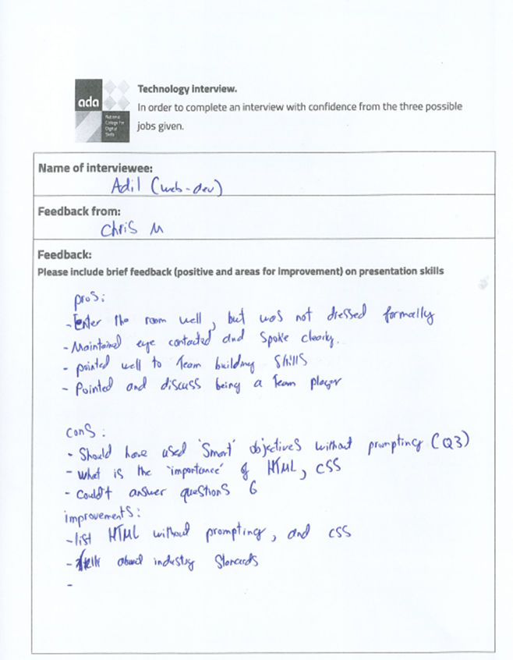

The feedback from my mock interview has helped me understand the areas of my improvements. Weaknesses that I have discovered are that I need to discuss the main objectives, which suggests that I need to improve my confidence and preparation when answering structured interview questions independently. Indeed, to improve my knowledge in HTML and CSS without relying on further prompts. THis is key because technical understanding is a key requirement for roles such as web designer' and 'front-end developer'. Another improvement point was that I need to get a better understanding of industry standards and professional expectations in the IT sector.

But the positive feedback was that I was confident with entering the room and speaking throughout the interview. The feedback also stated that I maintained good eye contact and spoke clearly throughout my answers, which helped create a more professional impression.
- Enhanced Applications
After going through my original applications and going through major feedback from others, I have refined my CVs and cover letters to better match my expectations of employers within the IT industry. This process has improved the professionalism, the relevance and the quality of my applications

Original Application Feature | Improvement Made | Reason for Improvement
Generic personal statement | Tailored each personal statement to the specific role | Makes the application more relevant to the employer
Limited technical detail | Added role-specific skills such as HTML, CSS, JavaScript and troubleshooting | Demonstrates technical suitability for the role
Basic cover letter structure | Included company research and role responsibilities | Shows preparation and genuine interest
A few examples of experience | Added examples of teamwork, leadership and customer service | Demonstrates employability skills

Refining my applications was important because employers expect applications to be specifically targeted towards their workplace rather than copied and reused multiple times for different roles. By adapting each Cv and cover letter individually, I was able to show a clearly understanding of the requirements and the expect skills within the different roles of the IT industry
For example, the front-end developer application focused primarily on the programming skills of a responsive design and user experience, while IT technician application was focused on troubleshooting, communication and customer support. These differences made the applications more realistic and professional because each reflected the priorities of the employer.
Overall the enhanced applications are significantly stronger because they help demonstrate the technical ability, employability skills and a better understanding of an employer's expectations within the IT sector.
- Health and Safety
Health and safety procedures are important within the IT workplace because employees regularly work with electrical equipment, computer systems, cables, and any sensitive data. Failing to follow a safety procedure could result in issues, such as physical injury, damage to equipment or serious data issues. During IT work experience, it is extremely important to follow workplace policies carefully in order to protect both others and myself within the environment.
One of the main risks within an IT workplace could be electrical equipment. These include computers, chargers, and extension cables, which can be dangerous if they are damaged or overloaded.
To reduce the risk, all equipment should be checked regularly, and faulty devices should be reported immediately to a supervisor. Employees should need to avoid touching any damaged cables and should never overload the sockets with multiple devices.
Many IT roles involve spending long periods working at a computer. This can lead to multiple health issues, such as eye strain, headaches, repetitive strain injuries, and poor posture. If workstations aren't modified correctly, then issues like long-term back and neck and wrist problems may occur.
To minimise these risks, employees should take regular breaks from screens, maintain a good sitting posture and have adjustable chairs and monitors that suit them the most.
For trip hazards, such as loose wires, cables and equipment left around the workspaces may cause hazards that could cause injuries. In a large and busy office environment, poor cable management can become a safety issue.
The risk can be reduced by keeping workspaces clean and organised at all times. Cables should be secured properly by using cable management systems, and any unnecessary equipment should be removed from any main walkways.

- Potential Health and Safety Risks During IT Work
The first potential health and safety risk could be when an employee works continuously at a computer screen; this can cause headaches, eye strain and fatigue. Poor workstation positioning can increase the likelihood of a long-term posture problem and repetitive strain injuries.
Measures such as employees getting screen breaks, maintaining a good posture and ensuring monitors are positioned at an easy-to-read eye level. Adjustable chairs and ergonomic equipment should also be used to support comfort and reduce strain.
Damaged plugs, exposed wires or clustered extension leads may create a risk of electric shock or fires within the workplace. IT environments often rely on electrical equipment, making this a significant safety concern.
A way to reduce this could be testing equipment regularly and checking if devices are faulty to prevent any future issues. If issues do come up, then they should be reported immediately.
For loose cables and equipment that are left around, this can cause issues such as falls or injuries. This is especially dangerous in an environment with a large amount of computers and cables.
Cables need to be organised and workspaces should be kept tidy to prevent any hazards.

- Measures to reduce Risks During IT Work
There are several measures that organisations should teach to employees so that they can reduce risks during IT work experience placements.
Firstly, employees should complete health and safety training programmes before using any special equipment. Training helps employees better understand emergency procedures, workplace rules and how to use the equipment safely.
Secondly, workstations should be reworked correctly to support safe and comfortable computer use. This can be done by providing ergonomic equipment where possible, including adjustable chairs, monitor stands and a suitable desk layout. These adjustments reduce the risk of posture-related injuries.
Finally, maintaining a clean and organised workspace is key within IT environments. Good organisation reduces any trip hazards, improves productivity and creates a more professional atmosphere. Employers should also regularly inspect any electrical equipment and update security systems to ensure the workplace remains safe and secure at all times.

Conclusion
This portfolio has been organised around the full checklist for Assignment 1 and includes evidence of suitable job searches, tailored application documents, interview preparation, enhanced application materials, feedback and refinement structures, and a detailed health and safety report. The strongest feature of the portfolio is that each application is targeted to a specific role rather than using a generic approach. Before final submission, the remaining placeholders should be completed with genuine interview evidence, named feedback from two others, real contact details and a real portfolio link so the work is both accurate and fully ready for assessment.

