logo

QEFileImage Widget

Andrew Starritt

18th March 2022

Copyright (c) 2022 Australian Synchrotron

Permission is granted to copy, distribute and/or modify this document under the terms of the GNU Free Documentation License, Version 1.3 or any later version published by the Free Software Foundation; with no Invariant Sections, no Front-Cover Texts, and no Back-Cover Texts.  
A copy of the license is included in the section entitled "GNU Free Documentation License" within the QE_QEGuiAndUserInterfaceDesign document.

Contents

Introduction 3

Description 3

Properties 4

variable : QString 5

variableSubstitutions : QString 5

elementsRequired : int 5

arrayIndex : int 5

threshold : int 5

thresholdColor : QColor 5

scaledContents : bool 5

# Introduction

This document describes in detail the QEFileImage widget which is an EPICS aware widget provided by the EPICS Qt, aka QE, Framework.

This document was created as a separate widget specification document. The main reason for this is ease of maintenance and avoiding editing large and unwieldly word documents.

The QE Framework is distributed under the GNU Lesser General Public License version 3, distributed with the framework in the file LICENSE. It may also be obtained from here: <http://www.gnu.org/licenses/lgpl-3.0-standalone.html>

# Description

The QEFileImage displays an image file where the name of the file to display has been provided through a process variable. The process variable may provide a DBF_STRING value, however as this is limited to 40 characters, it would be typically an array of DBF_CHAR (e.g. from a waveform record) which can be any size.

The file type can be any type that can be loaded into a QPixmap – for example, .png, .jpg, .bmp, .tiff, etc.

If the file referenced changes it is updated in the widget.

This widget can be used in several ways:

* Displaying an updating image. This is useful where a third-party system is generating an image file that is not integrated into EPICS.
* Displaying the last image captured in a scan where a variable is set to point to the last most recent image capture during a scan. Note, the image path must be valid on the machine where the widget is used (as opposed to the machine on which the IOC runs)
* Selecting a graphic for display. A calculation can be used to select a file name based on a value. Note, using the widget like this embeds GUI functionality in the control system which is generally not good practice.
* Previewing image file selected using the QEFileBrowser widget. This may be performed in a couple of ways:
  + Linking the QEFileBrowser widget’s ‘selected’ signal to the QEFileImage ‘setImageFileName’ slot directly on the GUI.
  + Where the QEFileBrowser widget’s output is written to a variable, using that variable as the ‘variable’ property of the QEFileImage widget.

Note, if an image is available directly through channel access, the QEImage widget can be used to display the image.

A luminescence threshold may be applied to the image. Luminesces values range from 0 to 255. The threshold (int) and thresholdColor properties allow high luminescence pixels to be replaced with the threshold colour. A threshold of 0 means every pixel’s colour is replaced, while a threshold of 256 means no pixel’s colour is replaced. The threshold may be set statically at design time, or dynamically using the ‘setThreshold(int)’ slot. The source can be any widget that provides an integer signal value include the ‘dbValueChanged(int)’ signal available from many QEWidgets.

Figure 1 (page 4) shows examples of QEFileImage used to display an image as specified by an EPICS variable, and to preview an image selected from a QEFileBrowser widget. The QEFileBrowser preview uses the ‘selected’ signal from the QEFileBrowser widget connected to the ‘setImageFileName’ slot of the QEFileImage widget.

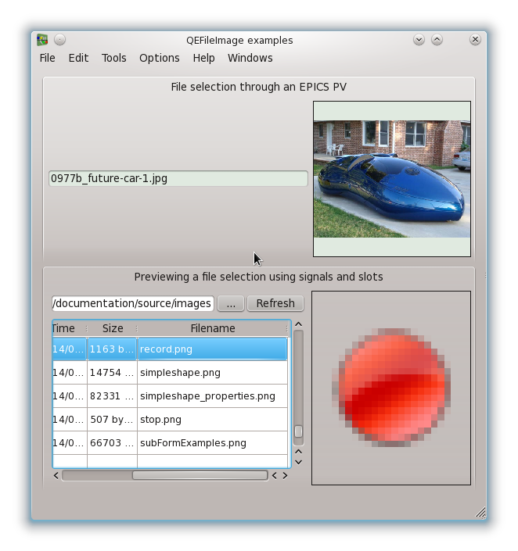

Figure QEFileImage widget taking file information from variable and from a signal

# Properties

The QEFileImage inherits directly from QLabel and as such inherits all the properties. As well as the standard properties (such as variableAsToolTip, defaultStyle – not described here), the widget has the following class specific properties.

## variable : QString

This defines the process variable protocol and name. The variable provides the filename as text. The file will be searched for using standard rules for locating files described in the QE_QEGuiAndUserInterfaceDesign document. The variable name can also be set directly using the ‘setImageFileName’ slot.

## variableSubstitutions : QString

This defines the default substitutions that are applied to the variable name.

## elementsRequired : int

*default value:* 0

For a DBF_STRING array PV, this can be used to limit the number of elements subscribed for (0 implies all elements). For a DBF_CHAR array PV, this should be left as the default value.

## arrayIndex : int

*default value:* 0

For a DBF_STRING array PV, this nominates the array element subject to the statistical analysis. For a DBF_CHAR array PV, this should be left as the default value.

## threshold : int

*range: 0 to 256  
default value:* 256

This defines a threshold value at which colour substitution applies. The threshold can also be set directly using the ‘setThreshold’ slot.

## thresholdColor : QColor

*default value:* white

This defines a colour which is substituted for each pixel with a luminescence >= the specified threshold.

## scaledContents : bool

*default value:* false

This controls weather the aspect ratio is ignored to allow the image to fill the complete screen area used by the widget.