logo

QELink Widget

Andrew Starritt

9th January 2025

Copyright (c) 2025 Australian Synchrotron

Permission is granted to copy, distribute and/or modify this document under the terms of the GNU Free Documentation License, Version 1.3 or any later version published by the Free Software Foundation; with no Invariant Sections, no Front-Cover Texts, and no Back-Cover Texts.  
A copy of the license is included in the section entitled "GNU Free Documentation License" within the QE_QEGuiAndUserInterfaceDesign document.

Contents

Introduction 3

Description 3

Slots 4

Signals 5

Properties 5

condition: enumeration 5

comparisonValie: string 6

signalTrue: bool 6

signalFalse: bool 6

outTrueValue : string 6

outFalseValue : string 6

lookupValues : string list 6

runVisible: bool 6

# Introduction

This document describes in detail the QELink widget provided by the EPICS Qt, aka QE, Framework.

This document was created as a separate widget specification document. The main reason for this is ease of maintenance and avoiding editing large and unwieldly word documents.

The QE Framework is distributed under the GNU Lesser General Public License version 3, distributed with the framework in the file LICENSE. It may also be obtained from here: <http://www.gnu.org/licenses/lgpl-3.0-standalone.html>

# Description

The QELink widget is a non-EPICS aware widget which is part of a general mechanism to allow a GUI to be modified by data changes. For example, to disable a GroupBox if a variable is equal to a nominated value.

By default, QELink widgets are only visible while in Designer. After placing them in a GUI, the appropriate signals/slots connections and properties are defined to configure the GUI behaviour based on a signal value, typically but not always based on a PV value. When opened in QEGui (or in any application except Designer) the functionality remains, but the QELink widget itself is hidden. This may be overridden by setting the runVisible property to True.

Typically, a QE widget sends data update signals to a QELink widget which makes a comparison and signals a value to another widget depending on the comparison result. The output signal can be used to set a widget invisible, or enabled, or click a button, or set focus, or raise, etc. Alternatively the signal value can be used to select the output value from a predefined list of values.

In Figure 1, A QELink widget (circled) is configured to receive data update signals from a QELabel displaying beam current. It compares this to 205 (mA) and if greater sends a signal to enable the group box on the right. The signals used and the relevant QELink Properties are shown in the figure. Figure 2 shows this GUI in use by the QEGui display application. The QELink widget is not visible. The ‘Shutdown’ group box on the right is not enabled as the beam current is less than 205 mA.

The QELink widget can be made visible at all times by setting the ‘visible’ property.

Traditionally, the type of GUI functionality QELink widgets support has been provided by using EPICS database variables (often CALC records) to determine the state of GUI items. Where the variable is primarily a part of the control system this is appropriate. Where the variable is only present to support the GUI, then this functionality should be embedded in the GUI.

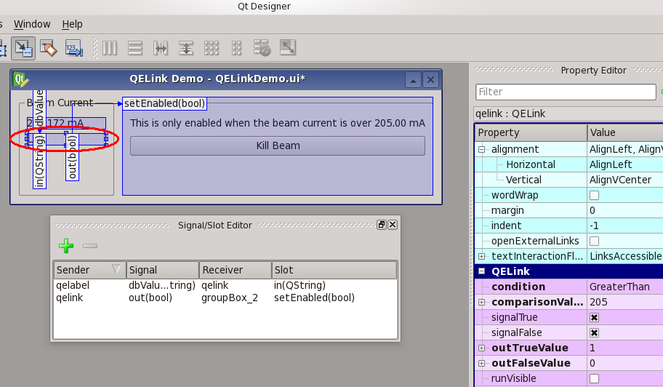

Figure 1 QELink being configured

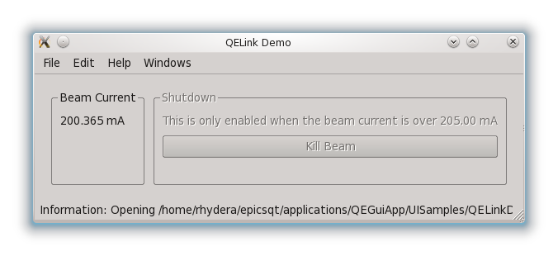

Figure 2 QELink in use

# Slots

The QELink widget provides the following slots to receive values of various types. Typically, a connection would only be made to one slot only, however nothing prevents multiple slots being used.

**void** in (**const** bool& in);  
**void** in (**const** int& in);  
**void** in (**const** long& in);  
**void** in (**const** qlonglong& in);  
**void** in (**const** double& in);  
**void** in (**const** QString& in);

# Signals

The QELink widget provides the following signals to provide values of various types. Note: a signal is only emitted if the output value and be converted to the associated data type.

**void** out (**const** bool& out);  
**void** out (**const** int& out);  
**void** out (**const** long& out);  
**void** out (**const** qlonglong& out);  
**void** out (**const** double& out);  
**void** out (**const** QString& out);

# Properties

The specific properties for this widget are shown in Figure 3 QELink properties below.

Figure 3 QELink properties

## condition: enumeration

*allowed values:* Equal, NotEqual, GreaterThan, GreaterThanOrEqual, LessThan,  
 LessThanOrEqual, or Lookup. *default value:* Equal

This determines show the widget processes data received via one of the in slots.

When the condition is one of the comparators, the incoming slot value is compared against the comparisonValue (if it can) and the widget signals the True or False output value (if the corresponding signal control properties is set).

When the condition is Lookup, the incoming slot value is used to access the appropriate lookupValues entry (provided the slot value is numeric and in range) to provide the output signal value.

## comparisonValie: string

*default value:* empty

This provide the value that incoming slot values are compared against when condition is not Lookup.

## signalTrue: bool

*default value:* True

This controls if a signal is emitted when the value comparison yields true.

## signalFalse: bool

*default value:* True

This controls if a signal is emitted when the value comparison yields false.

## outTrueValue : string

*default value*: empty

This is the value is emitted when the value comparison yields true.

## outFalseValue : string

*default value*: empty

This is the value is emitted when the value comparison yields false.

## lookupValues : string list

*default value*: empty list

This property is only used when the condition property is set to ‘Lookup’.  
If the in incoming slot value can be interpreted as an integer and is in the range 0 to N-1 (where N is the number of entries in the string list), the corresponding entry is used as the emitted signal value.

## runVisible: bool

*default value*: false

This controls whether the QELink widget is visible in QEGui and any other not designer display managers. The QELink widget is always visible in designer.