logo

QERadioGroup Widget

Andrew Starritt

16th July 2020

Copyright (c) 2020 Australian Synchrotron

Permission is granted to copy, distribute and/or modify this document under the terms of the GNU Free Documentation License, Version 1.3 or any later version published by the Free Software Foundation; with no Invariant Sections, no Front-Cover Texts, and no Back-Cover Texts.  
A copy of the license is included in the section entitled "GNU Free Documentation License" within the QE_QEGuiAndUserInterfaceDesign document.

Contents

Introduction 3

QRadioGroup 3

Description 3

Properties 3

title : QString 3

buttonStyle : enumeration 3

buttonOrder : enumeration 3

columns : int 4

spacing : int 4

strings : QStringList 4

value : int 4

QERadioGroup 5

Description 5

Properties 6

variable : QString 6

variableSubstitutions : QString 6

elementsRequired : int 6

arrayIndex : int 6

title : QString 6

columns : int 7

spacing : int 7

useDbEnumerations : bool 7

localEnumeration : QString 7

buttonStyle : enumeration 7

buttonOrder : enumeration 7

# Introduction

This document describes in detail the QRadioGroup and QERadioGroup widgets provided by the EPICS Qt, aka QE, Framework.

This document was created as a separate widget specification document. The main reason for this is ease of maintenance and avoiding editing large and unwieldly word documents.

The QE Framework is distributed under the GNU Lesser General Public License version 3, distributed with the framework in the file LICENSE. It may also be obtained from here: <http://www.gnu.org/licenses/lgpl-3.0-standalone.html>

The QRadioGroup is a non-EPICS aware widget that allows updating a value by selecting one of a number of radio buttons, each showing single enumeration value. QERadioGroup extends the functionality of the QRadioGroup widget and provides EPICS-awareness via a single control Process Variable, typically associated with a bo record or an mbbo record.

# QRadioGroup

## Description

The QRadioGroup inherits directly from Qt’s own QGroupBox. It provides a container that holds a number of dynamically created buttons, one per item of the strings QStringList property. It was designed to mimics the Delphi TRadioGroup component.

Selected values are made available via the *valueChanged(int)* signal.

## Properties

### title : QString

*defaultValue*: " QRadioGroup "

This replaces the QGroupBox title property which is hidden, and provides the title for the group box. A single hyphen, i.e. "-", should be used to represent no title.

### buttonStyle : enumeration

*allowed values*: Radio, Push  
*defaultValue*: Radio

This property controls the style of the embedded enumeration selection buttons. See Figure 1 below as an example of each style.

### buttonOrder : enumeration

*allowed values*: rowMajor, colMajor  
*defaultValue*: rowMajor

This property controls the way in which the embedded enumeration selection buttons are displayed within the group box. See Figure 1 below as an example of each. Note for both examples, the enumeration order is "Red", "Green" and "Blue".

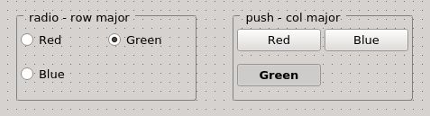

Figure 1 QRadioGroup example with radio buttons (left) and push buttons (right)

### columns : int

*allowed values*: 1 – 16  
*default value*: 2

This property controls the maximum number of columns used to layout the enumeration selection buttons.

### spacing : int

*allowed values*: 0 – 20  
*default value*: 4

This property controls the margin and spacing between the buttons with the group box.

strings : QStringList  
*default value*: empty list

This property defines the set of enumeration values. Note: the widget neither enforces these values to be unique nor forces these not to be empty/null values.

### value : int

*allowed values*: -1, or 0 to number of items less.

This is the value of the selected enumeration value if >= 0. Or no selection is set to -1.

# QERadioGroup

## Description

The QERadioGroup inherited directly from QEAbstractWidget and in this way inherits many standard properties used by QEWidgets, and includes an embedded QRadioGroup widget in order to provide the radio group box capability (recall Qt only allows direct inheritance from one QObject/QWidget only). This allows a QERadioGroup widget to set the value of an enumeration PV.

Essentially this widget provides the same functionality that is provided by QEComboBox widget, albeit presented very differently. On selection of one of the embedded buttons, the underlying value is written to the associated PV. Typically a QERadioGroup widget would be used with a bo record or an mbbo record.

As with the QEComboBox, within Qt’s designer, the user may elect to use the enumeration strings that are defined in the EPICS database and these will be assigned to the buttons within the radio group if the ‘useDbEnumerations’ property is set (the default). If the ‘useDbEnumerations’ property is not set, then the strings used by the radio group for each variable value must be set up in localEnumeration property (see the QE_QEGuiAndUserInterfaceDesign document for details). The latter is useful if/wehen writing to a longout record for example.

The examples in Figure 2 shows two QERadioGroup widgets connected to the same mbbo record. The widget on the left is using the database provided enumeration strings, and the widget on the right is using the enumeration values defined using the localEnumeration property.

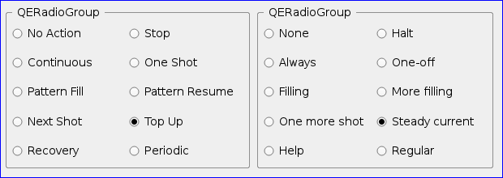

Figure 2 QERadioGroup example showing local and database defined enumeration strings

Figure 3 below shows two radio group widgets controlling the same process variable, one in each style. For the push button style, the font style of the button corresponding to the selected state is set bold.

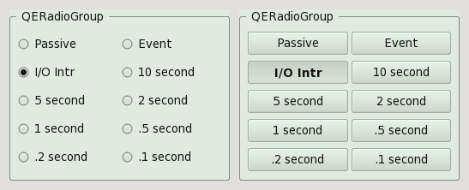

Figure 3 QERadioGroup example showing radio and push button styles

## Properties

Many QRadioGroup properties are exposed as QERadioGroup properties.

variable : QString  
*default value*: empty string

This property specifies the PV variable name associated with this widget. Standard macro substitutions are allowed.

variableSubstitutions : QString  
*default value*: empty string

This property specifies the default substitutions to be used. This may be particularly useful when creating/modifying a form within *designer*.

elementsRequired : int  
*default value*: 0

The maximum number of elements to be read, 0 means all elements.

arrayIndex : int  
*default value*: 0

The element of an array PV to be updated by the widget.

title : QString  
*default value*: " QERadioGroup "

This property provides the title for the group box. A single hyphen, i.e. "-", should be used to represent no title.

### columns : int

*allowed values*: 1 – 16  
*default value*: 2

This property controls the maximum number of columns used to layout the enumeration selection buttons.

### spacing : int

*allowed values*: 0 – 20  
*default value*: 4

This property controls the margin and spacing between the buttons with the group box.

useDbEnumerations : bool  
*default value*: true

localEnumeration : QString  
*default value*: empty string

### buttonStyle : enumeration

*allowed values*: Radio, Push  
*defaultValue*: Radio

This property controls the style of the embedded enumeration selection buttons. See Figure 3 above as an example of each style.

### buttonOrder : enumeration

*allowed values*: rowMajor, colMajor  
*defaultValue*: rowMajor

This property controls the order in which the embedded enumeration selection buttons are displayed within the group box. See Figure 1 above as an example of each.