Strip Chart User Guide

24 September 2018

# Introduction

This technical note provides a user guide to operating the Strip Chart. Although based on Technical Note AS-CIT-200904-03 which describes the Delphi GUI Strip Chart on which the EPICS Qt Strip Chart look and feel is based, this document focuses on the EPICS Qt Strip Chart widget.

The Strip Chart widget provides the user the means to plot up-to 16 Channel Access arbitrary scalar values over a user selectable time period. The widget also provides the ability to extract archived data from either one or more Channel Access archivers or the Archive Appliance and to integrate this with the real time data.

# Accessing the Strip Chart

The Strip Chart, although complicated (compared to a QLabel) is just a widget and may be dropped onto any form from within designer, or an instance may be created programmatically and placed into a QMainWindow. However, if using the standard QEGui display manager, the Strip Chart is available as a built in form, accessible via the Tools menu as illustrated below.

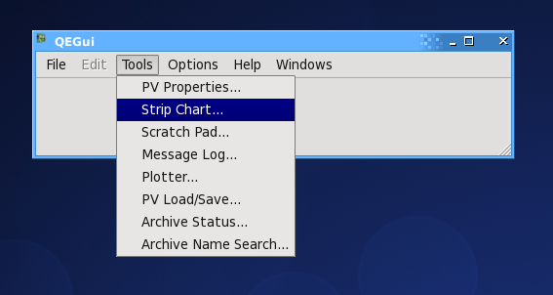

Alternatively, right-clicking on any QE EPICS aware widget with offer the “Plot In StripChart” context menu option. Selecting this will open a new Strip Chart with this PV as the first item.

# Using the Strip Chart

The following sub-sections describe the function and operation of the major parts of the Strip Chart.

## Tool Bar

The Tool Bar is located at the top of the Strip Chart. It consists of a number tabs, each with buttons, icons and/or text and associated status information.

### Standard Tab

The main tab is illustrated below.



The function of each of these controls is described below.

1. Backward/Forward Control



These buttons are used to go back to a previous Strip Chart state or forwards again (the Strip Chart state is set by the other controls on the tool bar (described below)). The paradigm mimics that of a browser going back to the previous page or forwards again.

1. Normal Video / Reverse Video  
     
     
     
   These buttons are used to select either a white or a black background colour to be used on the actual chart area. The former is better for printing and for inclusion within a document.
2. Linear Display / Log Display  
     
     
     
   Selects whether the display is linear (default) or logarithmic. To avoid invalid floating point operation exceptions, the log of any value less than 1.0E-20 is taken to be -20.
3. Manual / Auto / Data / Dynamic / Normalised Scaling  
     
   strip_chart_buttons.png  
     
   These buttons allows the selection of one of the vertical (y-axis) scaling modes of operation. From left to right these buttons do:  
     
   *Manual Scale*: - launches a dialog box to allow the user to manually specify the required lower and upper display bounds of the chart.  
     
   *Auto Scale*: - scales chart to encompass the lower to the upper display limits of all the PVs currently being monitored, i.e. from the minimum of all the LOPR values to the maximum of all the HOPR values. If a PV has not specified LOPR and HOPR (essentially both values are set to 0) then the PV is excluded from the auto scale calculation. If none of PVs have LOPR/HOPR specified the vertical scaling remains unchanged.

*Plotted Scale*: - scales the chart’s vertical axis to encompass all values within the Strip Chart’s current timeframe.

*Buffered Scale*: - similar to above, save that scales chart to encompass all buffered values as opposed to just displayed values.

*Dynamic Scale*: - similar to Plotted Scaling above, except that the required chart limits are continuously re-evaluated and re-applied.  
  
*Normalised Scale*: - each PV is drawn as if the Strip Chart is scaled to the HOPR/LOPR bounds of the PV itself. The nominal Y-axis scale is 0 to 100.   
‘Better’ icons are still under development.

1. Select Time Duration  
     
   strip_chart_time_buttons.png

These buttons allow the selection of the time scale duration of the Strip Chart from a pre-determined number of durations from ranging 1 minute to 2 days.   
  
The button on the extreme right opens a dialog form that allows for the selection of an arbitrary time, expressed in days, hours minutes and seconds. The minimum duration that can be specified is 1 second. The maximum is 9,999 days, i.e. about 27 years which is well beyond the expected operational lifetime of the synchrotron.

1. Time Zone selection.  
     
   strip_chart_time_zones.png  
     
   These buttons select the time zone to be used by the Strip Chart. From left to right these buttons are:  
     
   Left Button : use local time. The widget attempts to extract the time zone abbreviation from the operating system and use this for the button text. For example as shown here - AEST (Australian Eastern Standard Time).

UTC: use Universal Coordinated Time, i.e. essentially Greenwich Mean Time (GMT).  
  
Note: both EPICS in general and the Channel Archiver in particular use UTC.

1. Read Archive/Control Time view

strip_chart_control_time.png  
  
These buttons allow the retrieval of archived data or the selection of the time view of the Strip Chart. From left to right these buttons:

For all PVs on the Strip Chart that are archived, sends a request to the appropriate archive data host for data covering the current time range of the Strip Chart. Below this button is a label showing the number of outstanding archive requests.

Open a start time-end time dialog. Start times are restricted to being no earlier than 1 Aug 2005, while end times are no later than current time. The time frame (start time to end time) is no less than 1 second.   
***Note***: the times are interpreted as per the time zone selection described in paragraph f above.  
  
 Select real time mode (this is the default mode). In this mode, the end time of the Strip Chart is always the current time or time now. The start time is a fixed duration before that.  
  
Pause the Strip Chart - no real time updates occur (although real time data is still buffered for subsequent display).  
  
Page backwards one frame. The frame size is the current chart time frame.  
  
Page forwards one frame. The frame size is the current chart time frame.

1. Tool Bar size control  
     
   Located at the bottom of the tool bar is a horizontal pale blue bar which can be grabbed and used to resize the tool bar. This allows more real estate for plotting.

### Configuration Tab

This tab provides the means to save and load strip chart configurations. This functionality leverages off the QE Framework load and save configuration functionality, but applies to a single strip chart instance as opposed to the whole application.

There are three controls on this tab:

1. The predefined configuration selection combo box. This combo box presents the user with a predefined list of selectable strip chart configurations - see 4.3 below;
2. Load configuration button. This button launches the open file selection dialog that allows the user to select an arbitrary strip chart configuration; and
3. Save configuration button. This button launches the save file selection dialog that allows the user to save the current strip chart configuration.

### Marker Tab

TDB

### Lock Tab

Not used - a place holder.

### PV Status Tab

Not used - a place holder.

## Process Variable (PV) Panel

Below the tool bar is the PV Panel, which displays 16 coloured bars (eight rows by two columns) plus associated value displays and open dialog button (lettered A to P).

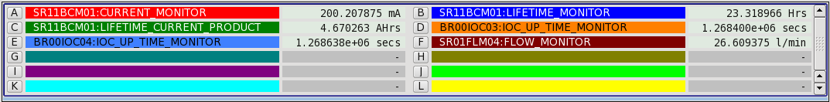

The coloured bars show the names of the PVs being monitored by the Strip Chart. The colour of the line on the chart and the colour of the bar are the same. If the PV is currently connected, i.e. we can get the live value directly from an IOC (perhaps via a gateway) the current value and engineering units are displayed adjacent to the bar.

Right click on any one of these bars to launch a PV specific popup-menu.

For a blank bar, the available options are is:

1. Add PV - this launches a dialog box to allow a PV name to be manually entered. Once the Okay button is clicked, the PV name will appear in the bar, and monitoring of the PV will begin. Double clicking on a blank bar also launches this dialog.
2. Select from a predefined list of up to ten PVs. These PV names are specified in the adaptation\_parameters\_file.ini file located in the start-up directory / folder.
3. Colour… - launches a colour selection dialog.
4. Up to ten predefined PV names. The environment variable QE\_STRIPCHART\_PREDEFINED\_PVS may be used to define up to ten space separated PV names that to appended to the end of pop-up menu. The following figure illustrates this using for the operators’ three favourite PVs.

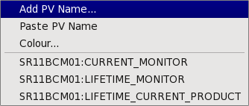

For a non-empty bar, the options available are:

1. Read Archive - this causes the Strip Chart tool to request historical data from the Channel Archiver for the selected PV only, and display that data if a valid response is received.
2. Scale Chart To This PV - brings up the scale sub-menu:

* Scale to HOPR/LOPR values - scales the Strip Chart to the HOPR and LOPR values of this PV, providing the PV is connected and HOPR and LOPR are defined;
* Scale to displayed Min/Max values - scales the Strip Chart to the current minimum and maximum displayed values of the selected PV;
* Scale to buffered Min/Max values - scales the Strip Chart to the current minimum and maximum buffered (i.e. includes off display) values of the selected PV.

1. Adjust PV – this brings up the adjust PV sub-menu: In order to more easily correlate two or more PVs, the Strip Chart enables the display of a PV is be linearly adjusted using the formula:  
     
    YDisplayed = (YPV – origin) \* slope + offset  
     
   This is a variation of the more usual y = m.x + c formula, but essentially has a scaled and unscaled offset constant (which makes it a bit easier for the human user).

The sub-menu items are:

dialog box allows the user to manually enter origin, slope and offset values. It also provides four automatic origin, slope and offset value selection buttons. These are:

* Reset – sets slope to 1 and origin & offset to 0, i.e. YDisplayed = YPV
* General … - launches a dialog that allows the user to select arbitrary origin, slope and offset values.
* HOPR/LOPR values map to chart range - calculates origin, slope and offset such that:  
     
   the HOPR value is displayed at the current chart maximum   
   the LOPR value is displayed at the current chart minimum.
* Plotted values map to chart range - calculates origin, slope and offset such that:  
     
   the maximum displayed PV value is displayed at chart maximum   
   the minimum displayed PV value is displayed at chart minimum.
* Buffer values map to chart range - calculates origin, slope and offset such that:  
     
   the maximum buffered PV value is displayed at chart maximum   
   the minimum buffered PV value is displayed at chart minimum.
* First value maps to chart centre - sets origin, slope and offset such that the left / first displayed value is at the middle of the Y-axis. The slope is set to 1.

1. Mode - brings up the mode sub-menu:

* Rectangular (default) - squares off display trace; and
* Smooth - continuous display of PV values - suitable for floating point PVs.
* Use PV Process Time (default) - the time (X-axis) value used is based on the PV process time.
* Use Receive Time - the time (X-axis) value used is derived from the time on the client machine when the PV update is received – this is useful if an IOC has the incorrect time, and for some of the more complex record that post values while the record is still processing.

1. Line - brings up the line sub-menu:

* Hide - hides the trace of this PV from the chart;
* Regular - includes the trace of this PV on the chart (default);
* Bold - draws the trace double thickness; and
* Colour - launches a colour selection dialog.

1. Edit PV Name - this launches a dialog box to allow a PV name to be manually modified. Once the Okay button is clicked, the PV name will appear in the bar, and monitoring of the new PV will begin. Double clicking on a bar also launches this dialog.
2. Write PV trace to file… - this allows the user to select an output file and then writes the displayed values, together with the associated time stamp and status, to the selected file.
3. Generate Statistics – this lunches a form displaying statistics of the displayed PV values. This includes the minimum value, maximum value, the range of values, the time weighted mean value, the time weight standard deviation, the integral (i.e. area under the curve) and the mean rate of change.
4. Add to predefined PV names - this adds/moves the current PV name to the top of the list of PV names selectable from an empty slot.
5. Clear - removes this PV from the chart.

### Expressions

The StripChart now allows expressions to be entered, as opposed to PV names. The look and feel of this is very similar to that provided by the QEPlotter widget.

An expression is designated by the first character of the "PV Name" being a '=' char. The expression may be any other actual PV on the current chart, referenced by the letters 'A' through 'P', or a previously defined expression PV with a lesser letter.

The calculation is performed at 10Hz, and a new point added to the chart of a change since the last time the expression was evaluated is detected.

The calculation engine is the same as used by the calc/calcout records. Any expression allowed in these records should work in the StripChart. The expression engine only allows up-to 12 inputs, 'A' to 'L', and under-the-covers the StripChart maps the 'A' to 'P' of the user expression onto the 'A' to 'L' input which it can do if no more than 12 are specified.

## Chart Area

This displays the data for the selected PVs graphically. The time axis shows the relative time from the chart time end time in units of seconds, minutes, hours or days as appropriate.

### Zoom

A graphical zoom capability is provided. By clicking on the chart, and then moving the cursor down and to the right, a dashed green rectangle is drawn. When the user un-clicks, the Strip Chart examines the rectangle and zooms in either in time or in scale ***but not*** both at the same time.

If the prescribed rectangle is wider than it is tall, i.e.

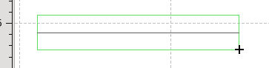

then the zoom is applied to the time scale and the vertical scale remains unchanged.

If the prescribed rectangle is taller than it is wider, e.g.:

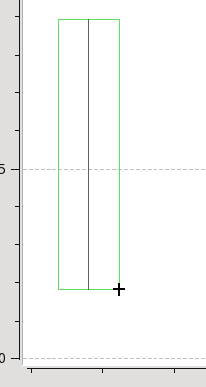

then the zoom is in the vertical scale and the time scale remains unchanged.

If the rectangle is square, or nearly so, then no selection occurs.

### Origin to Mouse Display

A relative delta time and delta value capability is also provided. By middle button clicking on the chart area, the location is saved and a cross drawn at that location; and a solid pale blue line drawn to the current cursor position. The relative time and relative values are displayed on the status bar as the cursor is moved.

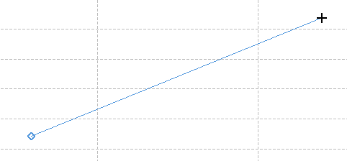

### Horizontal/Vertical Lines

TDB

### Data Point Information

TDB

### 

## Status Bar

This shows mouse position status information when the mouse is move over the chart area. These are:

The time associated with the mouse position, either in local time or UTC time as per the Time Zone selection - see 3.1 f above.

E:\tec_gui_qeframework\documentation\source\images\QEStripChart5a.png

The relative time of the mouse position from the end, or right hand side, of the chart. This is shown as days, hours, minutes and seconds. This value is always negative.

E:\tec_gui_qeframework\documentation\source\images\QEStripChart5b.png

The y-axis value associated with the cursor position.

E:\tec_gui_qeframework\documentation\source\images\QEStripChart5c.png

When the middle button is held down and the origin point to current mouse position line is displayed, the delta time, the delta value and slope are also displayed.

E:\tec_gui_qeframework\documentation\source\images\QEStripChart5d.png

It also shows status information such as PV successfully read (or otherwise not read) from the archiver.

# Environment Variables

The behaviour of QEStripChart widget can be configured by the fallowing environment variables

## QE\_ARCHIVE\_LIST

This environment variable defines the Channel Access Archives that are used to retrieve archive data. Each archive must be space separated. The format is, by example:

cr01arc01v:80/cgi-bin/ArchiveDataServer.cgi cr01arc02:80/cgi-bin/ArchiveDataServer.cgi

i.e. each is a triplet of hostname, port number path.

## QE\_STRIPCHART\_PREDEFINED\_PVS

This environment variable defines up to ten space separated pre-defined PV names selectable from the popup context menu. Linux example:

export QE\_STRIPCHART\_PREDEFINED\_PVS=\

'SR11BCM01:CURRENT\_MONITOR SR11BCM01:LIFETIME\_MONITOR'

## QE \_STRIPCHART\_CONFIGURATIONS

This environment variable specifies the file that is used to populate the combo box drop down list of files on the configuration tab of the tool bar. This file is a read as a text file containing a list of file names, one per line. Lines starting with hash (‘#’) are treated as comments and are ignored.

A filename may be an absolute pathname, or a relative pathname. Relative pathnames are not subject to any path search functionality, so are perhaps best avoided.

No check is made that the file exists until an attempt is made of load the configuration from the file.

## QE \_STRIPCHART\_MAX\_REAL\_TIME\_POINTS

This environment defines the number of real time or live data points the Strip Chart will store per channel. Once this number has been exceeded, older real time points are dropped. When not specified the value for the number of points defaults to 400,000. The smallest value than can be defines is 10,000. The upper limits is the maximum integer value (2,147,483,647).