<Contacts model database schema>
Security Classification: | <Internal> | Team/Department: | <Content & Messaging>
Document Reference: | <SXX.XXXnnn.nnn> | Author(s): | <Chris Dudding>
Status: | <Issued> | Owner(s): | <Core Apps Team>
Version: | <1.1> | Approver(s) | <Chris Dudding>
Last Revised Date: | <26> <04> <2004> |  | <Chris Dudding>

Introduction

Purpose and Scope
This document describes the Contacts model database schema for SymbianOS v8.0.
It is intended for engineers using the Contacts model component.

Logical data model
The diagram below summarises the logical data model for the Contacts model component:

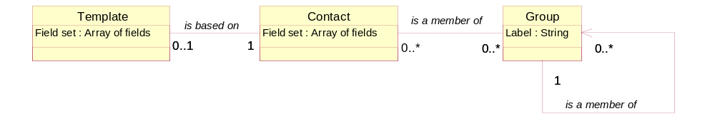

The contact database contains contact items. A contact item can be a contact card (e.g. a particular person), an own card (the database owner’s card), an ICC contact, a template card, or a contact group (a collection of contact items, e.g. used for a mailing list).
The maximum number of contact items the model can store is 2³¹ contact items. In practise, the real limitation on the number of contacts is the amount of disk space available.

Contacts model allows contact items to be based on a standard set of fields – a template. The content of a contact card is dynamic. Additional fields can be added to the standard set of fields inherited from the template.

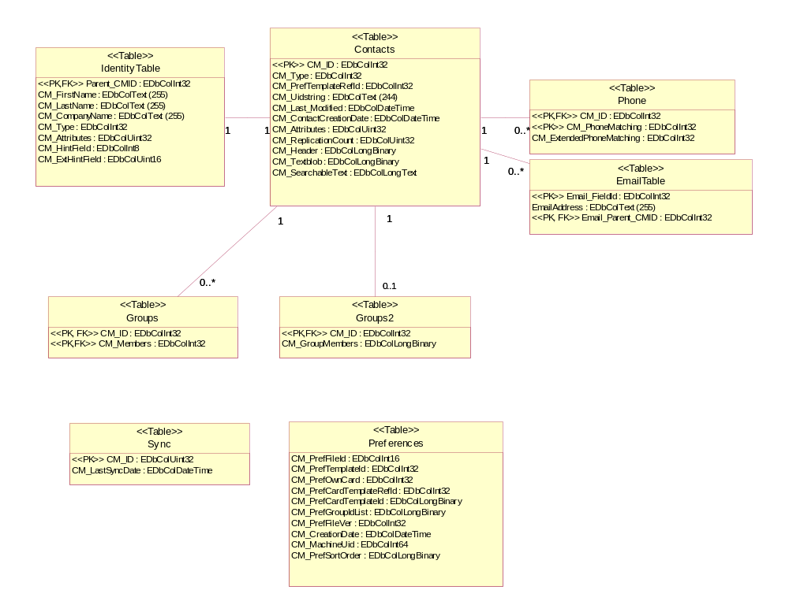
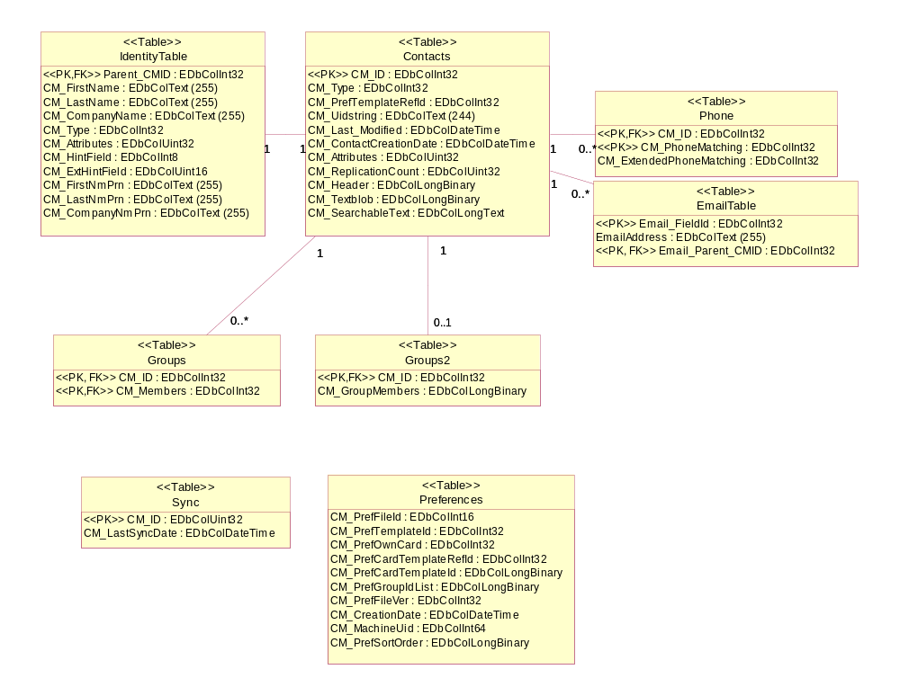Physical data model
The database schema for Contacts model in SymbianOS 8.0 is shown below using UML notation [1].

The database has eight tables.
Users of the contact database are not aware of the distribution of contact field data between database tables since the information is aggregated to make a single CContactItem-derived object before being returned to the client.

Contacts table
The Contacts table could be considered the most important table.
All contact items in the database must have a row in this table. The contact item ID for a contact item (represented by the TContactItemId class) comes from the CM_ID column.

The original design of Contacts model only used one table to store contact information - the Contacts table. All fields were stored in a single “blob” column.
The lead product for SymbianOS v6.0, the Nokia 9210, introduced picture storage for contact items. This lead to a decrease in search performance because the model needed to read the picture data when searching the contact’s text fields.
An optimisation was introduced June 2000 for SymbianOS v6.0 to split the “blob” column into two columns – CM_TextBlob and CM_SearchableText. This change increased search speed by reducing the amount of data read when searching, taking advantage of a DBMS optimisation to in-line storage of long columns under 255 bytes.

Column Name | Type | Description
CM_ID | EDbColInt32 | Primary key from Contacts table.  Auto-incrementing
CM_Type | EDbColInt32 | Contact item type UID
CM_PrefTemplateRefId | EDbColInt32 | Template ID used for this Contact
CM_Uidstring | EDbColText (244) | Unique ID string used for vCard synchronisation
CM_Last_Modified | EDbColDateTime | Date/Time when this contact was last updated
CM_ContactCreationDate | EDbColDateTime | Date/Time when this contact was first created
CM_Attributes | EDbColUint32 | Contact item attributes (system, hidden, deleted etc.)
CM_ReplicationCount | EDbColUint32 | Synchronisation count for contact item. Not required/used.
CM_Header | EDbColLongBinary | Field metadata for the text blob (eg. field type UIDs)
CM_Textblob | EDbColLongBinary | Non-text data for a contact (photo, logo, ring-tone)
CM_SearchableText | EDbColLongText | Text “blob” containing collection of field concatenated together, separated by null characters

Index Name | Columns | Description
CNT_ID_INDEX | CM_ID | Primary key index (unique)

Identity table
The Identity table was introduced in June 2001 as part of the LPD/GT Contacts model optimisation work for SymbianOS v6.1.
The identity table stores the fields most commonly used for sorting and searching. There is a one to one mapping between rows in the Contacts table and the Identity table.
CM_Type and CM_Attributes are duplicated from the Contacts table to prevent the need to access multiple tables when creating a sorted view of Contacts.
The CM_HintField was stored in the Contacts table in SymbianOS v6.1, but this was expensive to read. This choice in the 6.1 data schema was a significant factor in the performance of the filtering functionality on the Nokia 7650. An optimisation was made in June 2002 for SymbianOS v7.0 to move this column to the identity table. This increased the speed of filtered view creation significantly.
The CM_ExtHintField was added as part of change request LLUD-5JAGFP “Add support for ringtone and voice dial fields in filtered views” because there were no remaining bits to use in CM_HintField column.
The pronunciation fields, CM_FirstNmPrn, CM_LastNmPrn, and CM_CompanyNmPrn were added in May 2004 for the change request PHAR-5U6KGG, “Add support for reading (pronunciation) fields in Contacts model (for e.g. Japanese)”. These were added to the Identity table to speed creating views using the new fields.

Column Name | Type | Description
Parent_CMID | EDbColInt32 | Foreign key from Contacts table
CM_FirstName | EDbColText(255) | Contact first name (given name)
CM_LastName | EDbColText(255) | Contact last name (surname)
CM_CompanyName | EDbColText(255) | Contact company name
CM_Type | EDbColInt32 | Contact item type UID
CM_Attributes | EDbColUint32 | Contact item attributes (system, hidden, deleted etc.)
CM_HintField | EDbColInt8 | Indicates presence of certain fields in Contact.  Used for filtering a selection of contact items (eg. those that have an Email address)
CM_ExtHintField | EDbColUint16 | Additional storage for bit fields to indicate presence of certain fields in Contact.  Used for filtering a selection of contact items (eg. those that have an Email address)
CM_FirstNmPrn | EDbColText(255) | Contact first (given) name pronunciation
CM_LastNmPrn | EDbColText(255) | Contact last name (surname) pronunciation
CM_CompanyNmPrn | EDbColText(255) | Contact company name pronunciation

Index Name | Columns | Description
IdentityIdIndex | Parent_CMID | Primary key index (unique)

Phone table
The phone number matching table was introduced in SymbianOS v6.0.
The extended phone number matching column was added to provide fifteen digit phone matching as part of change request PHAR-5K2TAF ”Improvements to contacts matching”.

Column Name | Type | Description
CM_ID | EDbColInt32 | Foreign key from Contacts table
CM_PhoneMatching | EDbColInt32 | Reversed phone number (rightmost seven digits)
CM_ExtendedPhoneMatching | EDbColInt32 | Reversed phone number (remaining eight digits)

Index Name | Columns | Description
Cnt_Phone_Index | CM_PhoneMatching, CM_ID | Primary key index (unique)

Email table
The Email table was introduced in June 2001 as part of the LPD/GT Contacts model optimisation work for SymbianOS v6.1.
The Email_Parent_CMID is a reference to the contact information stored in the Contacts and Identity tables.

Column Name | Type | Description
Email_FieldId | EDbColInt32 | Identifies a single Email field
EmailAddress | EDbColText (255) | Contact Email address
Email_Parent_CMID | EDbColInt32 | Foreign key from Contacts table

Index Name | Columns | Description
EmailIdentityIdIndex | Email_FieldId, Email_Parent_CMID | Primary key index (unique)

Group table
The group table was introduced in SymbianOS v6.0.

Column Name | Type | Description
CM_ID | EDbColInt32 | Parent in the group relationship. Foreign key from Contacts table.
CM_Members | EDbColInt32 | Child in the group relationship. Foreign key from Contacts table.

Index Name | Columns | Description
Cnt_Group_Index | CM_ID, CM_Members | Primary key index (unique)

Groups2 table
The second group table, Groups2, was introduced as an optimisation for SymbianOS v6.0 in June 2000.
The Groups table already stores enough information to model the relationship between contact items, but finding out the list of members of a group requires the whole table to be searched.
To speed up loading of groups, a second group table was added to store the group as an array containing the contact item IDs of all of the members of the group. This has a lower overhead, in terms of database size, than a second index on the Groups table.

Column Name | Type | Description
CM_ID | EDbColInt32 | Group ID. Foreign key from Contacts table
CM_GroupMembers | EDbColLongBinary | Array of group member IDs. IDs refer to CM_ID column in Contacts table.

Index Name | Columns | Description
Cnt_Group_Index2 | CM_ID | Primary key index (non-unique)

Sync table
The Sync table was added in SymbianOS v6.0 for Symbian Connect.
It enables the storage of a last synchronised date/time identified by an integer using the CContactDatabase::SetLastSyncDateL API. This enables the application engine database to know when it was last synchronised rather than the responsibility being handled by the PC synchronisation implementation.
This table is no longer required for data synchronisation since SyncML uses item timestamps and records its own “snapshot” of the database.

Column Name | Type | Description
CM_ID | EDbColUint32 | Auto incrementing integer
CM_LastSyncDate | EDbColDateTime | Timestamp

Index Name | Columns | Description
Sync_Id_Index | CM_ID | Primary key index (unique)

Preferences table
The Preferences table was introduced in SymbianOS v6.0 to store preference information relating to the whole database. The preference table is dependent on information in other tables (because it contains IDs from the Identity/Contacts tables).

Column Name | Type | Description
CM_PrefFileId | EDbColInt16 | Preferences table format version number. Currently unused by contacts model.
CM_PrefTemplateId | EDbColInt32 | Contact item ID for the system template
CM_PrefOwnCard | EDbColInt32 | Contact item ID for the database’s owner card
CM_PrefCardTemplateRefId | EDbColInt32 | Contact item ID for the database's preferred template
CM_PrefCardTemplateId | EDbColLongBinary | Array of Contact item IDs for user-defined templates
CM_PrefGroupIdList | EDbColLongBinary | Array of Contact item IDs for contact groups
CM_PrefFileVer | EDbColInt32 | File version. SymbianOS 7.0s has version 5
CM_CreationDate | EDbColDateTime | Creation date of the contact database file
CM_MachineUid | EDbColInt64 | Randomly generated identifier for the database.
CM_PrefSortOrder | EDbColLongBinary | Preferred sort order for clients, as set by CContactDatabase::StoreSortOrderL

The Preferences table does not have an index, since there is only ever a single row in this table.

File version history
The Preferences table stores a file version. The current version can be identified using the value of the KFileLayoutVersion constant (defined in cntmodel\src\cntdb.cpp).
Details of each version are given below:

File version | First introduced in SymbianOS release | Description
1 | 5.0 | Original database schema
2 | not released | Added creation date of the contact database file (CM_creationdate) to the PREFERENCES table
3 | 5.0 and 6.0 | Removed unnecessary UID string index (cnt_uid_index)
4 | 6.1 | Multiple database table schema introduced.
5 | 7.0 | Hint column moved from CONTACTS table to IDENTITY table as part of defect DUG-59HHTZ "Filtered View needs performance enhancement"
6 | 7.0 | Added extended hint column (CM_ExtHintField)
7 | 7.0s | Added second phone matching column (CM_ExtendedPhoneMatching)
8 | 8.0 | Added pronunciation fields to IDENTITY table (CM_FirstNmPrn, CM_LastNmPrn, CM_CompanyNmPrn)

Compatibility Policy
Contacts model can read and upgrade file versions 4 onwards.
Old files are upgraded to the current data schema and further updates are written in the new format only. This enables a SymbianOS v6.1 contact database file to be read by future SymbianOS products but not vice-versa.

Further Information

People
Role | Person / People
Contributors | Bob Rosenberg
Reviewers | Core Apps Team, Dominic Badger
Distribution

References
No. | Document Reference | Version | Description
[1] | The UML and Data Modelling (Rational software, 2000) |  | http://www.rational.com/media/whitepapers/Tp180.PDF
[2]

Open Issues
The following issues need to be resolved before this document is completed:

Glossary
The following technical terms and abbreviations are used within this document.
Term | Definition
API | Application Programming Interface
DBMS | SymbianOS database management component
GT | Generic Technology
ICC | Integrated Circuit Card (the generic name for SIM cards)
LPD | Licensee Product Development
Logical data model | A logical data model shows entities, key attributes and the relationships between them. It is a conceptual model that does not take account how the data is stored.
Physical data model | A physical data model defines how the data is physically stored and specifies database tables, columns and indexes.
UID | Unique Identity

Document History
Date | Version | Status | Description
27-04-2004 | 1.1 | Draft | Updated for version 8 (pronunciation fields)
18-09-2003 | 1.0 | Issued | Issued after peer review
15-09-2003 | 0.4 | Draft | Incorporated comments from Nichola Turner, Bob Rosenberg and Andy Blackburn
21-03-2003 | 0.3 | Draft | Added logical data model. Ready for internal review.
10-03-2003 | 0.2 | Draft | Added physical data model
dd-mm-yyyy | 0.1 | Draft | First draft based on SGL.PPS001.500 Lightweight Document Template Rev 7.0

Document Review Date
This section should contain the date after which the document should either be reviewed or is out-of-date.

