Contents
1 Introduction 4
1.1 Purpose and Scope 4
1.2 Document outline 4
2 Requirements for migrating the Contacts Database to SQLite 4
3 Design Issues 5
3.1 SQLite Performance Characteristics 5
3.2 Test Results versus Performance Targets 5
3.3 Existing Contacts Model Data Schema in DBMS 5
4 Detailed Design of the Contacts Model Physical Data Schema in SQLite 7
4.1 Contact Table 7
4.1.1 Names Related Columns 9
4.1.2 Date Time Columns 9
4.1.3 type_flags Column 9
4.1.4 Contact Fields Data Columns 11
4.1.5 No non-key indexes 12
4.1.6 Contact Fields Metadata Structure 12
4.1.7 Manipulating contacts data in the database 14
4.2 Communication Address (comm_addr) Lookup Table 17
4.2.1 Phone number matching 18
4.2.2 Extensibility 19
4.3 Groups table 19
4.3.1 Constraints and usage 20
4.3.2 Selecting “X is a member of groups…” and “members of group X are…” 20
4.4 Preferences Table 21
4.4.1 Preference Table in DBMS 21
4.4.2 Proposing Preferences Table Schema 21
5 Rejected Designs: Two Approaches for the Contact Physical Data Schema 23
5.1 Ideal Normalized Schema 23
5.2 Possible Best Performance Schema 23
5.2.1 Contact Field Columns 24
5.2.2 Common Address Lookup Table 24
5.3 Comparison between Two Approaches 25
5.3.1 Performance 25
5.3.2 Scalability and Maintainability 25
5.4 Justification 26
6 Further Information 27
6.1 References 27
6.2 Open Issues 27
6.3 Glossary 27
Appendix A - Contacts Data Entities Diagram 28
A.1 Contact 28
A.2 Contact Field 28
A.3 Contact Group 28
A.4 Contact Template 28
Appendix B - Hint Field Types 29
Appendix C - Additional Field Types 30
Appendix D - Attribute Field Values 31
Appendix E - SQLite’s column affinity / manifest typing system and storing integers as strings 32
Appendix F - Contact Fields Physical Data Structure on DBMS 33
F.1 Physical Data Structure 33
F.2 Optimise Analysis on Contact Field Metadata 34
F.2.1 Contact Field ID 35
F.2.2 Contact Field Label 35
F.2.3 Contact Storage 35
F.2.4 Contact Field Attributes 35
Appendix G - Contacts Model Preference Table in the DBMS schema 36
Appendix H - Proposed Template Table 37
H.1 Template Item versus Contact Item 37
H.2 Proposing Template Table Schema 37
H.3 Template Fields Header 38
H.4 System Template ID 38
H.5 Constrains Check on Template Deleting 38
H.6 Performance Concern 38

Introduction

Purpose and Scope
This document briefly describes the current logical and physical schemas for the contacts model. It then presents the proposed new physical schema design for the SQLite RDBMS engine which forms part of the development work in PREQ1187 “Enhance Contacts performance by moving to a SQL database”. It should be read in conjunction with the DBMS schema document [R4] as this document builds on certain concepts and issues described more fully there.

Document outline
The document is structured as follows:
- Requirements of contact database migration to SQLite
- Design considerations and constraints
- Detailed design contact physical data schema on SQLite
- Rejected designs: Two approaches for the contact physical data schema
- Appendices
The document briefly discusses both the requirements of the PREQ and the considerations and constraints faced, where necessary providing links to appendices and other documents for more detailed information relevant to the discussion. Having set this context, it then describes the physical schema design in detail. Finally it presents some rejected designs that, under different circumstances, may have been viable and which will add more background to the decisions made for the successful design. Appendices containing relevant and more detailed information are provided at the end.

Requirements for migrating the Contacts Database to SQLite
PREQ 1187 requirement is to improve performance by migrating Symbian contact database from original DBMS to SQLite database (detail wording can be found in Focal Point).
The contact performance is the key system characteristic in the overall requirement of PREQ 1187 and the contact data schema has to be designed to serve best performance as required.
And also there is no binary compatibility break allowed, though data compatibility will not be maintained.
Below are the performance Use Cases, in priority order, for PREQ 1187 (refer to [R1] for more detail):

- Contacts application start up
- Phone number lookup for matching incoming call
- Contacts List View scrolling
- Contacts update
- Contacts resort time
- Delete contacts store/delete all contacts
- Add contact
- Fetch a contact
- Deleting a contact in contacts application
- Deleting 20 contacts in contacts application
- Initial Contacts sync over USB

Design Issues

SQLite Performance Characteristics
During PREQ 1187 MS2 work, 2 stage performance tests have been carried out in PIM internal. The detail test results are in [R2] and [R3]. Based on the test results, the following conclusions were drawn:
- More tables and indexes, worse performance in SQL writing
- SQL read is really fast and far beyond the performance requirement while insert, delete and updating are relatively slower.
- Duration time of multiply rows deletion is linear to the number of rows deleted
- Smaller size of data (in terms of numbers of tables), the better the performance generally
- The number of disk IOs are key factor to the performance of SQL operations

Test Results versus Performance Targets
The follow table shows the gap between performance target PREQ 1187 aiming to reach and the test results we got based on the simplest possible contact schema (2 table schema, see [R3] for detail).
Test Case | Risk that Target is missed
Add Single Contact | High
Update Single Contact | High
Delete Single Contact | High
Delete 20 Contacts | High
Delete All (but one) Contact | Medium
Initial Sync (Bulk Insert) | Medium
Match Phone Number & Read Contact | Low
Read Single Contact | Low

The above indicates that even the simplest schema we can get to simulate contact use cases are still weak to 4 of 6 of the performance requirements, and to improve the performance on those cases are very important to the data schema design. And all 4 test cases lacking of speed in the tests are related to database write.

Existing Contacts Model Data Schema in DBMS
Currently, there are 8 tables in the schema:
- Contacts – Contacts table could be considered the most important table.
- Identity Table – Identity table store the fields most commonly used for sorting and searching.
- Phone – Phone number-matching table
- Email Table – Email addresses look up table
- Group – Group table create mapping for group ID and contact item
- Group2 – Another group mapping table for performance reason
- Sync – Record last sync date to each contact item.
- Preferences – Storing contact model preference data.

See [R4] for more information on the current schema. A data entity diagram showing the current entities in the contacts model is provided in Appendix A.

Whilst there will be a data compatibility break with the database file format changing from DBMS to SQLite, much of the data stored in the current schema must be retained for compatibility reasons – data missing will cause behaviour changed in some published APIs exported by contact model, this will break binary compatibility of contact model which is not allowed in the project requirement (PREQ 1187). Other data is actually internal meta-data peculiar to the DBMS schema for historical and performance reasons. Some of this can be discarded. Decisions on what data must be kept and what data will be altered or removed will be discussed below.

Detailed Design of the Contacts Model Physical Data Schema in SQLite

Taking into account the requirements for the PREQ (section 2) and the constraints of performance requirements and maintaining binary compatibility, which is arising from the various issues that needed to be taken into account, the following diagram represents the physical data schema for the contacts model database in SQLite:
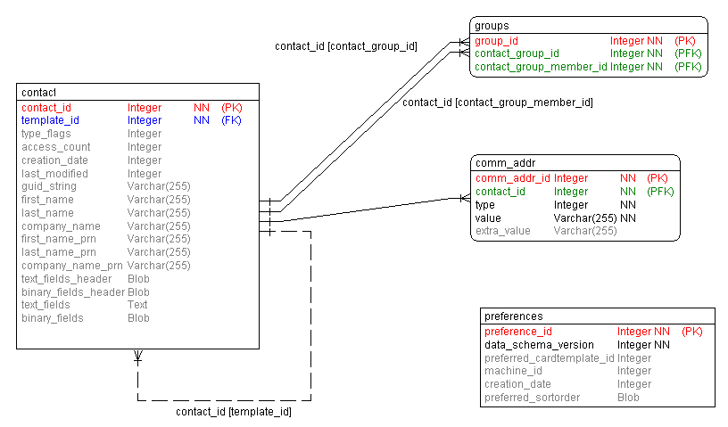

Key

Red: primary key (PK), non-NULL (NN)
Green: mandatory foreign key (PFK), non-NULL (NN)
Blue: optional foreign key (FK), can be NULL
Black: non-NULL (NN); UNN unique non-NULL
Grey: can be NULL

To some extent, the data schema currently used in DBMS is similar to what we will use in SQLite, owing to the performance requirements.

Contact Table
The contact table is the combination of original contacts and identity tables, the merging of the two tables reduce data duplication therefore improves the database performance.
The following creates the contact table in SQL:

CREATE TABLE contact
(
contact_id INTEGER NOT NULL PRIMARY KEY AUTOINCREMENT,
template_id INTEGER, type_flags INTEGER,
access_count INTEGER,
creation_date ,
last_modified ,
guid_string VARCHAR(255) NULL,
first_name VARCHAR(255) NULL,
last_name VARCHAR(255) NULL,
company_name VARCHAR(255) NULL,
firstname_prn VARCHAR(255) NULL,
lastname_prn VARCHAR(255) NULL,
companyname_prn VARCHAR(255) NULL,
text_fields_header BLOB,
binary_fields_header BLOB,
text_fields TEXT,
binary_fields BLOB
);

CREATE INDEX contact_guid_string_idx ON contact (guid_string);

n.b.: Where the data type is not mentioned, SQLite defaults to type “numeric”. SQLite does not use data types in the same way as other databases. It supports them for compatibility with other databases. However, it dynamically decides the type of the data at runtime, based on the data itself, in the context of the operation it is performing. This is what they call “column affinity” in the documentation:
“The type affinity of a column is the recommended type for data stored in that column. The key here is that the type is recommended, not required. Any column can still store any type of data, in theory. It is just that some columns, given the choice, will prefer to use one storage class over another. The preferred storage class for a column is called its "affinity".” [http://www.sqlite.org/datatype3.html#affinity]
See Appendix E for more detail.

For those columns with obvious names and would be simply placed in database without any formatting, they are described as following:
- contact_id – the primary key of the table and the unique id represent a contact item in the database.
- template_id – the foreign key reference the template id in template table, the value could be NULL to 7indicate that the contact is not dependent on any template. Otherwise it would be zero to indicate the system template or a positive integer corresponding to the ID of a user-defined template in the template table.
- access_count – the reference count of users who are using/accessing the contact.
- creation_date, last_modified – these are both 64-bit integers from a TTime representing the UTC time the contact item was created or last modified,
- guid_string – the unique string to represent the contact globally. Internally, this is generated using the same algorithm as in the <=v9.4 (DBMS) version of the database and is a compressed UID.
However, any other contact items, not generated on the device by the cntmodel, should be supplied with a full GUID string (i.e. not compressed) in the format:
  - <16-char string of hex digits>-<16-char string of hex digits >-<string of an integer greater than 0 of any number of digits>
  - e.g. 89e48b18d34234c5-a09d5872a79e7a23-123
The GUID string can be generated by creating random 16-char hex digit strings for the first two parts and then an string of the integer of the contact ID. So, in the example above, the contact would have had an ID of 123.
The first of the two 16-char hex strings can be re-used for multiple contacts as, in the cntmodel, the machine ID is used for this part of the GUID string. The second hex string should be unique to the contact.

Names Related Columns
Following are columns related to contact names. Unlike other contact fields which content and types are all stored in the latest 3 blob/clob columns in contacts table, each of these 6 fields are especially stored in a column instead. This aims to help the performance of some use cases most frequently used such as ‘Contacts application start up’ and ‘Phone number lookup for matching incoming call’ (see section 2 for more information).
- first_name – first name of the contact
- last_name – last name of the contact
- company_name – company name of the contact
- firstname_prn – pronunciation string of first name
- lastname_prn – pronunciation string of last name
- companyname_prn – pronunciation string of company name.
The pronunciation columns were added into original identity table in PREQ 704 for Japanese customers.

Date Time Columns
Here is the column named as last_modified, which should be stored in datetime type (or timestamp), but since SQLite does not support this type, for creating a best performance schema, we decide to store the column in integer in UTC time.
- creation_date -- the time the contact was created.
- last_modified – the time the contact was last modified.

type_flags Column
The type_flags column in contacts table is a combination of 4 columns in old schema – cm_type, cm_attributes, cm_hintfield and cm_exthintfield.
They are stored in 4 bytes integer shown as following diagram:
Contact Type
Contact Attributes
Contact Hint Fields
Contact Hint Fields
1st byte
2nd byte
3rd byte
4th byte
Contact Type is bit-flags to identify the card type of the contact item and the type can be 1 of following and the types are stored in first byte of the 4 bytes integer.

Contact Types | Description
Card | Identifies a contact card.
OwnCard | This shows the contact item is phone user own card
ICCEntry | These are a special type of contact item that are stored in the SIM (ICC) card on the phone
Group | Identifies a contact group(see group table for detail)
Template | Identifies a template.
Card Template | Identifies a card template.

These values are exclusive (i.e. a contact item can only be one of these types only. Therefore, an item cannot be, for example, the own card and an ICC entry). As far as users of the contacts model APIs are concerned, the types have not changed from v9.4 and they should still use the UID constants defined in the file cntmodel/group/cntdef.h(rh) (e.g. KUidContactCard). However, in the SQLite version of the contacts database, we have saved space by translating the 4-byte UID into the following internal enum values (defined in cntmodel/cntplsql/inc/dbsqlconstants.h) that can be represented in 1 byte:

Constant | Value
EContactTypeFlags_ContactCard | 0
EContactTypeFlags_OwnCard | 1
EContactTypeFlags_ICCEntry | 2
EContactTypeFlags_Group | 3
EContactTypeFlags_Template | 4
EContactTypeFlags_CardTemplate | 5
EContactTypeFlags_UnknownType | 6

Contact Attributes are bit-flags to represent some special characters of the contact and stored in second byte of the 4 bytes integer:

Contact Attributes | Description
System | Currently not been used in contact model.
Hidden | The contact item is not displayed if the view definition excludes hidden fields
Compressed GUID | To show if the GUID of contact item is compressed. This is for internal used only in that only the contacts model itself should create compressed GUIDs. GUIDs for all other externally created contact items should have a full, uncompressed GUID string. See the discussion of the guid_string field above, in section 4.1.
Deleted | If the attribute is set, this means that an attempt has been made to delete the contact item, but because the item's access count is greater than zero, its data persists and the item is just marked as deleted.

Contact Hint Fields are bit-flags to show the view capability of the contact and stored in highest 2 bytes of the 4 bytes integer.

Contact Hint Fields | Description | Enum constant | Value
Mailable | The contact has email addresses. | EMailable | 0x00000001
Smsable | The contact has mobile phone numbers. | ESmsable | 0x00000002
LandLine | The contact has land line phone numbers. | ELandLine | 0x00000004
Faxable | The contact has fax numbers. | EFaxable | 0x00000008
Phonable | The contact has phone numbers | EPhonable | 0x00000010
Work | The contact has either a work phone number or work email address | EWork | 0x00000020
Home | The contact has either a home phone number or home email address | EHome | 0x00000040
RingTone | The contact has a non-empty ring tone field | ERingTone | 0x00000080
VoiceDial | The contact has a a non-empty voice dial field | EVoiceDial | 0x00000100
IMAddress | The contact has any non empty instant messaging address field. | EIMAddress | 0x00000200
WirelessVillage | The contact has a non empty Wireless Village ID field. | EWirelessVillage | 0x00000400

The “-able” suffix on some of the fields means that there are one or more numbers/addresses available for that contact item. I.e. if a contact item is “mailable” it means it contains one or more email addresses; if it is “smsable” it means it contains one or more mobile phone numbers to which an SMS text message may be sent. “Home” and “Work” values can be overlayed on the bit field if there are phone numbers or email addresses pertaining to those locations. Therefore a work mobile phone number and a home email address would see the “Mailable”, “Smsable”, “Phonable”, “Work” and “Home” flags being set.

Contact Fields Data Columns
Refer to 5.2.1, it’s the possible best performance solution that use 2 columns (contact field header and contact field content) in contact table to store the content of all contact fields contained by a contact item.
In the proposing schema we actually are using 4 columns to store contact fields data instead of 2 columns, this is because of compromising the requirements of quick searching on all text fields in a contact item and quick retrieving contact photo.
- text_fields_header – storing the metadata of all text fields, the metadata is described in 4.1.6
- binary_fields_header – storing the metadata of all contact fields stored as binary data, the metadata is same as that used in text_fields_header and is described in 4.1.6
- text_fields -- containing collection of text fields concatenated together, separated by null(‘\0’) character
- binary_fields – storing the data of binary fields for a contact in using Symbian store stream objects to persist and retrieve such data (e.g. thumbnail photo, logo, ring-tone)

No non-key indexes
A compound index could be created on first_name and last_name columns as most uses cases require querying and sorting these two fields. However, owing to the constraints of SQLite sort plug-in support on different locales, we have to implement the other sort plugin mechanism outside of the SQLite database. Thus, such an index is not useful for the sort and so we decided against it.

Contact Fields Metadata Structure
Refer to the physical contact field data structure being used on DBMS and optimising analysis in Appendix G, the proposing contact field data structure is like this diagram:
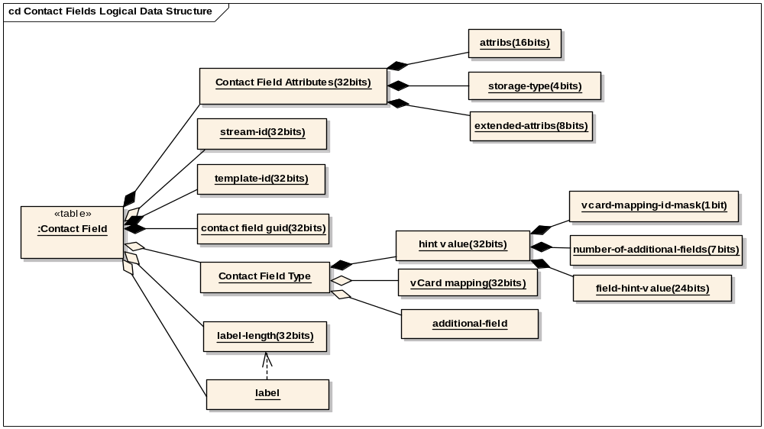

Contact Field Attributes
Contact field attributes is the first integer in the contact field header that is composed of:
- Attributes – occupies the highest 4 bits and lowest 12 bits of the integer, each bit represents an attributes of the field: Hidden, ReadOnly, Synchronize, Disabled, UserMask, TemplateMask, OverRidesLabel, UsesTemplateData, UserAddedField, Template, LabelUnspecified and Deleted. In the case of contacts database generation external to the phone, for simple contact items none of these attributes should be set. The only exception to this is the Template attribute that should be used for contact item fields in the system template.
- Storage Type – occupies 21st – 24th bits of the integer and the storage types are categorized into four types: Text, Store, Agent and DateTime.
- Extended Attributes – uses 13th – 20th bits of the integer and represent the attributes of Private, SpeedDial and UserDefinedFilter.

Stream Id
This is optional integer storing the id of the actual stream data stored in the blob column and it only exists when the field storage type is not Text. If the contact item is being created externally to the contacts model, it is acceptable to use any non-zero 32-bit integer. It appears usually to be 1 in contacts model created items and so this would be as good as any value to use as a default.

Template Id
The template id shows the field id of the template the contact refers to.

Contact Field GUID
We have to use one integer for the field, see detail in F.2.1.

Contact Field Type
The contact field type is optional and only exists when UsesTemplateData bit flag in Contact Field Attributes is not set. The contact field type consists of 3 parts of data:
- Hint Value – the first integer in the contact field type and the 32bits of the data splits into 3 parts:
  - VCard Mapping UID Mask – The highest bit of the integer, if set it means an extra integer is needed and appended after Contact Field Type to store VCard Mapping UID.
  - Number of Additional Field UIDs – The 7 bits next after VCard Mapping UID Mask, it is showing how many additional field uids will append after VCard Mapping UID.
  - Contact Field Hint Value – it occupies the lowest 24 bits of the integer.
These field hint values work in a similar way to the contact item hints in that they provide a bit map which can be queried easily and efficiently to establish whether the field is likely to contain whatever it is that we want.

The values are as follows:

Constant | Value | Comment
 |  | “Is a …”
KIntContactHintIsPhone | 0x02 | phone number
KIntContactHintIsMsg | 0x04 | number with a messaging service
KIntContactHintIsCompanyName | 0x08 | company name
KIntContactHintIsFamilyName | 0x10 | family name
KIntContactHintIsGivenName | 0x20 | given name
KIntContactHintIsAddress | 0x40 | postal address
KIntContactHintIsAdditionalName | 0x80 | additional name
KIntContactHintIsSuffixName | 0x100 | suffix name
KIntContactHintIsPrefixName | 0x200 | prefix name
KIntContactHintIsPronunciation | 0x800 | pronunciation field
KIntContactHintIsEmail | 0x4000 | email address
KIntContactHintIsCompany  NamePronunciation | KIntContactHintIsPronunciation | KIntContactHintIsCompanyName | company name pronunciation
KIntContactHintIsGivenName  Pronunciation | KIntContactHintIsPronunciation |  KIntContactHintIsGivenName | given name pronunciation
KIntContactHintIsFamilyName  Pronunciation | KIntContactHintIsPronunciation | KIntContactHintIsFamilyName | family name pronunciation
 |  | “Tells us…”
KIntContactHintStorageInline | 0x400 | storage is inline
KHintAdditionalMask | 0x7F000000 | number of additional type IDs.
KHintVCardMappingMask | 0x80000000 | if there is a vcard mapping UID.

- VCard Mapping – The integer stores vCard mapping GUID.
- Additional Fields – The integer stores contact field type GUIDs not in the hint value.

Contact Field Label
Contact field label is optional and it is used to support the case that customer can name certain fields themselves. The template contains the field names but, should a licensee or, if they expose this functionality in their UI, the end user, want to change the name of a field, the replacement name can be stored in this label and it can be displayed like this on the screen in the phonebook application.
If a Contact Field Label exists in a contact item is decided by the according flag (OverRidesLabel) in Contact Field Attributes. If the flag set, the label length is stored in the 32bit data next after Contact Field Attributes, followed by label content which size is determined by the label length.
This field is remained in the schema because the constraints of no BC break allowed in PREQ1187, but the case that customise the label a particular contact field is rarely used and would be dropped from the schema when the BC constraints is relaxed.

Manipulating contacts data in the database
Below are examples of likely use cases.

Retrieving contact data to build a view
Create a view based on first name, last name and company name:
SELECT contact_id, first_name, last_name, company_name
FROM contact
WHERE (type_flags & 0x08000000) = 0; -- the number here is the value of
-- of EGroupFlag and may differ in
-- the final implementation.

Using the group flag to mask the type_flags, in this example, we can ensure that the records retrieved from the contact table are not groups.

Inserting a new contact item
Insert a newly-created contact item into the contacts database:
-- find the last contact_id used in the database.
-- for this we query the internal SQLite table which
-- stores such information.

SELECT seq FROM SQLITE_SEQUENCE WHERE name = 'contact';

-- in the contacts model code we add 1 to this number and
-- if, in this case the number returned is 137, we use 138
-- as our the contact_id for our new contact item
-- NB: We DO NOT reuse contact item ID values. This is
-- because it would pose potential problems when syncing
-- if there were two items with the same ID.

BEGIN TRANSACTION;

INSERT INTO contact
(contact_id, template_id, type_flags,
access_count, last_modified, guid_string,
first_name, last_name, company_name,
firstname_prn, lastname_prn, companyname_prn,
text_fields_header, binary_fields_header,
text_fields, binary_fields)
VALUES
(138, ...); -- data values left out here for
-- reasons of presentation

-- add the communication addresses to the comm_addr
-- lookup table

INSERT INTO comm_addr
(comm_addr_id, type, value, extra_value, contact_id)
VALUES
(NULL, 1, '7941451', '70244', 138);

INSERT INTO comm_addr
(comm_addr_id, type, value, extra_value, contact_id)
VALUES
(NULL, 1, '8294451', '70244', 138);

INSERT INTO comm_addr
(comm_addr_id, type, value, extra_value, contact_id)
VALUES
(NULL, 1, 'james.clarke@symbian.com', NULL, 138);

COMMIT;

For details of the comm_addr tables, see below.

Retrieving a contact item
Retrieve a specific contact item (contact_id == 138) in its entirety, for example, for the phone user to edit:
SELECT template_id, type_flags, access_count,
first_name, last_name, company_name,
firstname_prn, lastname_prn, companyname_prn,
text_fields_header, binary_fields_header,
text_fields, binary_fields
FROM contact
WHERE contact_id = 138;

Updating a contact item
Updating a specific contact item (contact_id == 138):
BEGIN TRANSACTION;

UPDATE contact
SET
contact_id = 138 ,
template_id = ... ,
type_flags = ... ,
access_count = ... ,
last_modified = ... ,
guid_string = ... ,
first_name = ... ,
last_name = ... ,
company_name = ... ,
firstname_prn = ... ,
lastname_prn = ... ,
companyname_prn = ... ,
text_fields_header = ... ,
binary_fields_header = ... ,
text_fields = ... ,
binary_fields = ... ; -- data values left out here for
-- reasons of presentation

-- delete the existing communication addresses from the
-- comm_addr lookup table and then add the new ones.

DELETE FROM comm_addr
WHERE contact_id = 138;

INSERT INTO comm_addr
(comm_addr_id, type, value, extra_value, contact_id)
VALUES
(NULL, 1, '7941451', '70244', 138);

INSERT INTO comm_addr
(comm_addr_id, type, value, extra_value, contact_id)
VALUES
(NULL, 1, '8294451', '70244', 138);

INSERT INTO comm_addr
(comm_addr_id, type, value, extra_value, contact_id)
VALUES
(NULL, 1, 'james.clarke@symbian.com', NULL, 138);

COMMIT;

Here, the contact item is deleted and re-inserted, using the same contact_id (which is guaranteed to be possible using the transaction). This is simpler and more performant than using UPDATE. Also, in the case of the one-to-many relationship between contact and comm_addr (see below), this is the only to perform an update as the contacts model will not know exactly which comm_addr record has been updated.

Deleting a contact item
Deleting a specific contact item (contact_id == 138):
BEGIN TRANSACTION;

DELETE FROM contact
WHERE contact_id = 138;

DELETE FROM comm_addr
WHERE contact_id = 138;

DELETE FROM groups
WHERE contact_group_id = 138
OR contact_group_member_id = 138;

COMMIT;

For details of the comm_addr and groups tables, see below.

Communication Address (comm_addr) Lookup Table
These tables are used for matching incoming communication addresses (phone number, email address, SIP address, etc.) to the contact items containing them, as quickly as possible. The main use case for this in PREQ1187 is phone number matching – to identify the caller of an incoming call if their details are contained in the contacts database. The diagram and SQL statements below describe the communication address lookup tables:

Key

Red: primary key (PK), non-NULL (NN)
Green: mandatory foreign key (PFK), non-NULL (NN)
Blue: optional foreign key (FK), can be NULL
Black: non-NULL (NN); UNN unique non-NULL
Grey: can be NULL

CREATE TABLE comm_addr
(
comm_addr_id INTEGER NOT NULL PRIMARY KEY AUTOINCREMENT,
type INTEGER NOT NULL,
value CHAR(255) NOT NULL,
extra_value CHAR(255),
contact_id INTEGER NOT NULL,

FOREIGN KEY (contact_id) REFERENCES contact(contact_id)
);

CREATE INDEX comm_addr_val_idx ON comm_addr (value);
CREATE INDEX comm_addr_contact_id_idx ON comm_addr (contact_id);

The communication address or comm_addr table replaces both the old phone and email tables. It allows phone numbers, email addresses or SIP addresses to have a copy stored outside of the text_fields field in the contact table to enable faster lookup. Different types of communication address will be specified by the integer type which will reflect enums defined in the contacts model business logic. For example, phone numbers might be:
enum TCommAddrType {ECommAddrPhone = 1};
The table has the fields value, which is the actual address value upon which to do the matching. In the case of phone numbers, this will perform the same role as the CM_PhoneMatching field in the Phone table in the DBMS schema. It will store the rightmost 7 digits of a phone number in reverse order, as an integer. For example, for the phone number “+442071541497”, value will store the integer 7941451. The rest of the phone number will be stored in extra_value in the same manner as CM_ExtendedPhoneMatching in the DBMS schema. This would provide further information for distinguishing multiple phone numbers found using the first 7 digits.
In the case of other types of communication address will just use the value field. For example, an email address (e.g. “fred.bloggs@symbian.com” ) would be stored in this field, with the appropriate value in the type field. The extra_value field will be left blank for non-phone numbers, with the option of other uses in the future, if needed.
The table also contains the contact_id field which relates the address back to a contact item in the contact table (see section 4.5) and there is an index created on the value field in order to improve the speed of lookup.
Application logic in the contacts model will process the address values to ensure they are in the correct format. For example, telephone numbers will be cleaned up to remove DTMF characters for the purpose of matching, leaving only numeric characters.
In the phone table in the existing DBMS contacts database, the phone number is stored as a numeric data type. In the comm_addr table, the address value is stored as a text string to accommodate textual addresses (such as email addresses) as well as phone numbers.
There is little difference in storing telephone numbers as strings instead of numbers. Our testing has shown that performance for retrieving a short string (i.e a telephone number or name as opposed to a large amount of text) is similar to that of an integer.
For more details on SQLite’s handling of integers stored as strings, see Appendix E.

Phone number matching
Phone number matching will be performed by selecting the contact_id of a contact item with a simplified select statement (no join) when the type value that represents phone is already known:
SELECT contact_id, extra_value
FROM comm_addr
WHERE type = 1
AND value = ‘7941451‘;

If more than one contact id is returned, the extra_val field can be used in the application logic to do further matching on the small subset.
.

Extensibility
In the DBMS schema, there is a phone table and an email table. To store SIP addresses, if that was required, there may be the need to add a SIP table. In this schema, the database is comm_addr type-agnostic. It just stores the types for the contacts model which is responsible for their use. Therefore, new types can be stored without requiring any changes to the physical schema.
However, licensees will not be able to configure the types. This will only be done by Symbian as modifications to the contacts model application logic will be required. For example, to add a new type requires new behaviour in the contacts model to extract the data from the contact item and insert/update/delete it separately in the comm_addr table.
It may be that a future PREQ may add the ability for licensees to add new communication address types or even for new types to be added at runtime. The physical schema is therefore ready for such development.

Groups table
This table stores information on which contact items (or groups) belong to which contact groups. It will be used primarily in the creation of group views. It will allow two-way look up, both to find which contact items (or groups) belong to which group and to find to which groups a contact item (or group) belongs. It replaces the two groups-related tables in DBMS which, owing to the way DBMS worked, were required to carry out both operations in a performant manner. SQLite’s fast select performance means only one table is needed.
The diagram and SQL statements below describe the groups table:

Key

Red: primary key (PK), non-NULL (NN)
Green: mandatory foreign key (PFK), non-NULL (NN)
Blue: optional foreign key (FK), can be NULL
Black: non-NULL (NN); UNN unique non-NULL
Grey: can be NULL

CREATE TABLE groups
(
group_id INTEGER NOT NULL PRIMARY KEY AUTOINCREMENT,
contact_group_id INTEGER NOT NULL,
contact_group_member_id INTEGER NOT NULL,

FOREIGN KEY (contact_group_id) REFERENCES contact(contact_id),
FOREIGN KEY (contact_group_member_id) REFERENCES contact(contact_id)
);

CREATE INDEX contact_group_id_idx ON groups (contact_group_id);
CREATE INDEX contact_group_member_id_idx ON groups (contact_group_member_id);

It has two fields of importance, contact_group_id and contact_group_member_id, both foreign keys on the contact_id field in the contact table. In the case where a contact group is a member of another group, to express this relationship, the group’s contact_id from the contact table would be placed in the contact_group_member_id field and the group to which it belonged would be referenced in the contact_group_id field.

Constraints and usage
The contacts model will have to ensure that the same contact item–group pairing is not included in the table twice, or will be able to handle such an occurrence. The effects of multiple entries for the same pairing might be, for example, a group view with the same contact item displayed multiple times. This could cause serious problems for updating and deletion.
Perhaps the best way of achieving this is to check for the pairing’s existence before inserting (or updating) the table and only proceeding with the operation in its absence. Controlling input (or modification) to the table will ensure that reading and deletion will be free from this issue.

Selecting “X is a member of groups…” and “members of group X are…”
Selecting the contact_ids that are a members of a group:
SELECT contact_group_member_id
FROM groups
WHERE contact_group_id = 1;

Selecting the contact_ids of the groups of which a contact item is a member:
SELECT contact_group_id
FROM groups
WHERE contact_group_member_id = 1;

Preferences Table
The preferences table is used in present schema to store some preference and configuration information related to contact database. Each contact database only has 1 row in the table.

Preference Table in DBMS
The columns in the old schema are listed in Appendix F. Some of columns in the DBMS preference table are obviously used for improving data retrieval performance for relevant use cases. These columns are CM_PrefOwnCard, CM_PrefCardTemplateId, CM_PrefGroupIdList. Because of the very fast performance of reading/selecting data from SQLite database, the data of the columns can be retrieved from relevant tables so the columns in the preference table are not needed in the new schema.
CM_PrefTemplateId can also be dropped as the system template id in template table should always be 0 (the first template in template table).

Proposing Preferences Table Schema

CREATE TABLE preferences
(
preference_id INTEGER NOT NULL PRIMARY KEY AUTOINCREMENT,
data_schema_version INTEGER NOT NULL,
preferred_cardtemplate_id INTEGER,
machine_id ,
creation_date ,
preferred_sortorder BLOB
);

N.b. Fields that do not have a type specified, they are, by default, of type “numeric”. For further information on this see the discussion in section 4.1.

- data_schema_version – the version of the data schema, it’s same as CM_PreFileVer in old schma.
- preferred_cardtemplate_id – this is the same as the old CM_PrefTemplateId in the old schema. The terms “template” and “card template” both refer to the same thing, a template for specifying the field layout of a contact card item and the difference in terminology in different places is historical (and a little confusing).
- machine_id -- Randomly generated identifier for the database, it is same as CM_MachineUid in old schema. A 64-bit, randomly generated number, generated internally in the contacts model by the method CPplPreferencesPersistor::GenerateMachineUniqueID(). The algorithm uses runtime variables such as the current value of the device's high resolution timer and the address of the instance of the preferences cache and rearranges these in an attempt to create well-distributed pseudo-random numbers to act as the machine ID.
In earlier versions of the contacts model, the older hardware upon which they ran had a unique machine ID that was queriable at runtime. This is no longer available on later hardware platforms and so this random UID is created at database creation time and is unique not only to the machine but also the database.
If the database is created by the contacts model, there is a good chance of this value being unique. However, if a database generation tool is used for device variant creation is used, whereby a default database is created once and then copied onto the ROM of many (thousands or even millions of) devices, one “unique” ID for many phones could cause problems when syncing contacts. A solution would need to be found to deal with this and so it remains an open issue.
- creation_date -- Creation date of the contact database.
- preferred_sortorder – The preferred sort order for clients, as set by CContactDatabase::StoreSortOrderL(). This is stored as a variable length BLOB field containing a persisted representation of the preferred sort order preferences for clients. The BLOB has the following structure:

Number of Sort Order Preferences  (4 bytes) | Sort Order Preference 1 Type UID  (4 bytes) | Sort Order Preference 1 Order  (4 bytes) | Sort Order Preference 2 Type UID  (4 bytes) | Sort Order Preference 2 Order  (4 bytes) |  | Sort Order Preference n Type UID  (4 bytes) | Sort Order Preference n Order  (4 bytes)

Therefore, for example, the following set of sort order preferences:

Sort Order Preference | Type | Order
1 | KUidContactFieldFamilyName | EDesc
2 | KUidContactFieldGivenName | EAsc
3 | KUidContactFieldCompanyName | EAsc

would be persisted in the CM_PrefSortOrder field as follows:

0x00000003 (3) | 0x1000137D  (KUid  ContactField  FamilyName) | 0x00000001 (EDesc) | 0x1000137C  (KUid  ContactField  GivenName) | 0x00000000 (EAsc) | 0x1000130D  (KUid  ContactField  CompanyName) | 0x00000000 (EAsc)
Number of  Sort Order  Preferences | Sort Order 1 |  | Sort Order 2 |  | Sort Order 3

If there are no sort order preferences, the BLOB will look like this (0x00 but not SQL “NULL”):

0x00000000
(0)
Number of
Sort Order
Preferences

Rejected Designs: Two Approaches for the Contact Physical Data Schema

Ideal Normalized Schema
Based on contact data entities model in Appendix A, the contact data schema can be easily fully normalized into third normal form, removing redundancy and adding a great deal of flexibility. However, having the data from individual contact items stored over several tables means to read them we have to use SELECT queries with multiple joins and to write them we must use multiple INSERT or UPDATE statements. As noted above in section 3, this would impact on the performance and the resultant increase in read and write time would be unacceptable, given the performance targets set for the PREQ’s use cases.

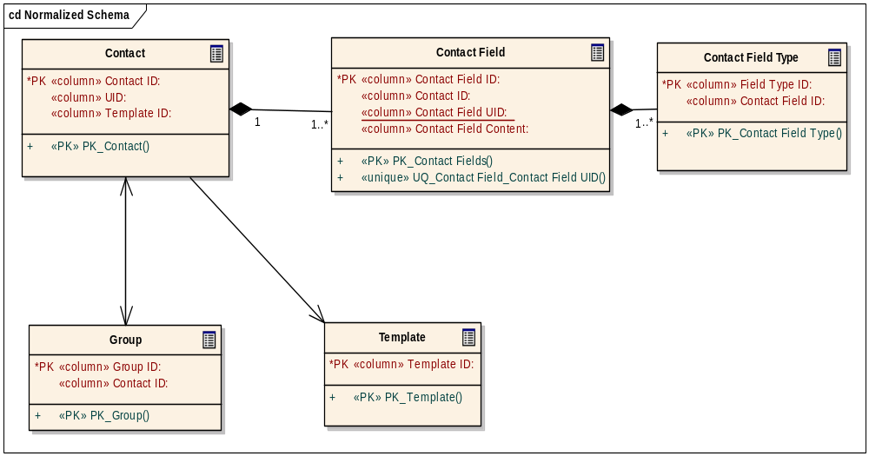

Possible Best Performance Schema
Considering the performance constraints in PREQ 1187 (section 2) and the results we got by SQLite performance testing (section 3), it appears that a similar data schema as present contact data schema which we also used in SQLite performance tests may be the most performant option. This is because it is probably the simplest data schema with least tables and would generate least rows for each contact object therefore possibly supply best performance according to the conclusion we got from the performance tests.
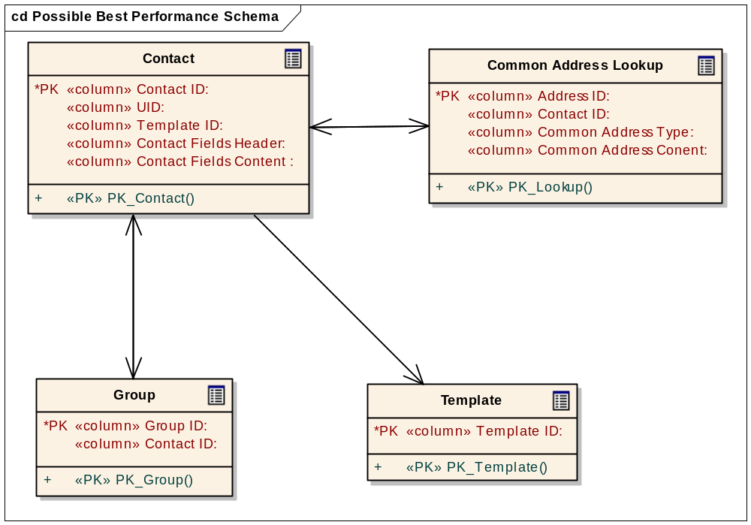

Contact Field Columns
In the schema shown above, it compact all contact field related rows included a contact, which would be added in Contact Field table and Contact Field Type table in the normalised schema, into only 2 rows stored separately into the 2 columns described as following in Contact table of this schema. This reduces the number of data rows being inserted or deleted during contact insertion or deletion, therefore reduces the number of disk IOs during these operations so would improve the performance on contact insertion and deletion.
- Contact Fields Header – Contact fields metadata for contact fields and their types.
- Contact Fields Content – Store the contents of all fields in special format.

Common Address Lookup Table
Although using the 2 contact field columns give performance gain on SQL writing operations (insert and delete), the back side of this is that there is no way to use SQL select to locate a contact by matching the particular content in its fields, phone number lookup is one of these use cases. To compromise the loss of the feature of content lookup, the common address lookup table is generated which contains

- Common Address ID – primary key of the command address
- Contact ID – foreign key associated with primary key in Contact table.
- Common Address Type – selected types of often used address such email, phone number and SIP address
- Common Address Type – the searchable content of the common address.

Comparison between Two Approaches

Performance
As mentioned in section 4.2, compare to normalized schema, the possible best performance schema reduced the number of data rows of a contact added into database and has less number of tables. This make the later one faster when inserting and deleting contacts on SQLite database based on the conclusion we got from performance tests against SQLite.
The following table shows the performance comparison between the two schemas based on the use cases of PREQ 1187:

Use Case | Normalized Schema | Best Performance Schema
Add Single Contact | Slower | Faster
Update Single Contact | Equal* | Equal*
Delete Single Contact | Slower | Faster
Delete 20 Contacts | Slower | Faster
Delete All (but one) Contact | Slower | Faster
Initial Sync (Bulk Insert) | Slower | Faster
Match Phone Number | Equal** | Equal **
Read Single Contact | Fast | Fast
*Update on normalized schema may be still fast on normalized schema because it is possible that only part of whole rows for a contact need to be updated. So it’s impossible to estimate which schema is faster in this case.
**By using common address lookup table in the possible best performance schema, the speed of phone number match could be as same as the normalized schema.

Scalability and Maintainability
This section is to compare the two schema approaches over scalability (how flexible the schema is to adopt new requirements) and maintainability (how easy the schema is to be understand and how much resilience to maintain data compatibility (DC) and binary compatibility (BC) when schema is extended in future).
Here is the use case which high likely will be added in the future:

Use Case | Normalized Schema | Best Performance Schema
Add new field type | Scalability is high, only need to add additional row of the new type for each contact in Contact Field Type table.  Maintainability is high.  Contact field content is stored simply in a singleton row so there is not extra work to decode it before it can be used by contact model. This makes the contact model code and data schema simpler and easier to be understood.  DC is highly maintained because there is no impact on overall schema, so as BC, old version contact model can still run on the schema with new field type added in. | Scalability is low, how easy to add a new field type depends on how the data structure is designed in Contact Field Header and if there is reserve place to store the new type.  Maintainability is low.  Contact model has to do the work for the database by decoding and encoding the data stored in Contact Fields Header column and Contact Fields Content column in order to retrieve content of all contact fields of a contact. The decoding and encoding part of code is potentially difficult to maintain.  And if DC and BC is maintainable is also dependent on how the data structure of Contact Field Header column in Contact table is designed.

Justification
As the result of comparison in last section, we can clearly see that the best performance schema is almost at stronger side in all performance uses case but is weaker in scalability and maintainability than the normalized one.
But in the performance tests, we found even using similar schema as the possible best performance schema we still may miss the performance target required in PREQ 1187. And since performance is so critical in PREQ 1187, we have to adopt the best performance approach to make the whole solution on SQLite as fast as it can be although we know it’s not angel from design point of view.

Further Information

References
No. | Document Reference | Version | Description
[R1] | SGL.BCD001.105.CAMPerformanceBenchmarks.doc | 0.9 | Performance benchmarks for Contacts, Agenda, and Message store services
[R2] | SQLite System Qualities Investigation.doc | 0.7 | Test results analysis for first stag SQLite performance tests.
[R3] | SQLite performance testing for Cntmodel migration.doc | 0.4 | Test results analysis for 2nd stag SQLite performance tests.
[R4] | cntmodel_dbms_data_schema.doc | 1.3 | Contacts Model DBMS Database Schema
[R5] | ??? | ??? | PREQ1187 configuration management plan

Open Issues

Glossary
Term | Definition

- Contacts Data Entities Diagram
The following diagram shows the data entities model currently used in contact model and the means of each entity are explained in relevant sub-sections. The diagram is to help on clearly understanding the whole essential data objects or entities which will construct the final data schema.
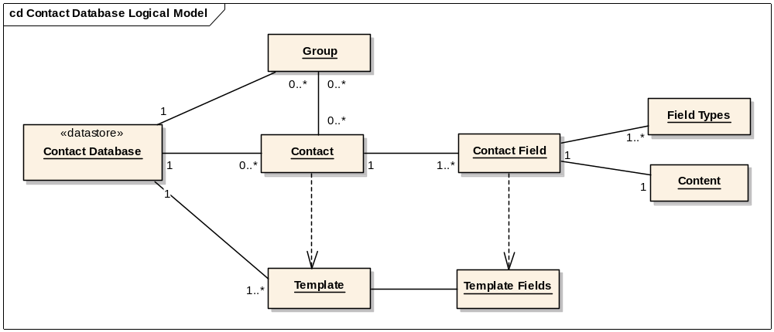
  - Contact
Contact is logical entity stored in contact database and each contact has:
- 1 or more Contact Fields – Essential content unit of a contact item.

  - Contact Field
Contact Field is logical content unit which make up together to give Contact meaningful and each field has
- A mix of several Contact Field Types – to decide what the content of the field will represent, for example work email address (combination of type ‘work’ and ‘email address’).
- 1 Field content – Actual data of the field

  - Contact Group
Contact can be grouped into differently defined Contact Groups.

  - Contact Template
Contact Template is a set of field types that can be used to be as template when create Contact.
It means, when creating a contact, the types and label of Contact Fields in the creating Contact are predefined in Contact Template it refers to.

- Hint Field Types

Contact Field Type | vCard Mapping | Hint Field Type
AdditionalName | Composite to VCardMapN | Additional Name
Address | VCardMapADR,  multiple lines value | Address
CompanyName | VCardMapORG | Company Name
CompanyNamePronunciation | VCardMapORGPronunciation | Company Name Pronunciation
Email | VCardMapEMAILINTERNET | Email
FamilyName | Composite to VCardMapN | Family Name
FamilyNamePronunciation | Composite to VCardMapN | Family Name Pronunciation
GivenName | Composite to VCardMapFN | Given Name
GivenNamePronunciation | Composite to VCardMapFN | Given Name Pronunciation
StorageInline | Will not be converted to vCard | Inline Storage
Msg |  | Msg
PhoneNumber | VCardMapTEL, VCardMapAssistantTel, VCardMapCELL, VCardMapPAGER | Phone
PrefixName | Composite to VCardMapN | Prefix Name
SuffixName | Composite to VCardMapN | Suffix Name

- Additional Field Types

Contact Field Type | vCard Mapping
Fax | VCardMapFAX
IMAddress | VCardMapWV
Anniversary | VCardMapAnniversary
Assistant | VCardMapAssistant
Birthday | VCardMapBDAY
Children | VCardMapChildren
Class | VCardMapClass
Country | VCardMapCOUNTRY
DepartmentName | VCardMapDepartment
DTMF*
ExtendedAddress | VCardMapEXTENDEDADR
Hidden*
JobTitle | VCardMapTITLE
Locality | VCardMapLOCALITY
Note | VCardMapNOTE, multiple lines value
Picture | VCardMapPHOTO, VCardMapLOGO
Postcode | VCardMapPOSTCODE
PostOffice | VCardMapPOSTOFFICE
Region | VCardMapREGION
SecondName | VCardMapSECONDNAME
SIPID | VCardMapSIPID
Spouse | VCardMapSpouse
TemplateLabel*
Url | VCardMapURL
RingTone*
VoiceDialField*
ICCGroup*
ICCPhonebook*
ICCSlot*
DefinedText*
None
Sms*
* These are contact fields defined and customised by contact application but will not be converted to vCard properties
- Attribute Field Values

Attributes | Bits Value
Hidden | 0x00000001
ReadOnly | 0x00000002
Synchronize | 0x00000004
Disabled | 0x00000008
UserMask | 0x000000F0
TemplateMask | EUserMask|ESynchronize|EReadOnly|EHidden
OverRidesLabel | 0x00000100
UsesTemplateData | 0x00000200
Template | 0x00000800
LabelUnspecified | 0x40000000
Deleted | 0x80000000

Extended Attributes | Bits Value
Private | 0x00000001
SpeedDial | 0x00000002
User Mask | 0x0000007C

- SQLite’s column affinity / manifest typing system and storing integers as strings
Strings of numbers can be treated as numeric data when using SQLite, owing to its system of manifest typing which, in effect, means that the value itself has a type and not the field or variable. Thus, when operations are performed on a value, its type is dynamically decided at run time, in conjunction with the nature of the operation. For example, consider the following SQLite command line session:

sqlite> CREATE TABLE tmp
...> (
...> tmp_id INTEGER PRIMARY KEY NOT NULL,
...> test_string TEXT
...> );
sqlite> INSERT INTO tmp (tmp_id, test_string) VALUES (1, 12345);
sqlite> SELECT test_string FROM tmp;
12345
sqlite> SELECT tmp_id FROM tmp WHERE test_string = '12345';
1
sqlite> SELECT tmp_id FROM tmp WHERE test_string = 12345;
1
sqlite> SELECT test_string||'1' FROM tmp;
123451
sqlite> SELECT test_string + 1 FROM tmp;
12346
sqlite>

When selecting, there is, in effect, no difference between comparing with an integer or the string representation of that integer. When comparing an integer with a text column, the integer is automatically converted to a string. By default, the two strings are compared by the standard C/C++ library function memcmp()which does a binary comparison of the two strings. Thus, comparison is relatively efficient and there is little difference in performance between integer:integer and integer:string matching (when measuring like data such as an integer and its textual representation).
When manipulating the data, if string operations are performed on test_string it will behave like a string; if numeric operations are performed on it, it will behave like a number.
Thus, there is little difference in storing telephone numbers as strings instead of numbers.
- Contact Fields Physical Data Structure on DBMS
  - Physical Data Structure
Following is the diagram of the physical data structure used in contact data schema on DMBS.
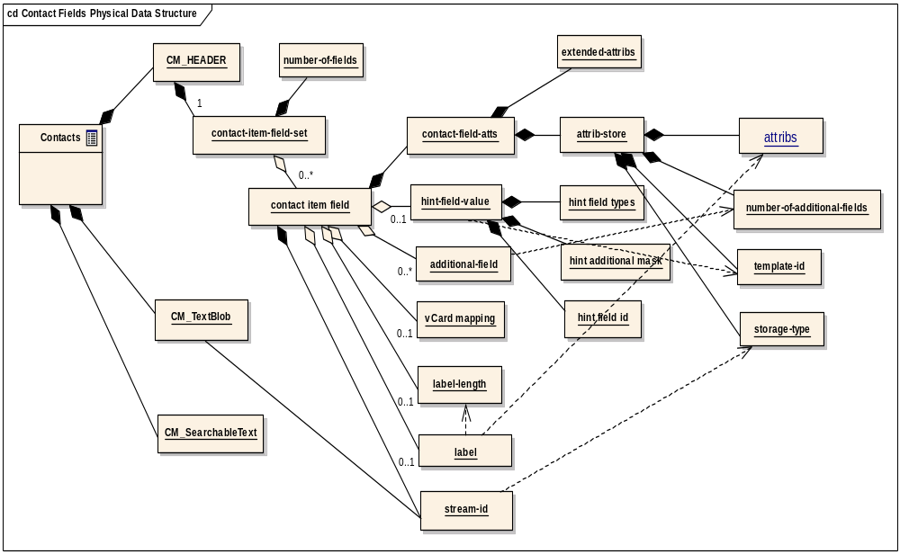
The so-called ABNF format put the content of contact fields in a contact into the three columns (divided contact field content into text field content and binary field content).
The Contact Fields Header composite of following elements:
- hint field value is stored as integer and composite of
  - hint field types(21bits) are bitwise flags to show if the field is an email, phone number and so on.
  - hint additional mask(1bit) is to show if there is additional field types apart from hint field types
  - hint field ID(10 bits) is the field ID of the field.
- additional-fields contains all field UIDs that can not be represented in hint value.
- vCard mapping is optional. It should be specified if the field type alone is not enough to identify the mapping between vCard property and the contact field.
- hint field value, additional-field and vcard mapping are dropped out if the field uses the template's content type
- label and label-length are in if there is a label which overrides the template label and label are dropped off if label-length is zero.
- additional-field is repeated a number of times as specified by number-of-additional-fields inside contact-field-atts
- extend attributes is bitfields and stored as unsigned integer: Private, Speed-Dial, 4 user-defined fields
- stream-id is a stream store id in CM_Textblob when field-type is binary otherwise it would be zero.
- attrib-store is stored as unsigned integer and a combination of:
  - attribs (12 bits) is bit-fields: Hidden , ReadOnly, Synchronize, Disabled, 4 user-defined fields, OverRidesLabel, UsesTemplateData
  - field type(6 bits) is bit-fields and the actual storage type of the field: text, binary, date-time, string-array
  - number-of-additional-fields(4 bits) is unsigned value to indicate how many additional field type UIDs in additional-fields
  - Template ID(10 bits) is field ID in the template that the field would refer to

  - Optimise Analysis on Contact Field Metadata
By simply abstract the physical contact field metadata described in last section, they can be shown in following diagram:

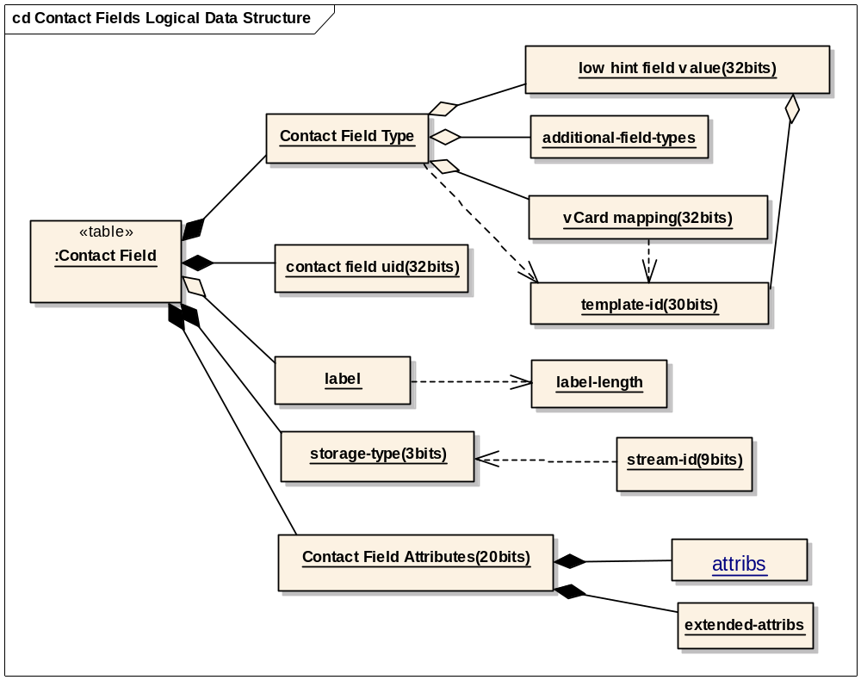

As what is demonstrated in above diagram, the complicated metadata can be divided into 5 areas:
- Contact Field Type – determines what type the field content represents. In the physical data structure it is made up by hint field types, additional field types and relevant vCard mapping, and the type is also determined by reference template if template id exists.
- Hint Field Type – defined to map contact field type UIDs which are unique integers into bit flags so that it can save space stored in database. The mappings can be found in a table in Appendix B. The hint bit flags actually only occupy 12 bits of data because the three pronunciation types are combination of there parent field type with pronunciation type, for instance:
Company Name Pronunciation = the bit of Company Name & the bit of Pronunciation.
- Additional Field Types –those contact field types UIDs left not having hint value mapping, therefore they are still stored in database as integers. The mappings can be found in a table in Appendix C.
- vCard Mapping – stored as integer and following are those not covered by contact field types so they have to stored in this field.
- Template ID – stored in limited integer (10 bits)

Rationale for Performance Optimization
- Template ID is used to saving data size because if it’s valid all 3 fields (hint field types, additional field types and vCard mapping) will be dropped. So we should still use this way.
- vCard mapping can not be replaced by bit flags because there is not any benefit from data saving.
- hint field types is good way to saving data, and it would be good to use 2 integers(or 1 64bits integer) to cover all contact field types into bit flag. Except 12 bits used in present hint field types representing 14 contact field types, there are 30 contact field types

    - Contact Field ID
The field ID currently is stored in 10 bits of the integer of hint field value, and this limits the range of the ID to be unique as required from a coming requirement (PREQ1036 -- Uniquely identify fields in Contacts).
With the DC allowance we got for this requirement, we are suggested to store the field ID as UID which occupy 32 bits integer.

    - Contact Field Label
Contact field label is optional and it is used to support the case that customer can name certain fields by their own opinion. If the label exists are decided by if OverRidesLabel bit in attributes is set.

    - Contact Storage
To determine where to find the contact field content, the storage type (6 bits) has been defined, and also along with stream ID (32 bits).
Rationale for Performance Optimization
- The size of Stream ID should be reduced because it represents how many binary data fields there are in a contact. Realistic quantities of binary data fields in a contact should be less than 512 so 9 bits to store the stream ID would be ok.
- Storage type currently is using bit flags which is not efficient from data saving point of view because the storage types are exclusive to each other, changing the data type of this field from bit flags to data value means to use only 3 bits is enough to store the 4 types (binary, date time, text, string array) and have 4 values reserved.

    - Contact Field Attributes
Possibly because of the historical reason (BC?), present data schema creates 2 fields to store contact field attributes: attributes (12 bits) and extended attributes (32 bits). But there are only 20 bits of total 44 bits actually being used in contact model, so the redundancy here is obvious. See Appendix D for the list of field attribute values.
Rationale for Performance Optimization
- Using 32bits integer to store the whole contact attributes.

- Contacts Model Preference Table in the DBMS schema

Column Name | Type | Description
CM_PrefFileId | EDbColInt16 | Preferences table format version number. Currently unused by contacts model.
CM_PrefTemplateId | EDbColInt32 | Contact item ID for the system template
CM_PrefOwnCard | EDbColInt32 | Contact item ID for the database’s owner card
CM_PrefCardTemplateRefId | EDbColInt32 | Contact item ID for the database's preferred template
CM_PrefCardTemplateId | EDbColLongBinary | Array of Contact item IDs for user-defined templates
CM_PrefGroupIdList | EDbColLongBinary | Array of Contact item IDs for contact groups
CM_PrefFileVer | EDbColInt32 | File version. SymbianOS 7.0s has version 5
CM_CreationDate | EDbColDateTime | Creation date of the contact database file
CM_MachineUid | EDbColInt64 | Randomly generated identifier for the database.
CM_PrefSortOrder | EDbColLongBinary | Preferred sort order for clients, as set by CContactDatabase::StoreSortOrderL

- Proposed Template Table
  - Template Item versus Contact Item
In the contact schema on DBMS, it is storing the template items as same as contact items in the contacts table. But as each template item is only a set of field types which contact items refer to and has not any detail content in the item so it’s much simpler than what a contact item has.
The following is the comparison between a template item and a contact item:
 | Template Item | Contact Item
Item Label | Yes | Has first name, last name, company name and their related pronunciation fields instead
Item Attributes | Yes | Yes
Item Types | No | Yes
Sync Related Columns (creation date, last modified) | No (this is based on the assumption that we don’t have requirement to expose templates to other phones) | Yes
Access Count | No | Yes
Field Label | Yes | Yes
Field Content | No | Yes
Field Types | Yes | Yes
Loading Time | Loaded at start-up time and be cached in memory until end-up time. | Loaded and unloaded at any time at or after start-up time to end-up time.
Update Frequency | Low | High

  - Proposing Template Table Schema
All the difference listed in the table in last section suggesting we can create another less accessed table to store template items. The SQL scripts for template table is

CREATE TABLE template
{
template_id INTEGER NOT NULL,
template_ref_id INTEGER,
creation_date INTEGER,
template_label VARCHAR(255),
fields_header BLOB,

PRIMARY KEY(template_id)
};

- template_id – is the primary key and unique id of a template item
- template_ref_id – is the template id the template refers to, NULL means no reference template.
- creation_date – is the time the template is created.
- template_label – is to represent the name of the template.
- fields_header – see detail in section 4.4.3 below.

  - Template Fields Header
The template field header is in same format as what are stored in contact field headers (text_fields_header and binary_fields_header in contact table).
  - System Template ID
The system template is the only build-in template and is loaded from contact ini file when the contact database is creating and can not be changed after the database is created.
As the unique read-only character of the system template apart from card templates, which can be added and deleted after the database is created, allow we assign an unique hard coded template_id for system template, and as it always the first template added into the table, we decide to use template_id 0 to represent the template as system template.
  - Constrains Check on Template Deleting
As the delete constrains of foreign key are not support in SQLite, so the code in contact mode to delete template has to check if there is any contact in contact table refer to the template(its template id is equal to the id of deleting template, if so delete request is not allowed.
  - Performance Concern
This new table will not do any harm to the performance of any key use case addressed in PREQ 1187. Because this will:
- Remove a few rows of template items from contacts table therefore would slightly improve the performance of those operations on that table
- Creating an independent simplified template table reduces contacts model start-up time spent on loading all templates into memory.

