
Cntmodel CContactViews & RContactRemoteViews
DocRef

Owner: | Graham Oldfield & Joe Branton
Last revised: | 24 April 2001
Revision: | 0.02
Status: | DRAFT
Contributors:
Key Reviewers:
Distribution
Approved By: |  | Approval Ref.:

Contents
1. Introduction
1.1 Purpose and scope
1.2 References
1.3 Open Issues
1.4 Glossary
1.5 Document History
Overview of New Contacts View Architecture

1. Introduction

1.1 Purpose and scope
To provide an overview of the new view interface in cntmodel.

1.2 References
None.

1.3 Open Issues
None.

1.4 Glossary
The following technical terms and abbreviations are used within this document.
DBMS – Database Management System (Epoc’s relational database component)
Table - Refers to records arranged in rows and columns.
Field – Refers to a single column in a record. (e.g. Contact ID, FirstName)
Record – Refers to a single row in a table.
Blob - binary large object, a collection of binary data.
SQL - structured query language used to query and update DBMS data.

1.5 Document History
Date | Version | Status | Description
 | 0.01 | Draft | First Draft

Overview of New Contacts View Architecture

A contact view architecture has been introduced with the new version of cntmodel. The architecture deals with various views of a sorted / unsorted list of contacts. The reason it has been introduction was that most clients of cntmodel require views in which the contacts are either sorted by type (contacts with e-mail addresses ect..) or by their position between two characters. For example an address book base view, may have various tabs such as ‘abc’ , ‘def’, ‘ghi’... At present all clients of cntmodel has to write their own code to sort contacts into their own ‘views’. This leads to a lot of code duplication between cntmodel clients, and makes writing a cntmodel based application more complex.
The new architecture allows clients to specify views, on a contacts name, the methods it contains and its sort order. It also allows for sharing of a contact views via the contacts lock server, avoiding the need to construct these potentially expensive views per client.

Views Design

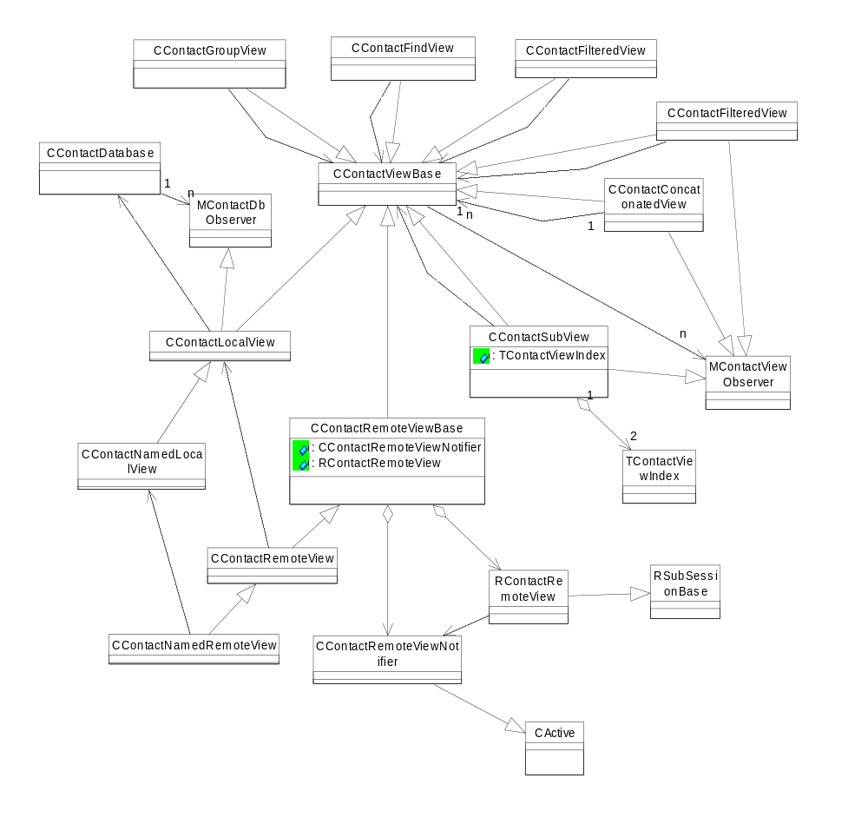
Choosing the correct view

There are two main types of contact view - local views and remote views.
The data associated with local views are allocated within the client's memory space.They are kept up to date by reception of database events from the underlyingCContactDatabase object.
The data associated with remote views are allocated within the memory space of the contacts server. Within the server there a local view object will be associated with each client side remote view object. The advatange of this configuration is that mult clients can share the same server side view objects, thereby reducing the overhead associated with initial sorting of the view data, and keeping the it in sync with the underlying data. Remote views should therefore be used when the same view is likely to be needed by more than one client.

CContactLocalView
The main local contact view class and is derived from CContactViewBase. It Contains an array of sorted (and potentially filtered) contact ids. It observes the contacts database to pick up notifications of changes in the underlying data. May be derived from if the default sorting algorithm is not suitable.

CContactNamedLocalView
This class adds the ability change sort orders to the functionality provided by CContactLocalView. When this is done, a notification will be sent to all observers. This is intented to be only used to the contacts server and clients should create and access named views via CContactNamedRemoteView.

CContactSubView
Objects of this class present a 'window' of data over a (potentially) larger data set contained in an underlying CContactViewBase object. As the underlying data is modified, objects of this class will keep themselves up to date.

CContactConcatonatedView
Objects of this class may be used to concatonate multiple CContactViewBase objects into a single contiguous view. The component views will be ordered according to the order of the array passed into the constructor.

CContactRemoteView
The main remote contact view class associated with a corresponding CContactLocalView object within the contact server. Provides a efficient means for multiple clients to share the same underlying view data

CContactNamedRemoteView
This class allows clients to create CContactNamedLocalView objects inside the contact server. Once one client has done this, other clients can share it by name. It extends CContactRemoteView by providing a method for changing the sort order. All users of the named view will be notified when the sort order is changed.

CContactFilteredView
Objects of this class may be used to provide a filtered view over an existing CContactViewBase derived object. For efficiency reasons there are a finite set of filters available (defined in TFilter).

CContactFindView
This class creates a view based on a find criteria (1..n find words), it is based on an underlying CContactViewBase and will contain all contact from the underlying view that match the find criteria.

CContactGroupView
This class gives a view representation of a group, all the contacts belonging to the group will be displayed. the view uses an underlying view to retrieve the contacts that belong to the group. TGroupType defines whether the view displays all contacts belonging to the group or all contacts that are not part of this group.

Using the view architecture
This section will describe how to use the architecture to create a sorted address book application base view with 3 tabs, tab 1 is all contacts with names greater than a and less than h ‘a-h’, tab 2 is all contacts with names greater than i and less than r ’i-r’, tab 3 is all contacts with names greater than s and less than z ’s-z’, therefore we will have all contacts from cntmodel but placed on tabs determined by their names under the current sort order.
First off all we have to have a underlining list of contacts to base these tab views on . For this example we will create a named sorted local view, with no filter.
CContactNamedLocalView* sortedUnfilteredLocalNamedView;
I now call NewL the class creating this view must pass in a MContactViewObserver to the view, this class will then recieve notifications when anything happens to the view. Its worth noting that the NewL call will complete instantly. However the view may not be ready for use, as it may be performing an asynchrounous sort. This MContactViewObserver will recieve an event Eready when the view is ready for use. Any attempt to use the view before this notification will cause it to panic.
The sortorder is an array of TContactSortPref, here I create an sorted based on, firstname,lastname, companyname in ascending order.
RArray<TContactSortPref> sortOrder;
sortOrder.Append(TContactSortPref(KUidContactFieldGivenName,TContactSortPref::EAsc));
sortOrder.Append(TContactSortPref(KUidContactFieldFamilyName,TContactSortPref::EAsc));
sortOrder.Append(TContactSortPref(KUidContactFieldCompanyName,TContactSortPref::EAsc));
I now created the sortedview.
sortedUnfilteredLocalNamedView=CContactNamedLocalView::NewL(*this,_L(“MySortedView”,iDb,sortOrder,EContactsOnly);
The final parameter in the NewL of any local or remote view determines what types of contact this view will contain, this is defined by the enum TContactTypeIncluded and gives the options of views that contain only contacts, only groups or views that contain both contacts and groups.
Once the sortedUnfilteredLocalNamedView is ready, we can start creating subview (the tabs). Subview are relatively cheap to create, compared to creating a CcontactView, or nameView. This is because they are based on an underlying CContactView and need only set up various indicies on the underlying views.
CContactSubView* subViewAtoH;
subViewAtoH=CContactSubView::NewL(*this,iDb,*sortedUnfilteredLocalNamedView,_L(">=a"),_L("<h"));
CContactSubView* subViewItoR;
subViewItoR=CContactSubView::NewL(*this,iDb,*sortedUnfilteredLocalNamedView,_L(">=i"),_L("<r"));
CContactSubView* subViewStoZ;
subViewStoZ=CContactSubView::NewL(*this,iDb,*sortedUnfilteredLocalNamedView,_L(">=s"),_L("<z"));
The subviews provide functionality to get at the contact ids within them, AtL, CountL and FindL.

