Architecture of maemo6 (Harmattan) backend for QT Mobility Messaging module

This document describes an architecture of Maemo6 backend for QT Mobility Messaging module.

Architecture of the Maemo5 (Fremantle) backend
Maemo5 (Fremantle) backend supports e-mailing (libmodest) and SMS/IM (TpSession based on Telepathy). Maemo5 backend implementation have universal (type independent) core and 3 type-specific engines that hide type specific message processing.

For generic Linux QT Mobility Messaging module have implementation of e-mailing support based on QT Messaging Framework QMF. This code can be ported to QMF engine that support e-mailing in maemo6.

Design Considerations
Maemo6 backend have the same architecture as maemo5. Type specific engines have to be reimplemented because of libraries used in maemo5 are not integrated into the maemo6 or not recommended.

Table and pictures below illustrate ideas of architecture and fast implementation of maemo6 backend for QT Mobility Messaging module.

 | QMF (generic Linux) | Maemo5 (Fremantle) backend | Maemo6 (Harmattan) backend
Data- representational classes | Implementation contains QMF specificity | Implementation is type independent | Maemo5 implementation + QMF converters
Service classes  (QmessageService, QMessageStore) | Implementation contains QMF specificity | Implementation is based on 3 type-specific engines | Implementation is based on 3 type-specific engines
E-mail support | Implemented in service classes | Based on modest-dbus-client | Based on QMF
SMS/IM sending/receiving support | NO | Based on tpsession | Based on telepathy-qt4
SMS/IM storage/search support | NO | Based on rtcom-eventlogger | Based on libcommhistory and libqttracker

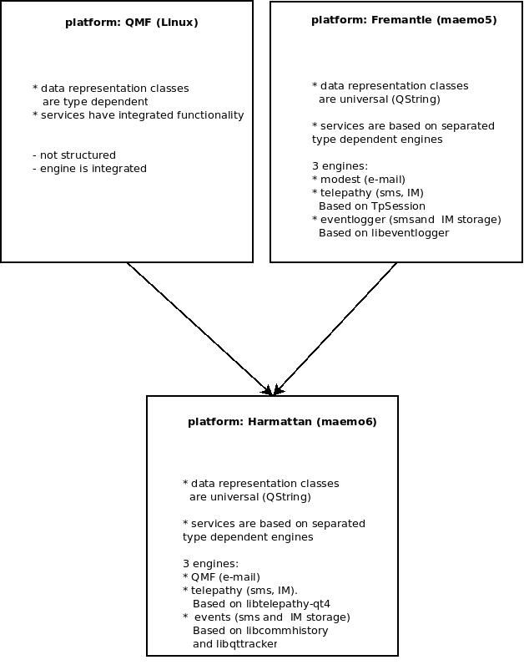

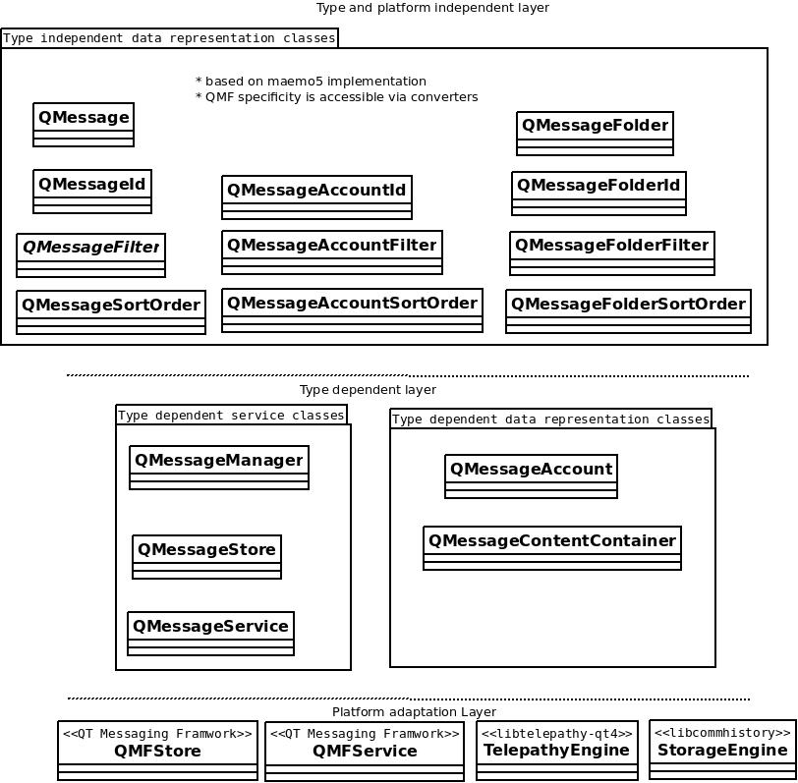

Testing of maemo6 backend.
Testing of maemo6 backend is organized in automatic and semiautomatic modes
Semiautomatic testing is based on messagingconsole utility (tests/messagingconsole).
Automatic testing is provided by two tests suites.
smsstore – for testing of class QMessageManager (tests/auto/smsstore)
smsservice - for testing of class QMessageService (tests/auto/smsservice)

