
Cntmodel Optimisation Notes
DocRef

Owner: | Graham Oldfield & Joe Branton
Last revised: | Friday, 16 March 2001
Revision: | 0.02
Status: | DRAFT
Contributors:
Key Reviewers:
Distribution
Approved By: |  | Approval Ref.:

Contents
1. Introduction 3
1.1 Purpose and scope 3
1.2 References 3
1.3 Open Issues 3
1.4 Glossary 3
1.5 Document History 3
2. Original Structure 4
2.1 DBMS Structure 4
2.1.1 How Contact Data stored is the original Cntmodel 5
2.2 Advantages of the ‘Blob’ Structure 6
2.3 Disadvantages of the ‘Blob’ Structure 6
2.3.1 Sorting 6
2.3.2 Field Access 6
3. New Structure 7
4. Compatibility 9
5. Populating ‘Base Views’ 9
6. Sorting 9
7. Searching 11
8. Phone Number Matching 11

Introduction

Purpose and scope
- To provide an overview original Contact Model structure and why this can lead to poorly performing UIs.
- To describe the changes that were made to address these performance problems.
- To describe how to use the new Contact Model in an efficient way.

References

None.

Open Issues

None.

Glossary

The following technical terms and abbreviations are used within this document.
DBMS – Database Management System (Epoc’s relational database component)
Table - Refers to records arranged in rows and columns.
Field – Refers to a single column in a record. (e.g. Contact ID, FirstName)
Record – Refers to a single row in a table.
Blob - binary large object, a collection of binary data.
SQL - structured query language used to query and update DBMS data.

Document History
Date | Version | Status | Description
 | 0.01 | Draft | First Draft
16/3/2001 | 0.02 | Released | Released with first cut source drop ‘cntopt001’.

Original Structure

DBMS Structure

There are currently 5 DBMS tables (shown in Figure 1), used to stored contacts information.
- CONTACTS stores all the data pertaining to contacts fields and attributes
- GROUPS & GROUPS2 stores the concept of a group that contains a number of contacts (from their ID).
- PHONE a new table that stores the contact Id and a phone number duplicated from the CONTACTs table.
- SYNC a new table that stores when a particular contact was last synchronised
- PREFERENCES – Contains Ids to point to the preferred template, group ect..
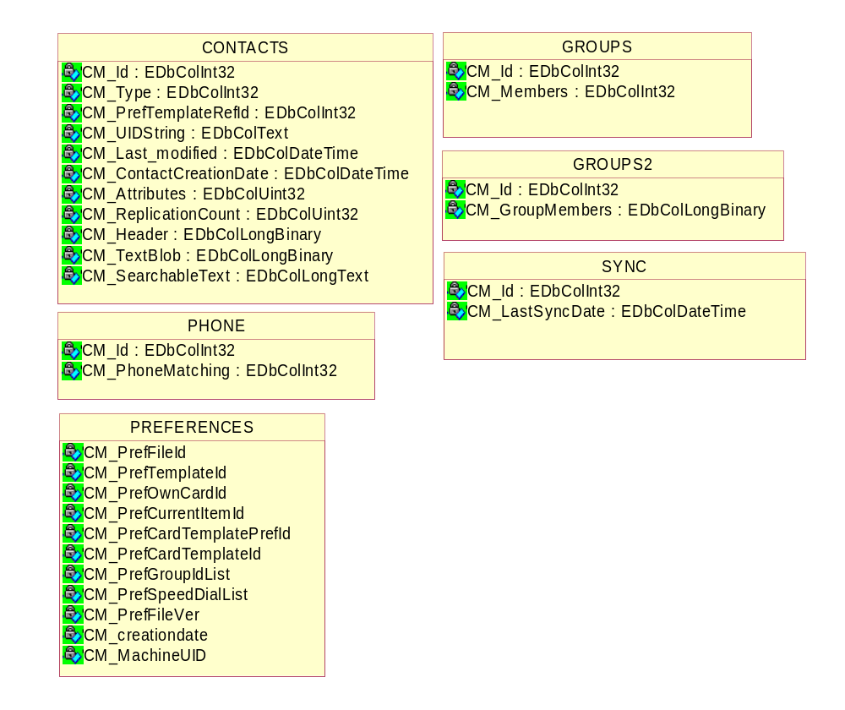
Figure 1, Existing Contact Tables

How Contact Data stored is the original Cntmodel

The major difference between contacts and the original ER3 data application is the introduction of a one to many relationship for contacts and their contact methods (e.g. phone and mobile numbers, e-mail addresses ect…)
Phone No: 077125496
Name: John Smith
Phone No: 02075631234
Phone No: 0208063155
Email: John@Work.co.uk
Email: John@Home.co.uk

To represent a contact having more than one contact method and thus many fields, the original solution was to abstract the idea of a field away from DBMS and to create ‘field like objects‘ as required and then store them in a steam within a field in the Contacts table. These stream fields could then be re-called and constructed when a record is required. This solution to the one to many relationship was solved by having 3 fields in the Contacts table CM_Header, CM_SearchableText and CM_TextBlob.
DB Field: CM_Header
Type: DbLongBinary
FieldCount
FieldLabel
FieldAttributes
FieldType
Repeated for every field
The first field is CM_Header, which contains information about the data stored in two other fields CM_SearchableText and CM_TextBlob. The first item in the steam in the number of fields contained in the contact. This is then followed by stream objects, which represent a single ‘field’ with information such a field type, field label and various attributes, this information directly represents data stored in either the CM_TextBlob field or CM_SearchableText field. So for example if there where 20 text ‘fields’ in the CM_SearchableText field there would also be 20 stream objects giving information on each of the text fields in the CM_Header field.
John Smith 0207123456 0234848374 077123234 John@homemail.com JohnSmith@Workmail www.work address.couk www.myhomepage.com 23 SomeHouse aStreet London UK E20DN This is a contact
DB Field: CM_SearchableText
Type: DBLongText

The second field CM_SearchableText simply contains the text from a field with a delimiter in between to mark the beginning of a new ‘fields’. The fields are indexed from the CM_Header field, which also contains information on the type of the field , its label and various attributes.

DB Field: CM_TextBlob
Type: DbLongBinary
Photo
Logo
Birthday
Photo

The third field CM_TextBlob contains any non-text data for a ‘field’, this field usually contains object such as photos, logos and dates. The fields are indexed from the CM_Header field, which also contains information on the type of the field the objects relate to.

Advantages of the ‘Blob’ Structure

The advantage of this structure is that it is extremely dynamic and extendable.
Any number of fields can be easily added to a contact, and each contact can contain different sets of fields.

Disadvantages of the ‘Blob’ Structure

Sorting

As the individual contact fields have been hidden within the blob structure, standard DBMS sorting can not be used. The way in which cntmodel currently sorts is rather complex and time consuming.
The information within the database can be used without being sorted however most `address book` type applications need a list of contact ids in some order.
At present if an app requests a sorted list of contacts sorted by a field (usually firstname, lastname or company name), the cntmodel has to step through each record in the database. For each record it has to internalise in the CM_Header field data to find out what fields the contact contains. It then has to parse the CM_SearchableText field and split the text into fields as defined in the CM_Header. Once this has been done a temporary fieldset is created and the required fields that are to be sorted are added to an array. This process is repeated for every contact. The array is then sorted and a list of ids is returned.

Field Access

Getting access to certain contacts fields is quite slow, as In the case of an address book style base view that needs to list every contacts firstname and last name for example. The overhead of retrieving these fields from the blob structure and constructing them from a large database takes an unacceptably long time.

New Structure
Table: CONTACT_IDENTITY
Fields:
Tint32 Contact_ID
DbColText First name
DbColText Last name
DbColText Company name

Table: CONTACTS
Fields:
TInt32 Contact ID
BLOB FIELDS
1
1
Table: PHONE_TABLE
Fields:
Tint8 FieldID
Tint32 Contact_ID
TInt32InvertedPhoneNo

Table: EMAIL_TABLE
Fields:
Tint8 FieldID
Tint32 Contact_ID
DbColTextEmailAddress

1
1
n
n
Figure 1- proposed new tables. (red shows primary key, blue shows foreign key)
The proposed structure of cntmodel is to have three new tables, contacts_identity table, phone numbers table and e-mail table. The blob structure will still exists but it will only be used to store field details, such as the field type uids, vcard mapping, hidden status ect. The actual text of the most commonly used fields will be exposed to DBMS in the new tables. Any other fields and their data will be stored in the blob structure in the normal manner. With this structure we should see an increase in performance for access and searching on the most commonly used contact fields, the contacts firstname, lastname, company name, phone numbers and e-mail addresses.
The field data in the blob will be linked to the text in the relevant table by an 8-bit id, which will be stored in the blob text storage area. This can be used to match a field from the relevant table. The id will be based locally by contact, therefore an 8bit id should be sufficient for the number of specific fields per contact.
The contacts_identity table, which will contain the contacts id, firstname, lastname and company name. This table will be used for sorting, from our investigation it has been shown that the fastest sorting occurs on tables with the least amount of columns.
The phone numbers table will contain the contract id, an 8-bit field id and a integer representing the number in the blob. This is similar to the new phone match table in the V6.1 release of cntmodel. However we will store the number inverted to allow hash table like look-ups.
The e-mail table will contain a contact id, 8-bit field id and the e-mail address text. The address will not be duplicated in the blob and will be linked to the field data in the blob by contact is and the field id.
The e-mail and phone numbers tables will also contain bit columns hinting whether this field is home, work, mobile or landline allowing quick exact matches
Please note that the groups, sync and preference tables are not mentioned in the above schema, as they are not being changed in the new structure in any way.

Compatibility

The new version of Cntmodel does not break source compatibility with previous versions. However the API needs to be used in the way described in the next section to get the most benefit from the optimisations.
File compatibility has been broken and previous version of contacts.cdb will not work with the new structure. However it will still be possible to import contact into the database via synching and beaming. It may also be possible to create an on target converter that will catch old versions of the database and convert them to the new format. However it is not currently within the scope of this project to write such a converter.
The cntmodel source may be built against either ER5u or GT 6.1 by enabling the correct pre-processor macros. In each mmp file, the macro __ER5U must be defined when building against ER5u.

Benchmark Tests
A suite of benchmark tests has been written to evaluate the performance of cntmodel. These can be found in the test executable t_bench whose source lives in \cntmodel\tsrc. This test program stores results in a file named c:\t_bench.log on the EPOC machine. Once the tests have been completed, it gives the option of dumping the contents of this file out of a comm port (to be captured by a suitable terminal app). The Perl scrip \cntmodel\optimisation\clog.pl may be used to combine multiple log files into a single ‘comma separated variable’ file, suitable for importing into a spreadsheet. Note, the log files much be saved as ASCII to order to be parsed by the Perl script.
Data gathered from running t_bench against both the original and the new cntmodels against ER5u on Roxette hardware can be found in \cntmodel\optimisation. Note, an experimental version of store was also used when gathering this data which supports significantly faster file writes when used on a logging flash file system.

Populating ‘Base Views’

Base views are usually found in a phone book application and mostly consist of a sorted list of contacts from the database, usually only the contacts full name is displayed.
As Contacts Firstname, Lastname and Company names are now stored in a separate DBMS table called the Identity table they can be retrieved far more quickly than in the original version.
To take advantage of this new structure, when constructing a base like view it is best to use the following function in CContactDatabase.
void ReadContactTextDefL( TContactItemId aContactId,TDes &aResult,CContactTextDef* aTextDef);
The function takes the contact’s id, a reference to a descriptor where the name / fields will be stored and a TextDef.
The TextDef defines what fields are to be written in the Result descriptor, a separator can also be specified in the textdef usually this is just a single white space that separates all the fields, and can be defined as anything.
A feature of ReadContactTexDefL is that if the specified field from the textdef can’t be found for the given contact the next full field will be written to the descriptor. (This feature is used for sorting). However if exact matches are required the CcontactTextDef provides an interface - SetExactMatchOnly(), which takes a Tbool that if set to True will force ReadContactTexDefL to only write exact field matches to the descriptor.
ReadContactTexDefL is at it quickest when retrieving Firstname, Lastname and Company fields, however it can be used to retrieve any other field and is substantially quicker than using ReadContactL. Use of this interface can remove the need for caching in a base view.

Sorting

The original API for sorting has not changed, however the semantics have been slightly modified. Previously the only way to get a contact id list sorted by more than one field type was to specify the required sort fields in via the text def interface, e.g.:

CContactTextDef* textDef=CContactTextDef::NewLC();
textDef->AppendL(TContactTextDefItem(KUidContactFieldGivenName));
textDef->AppendL(TContactTextDefItem(KUidContactFieldFamilyName));
textDef->AppendL(TContactTextDefItem(KUidContactFieldCompanyName));
iDb->SetTextDefinitionL(textDef); // Takes ownership.
CleanupStack::Pop(); // textDef.
CArrayFix<CContactDatabase::TSortPref>* sortOrder=new(ELeave)CArrayFixFlat<CContactDatabase::TSortPref>(2);
CleanupStack::PushL(sortOrder);
sortOrder->AppendL(CContactDatabase::TSortPref(KUidContactFieldDefinedText));
iDb->SortL(sortOrder); // Takes ownership.
CleanupStack::Pop(); // sortOrder

This means of specifying a sort order is still supported by CContactsDatabase::SortL, however a more natural alternative may now be use:

CArrayFix<CContactDatabase::TSortPref>* sortOrder=new(ELeave)CArrayFixFlat<CContactDatabase::TSortPref>(2);
CleanupStack::PushL(sortOrder);
sortOrder->AppendL(CContactDatabase::TSortPref(KUidContactFieldGivenName));
sortOrder->AppendL(CContactDatabase::TSortPref(KUidContactFieldFamilyName));
sortOrder->AppendL(CContactDatabase::TSortPref(KUidContactFieldCompanyName));
iSortedIdList.ChangeSortOrderL(*sortOrder);
CleanupStack::PopAndDestroy(); // sortOrder

Note, the speed of sorting is very dependent on the field types used for sorting. Using field types other than Firstname, Lastname and Company will result in sort speeds similar to the original version of cntmodel.

The new cntmodel also supports server side sorting and allows multiple clients to share a single sorted list with a very low overhead (the sort is only done once, regardless of how many clients are using it). The interface to this is the class RContactView and may be used as follows:

RContactView contactView;
User::LeaveIfError(contactView.Open(*iDb));
CArrayFix<CContactDatabase::TSortPref>* sortOrder=new(ELeave)CArrayFixFlat<CContactDatabase::TSortPref>(2);
CleanupStack::PushL(sortOrder);
sortOrder->AppendL(CContactDatabase::TSortPref(KUidContactFieldGivenName));
sortOrder->AppendL(CContactDatabase::TSortPref(KUidContactFieldFamilyName));
sortOrder->AppendL(CContactDatabase::TSortPref(KUidContactFieldCompanyName));
contactView.ChangeSortOrderL(*sortOrder);
CleanupStack::PopAndDestroy(); // sortOrder
const TInt numContacts(contactView.Count());
for (TInt ii=0;ii<numContacts;++ii)
{
TContactItemId thisContact(contactView.GetL(ii));
// Do something with thisContact.
}
contactView.Close();

Note:
- Currently only one sort order is supported for the entire system. Therefore if one client changes the sort order, this affects all other clients.
- In future versions of cntmodel a notification will be sent to all clients when the sort order is changed.
- The description of the sort order is persisted inside the contact database, and so only need be set when the machine is first booted.
- Important – The ‘text def’ means of specifying a sort on multiple field types is not supported by RContactView. You must use the new means of doing this (described above).
- The interface to RContactView is not yet finalised. Future releases of cntmodel may well not be source compatible with the version in this release.

Searching

Similarly to the base view, as the Firstname, Lastname and Company are now stored in a separate table searching for these fields is far quicker. A contact’s e-mail address is also stored in a separate table and this allows contacts to be quickly identified by their e-mail address.
When searching for specific fields e.g. Firstname, Lastname, Company name, e-mail if these field types are specified in the textdef that is passed in to the search function in CContactsDatabase, the searches will be far quicker than the original. If no fields are specified or non-of the optimised fields are specified then the speed will be the same as the original.
For example to perform a quick e-mail search:

CContactsDatabase* iDatabase

CContactTextDef* emailDef=CContactTextDef::NewL();
emailDef->Append(KUidContactFieldEMailValue);
CContactIdArray* results;
results=iDatabase->FindLC(_L(“someemail@email.com”),emailDef);

Phone Number Matching

A new api has been added for phone number matching:
CContactIdArray* MatchPhoneNumberL(const TDesC &aNumber,TInt aMatchLengthFromRight);
This function takes a phone number as a descriptor and an integer for the number of chars to match from the right of the phone number. This is because numbers are stored as reversed integers in the database.

