The room is a rectangle containing  cells. Each cell could be either:

* BLANK CELL: player and monster can go and stay in.
* BLOCKED CELL. Player and monsters can’t go to this kind of cell.
* PUZZLE CELL. If player go to this kind of cell, a puzzle would be activated which give player a chance to earn items/special attack. When the puzzle
* EXIT DOOR: Player must go to this kind of cell to complete the room.

Item and Special attack are not very different from each other. The effect is to restore Hp, upgrade regular waepon, or attack monsters by special method (we could consider some more methods like teleport).

The DBMS will store all 50 rooms.

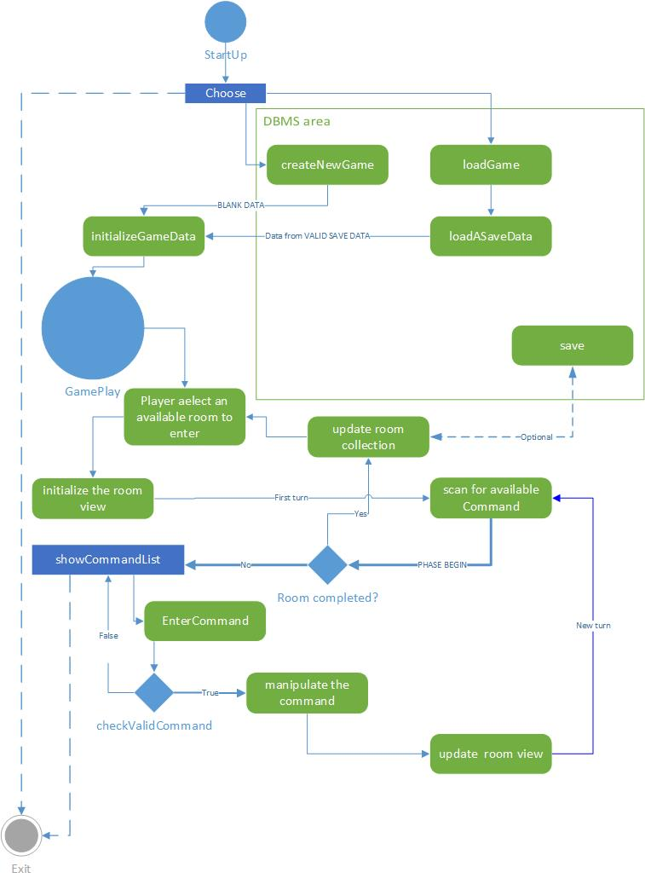

he start menu of game should have 3 choices:

* NEW GAME
* LOAD GAME
* EXIT

The “initialize game data” is to calculate stuffs of data given by dbms. The data could be either a blank new one, or a saved one.

Then player can select 1 avalable room to play.

Then we will initialze a play in the room requested by player. This include distribution of monsters, player, puzzles,... the specific room data would come from DBMS. After that, the game should be ready to play.

The game play is turn based. Each turn will go through the following order:

* Scan for avalable commands, (\*)
* if the player is in the exit door, which means room is completed, then we’d update the room collection and come back to screen “room selection“
* Show the list of commands that player can choose, the player must enter a valid command in the list.
* Manipulate the command. We’d sshow how monsters react to player’s command.
* Update the room view. And prepare for a new turn, back to step (\*)