**Dictionary Software Usage**

1. **Build program**

- Open Command Prompt, navigate to directory 'TryDictionary' and paste this:

javac -d "classfiles" javafiles/*.java

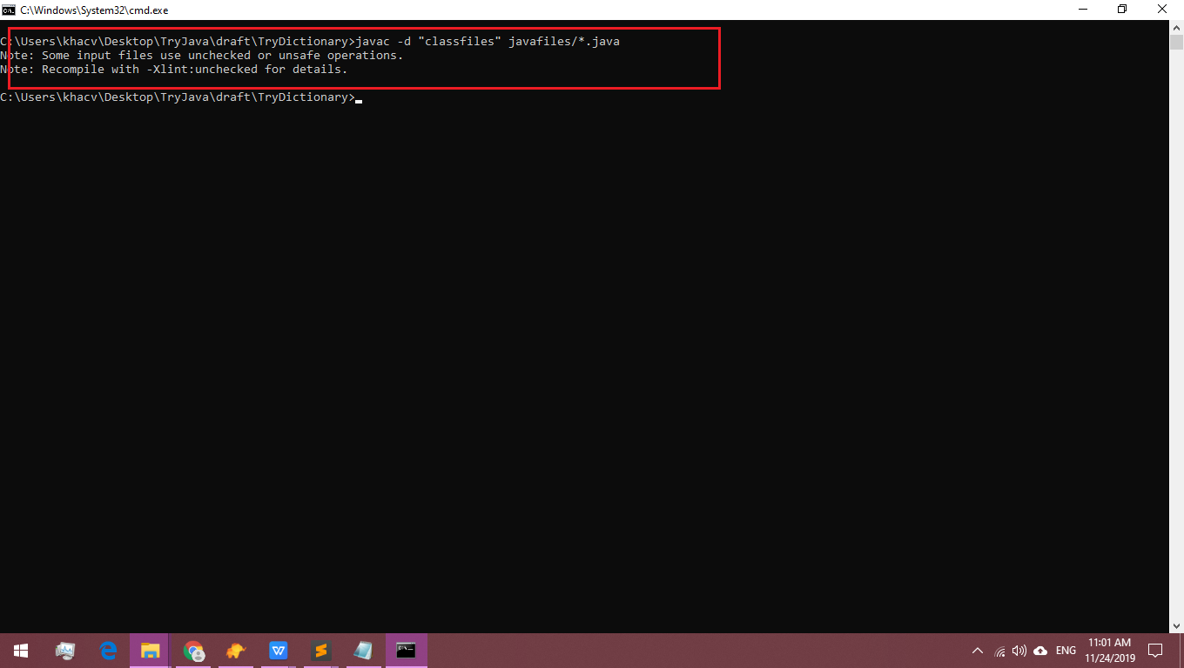

1. **Run program**

- Open Command Prompt, navigate to directory 'StudentManagement_Swing' and paste this:

java -cp "classfiles;classfiles/TryDictionary" TryDictionary.Main

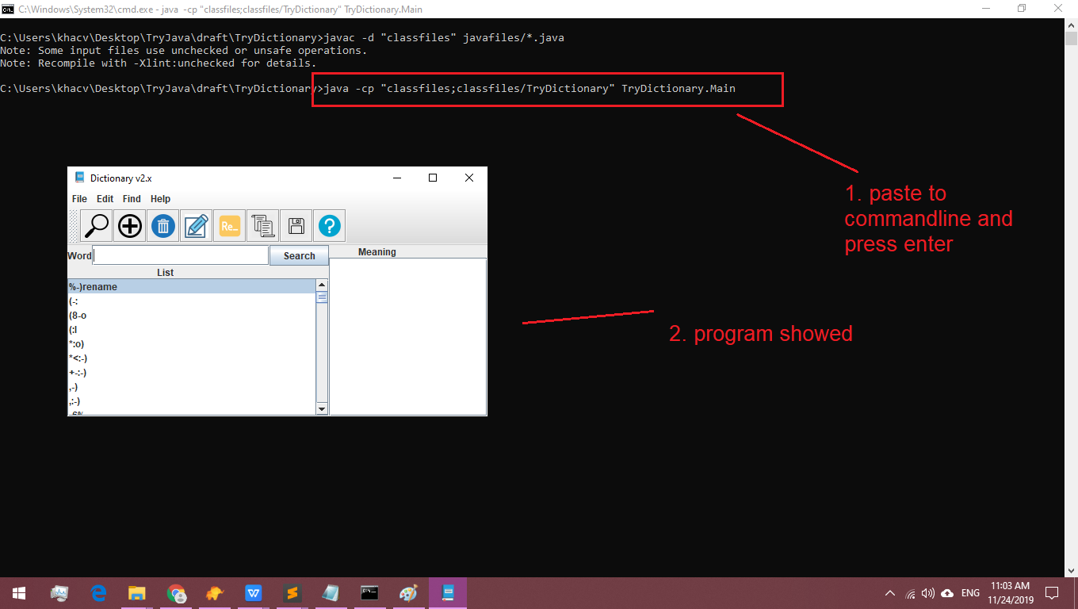

1. **Use program (some key features)**
   1. **Search word**

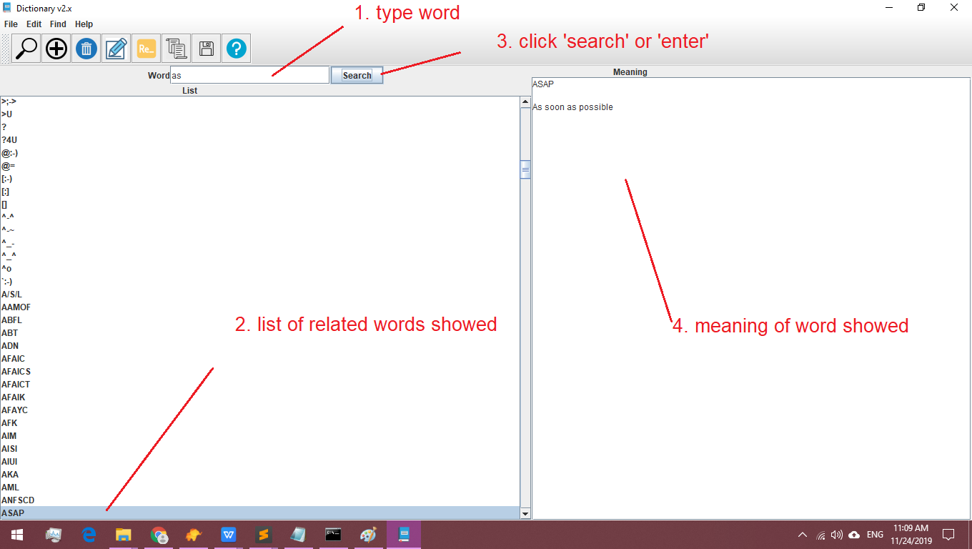

* 1. **Add word**

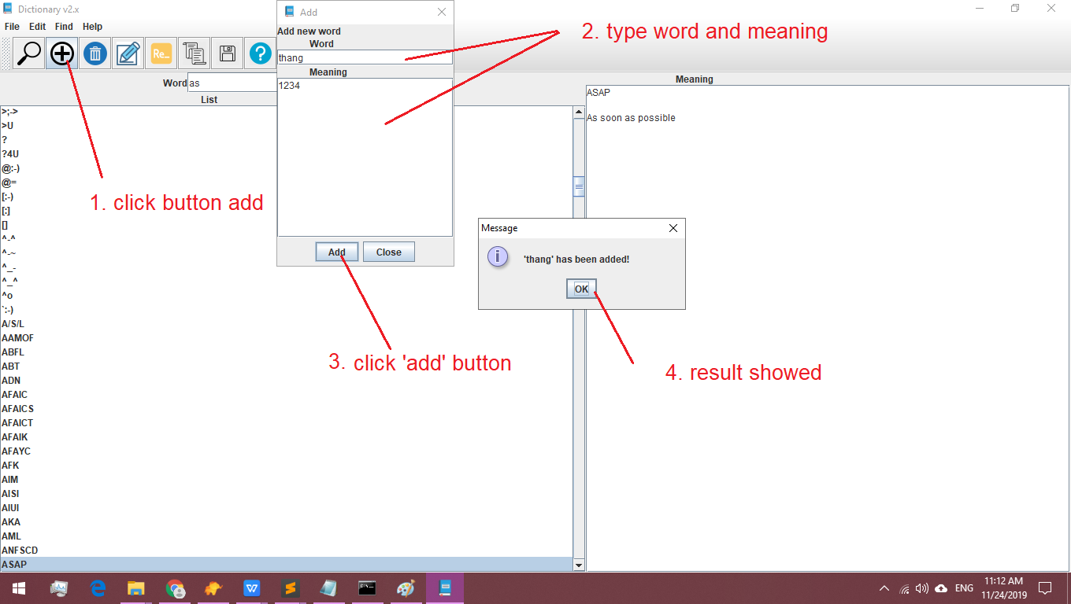

* 1. **See history**

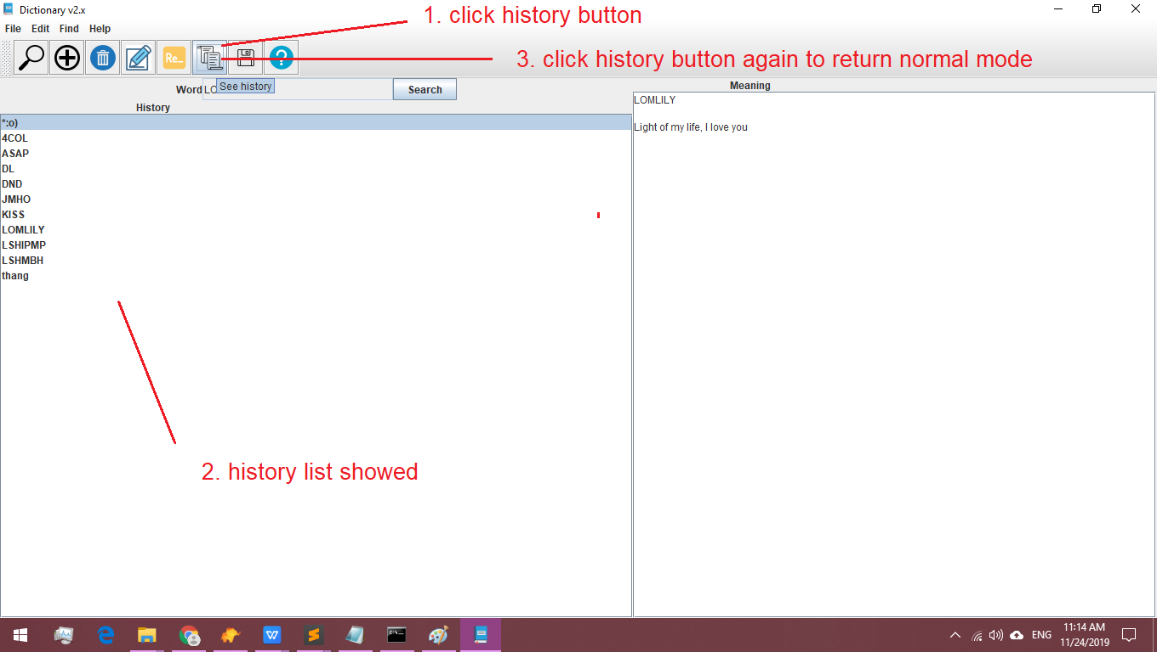

* 1. **Save all words**

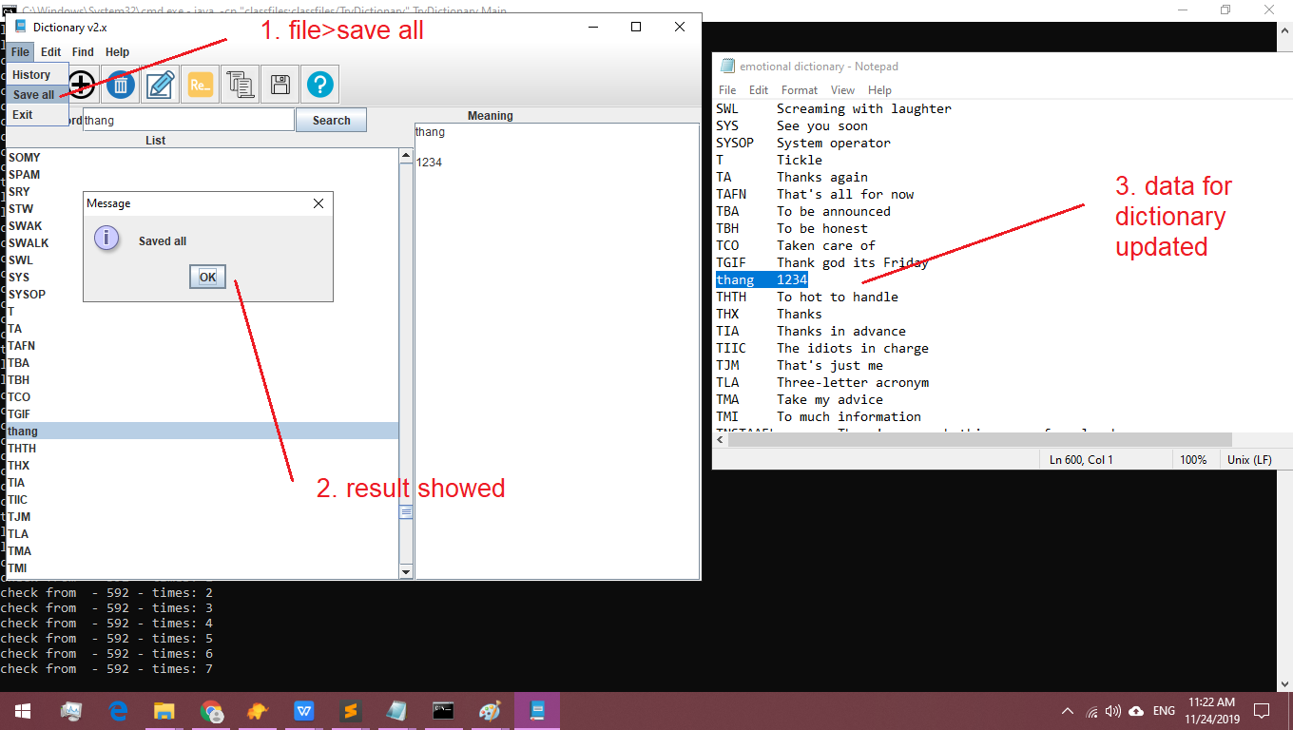

* 1. **Search meaning**

