**Online Auction Web Project**

**System Architecture**

Group: OneMember (1753102)

**Revision**

|  |  |  |  |
| --- | --- | --- | --- |
| **Version** | **Content** | **Date** | **Author** |
| 1.0 | Initial project | 21/11/2019 | Bui Quang Thang |
| 1.1 | Define overview system structure | 21/11/2019 | Bui Quang Thang |
|  |  |  |  |
|  |  |  |  |
|  |  |  |  |

1. **System structure**

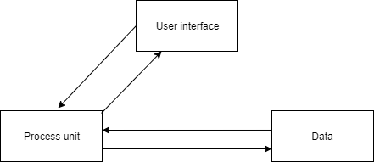

- User interface: stores in html, css, Javascript files

- Process unit: stores in Javascript file

- Data: stores in Javascript file

1. **System UI Prototype**

Draw in hand-notebook.

1. **Database**

Draw in hand-notebook.